A. Installation for Windows computer and Android phone (Part 1 of 2)

1. Download Visual Studio Community by entering this URL <https://visualstudio.microsoft.com/vs/> in your browser, hovering over “Download Visual Studio”, then clicking “Community” 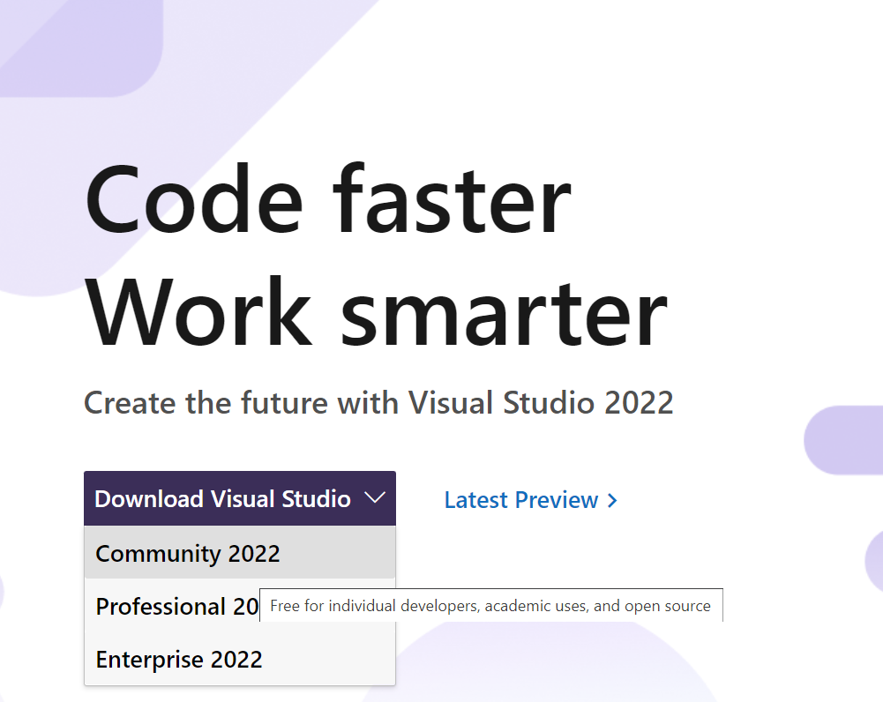
2. Click the downloaded installer

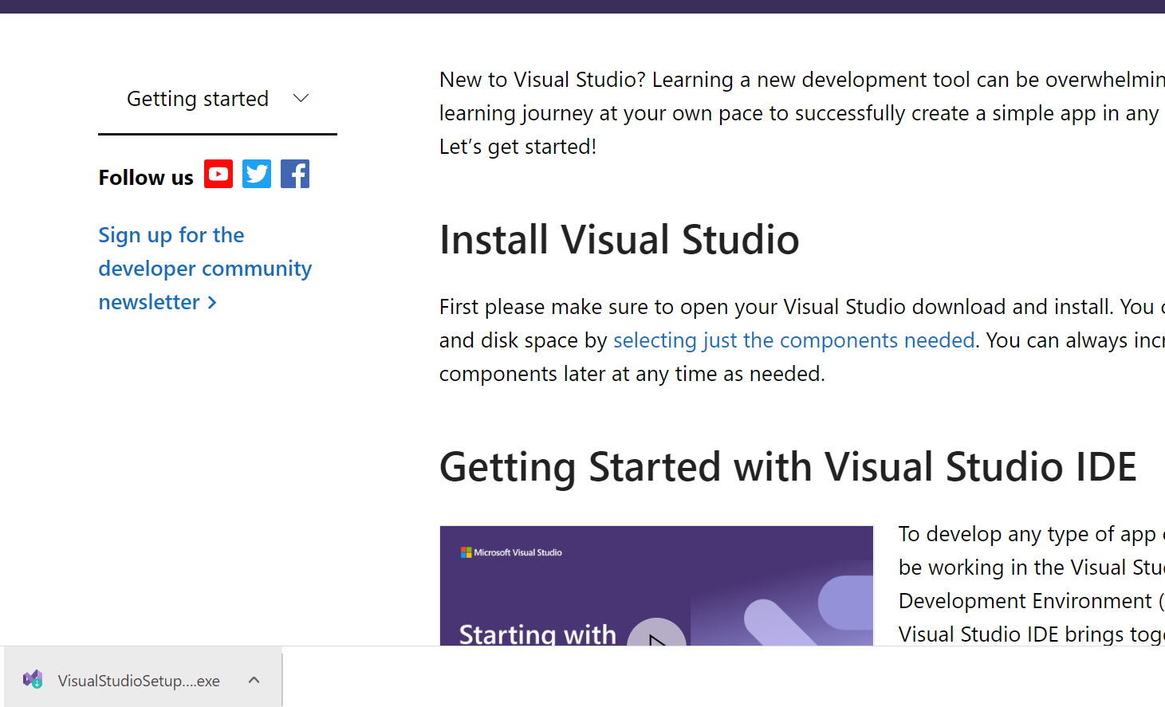

1. Allow administrator rights by clicking “Yes” or entering administrator username and password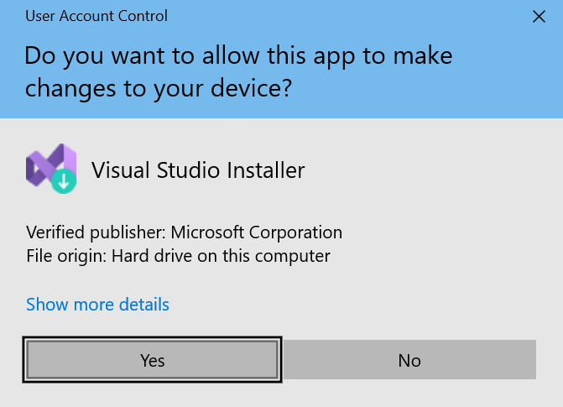
2. Click “Continue” 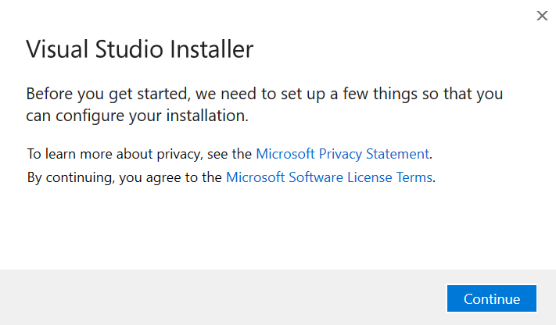
3. Click “Mobile development with .NET” then “Install” 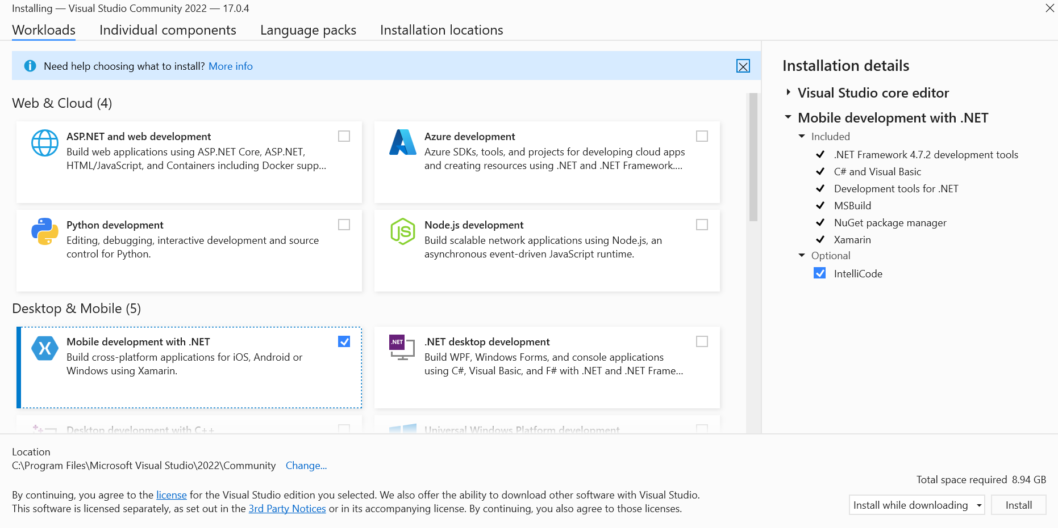
4. While waiting for installation, continue onto step 7 at the same time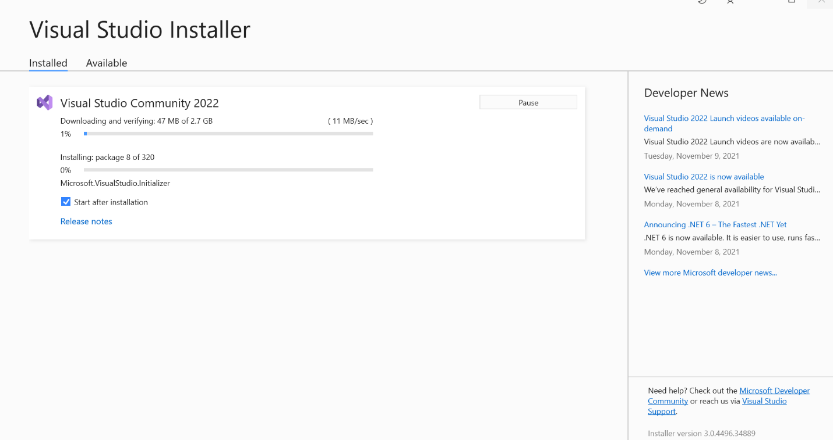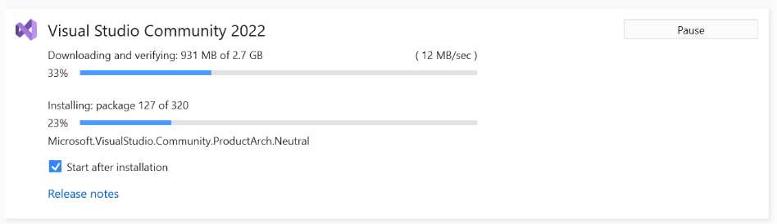
5. Enable USB Debugging in your Android phone   
   (NOTE: the Settings UI is different for each brand, below UI is for stock Android)
   1. Go to “Settings” > (if Android 8.0 or 8.1: “System” > ) “About phone” > Hit “Build number” for 7 times until get a message “You are now a developer!”
   2. Back to “Settings”, open “Developer options” and enable “USB debugging” switch > Tap OK.  
      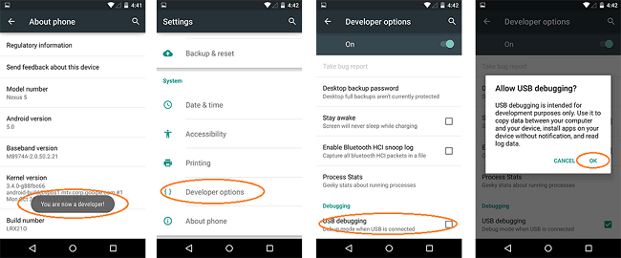
   3. Plug your phone into the computer via a USB cable 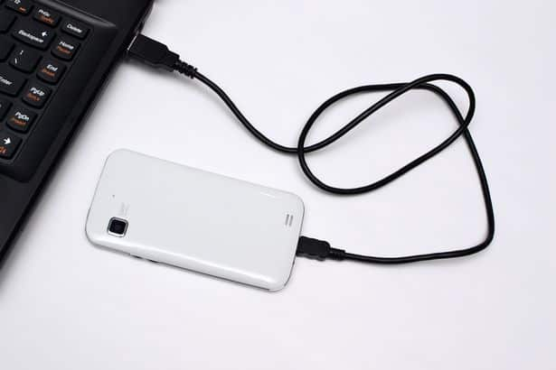
   4. Verify that the “Use USB for” selection appears or use another USB cable capable of data transfer instead of just charging the phone. Press “File transfer/Android Auto”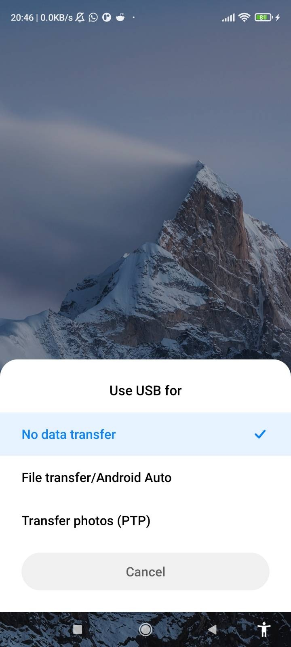
6. After Visual Studio installation completes, click “Not now, maybe later” 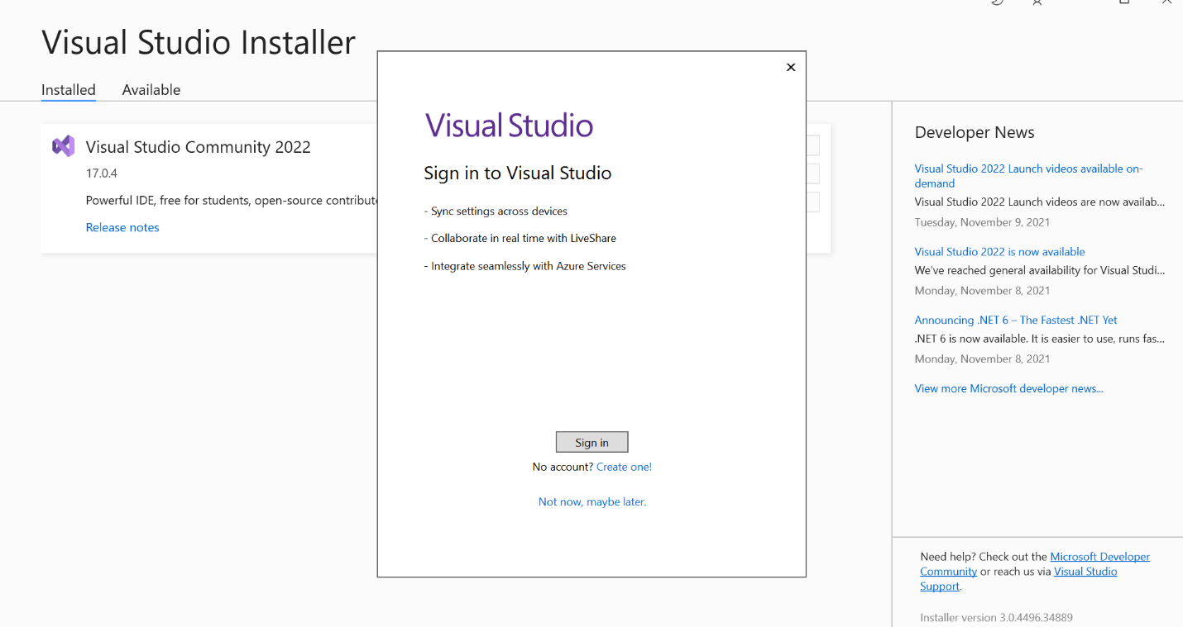
7. Click “Start Visual Studio” 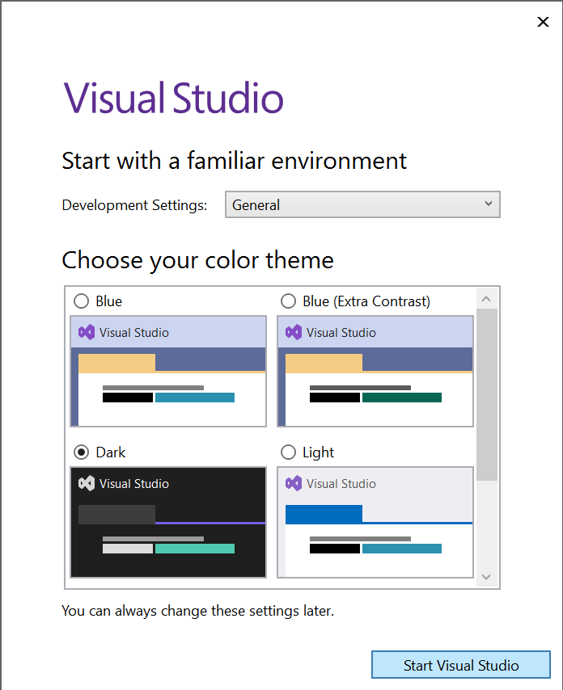
8. Wait a bit more 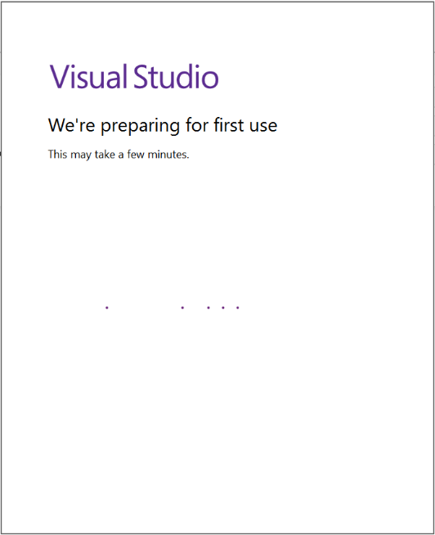

B. Getting the template

1. Click “Clone a repository” 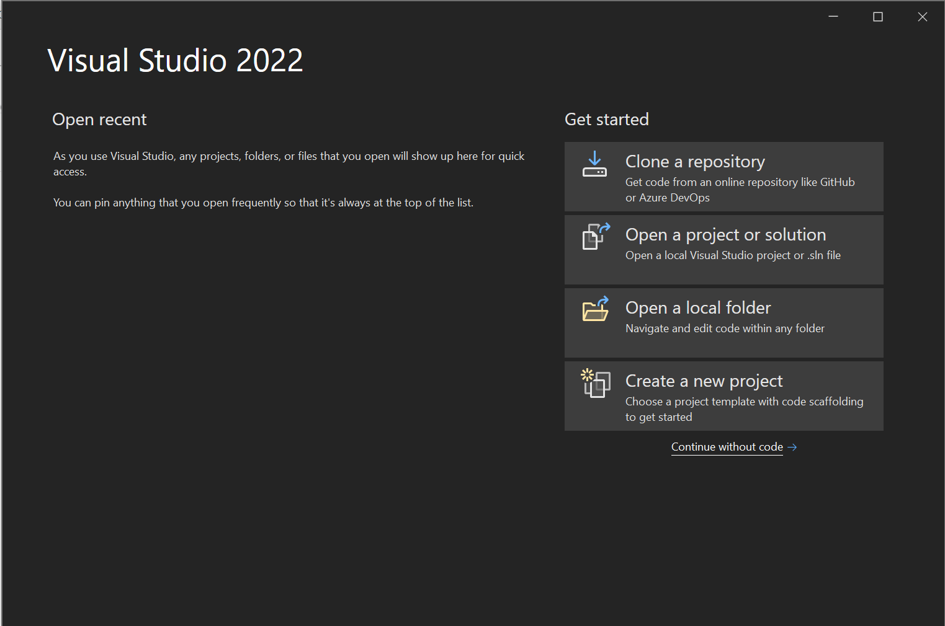
2. Paste https://github.com/Happypig375/PedoApp2 into Repository location, then click Clone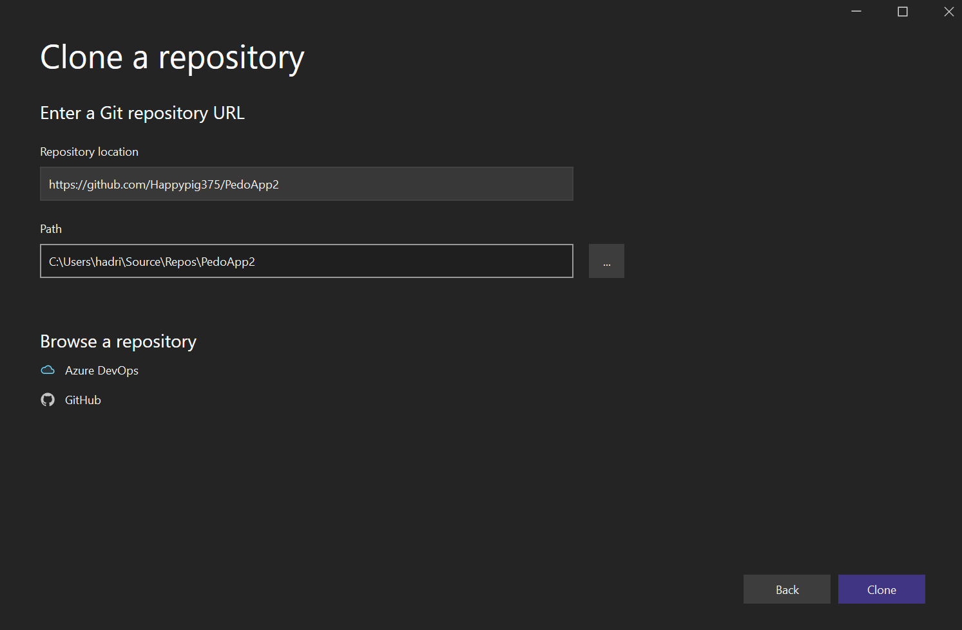
3. Wait for download 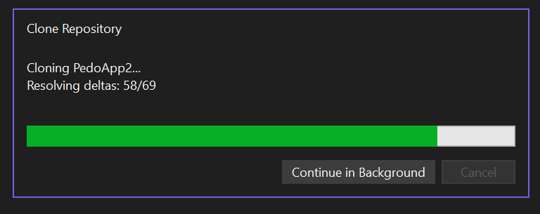

C. Installation for Windows computer and Android phone (Part 2 of 2)

1. Click “Accept” for “Android Sdk License” 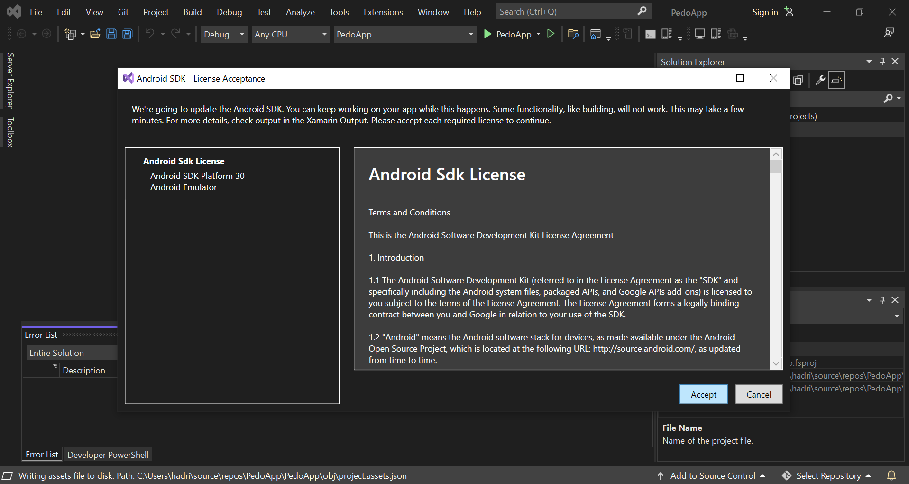
2. Allow administrator rights by clicking “Yes” or entering administrator username and password 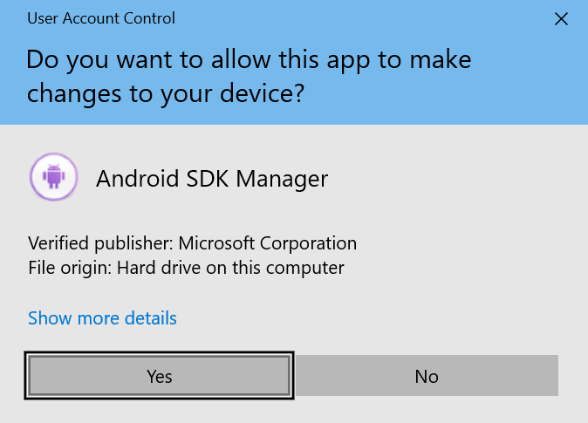

D. App overview

1. Click the dropdown arrow next to “App” and click “App.Android”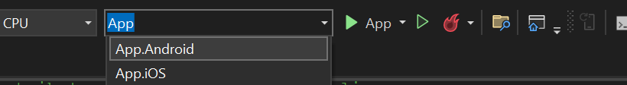
2. Click the dropdown arrow to the right of the green right-pointing triangle and click the option with your phone model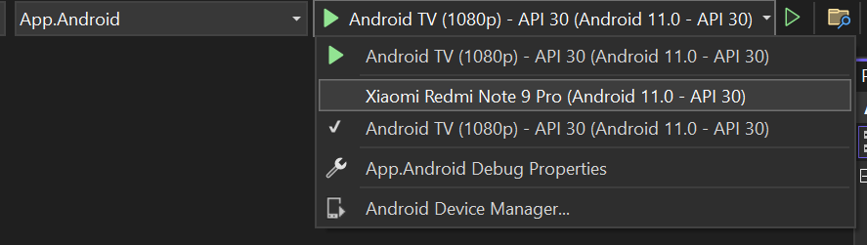
3. Press the green right-pointing triangle and wait for the app to build. Meanwhile, look at your phone for the next step  
   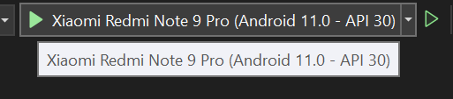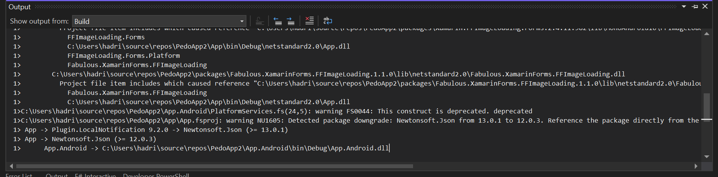
4. Press “Install” once the installation prompt comes up. You only have 10 seconds to accept, or accept the computer screen error prompt and repeat from the previous step  
   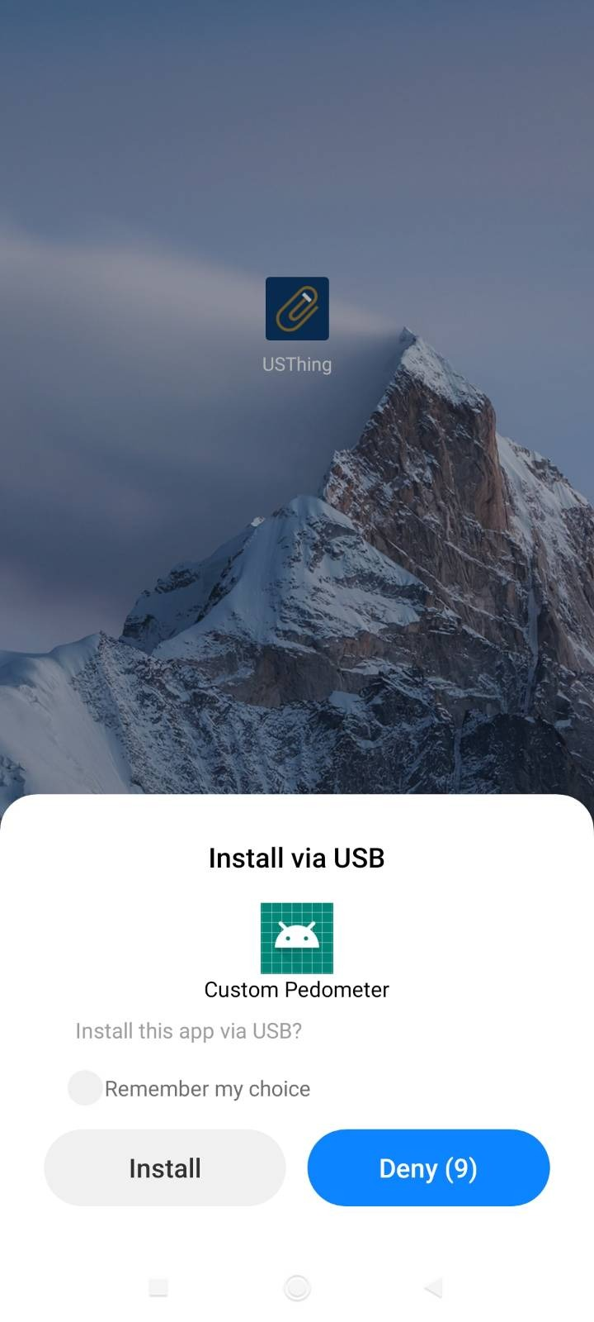
5. Press “Allow” 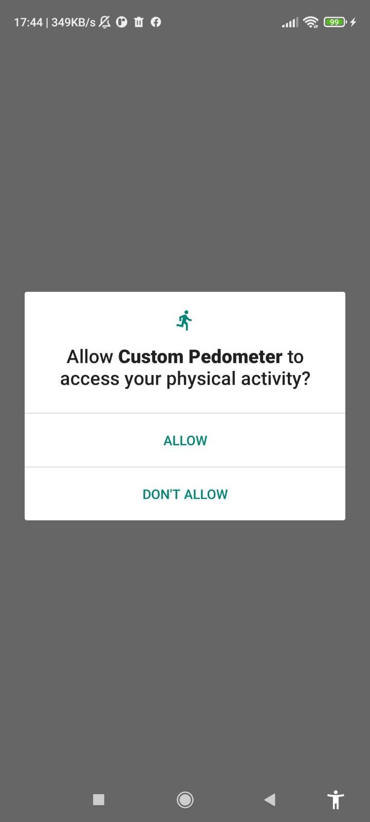
6. Test the pedometer by walking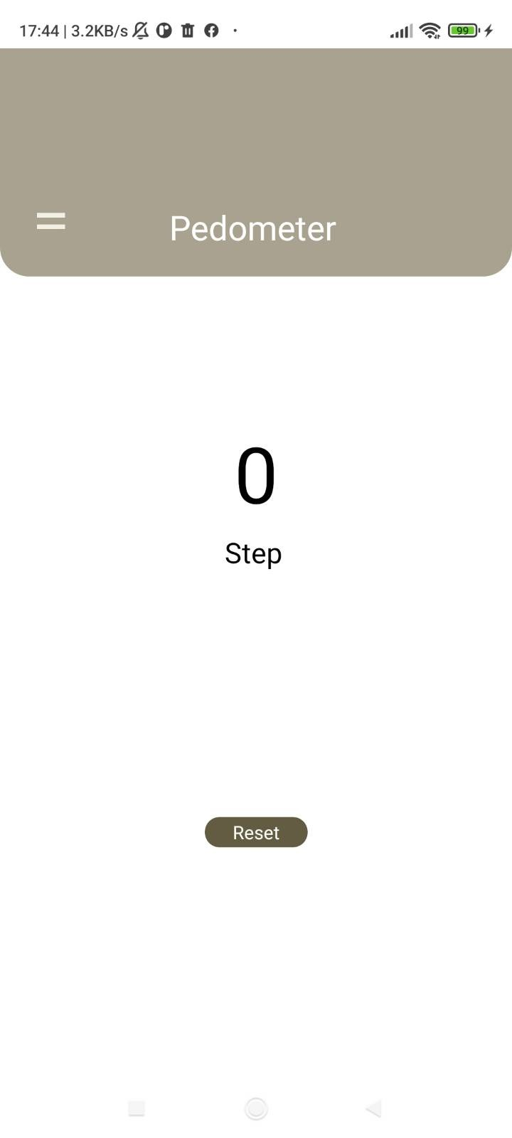
7. Press the menu button
8. Press “Alarm” 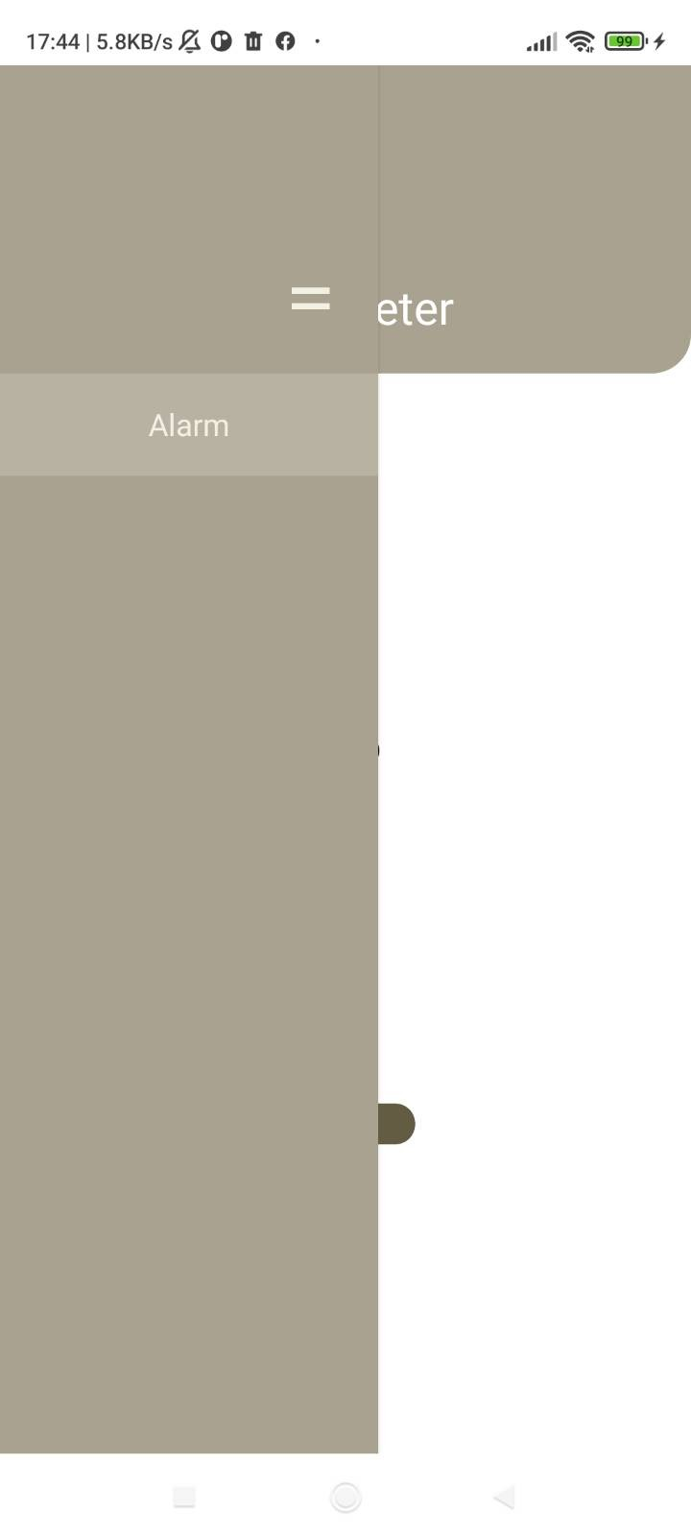
9. 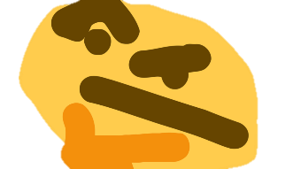We have some bugs here! 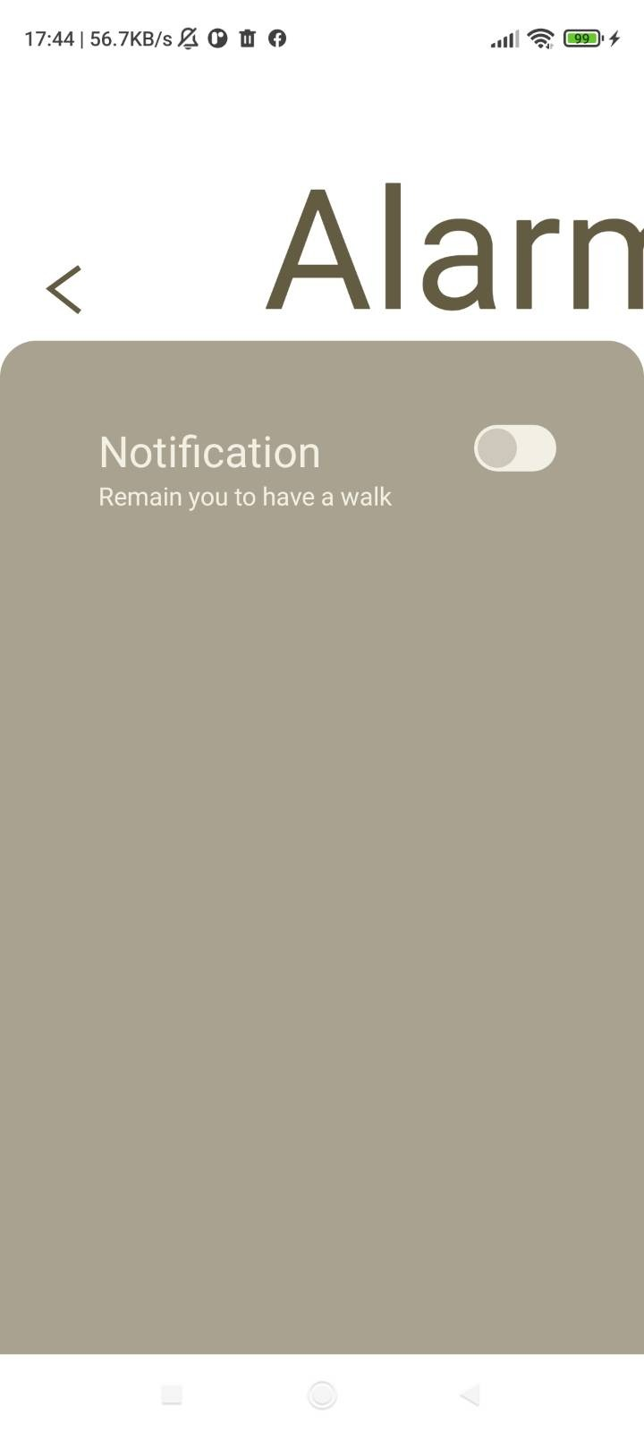

E. Bugfixing

1. Click to open Solution Explorer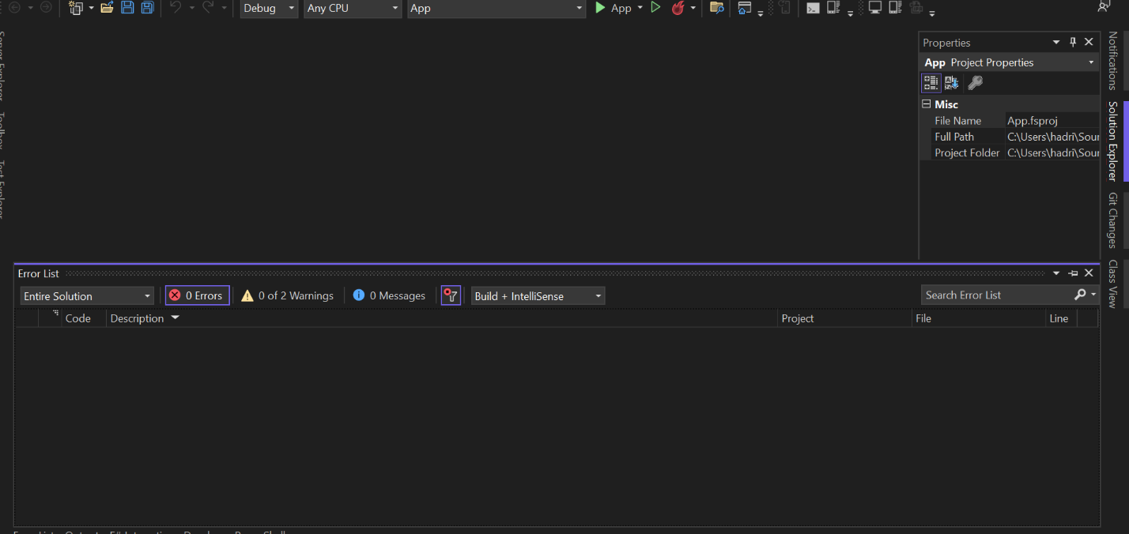
2. Click to open “App” dropdown 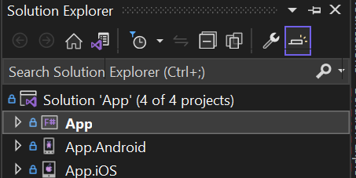
3. Double click to open App.fs 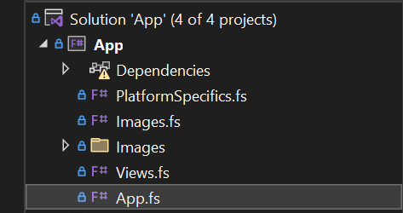
4. Hover over “Edit” at the top, then hover over “Find and Replace”, then click “Quick Find” 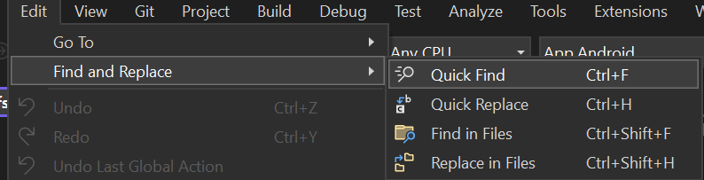
5. Type “todo” in the find prompt at the top right corner 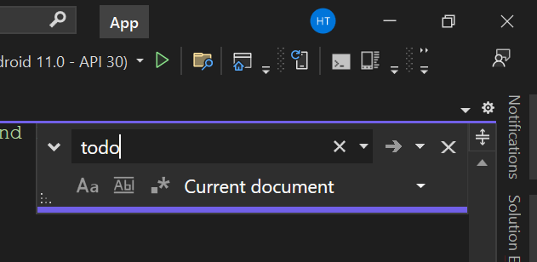
6. See the “TODO”s highlighted. The vertical scroll bar also highlights for lines containing these TODOs.

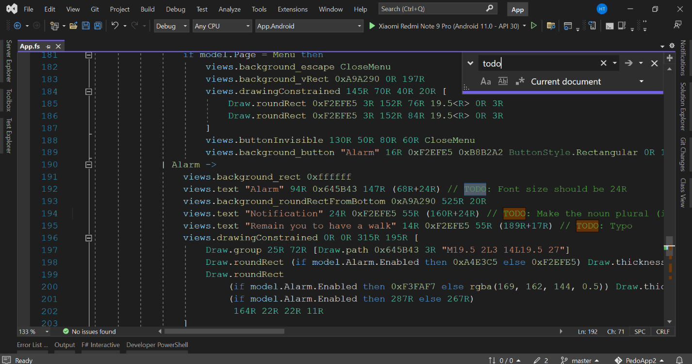

1. For example, on line 205, we have a TODO: Set the height to 50R.  
   First try to understand what that line is doing by hovering over the yellow part buttonInvisible  
   
2. Explanation: this is an invisible button, with its left edge at 250 (“R”atio-defined units), top edge at 150 (“R”atio-defined units), width of 75 (“R”atio-defined units), and height of 0 (“R”atio-defined units), and pressing it will cause a SwitchAlarm. It’s obvious that a button of zero height will not be desirable and the TODO tells us to change the height to 50 (“R”atio-defined units) instead, and after changing 0R to 50R, click the green right-pointing triangle again to see the effect of our change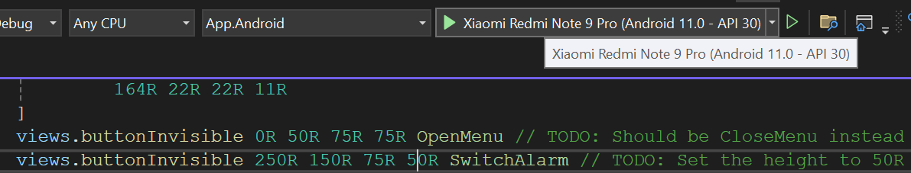

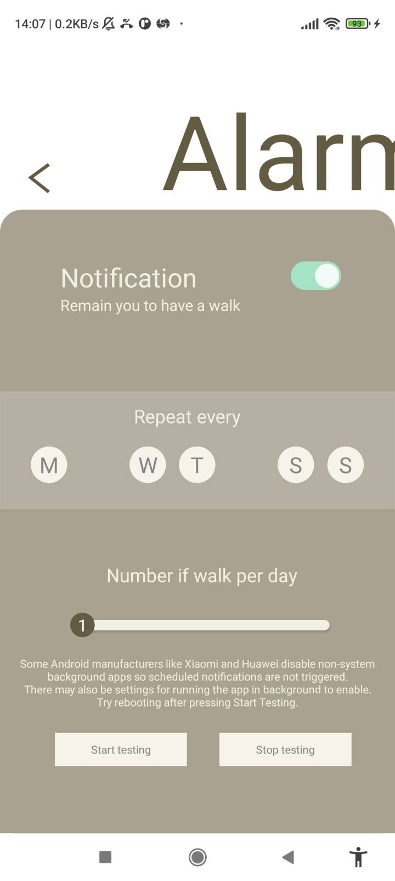

1. There are still more bugs to fix  
   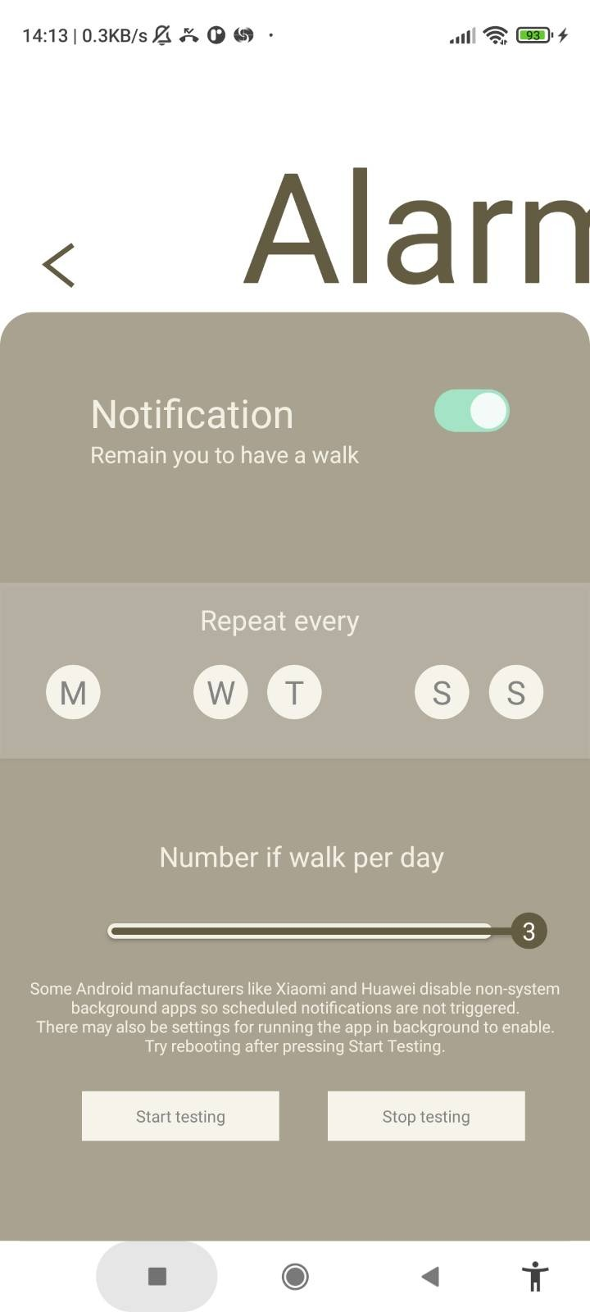
2. Click “Stop debugging” to return to editing code 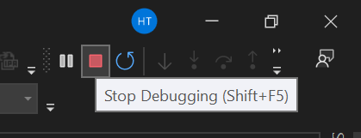
3. We can delete the TODO since we have completed it
4. As another example, let’s fix the slider getting over the right limit by looking at line 227  
   Explanation: We have the x coordinate touched, subtract it by 22R/2 (which is half of the knob  width so that we get where the left edge of the knob  should be), take the minimum between 384R and it, take the maximum between 64R and it, then raise the MoveKnob message (move the left edge of the knob  to that coordinate). It can be inferred that the coordinate of the left edge of the knob  is limited to a range between 64R and 384R. Meanwhile, the TODO tells us that the right limit should be at 284R instead. Therefore, we should change 384R to 284R
5. Click the green right-pointing triangle again 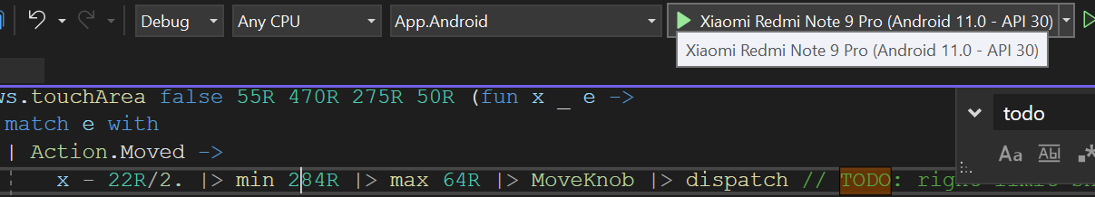
6. Navigate to the Alarm page, now the slider is unable to be moved past the right edge 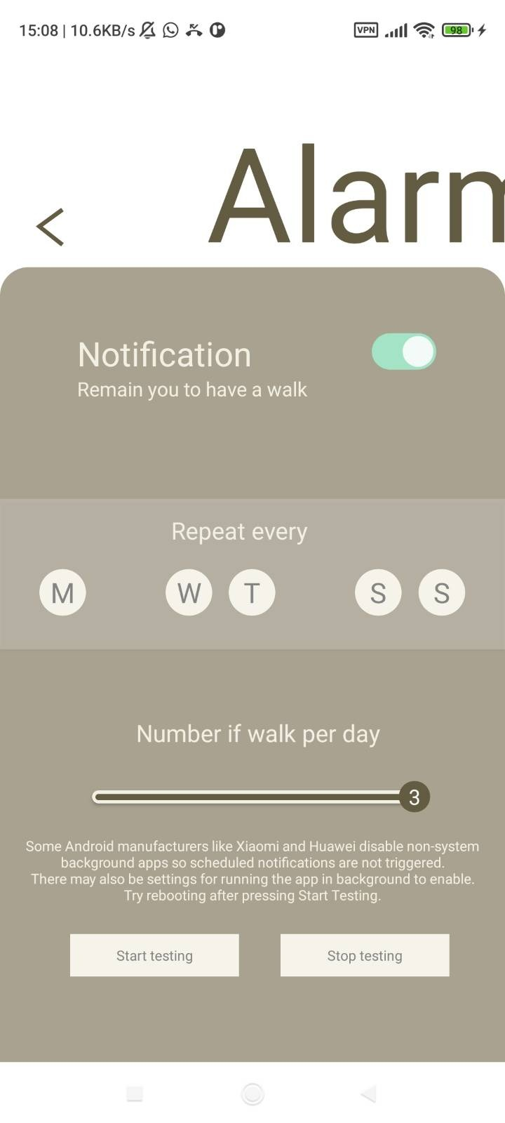
7. Delete the TODO since we have completed it
8. As the last example, we look at line 213 where we need to add another button for Tuesday. We can observe the code surrounding this line, where we can infer a pattern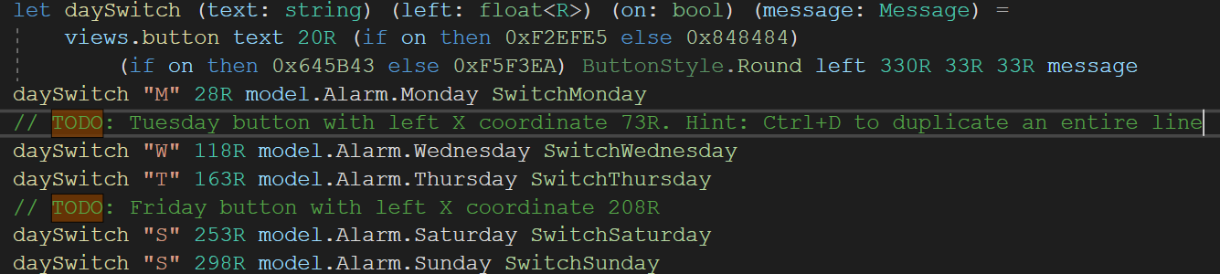
9. As the hint says, we can press Ctrl and D simultaneously to duplicate an entire line. Move the cursor onto line 212 and press Ctrl and D simultaneously
10. From the pattern we observed, we should change "M" to "T", 28R to 73R, Monday to Tuesday, and SwitchMonday to SwitchTuesday
11. Click the green right-pointing triangle again 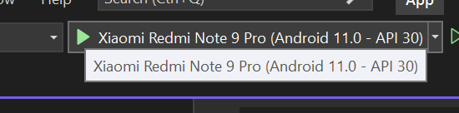
12. Navigate to the Alarm page, now we can see the new Tuesday button  
    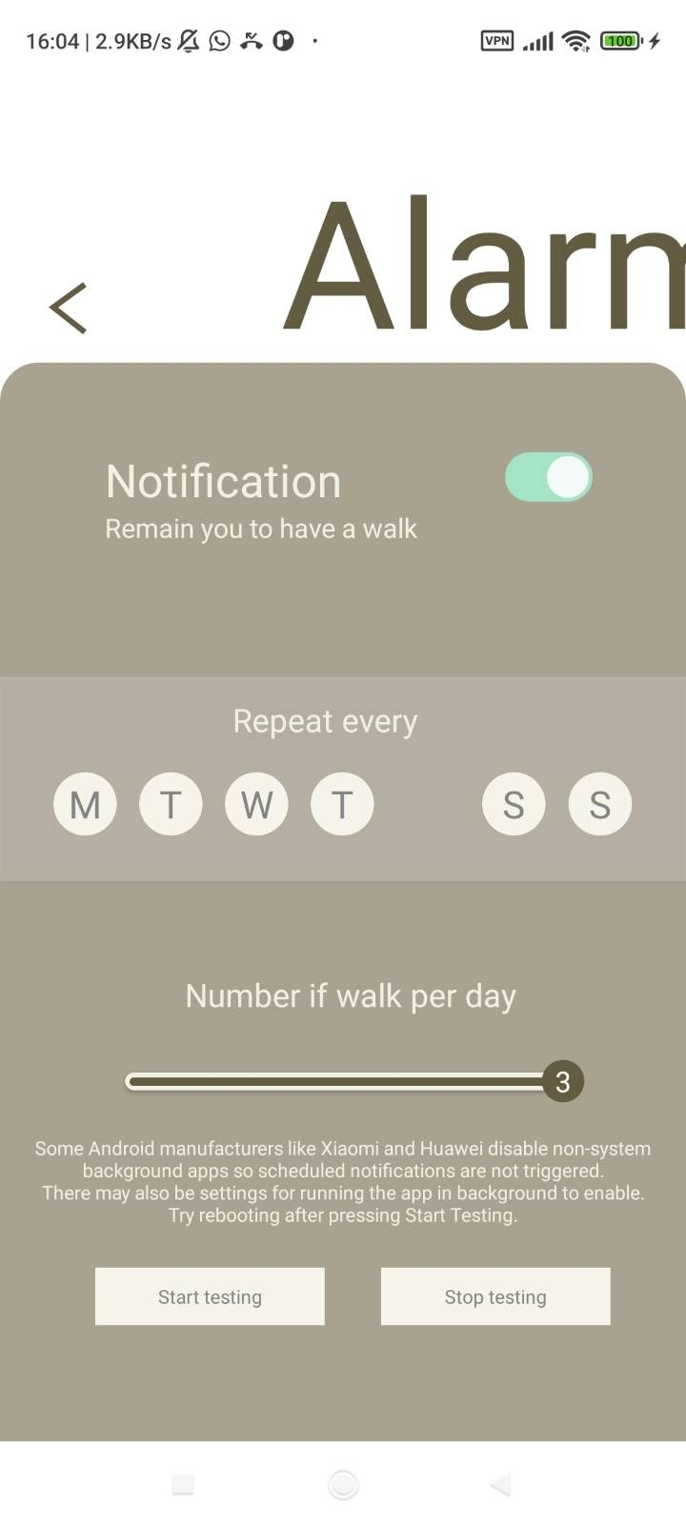
13. Delete the TODO which we just completed

Fix the other bugs as specified in the remaining TODOs so that the Alarm page looks like as below  
Hint: the TODO: Typos have the desired text shown below  
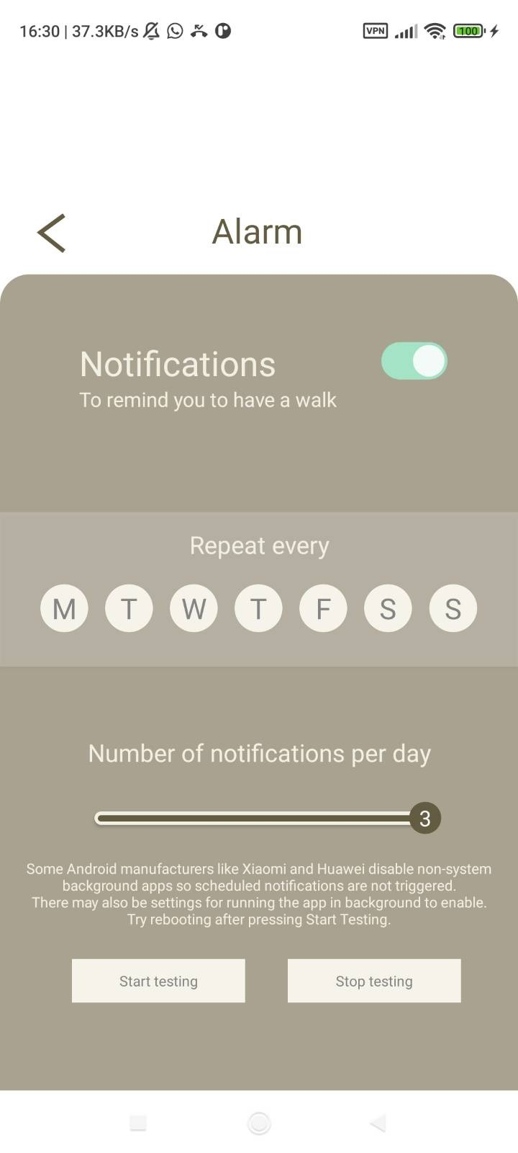

F. Color customization

1. 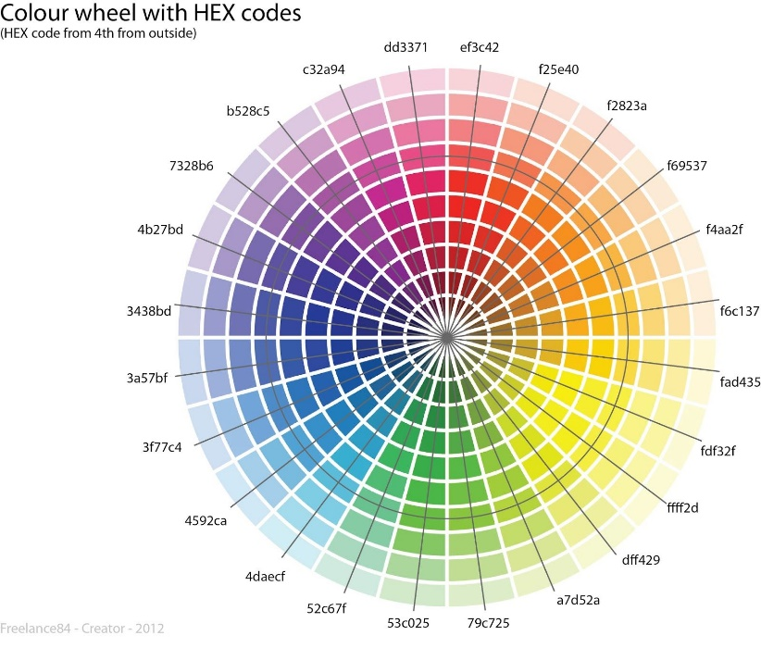There are various places in the code starting with 0x, such as line 178:   
   When hovering over textCenter,  
   we find that 0x000000 corresponds to color. To understand how this can represent a color, we can view 0x000000 as three parts: 0x000000 where the first two characters after 0x designate the amount of redness, then the next two characters designate the amount of greenness, and the final two characters designate the amount of blueness. These characters are hexadecimal digits, so instead of incrementing 09 to 10, 09 is incremented to 0A, then 0B, 0C, 0D, 0E, 0F, 10, …, 19, 1A, …, 1F, 20, …, 9F, A0, …, FE, FF. From 00 to FF, there are 256 possibilities in total. Therefore, from 0x000000 to 0xFFFFFF, there are 2563 = 16777216 possible colors. 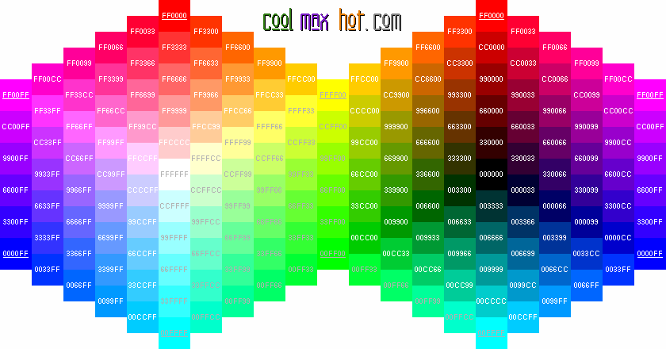  
   From the above chart, we can see how mixing red, green, and blue can produce different colors, using combinations of 00, 33, 66, 99, CC, and FF, as well as seeing how incrementing red, green, or blue affects the color. Together, a color wheel can be formed, as seen in the chart to the right
2. 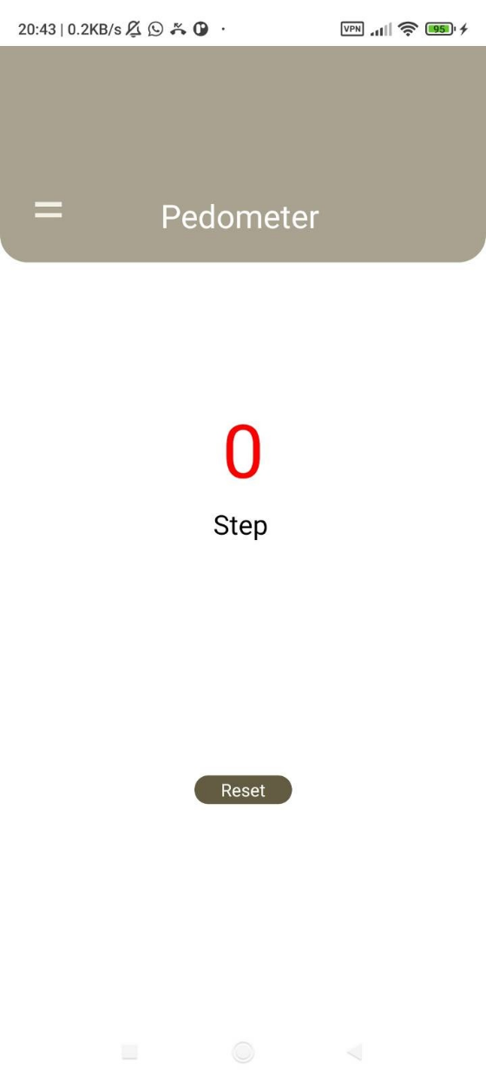Change 0x000000 to 0xFF0000 and click the green right-pointing triangle again. The counter should now have red text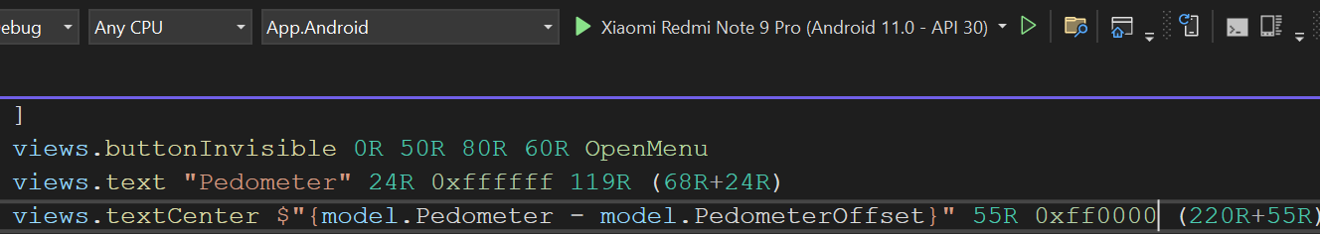
3. Try changing other colors and click the green right-pointing triangle to see the effects

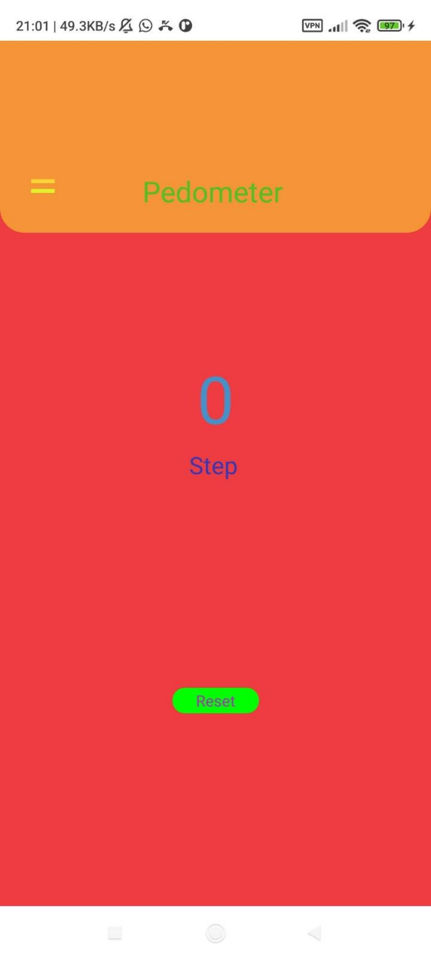

G. Unique app ID

1. To install our app on other Android devices easily, we must generate an APK file. Meanwhile, to publish the app to the Google Play store, we need to first generate an AAB file. However, before doing that, we should ensure a unique app ID so that we won’t be recognized as an existing app. In Solution Explorer, right click App.Android

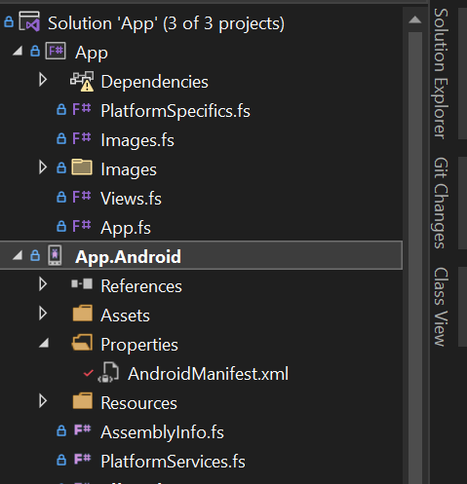

1. Click Properties 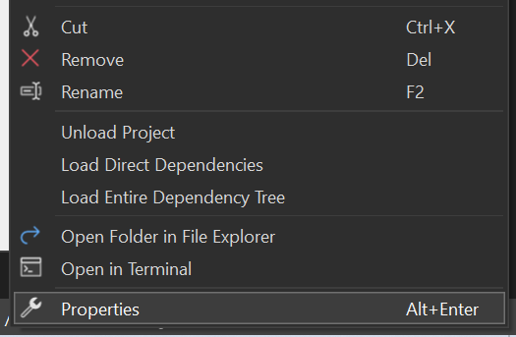
2. Click ”Android Manifest”, and see the “Package name” on the right. This is the app ID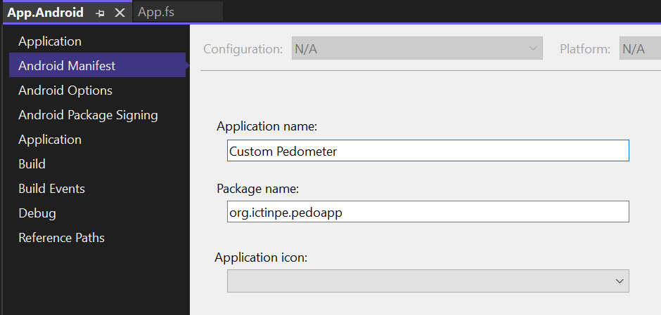
3. We can change the displayed name of the app on our phone screen in “Application name”. Meanwhile, we should also modify “Package name” to something unique, subject to the following restrictions:
   1. It must have at least two segments (i.e. contains one or more dots (.) for separation)
   2. Each segment must start with a letter (i.e. only letters at start or after a dot (.))
   3. All characters must be alphanumeric or an underscore (a-z, A-Z, 0-9, or _)
   4. Required by Google Play but not checked by Visual Studio:  
      It must start with a lowercase letter. It must be 150 characters or fewer.

Typically, these names start with the reversed domain name (ictinpe.org -> org.ictinpe) to avoid collisions, and only then the application identifier (pedoapp, in this case). However, you do not have to follow this convention, just make sure your name is unique enough to not collide with other apps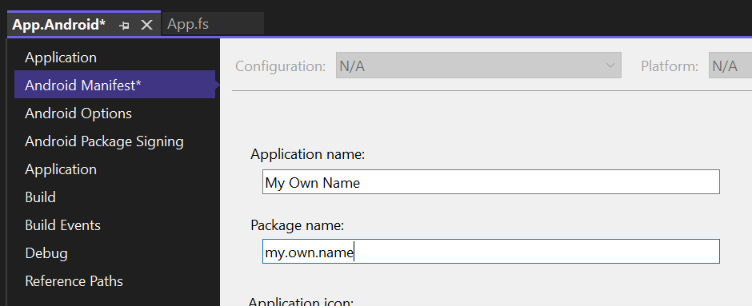

1. Remember to save changes by clicking the icon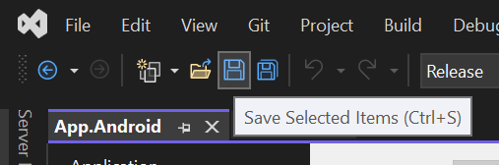
2. Close this tab when done 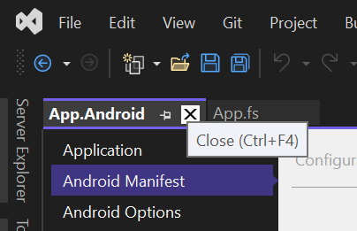

H. APK file generation

1. First we click the Debug on the top bar, then click Release in the dropdown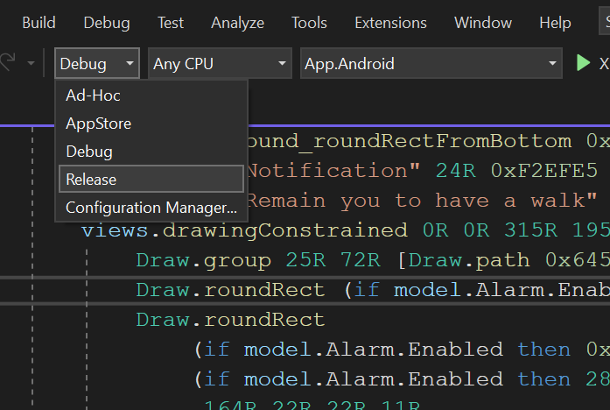
2. In Solution Explorer, right click App.Android 
3. Click “Archive…” 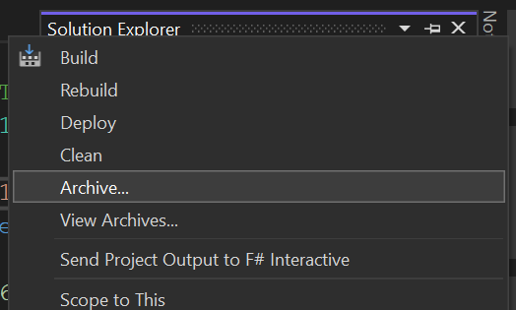
4. Wait for archiving to complete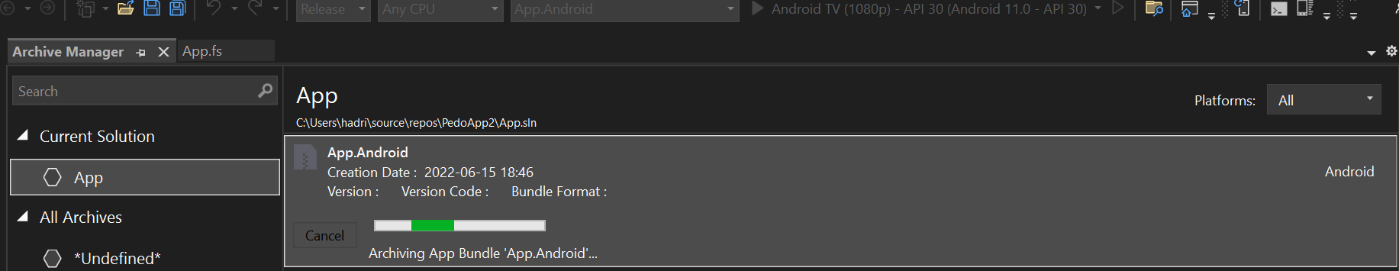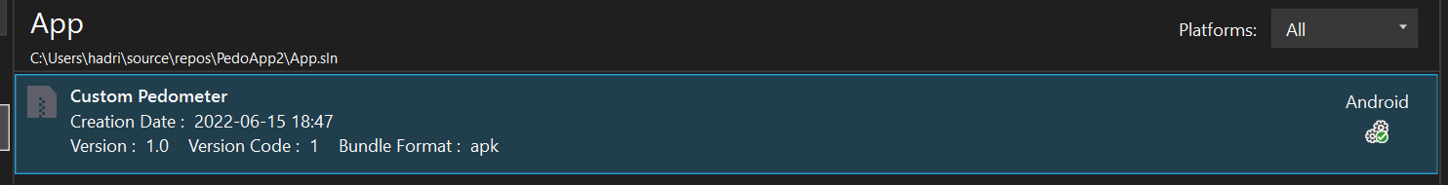
5. Click Distribute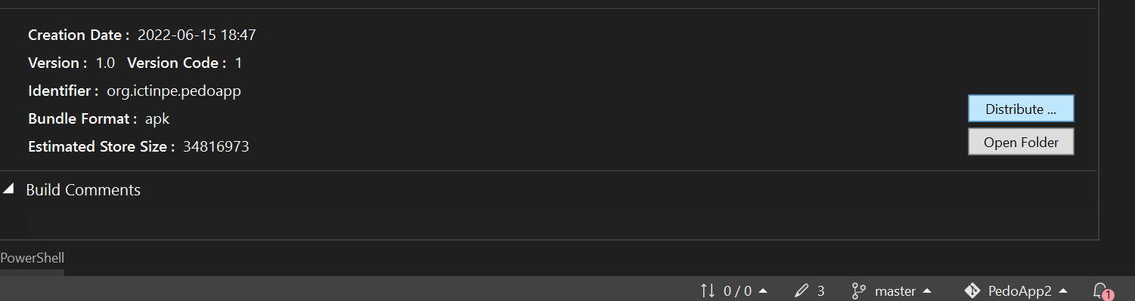
6. Click “Ad-Hoc”. Here, “Google Play” should only be used after we have successfully published our app, which is not applicable here because we haven’t published our app yet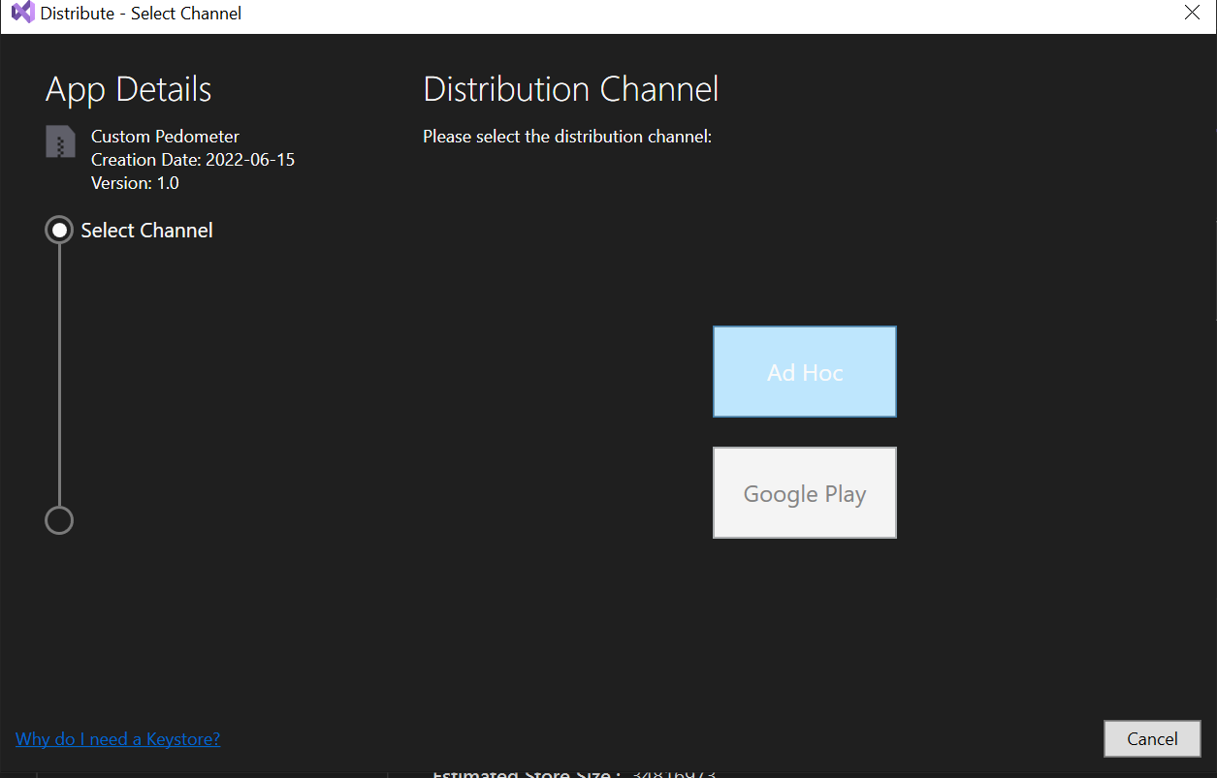
7. Now we are supposed to choose a Signing Identity which we don’t have yet. We can choose to add a new one or import one, here we import a standardized key instead of risking forgetting the password. Meanwhile, for actual apps, we should keep an actual key to prevent impostors from creating apps that impersonate ours. Click “Import…”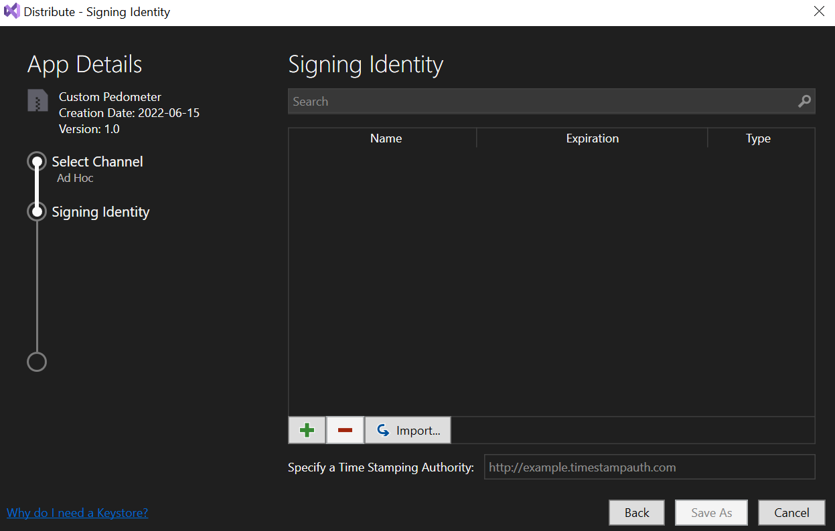
8. Click “…”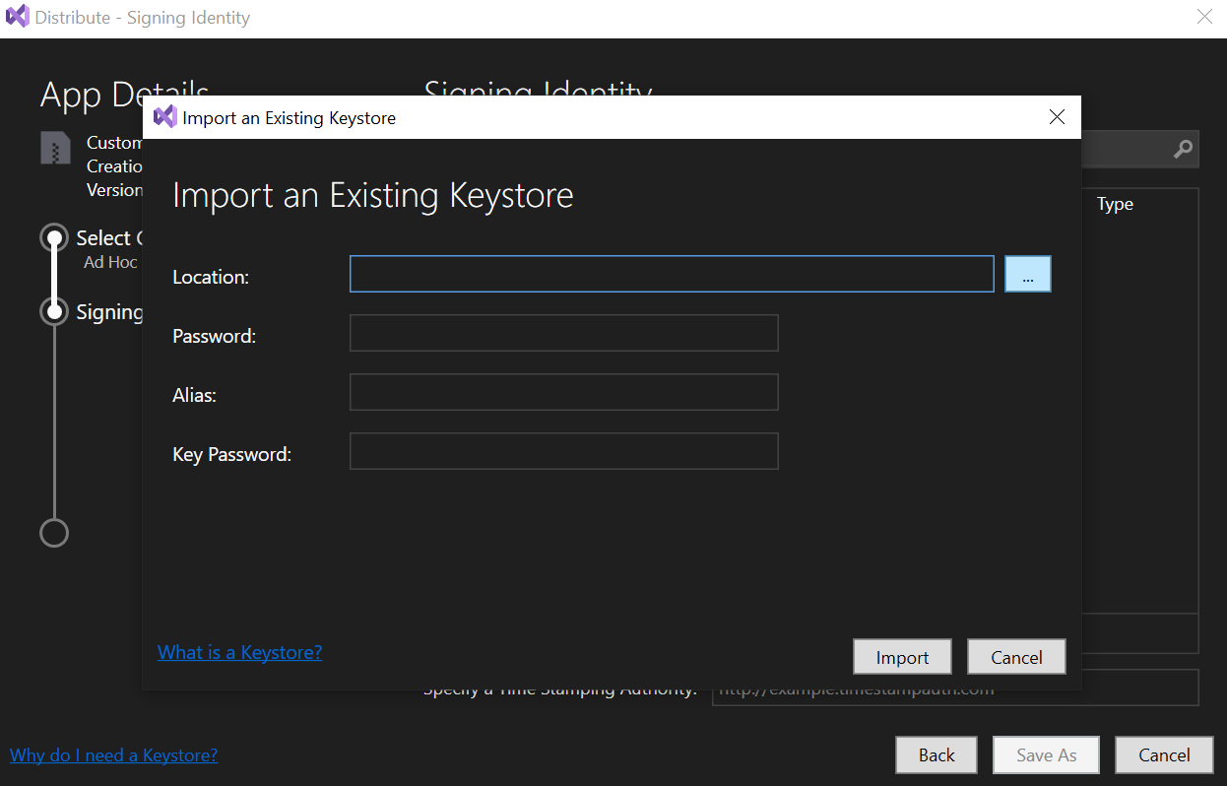
9. Open this URL in a web browser <https://github.com/Happypig375/PedoApp2/raw/master/PedoApp.keystore> 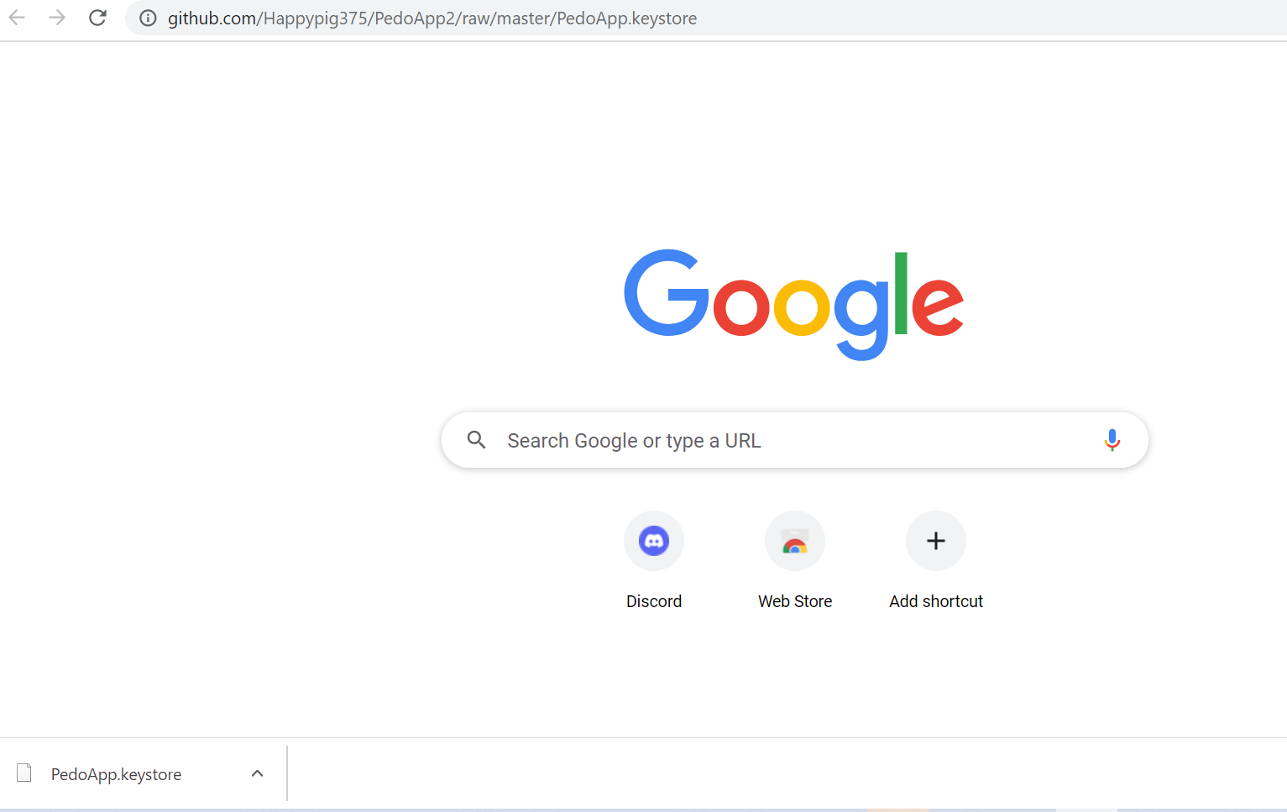
10. Back to Visual Studio, double click the file we just downloaded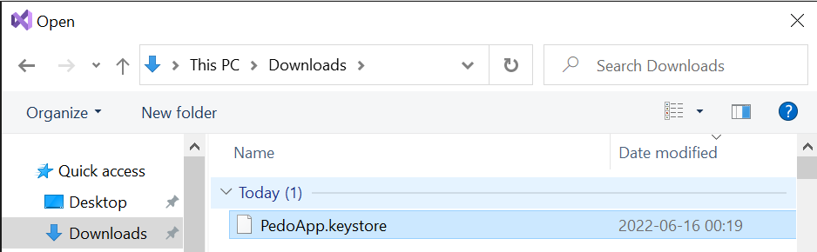
11. Input “PedoApp” (case sensitive) for all three text boxes, then click “Import” 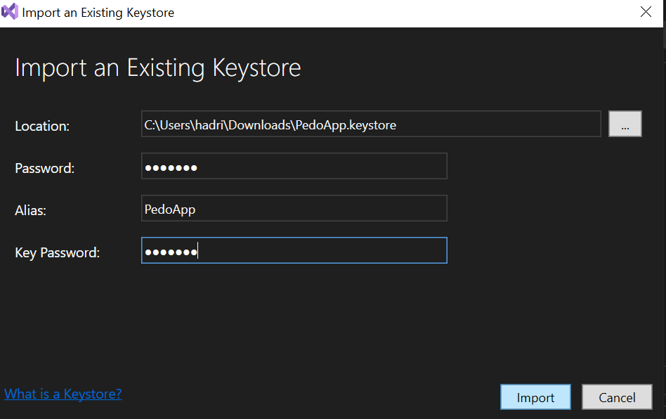
12. Click the “pedoapp” row we just created, then click “Save as” 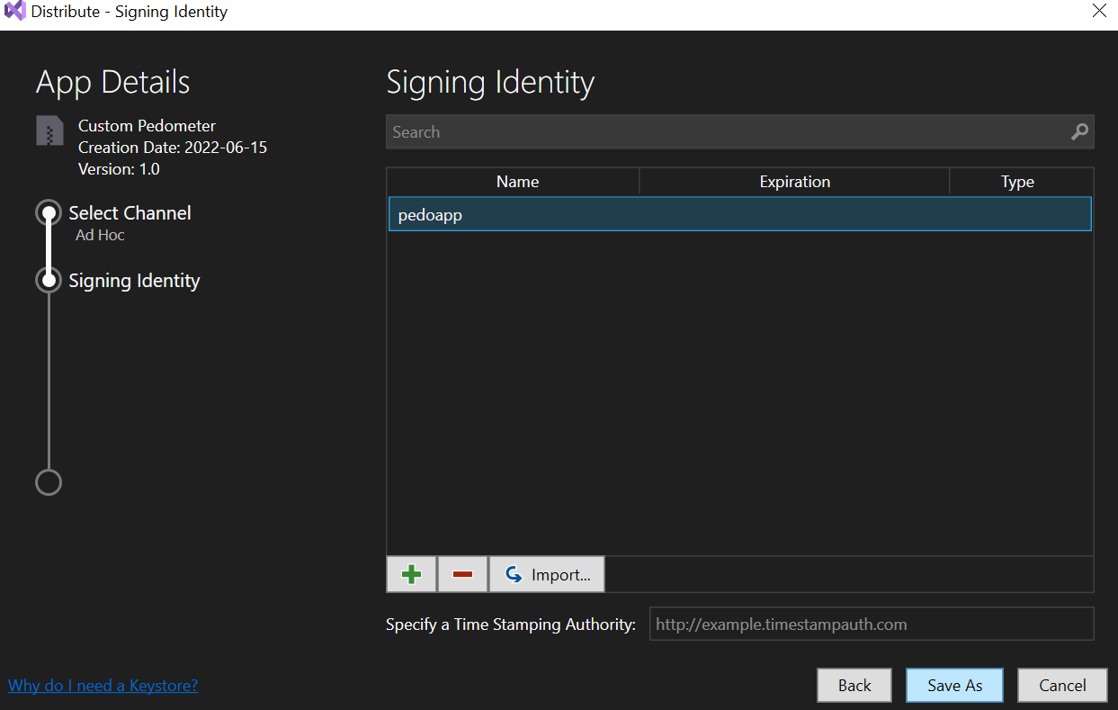
13. Click the Downloads folder, then click Save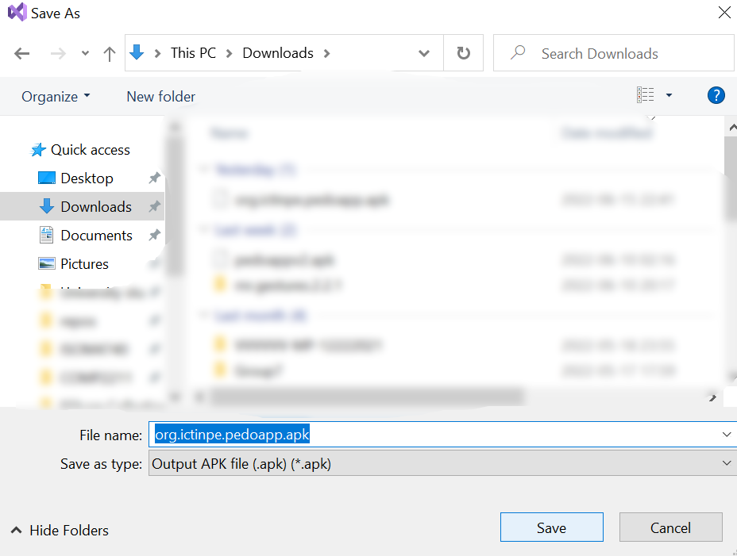
14. Input “PedoApp” (case sensitive) then click OK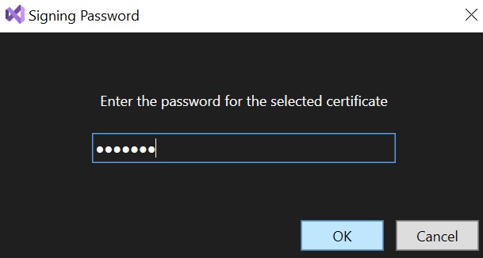
15. Check the Downloads folder, now we have an APK file generated successfully which can be installed on Android devices easily by transferring this file to them. If install fails, make sure to uninstall the existing installed app first before installing the APK file, because Android prevents us from installing apps with the same package name signed with different keystores, for example, installing an APK file to overwrite one downloaded from Google Play. **This file cannot be uploaded to Google Play directly. Follow later instructions to create an AAB file.**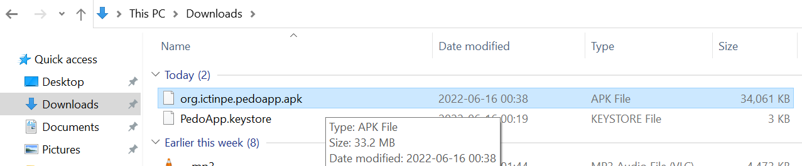

I. Google Play Developer registration

1. In the web browser, open this URL <https://play.google.com/console/about/>, then click “Go to Play Console”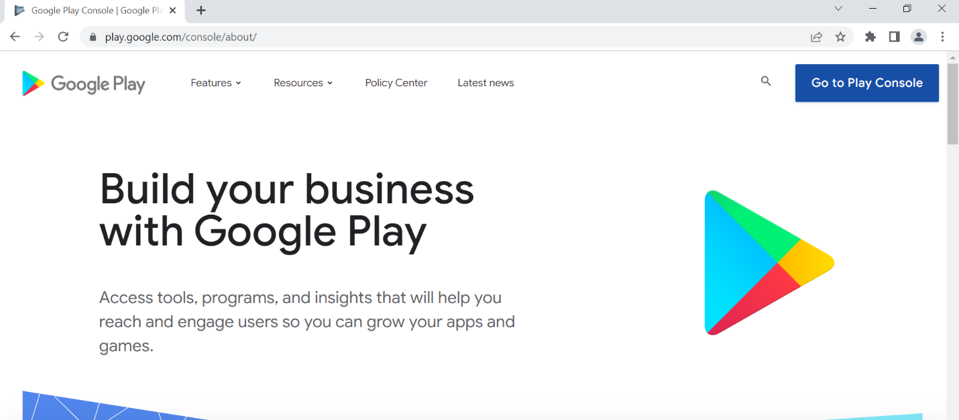
2. Log in with a Google account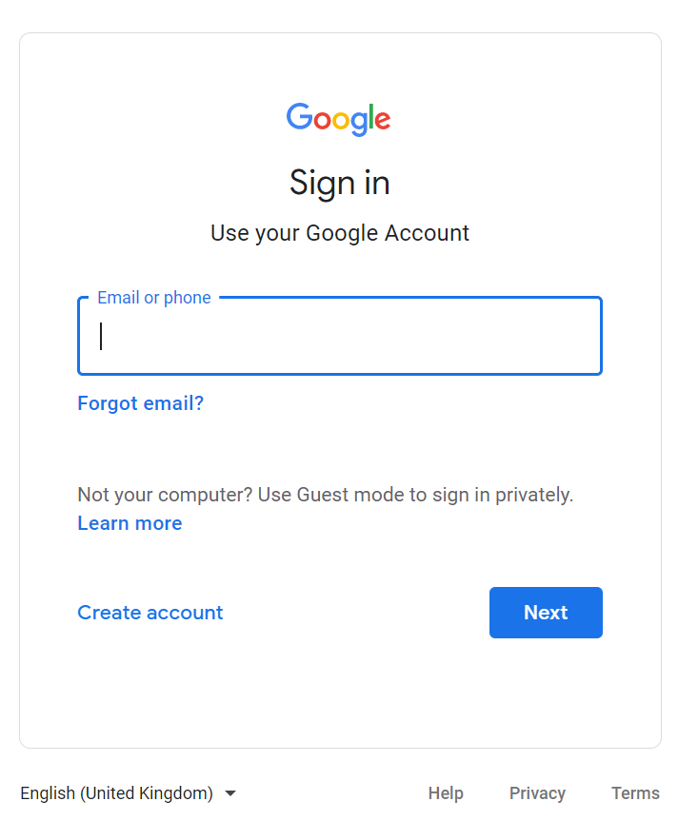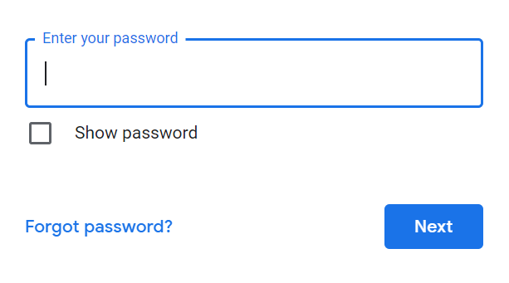
3. Accept new Terms of Service, if requested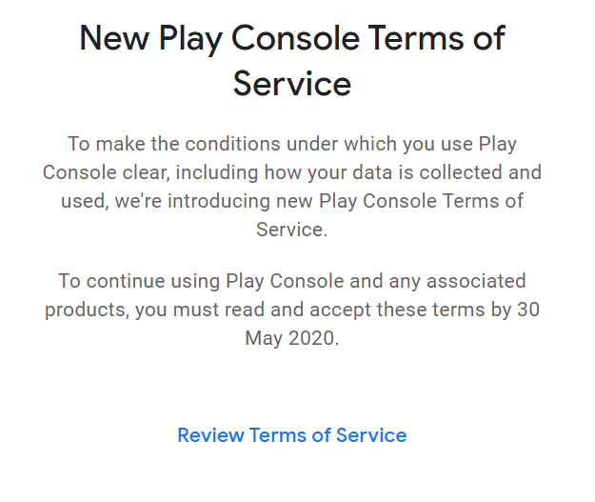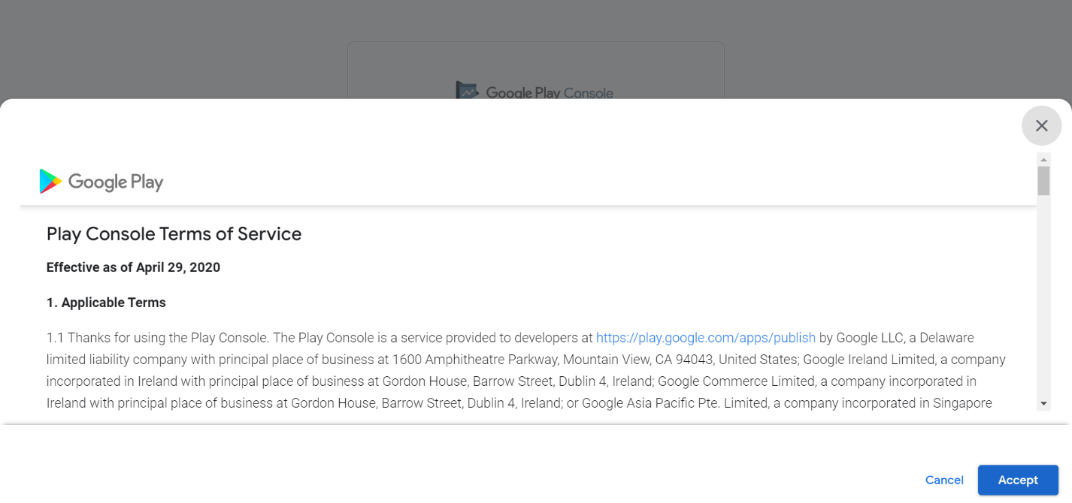
4. Google requires us to turn on 2-step verification before making a developer account so click it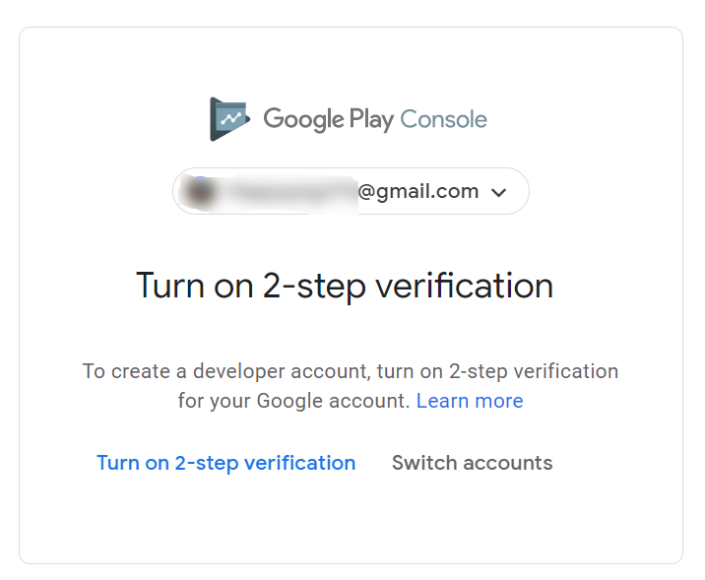
5. Click “Get Started” 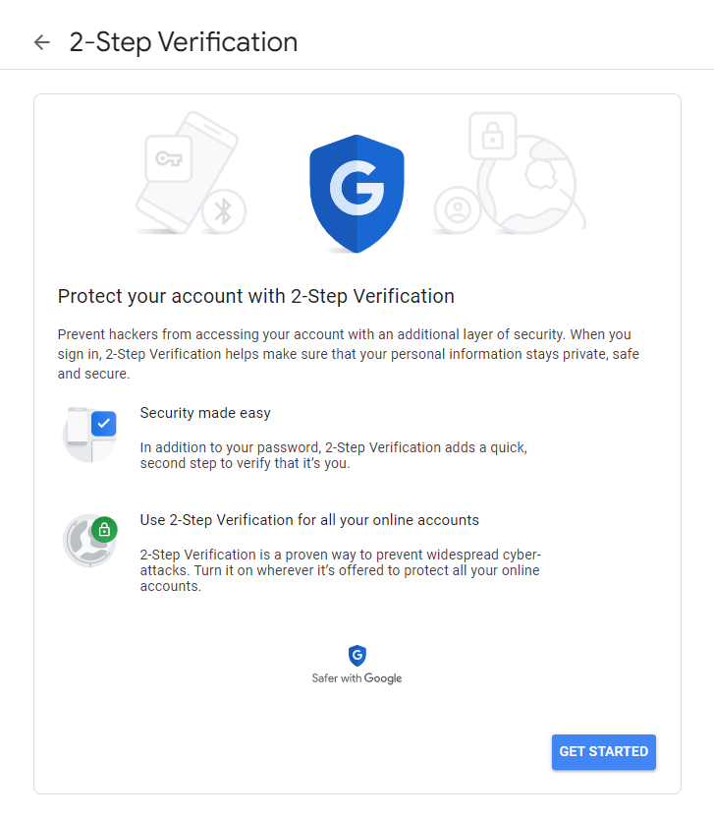
6. Click Next 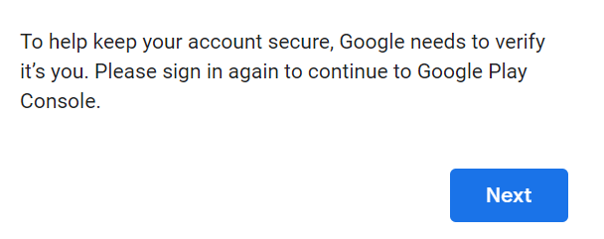
7. Enter password and click Next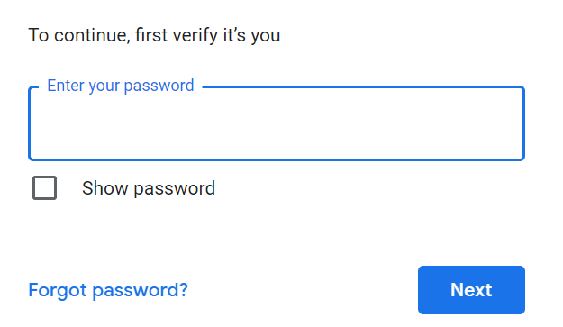
8. Ensure that your phone appears on the prompt, then click Continue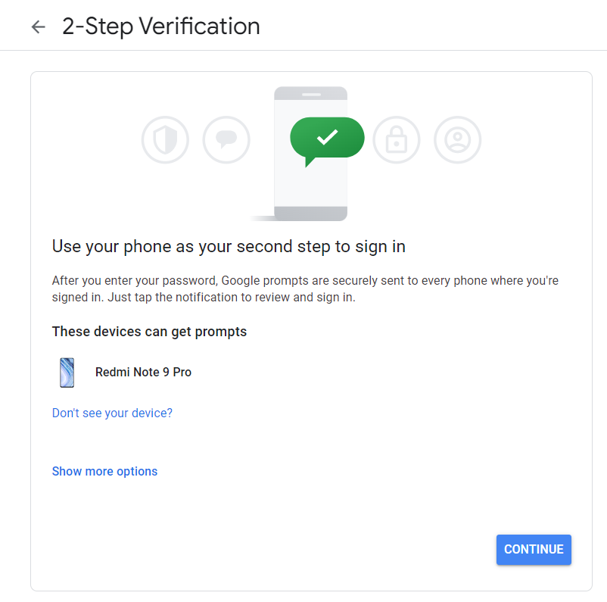
9. Select the correct country from the country box, then enter your phone number in the text box, then click Send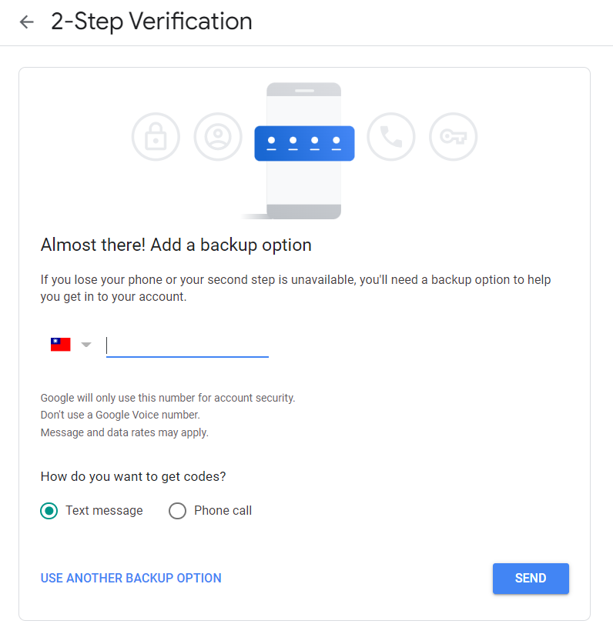
10. Check your phone’s SMS for the verification code
11. 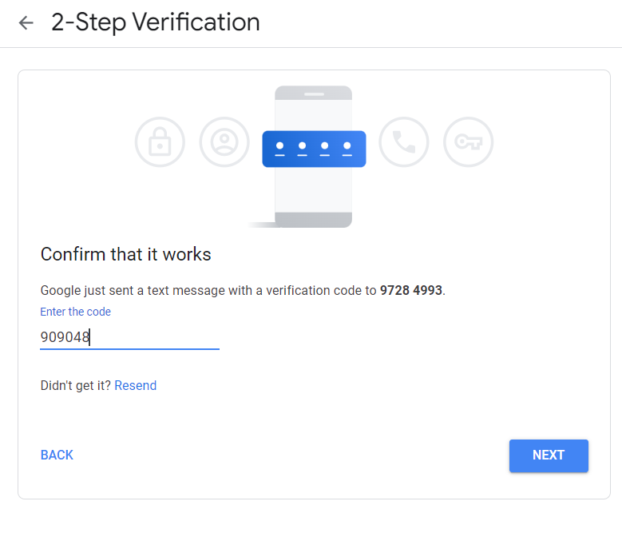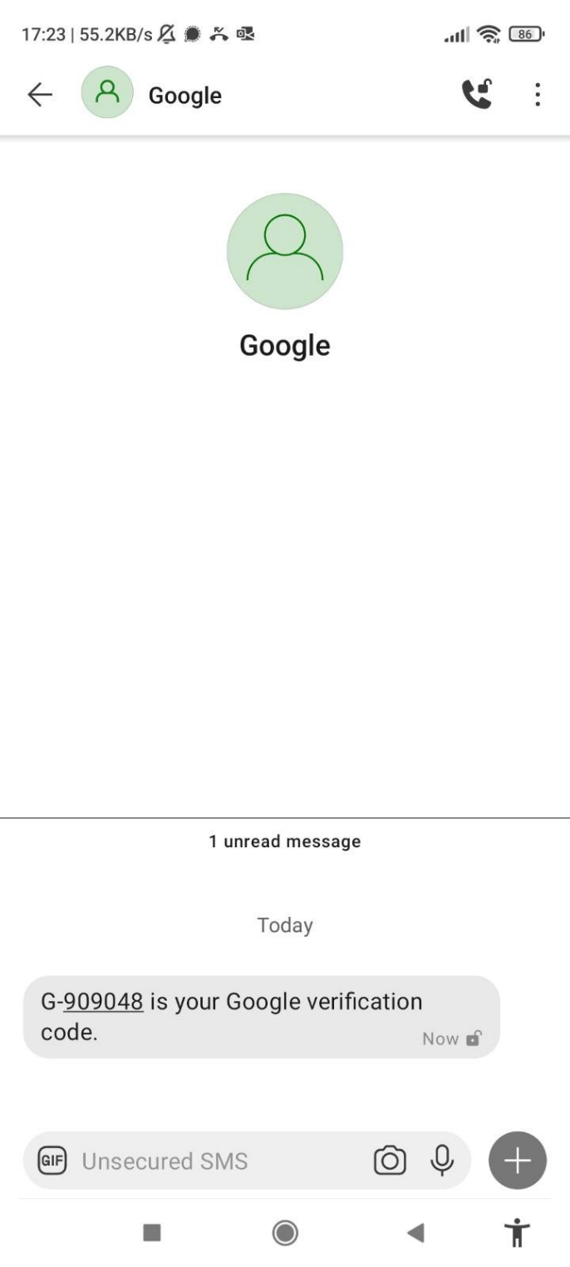Enter the verification code in the browser then click Next
12. Click Turn On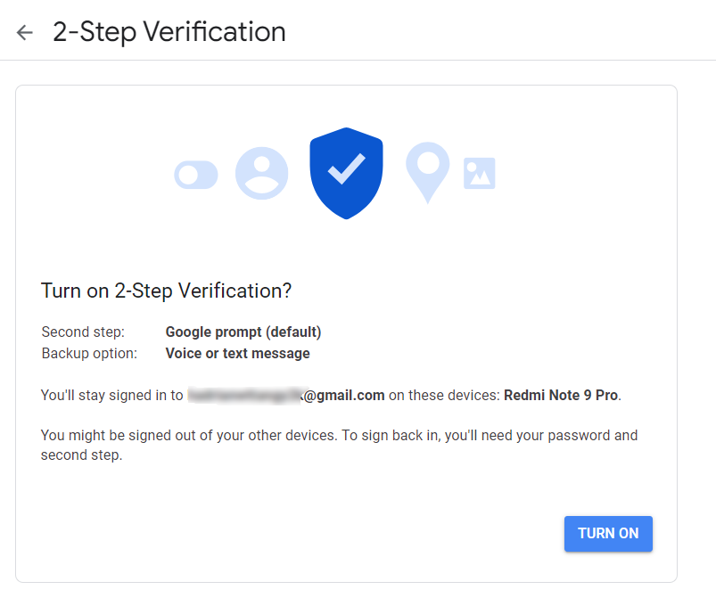
13. Ensure that 2-step verification is turned on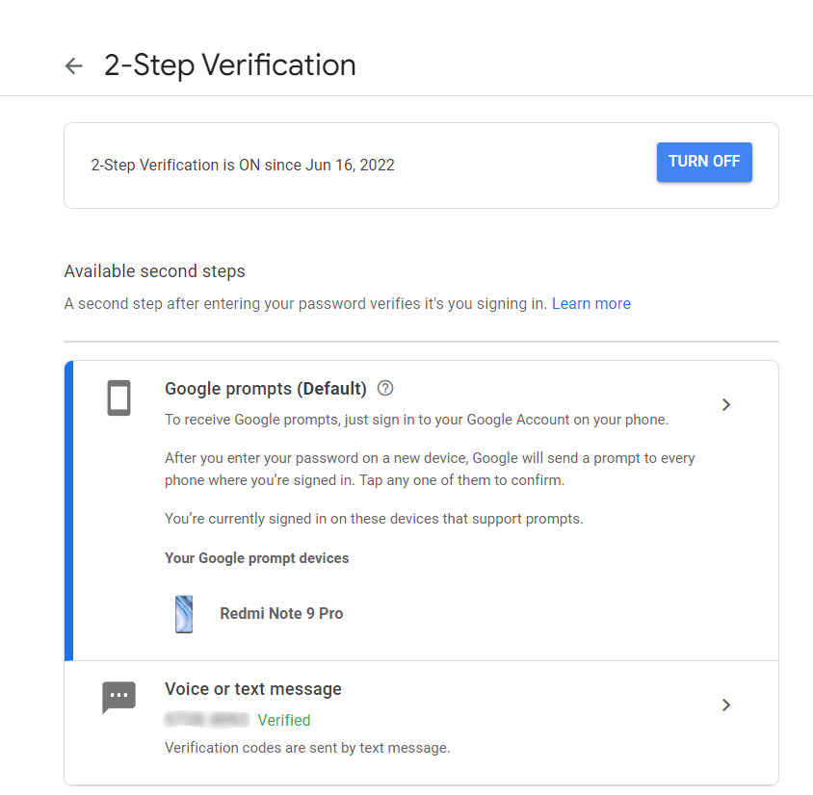
14. Go to this URL again <https://play.google.com/console/about/> and click “Go to Play Console” 
15. Click “Get started” under Yourself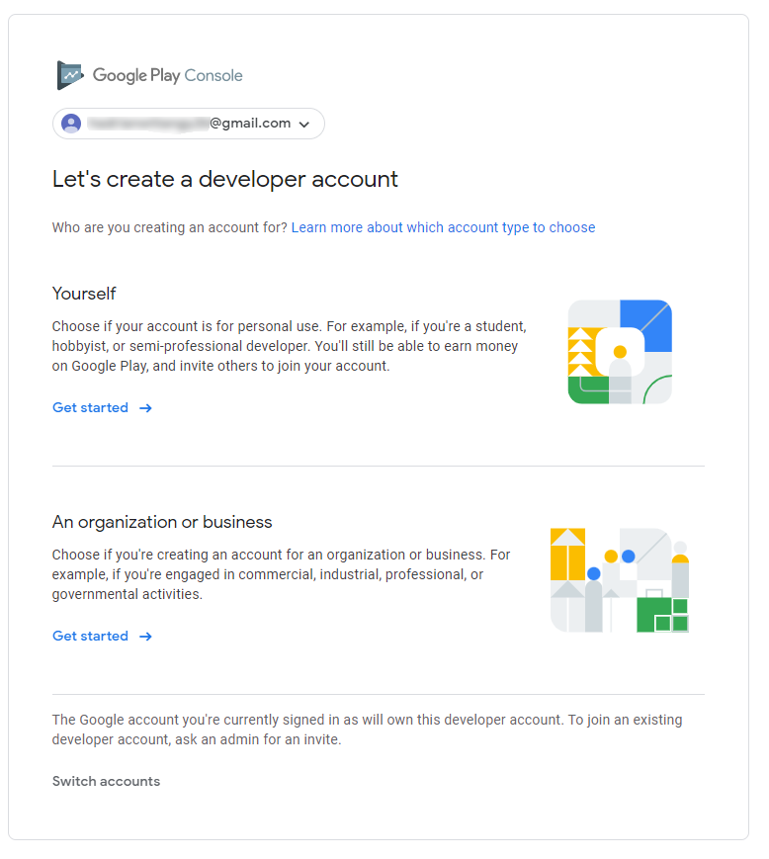
16. Fill information (“Developer name” must be unique, i.e. never used by others)  
     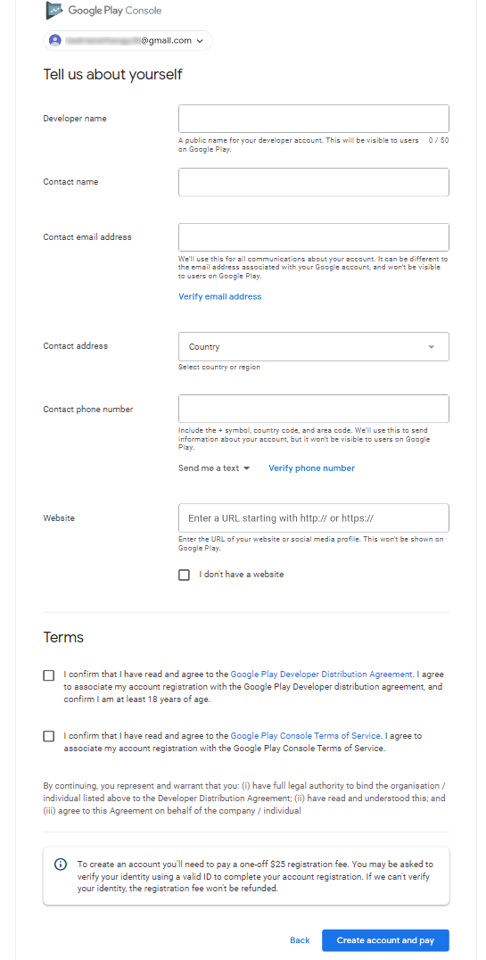
17. Verify email address if requested. You can just write the current gmail address and it will be verified automatically upon clicking “Verify email address” 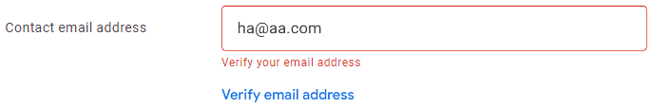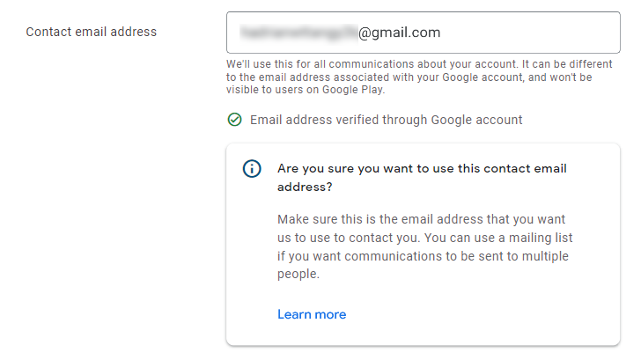
18. 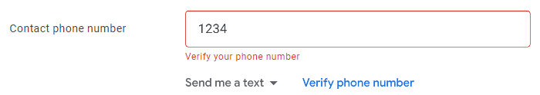Verify phone number if requested. You can just use the phone number you used for two-factor authentication, and check SMS again to fill in the required code

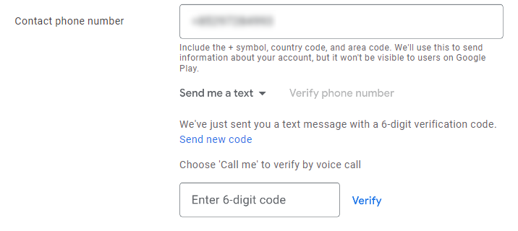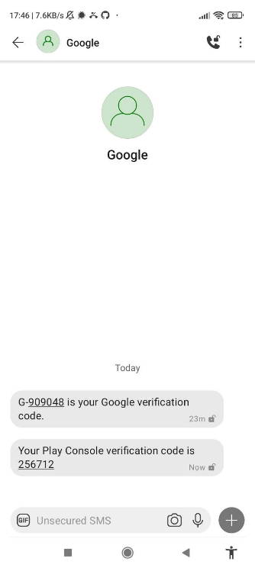

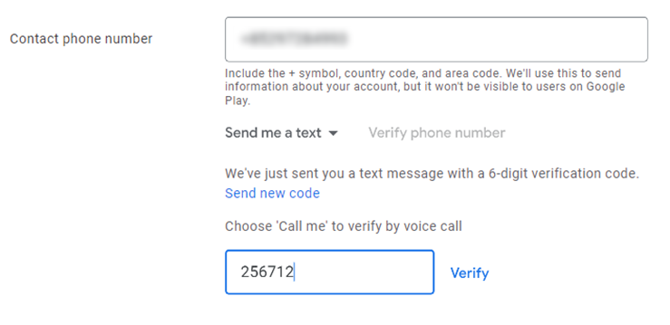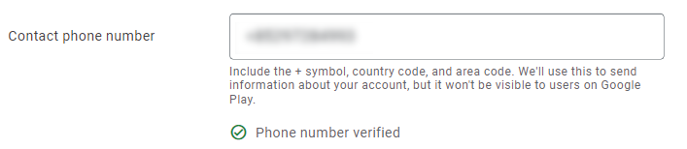

1. Click “Create account and pay” when finished entering information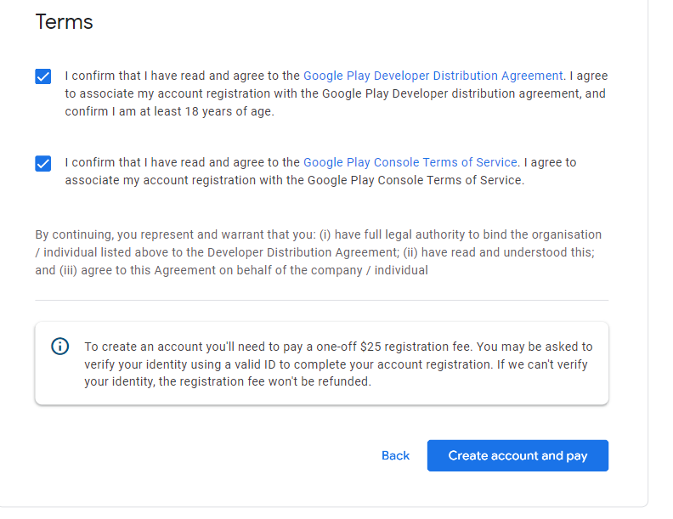
2. Add a credit card or debit card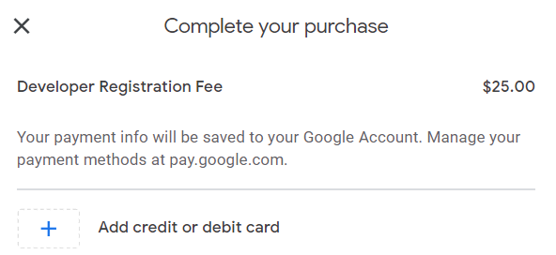
3. Fill in information then click “Save card” 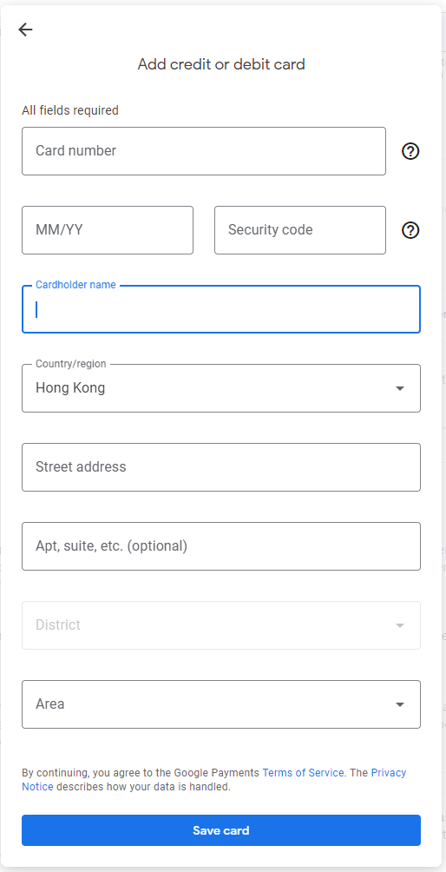
4. Click your card and proceed with the transaction (details omitted)

J. AAB file generation

1. In Solution Explorer, right click App.Android



1. Click Properties 
2. Click “Android Options” on the left, click the dropdown menu under “Android Package Format”, click bundle 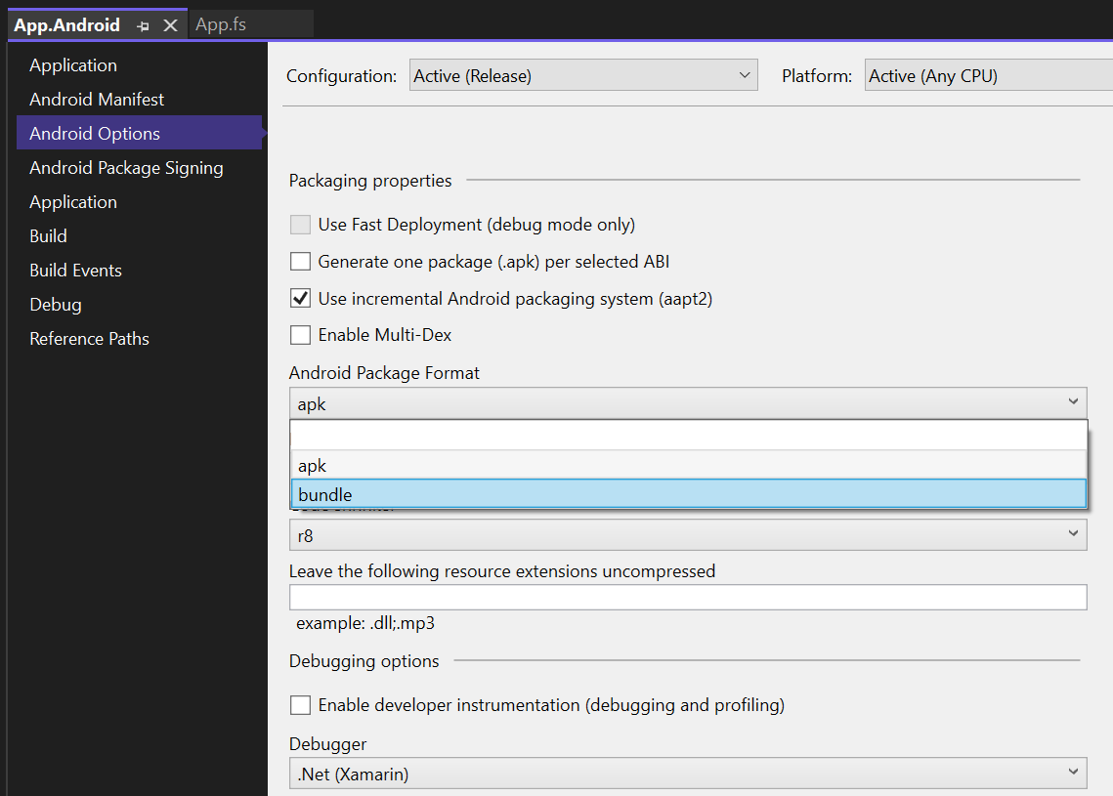
3. Remember to save changes by clicking the icon
4. Close this tab when done 
5. In Solution Explorer, right click App.Android 
6. Click “Archive…” 
7. Wait for archiving to complete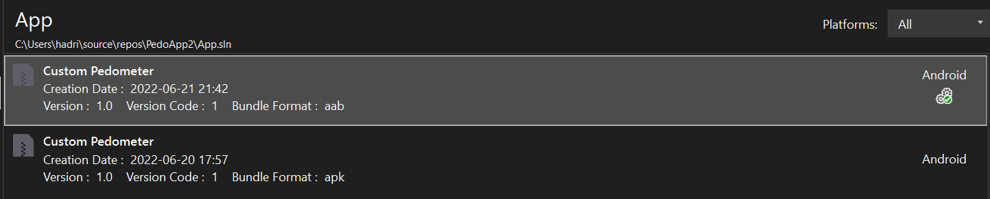
8. Click Distribute
9. Click “Ad-Hoc”
10. We can make use of the signing key that we have already created. Click “pedoapp” then “Save As” 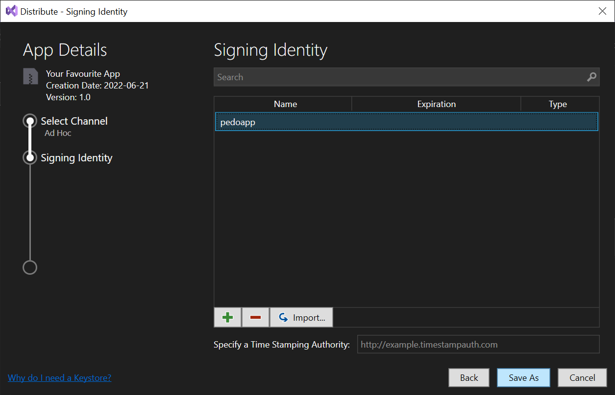
11. Click the Downloads folder, then click Save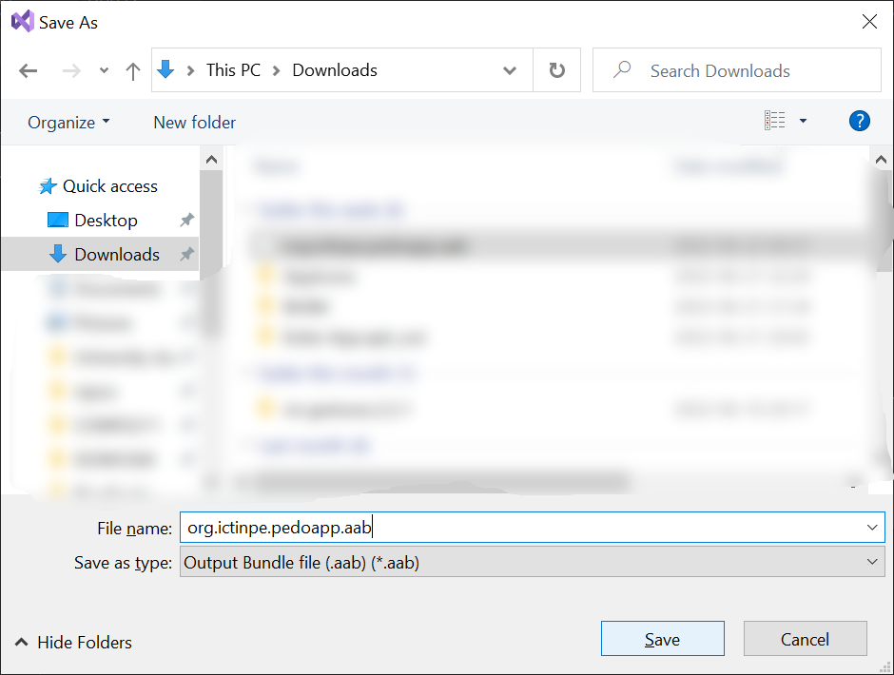
12. Input “PedoApp” (case sensitive) then click OK
13. Check the Downloads folder, now we have an AAB file generated successfully which can uploaded to Google Play but cannot be installed on devices unless we make use of external tools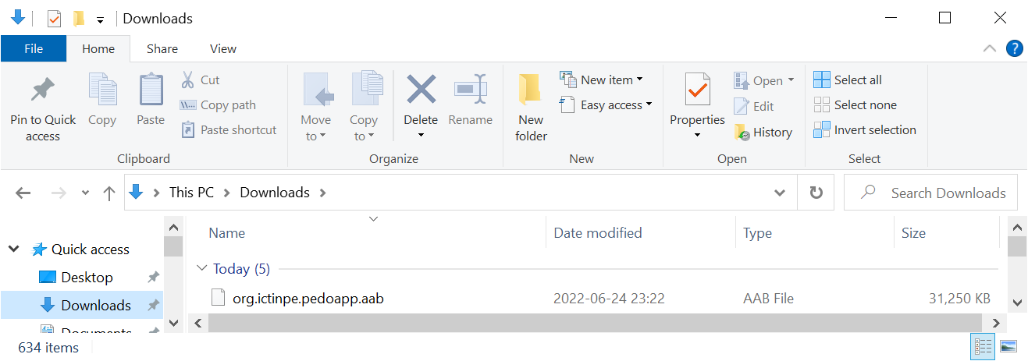

K. Publishing the app

1. Go to this URL again <https://play.google.com/console/about/>, then click “Go to Play Console”
2. Click the developer account that was just created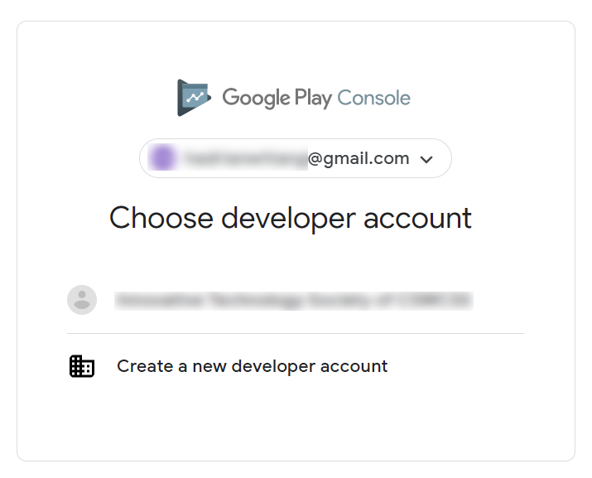
3. Click “Create app” 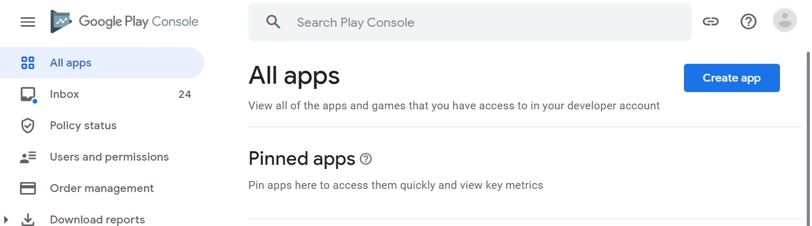
4. Fill in app name, select English as “Default language”, choose “App” and “Free”, and check required check boxes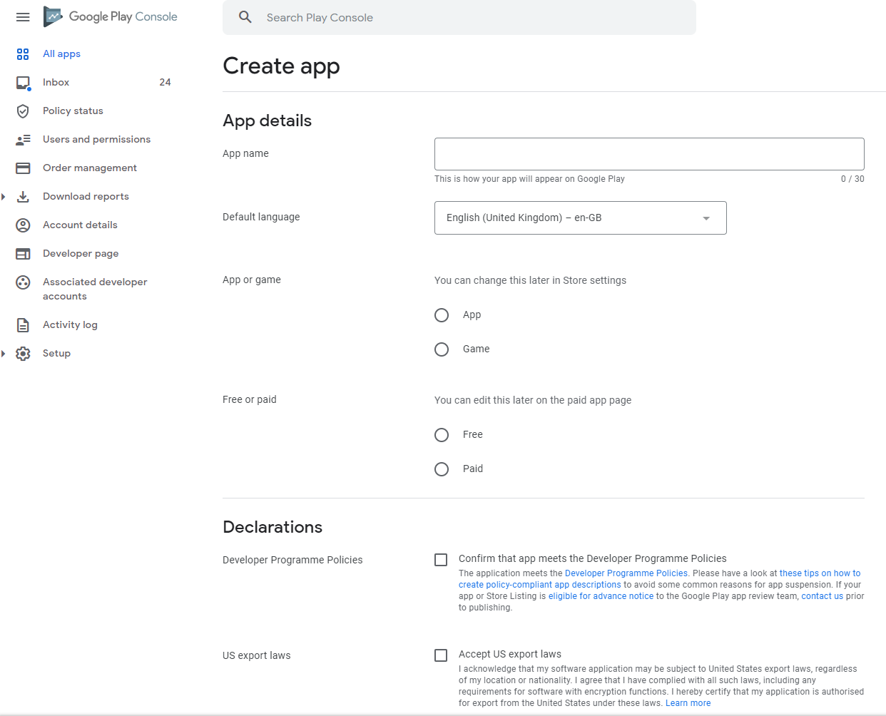
5. Click “Create app” 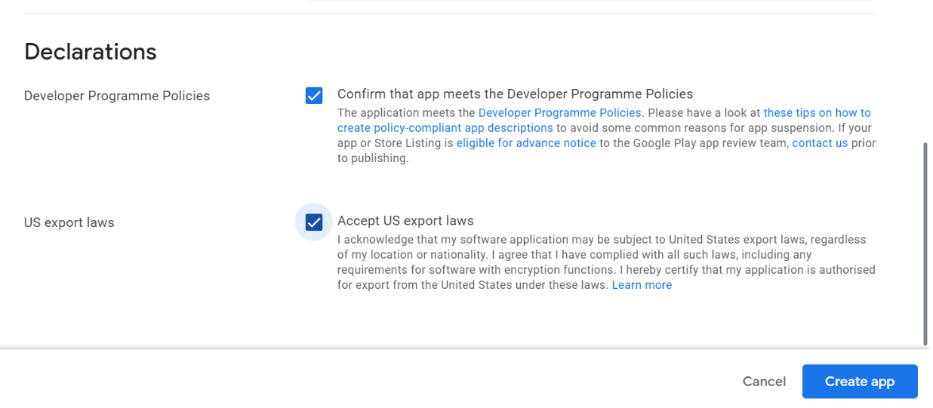
6. 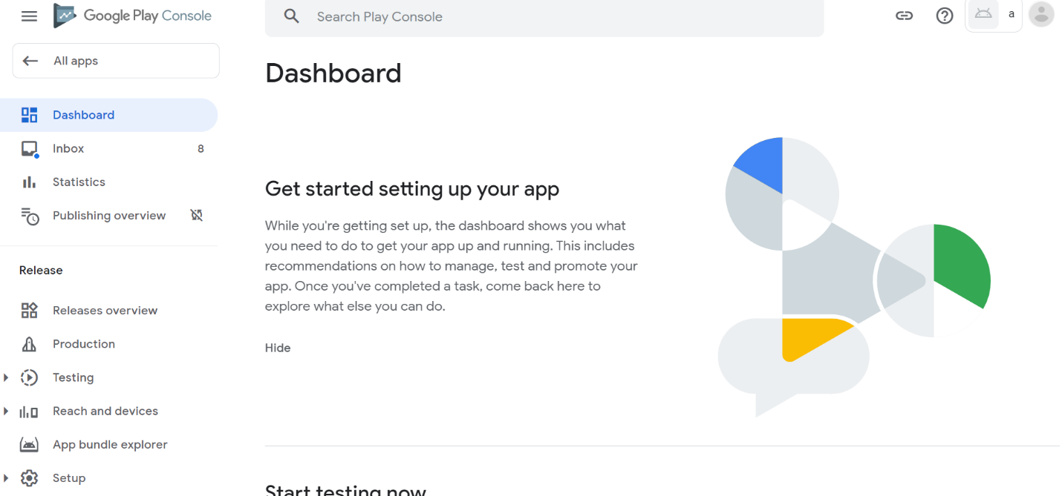Scroll down until “Set up your app” and click “View tasks”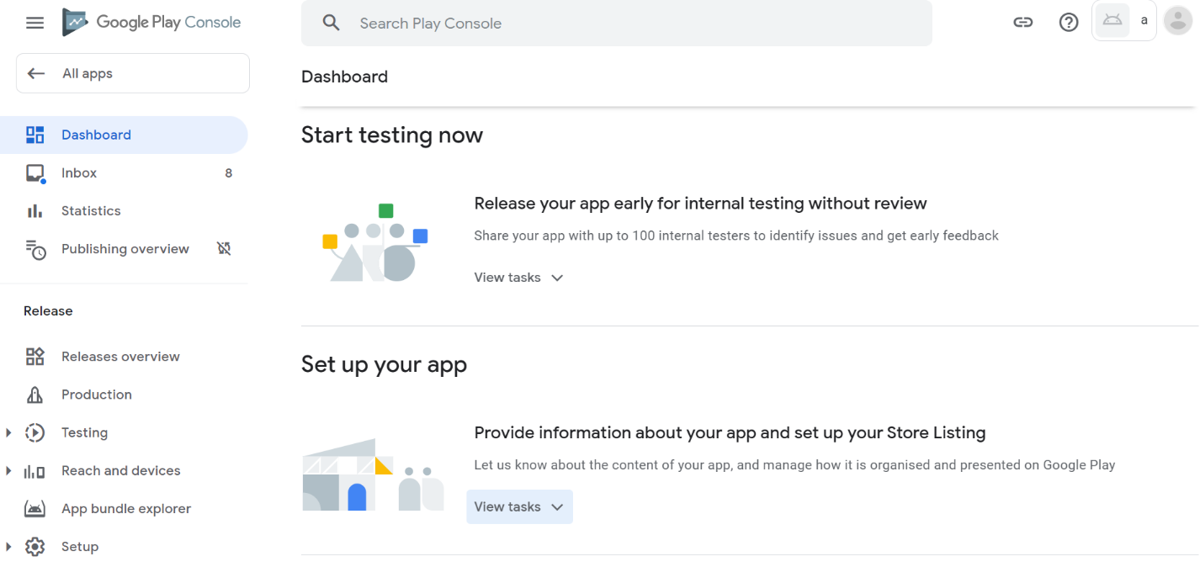
7. View the list of steps we have to do before publishing an app. Click “Set privacy policy” first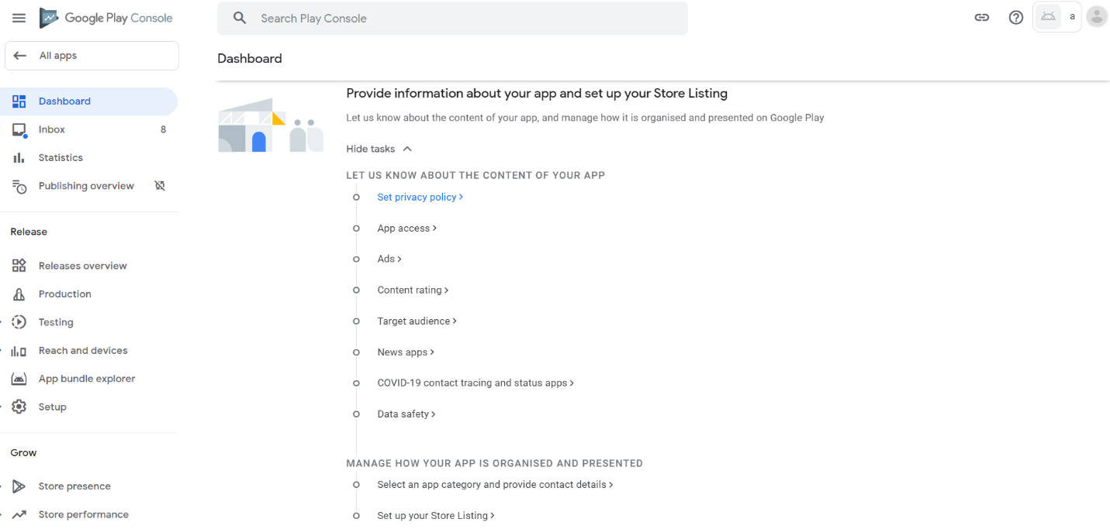
8. A privacy policy defines how our app will collect and store data. This is important because of laws that enforce open declarations of data usage, for example in the European Union. Click the textbox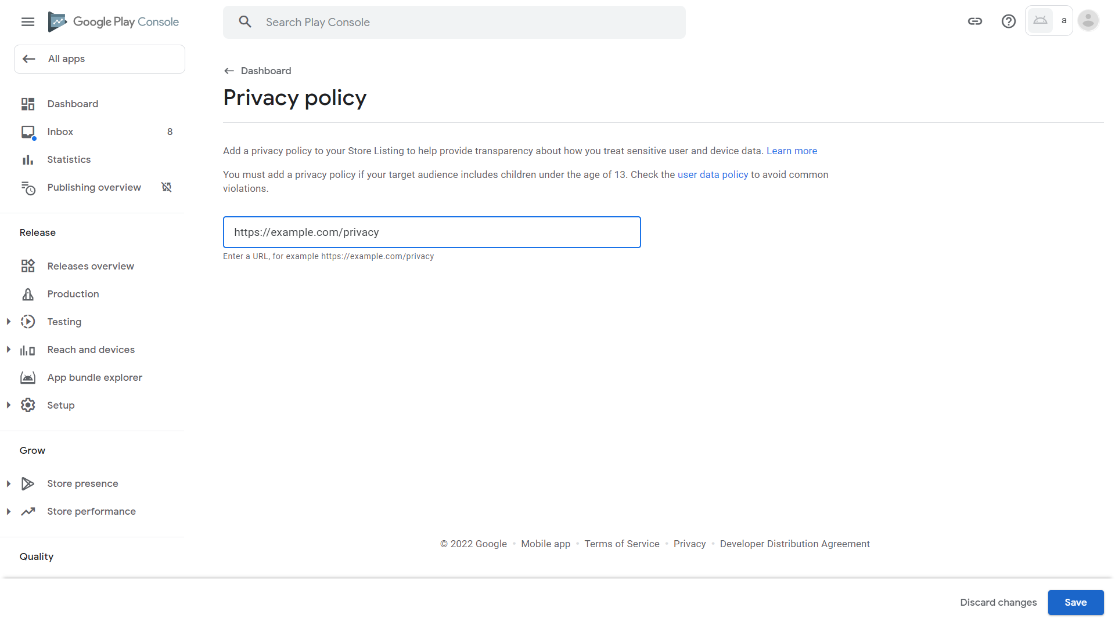
9. Paste this privacy policy which we have prepared: <https://gist.github.com/Happypig375/a7b6cd69d3fb8997ef500be5c2dff8ff> , then click Save. Our app will be rejected by Google if we provide an invalid link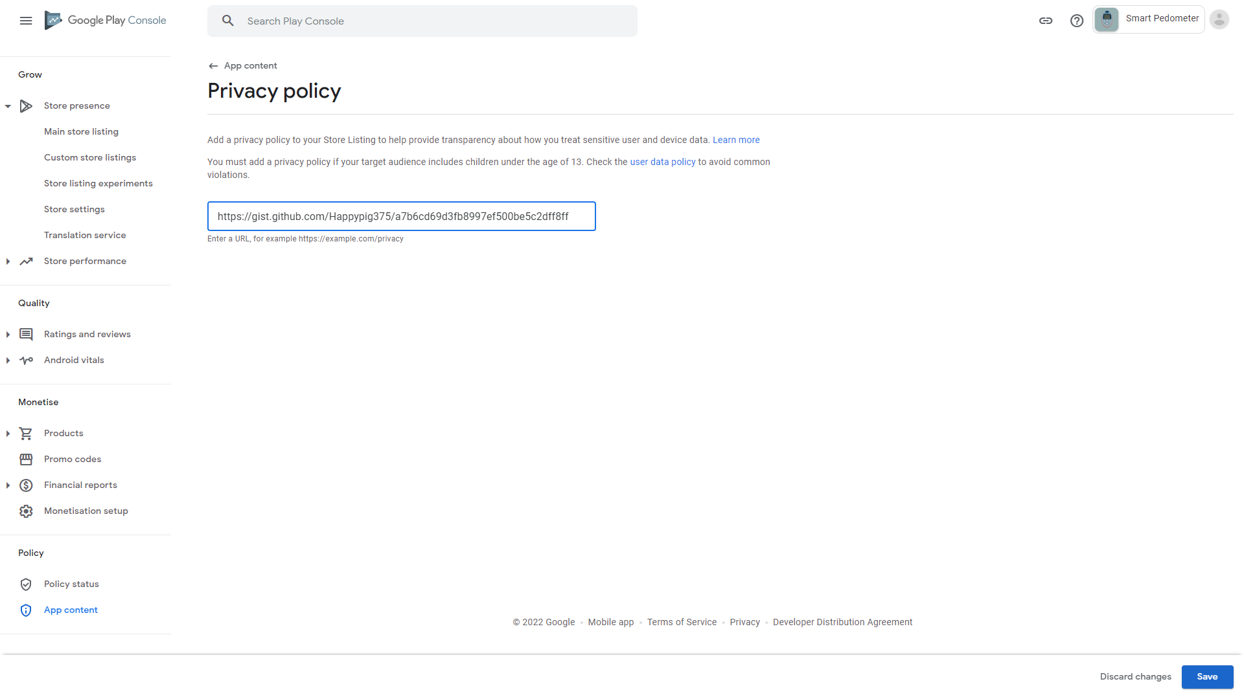
10. Click Dashboard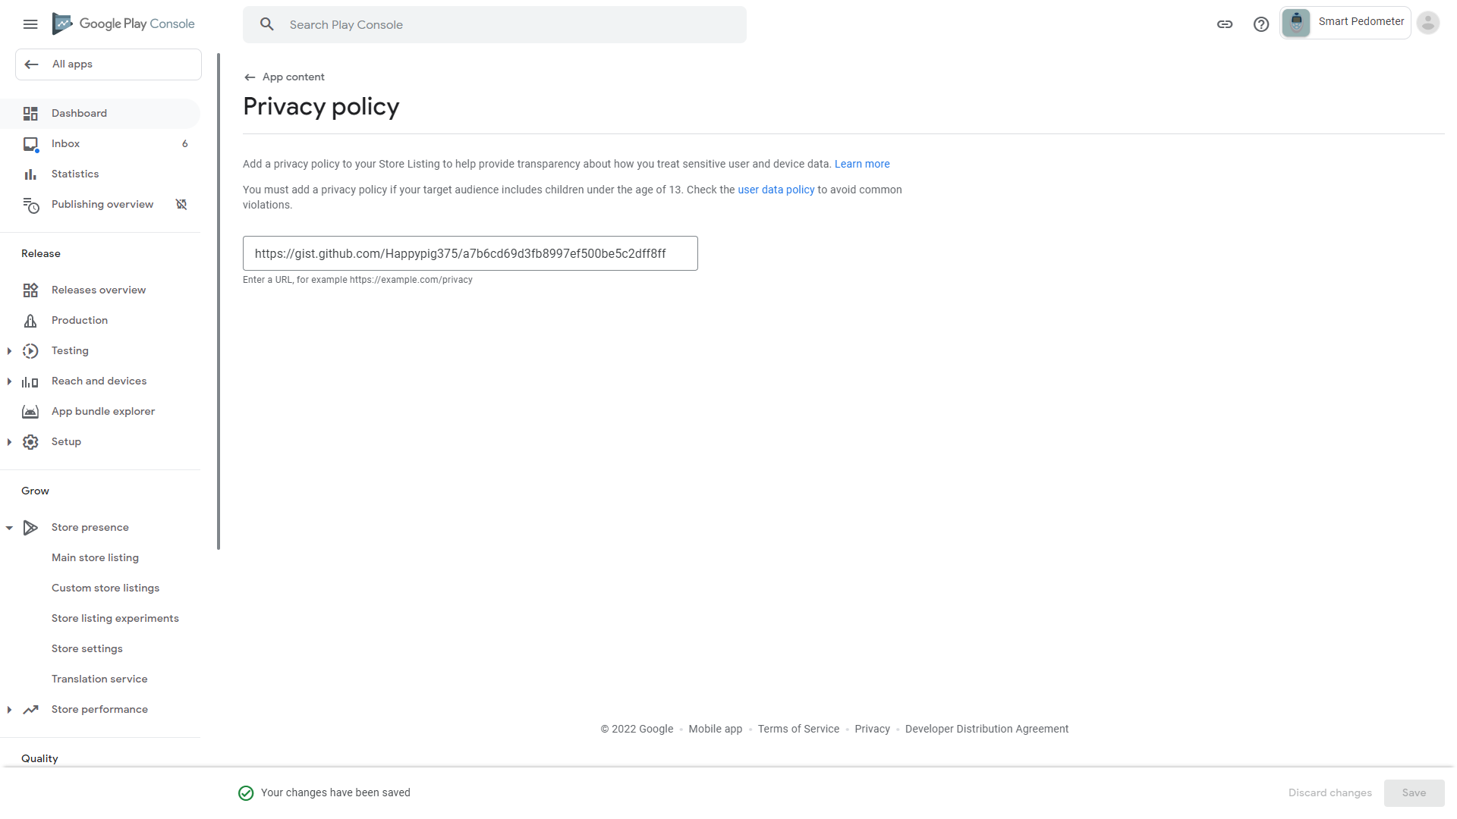
11. Scroll down and click “App access” 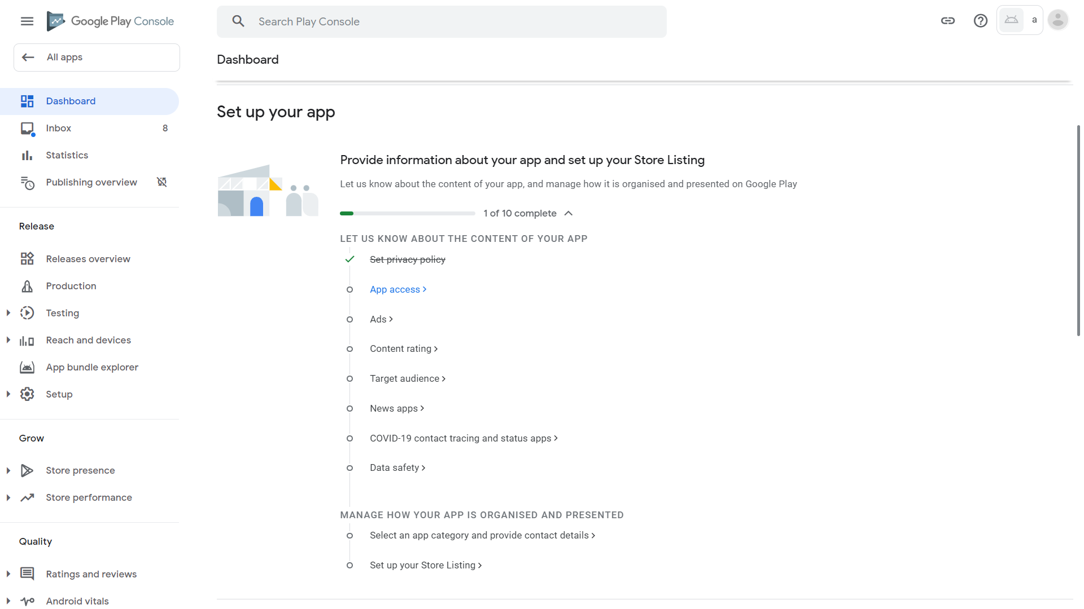
12. Our app does not hide any functionality behind any authentication. Google needs this information to ensure all parts of our app are in line with regulations. Click “All functionality is available without special access” then Save 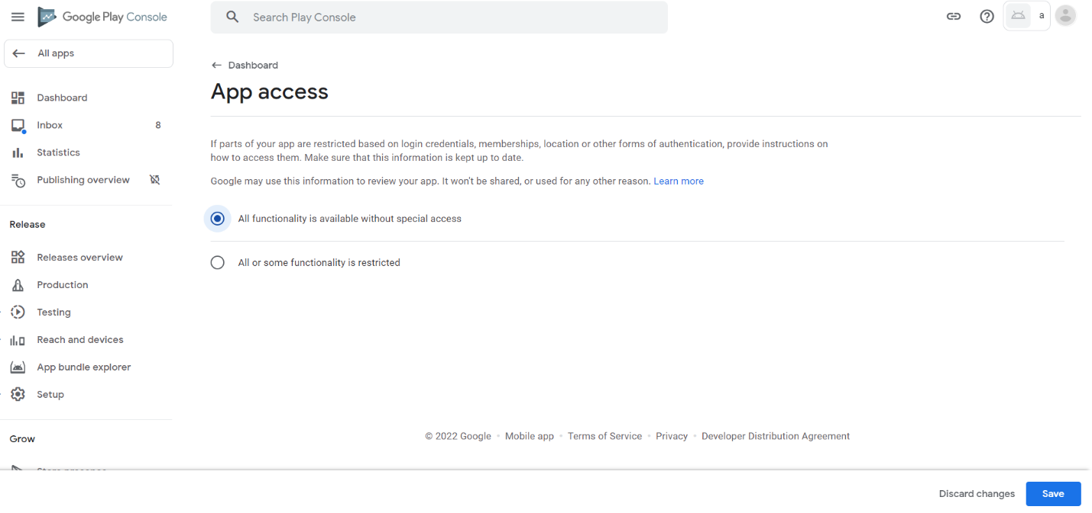
13. Click Dashboard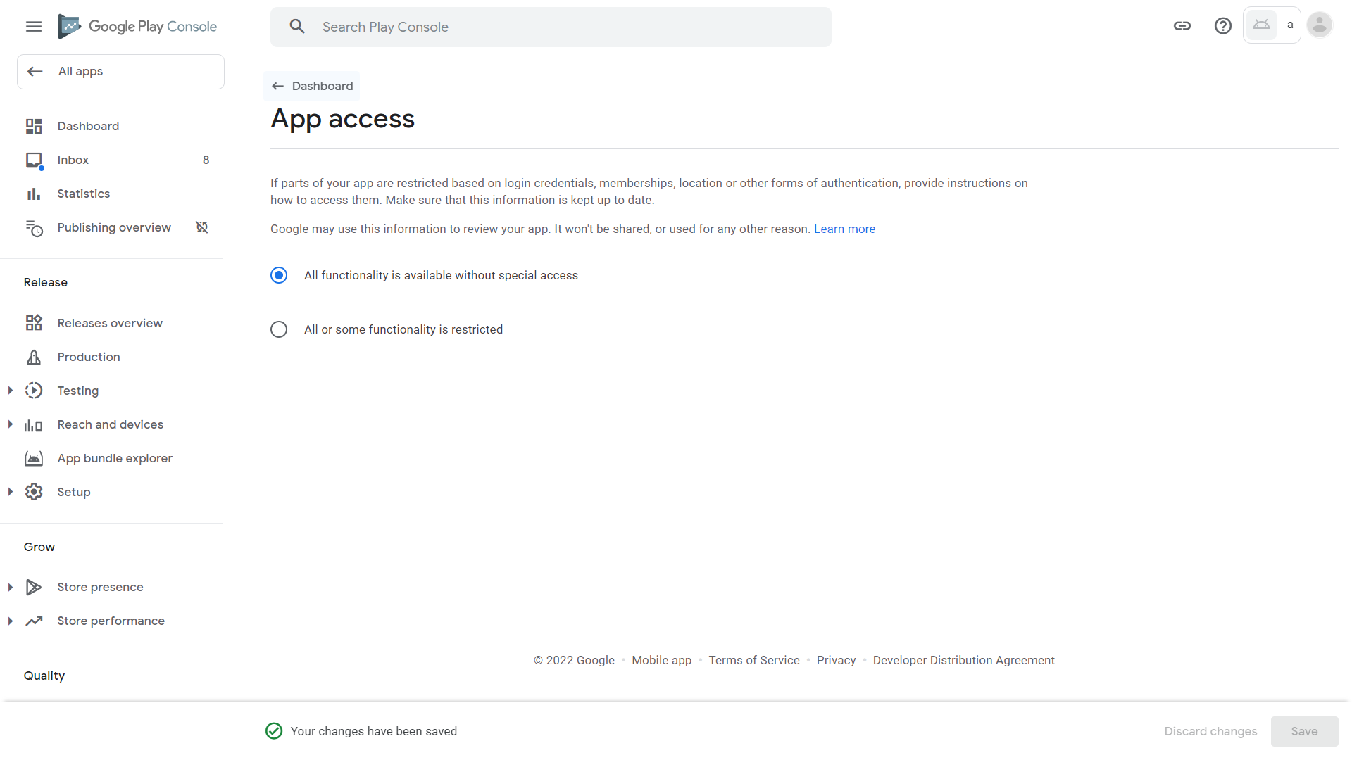
14. Scroll down and click Ads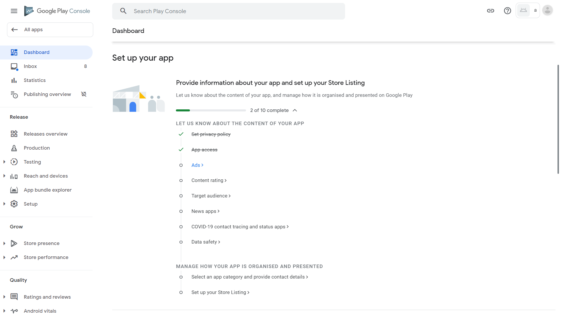
15. Our app does not have any advertisement. If we have, then we need to comply with advertising regulations, such as privacy, not interrupting user experience, and not generating fake clicks to earn money. Click “No, my app does not contain ads” then Save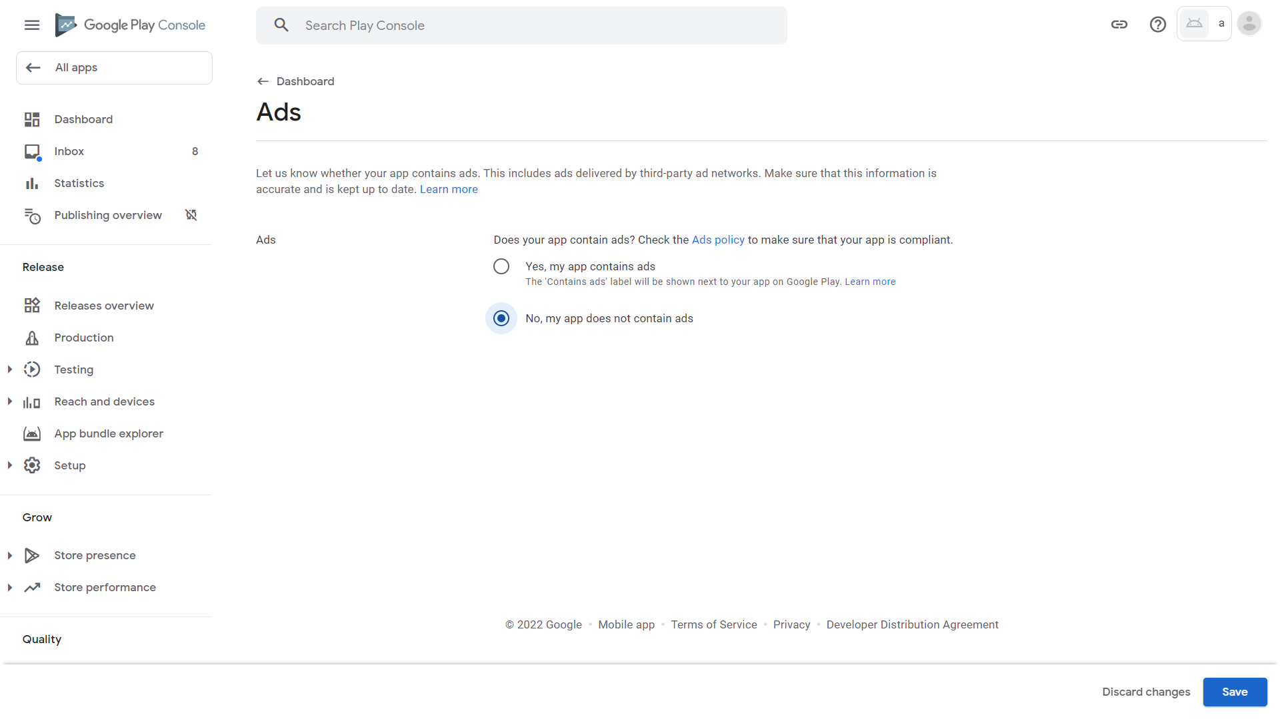
16. Click Dashboard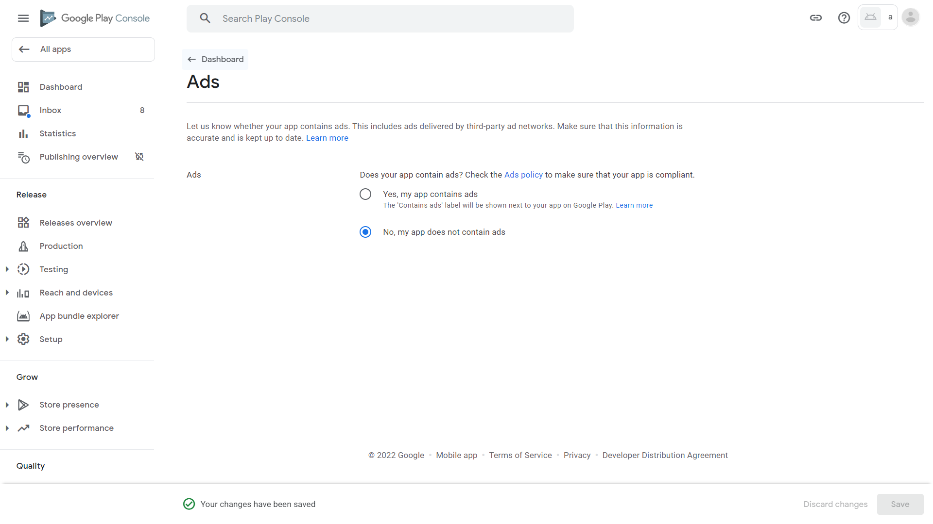
17. Scroll down and click “Content rating” 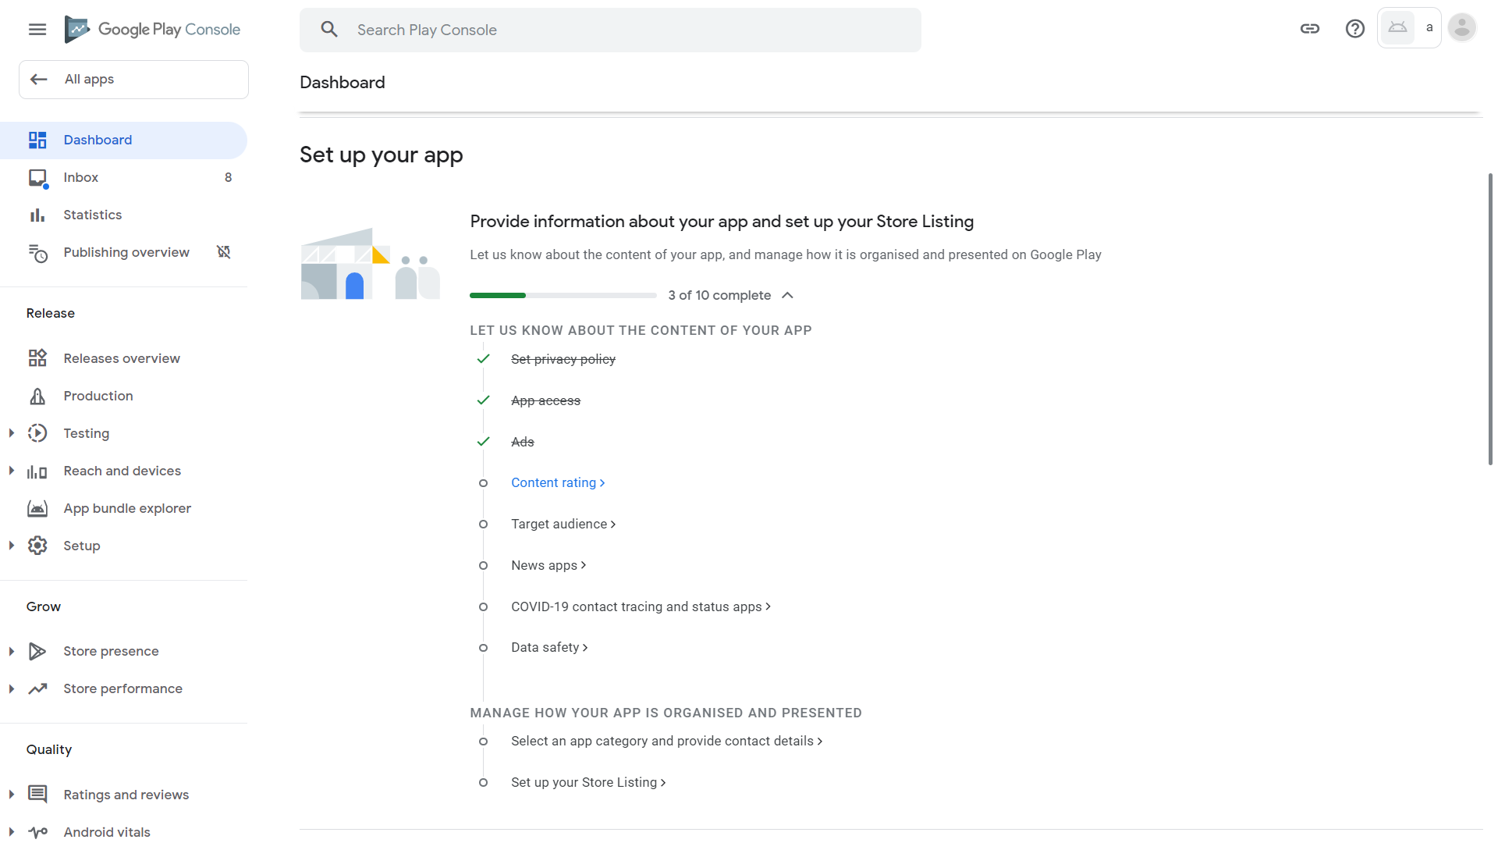
18. Google will ask us for any adult material within our app to determine whether children will be able to use our app. Click “Start questionnaire” 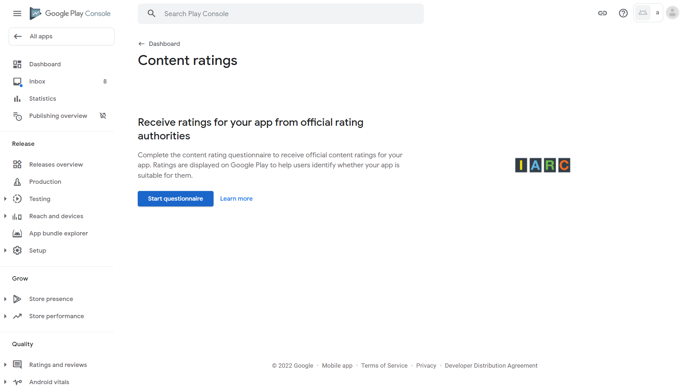
19. Enter an email address for contact with rating authorities. This can just be the same as the address we use daily. Then, click “All other app types” as our app is not a game, and is not social media. Next, click Next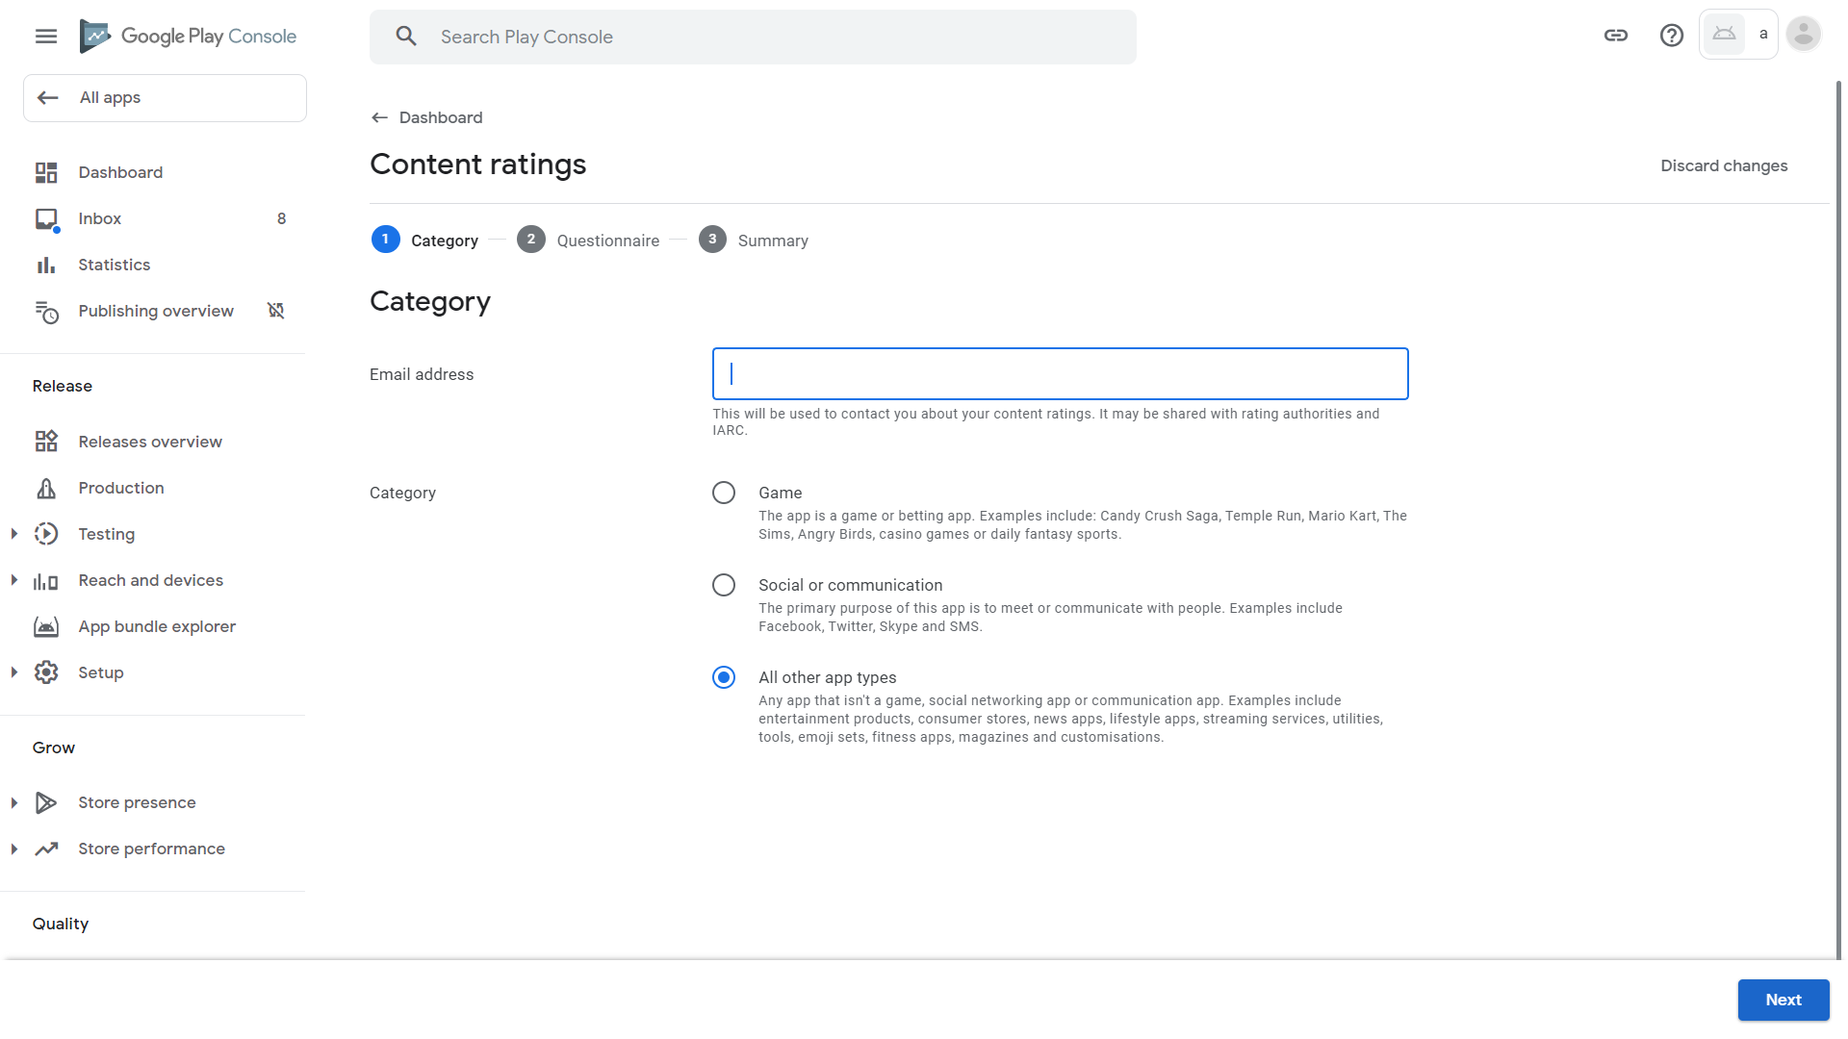
20. Our app does not contain adult content such as sex, violence and foul language. Click No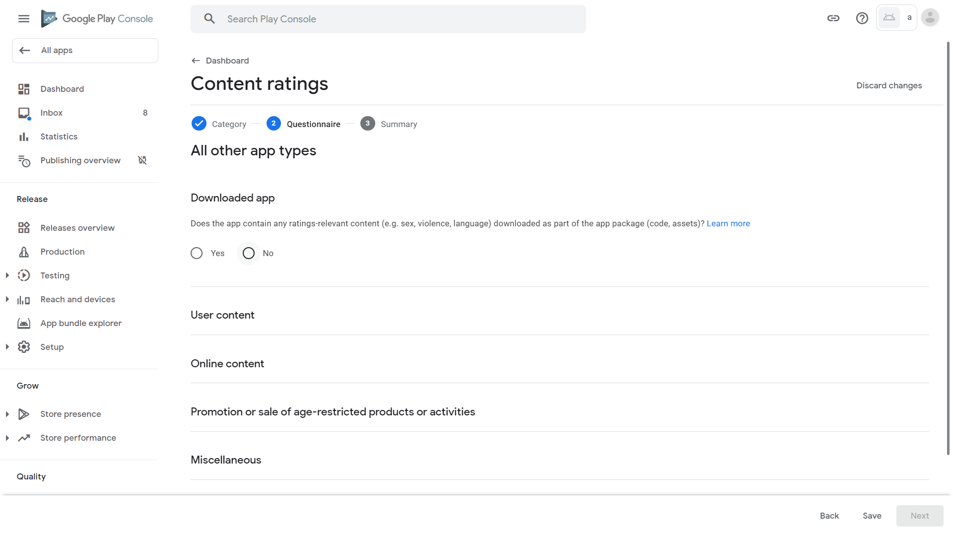
21. Our app does not allow communication between users (who might share adult content). Click No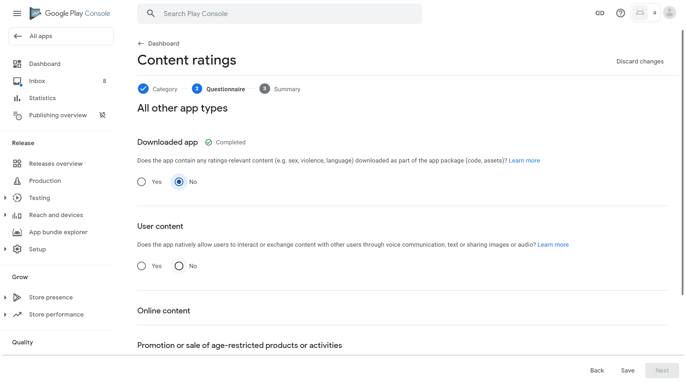
22. Our app will not access online material that may contain adult content. Click No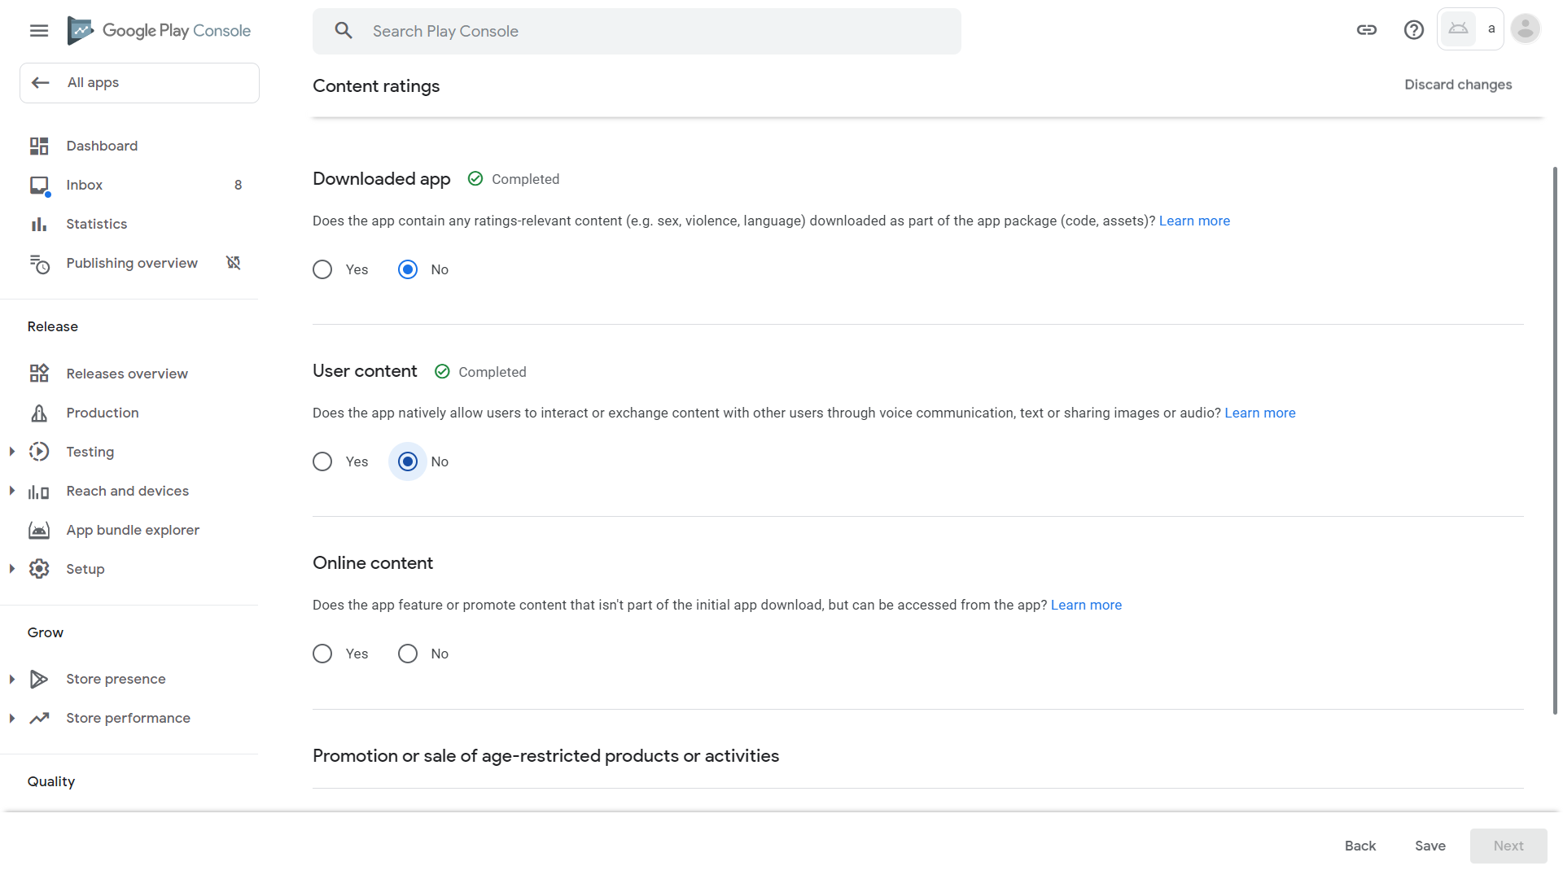
23. Scroll down. Our app does not promote or sell adult services such as cigarettes, alcohol, guns, and gambling. Click No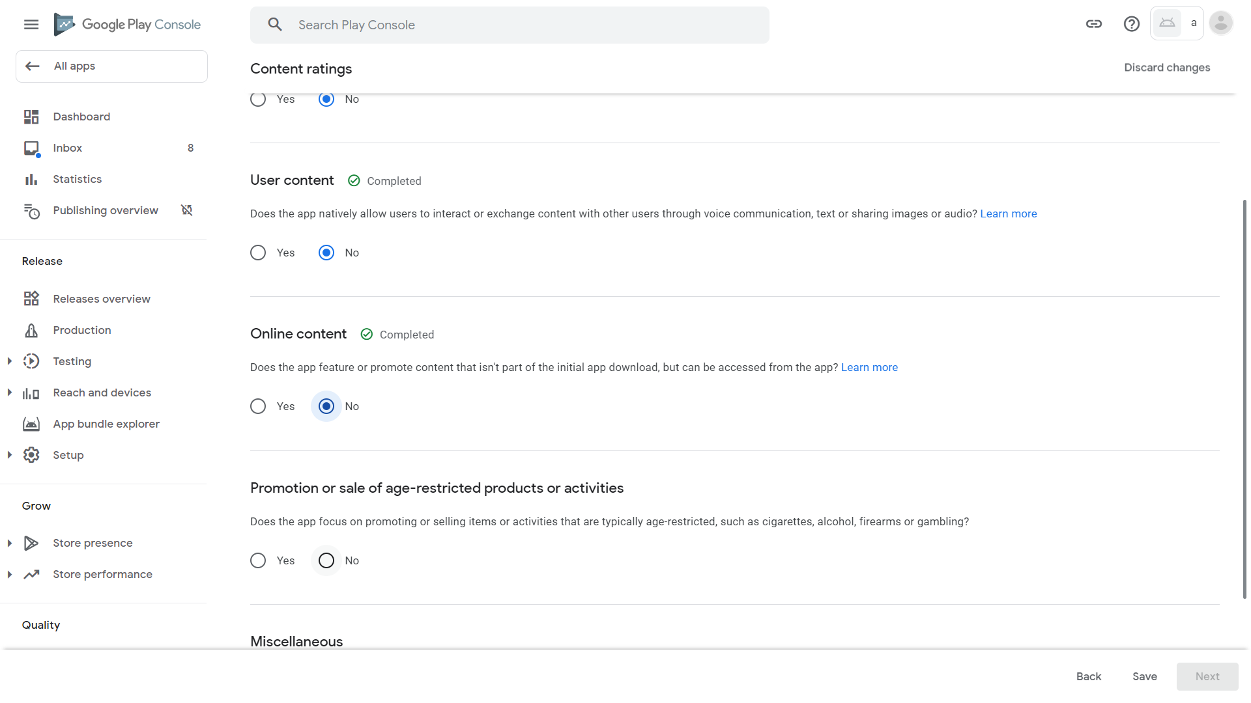
24. Our app does not share current and physical location of any user with other users (which may expose locations of children to other adults – violating child protection laws). Click No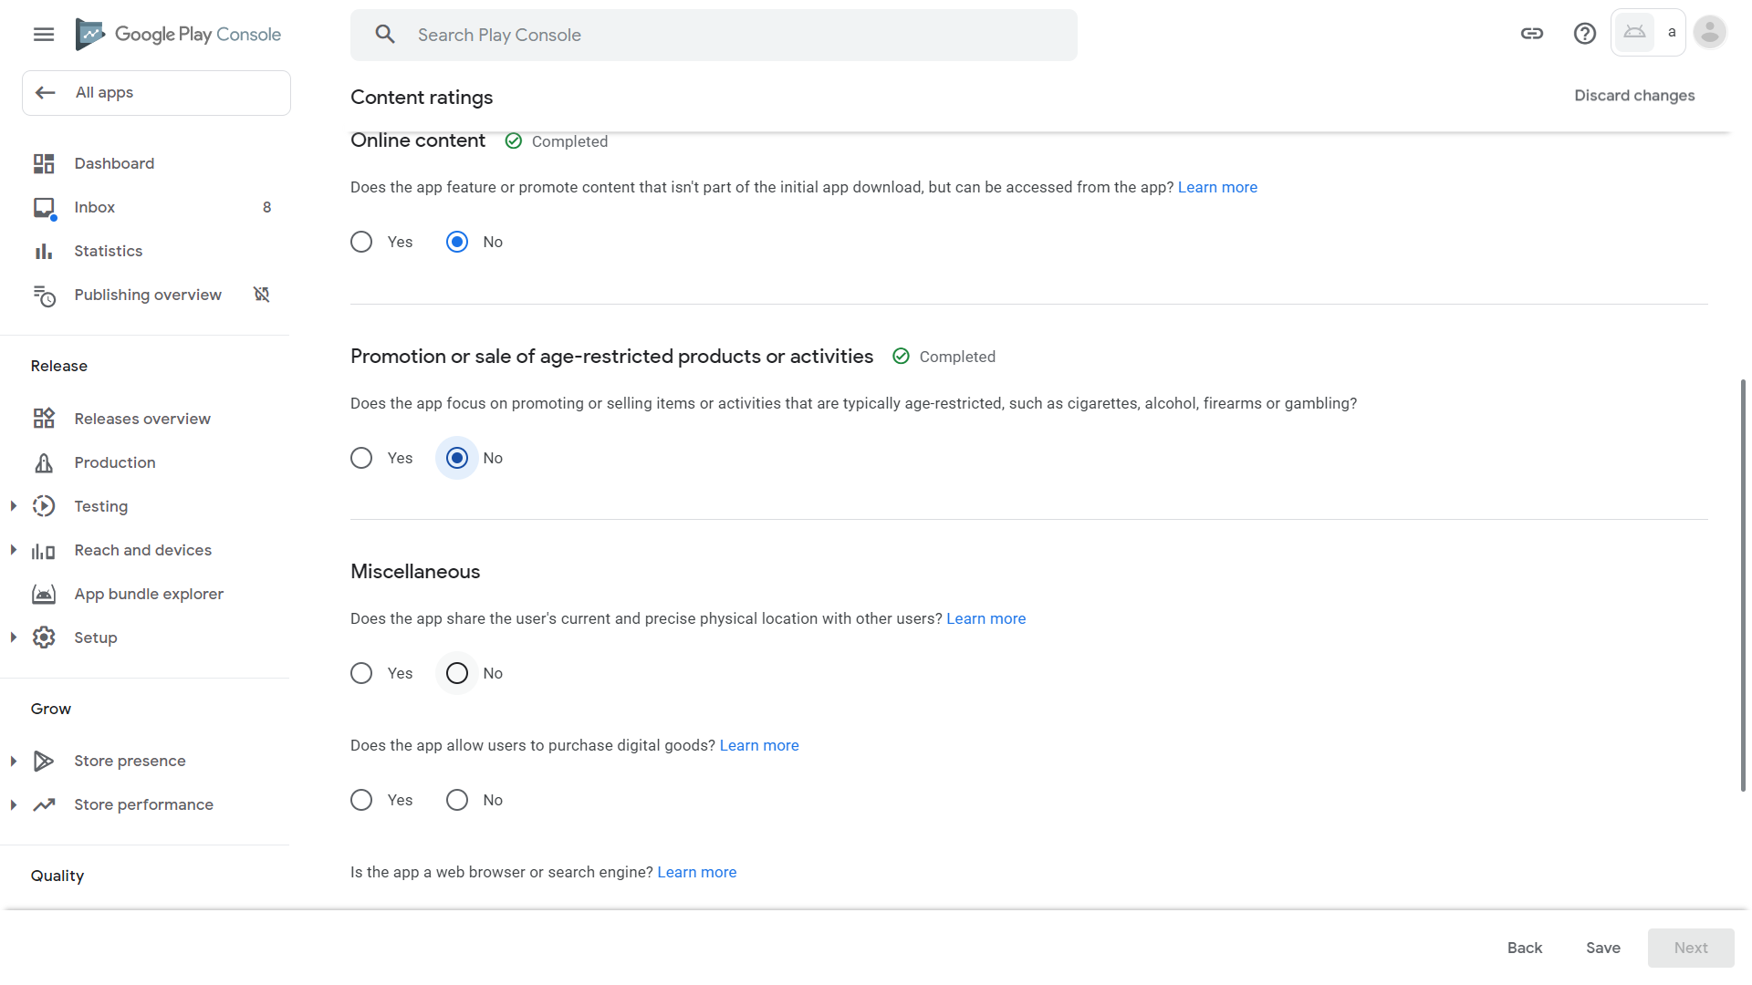
25. Our app does not allow users to buy digital goods (where children who do not understand money may overspend on). Click No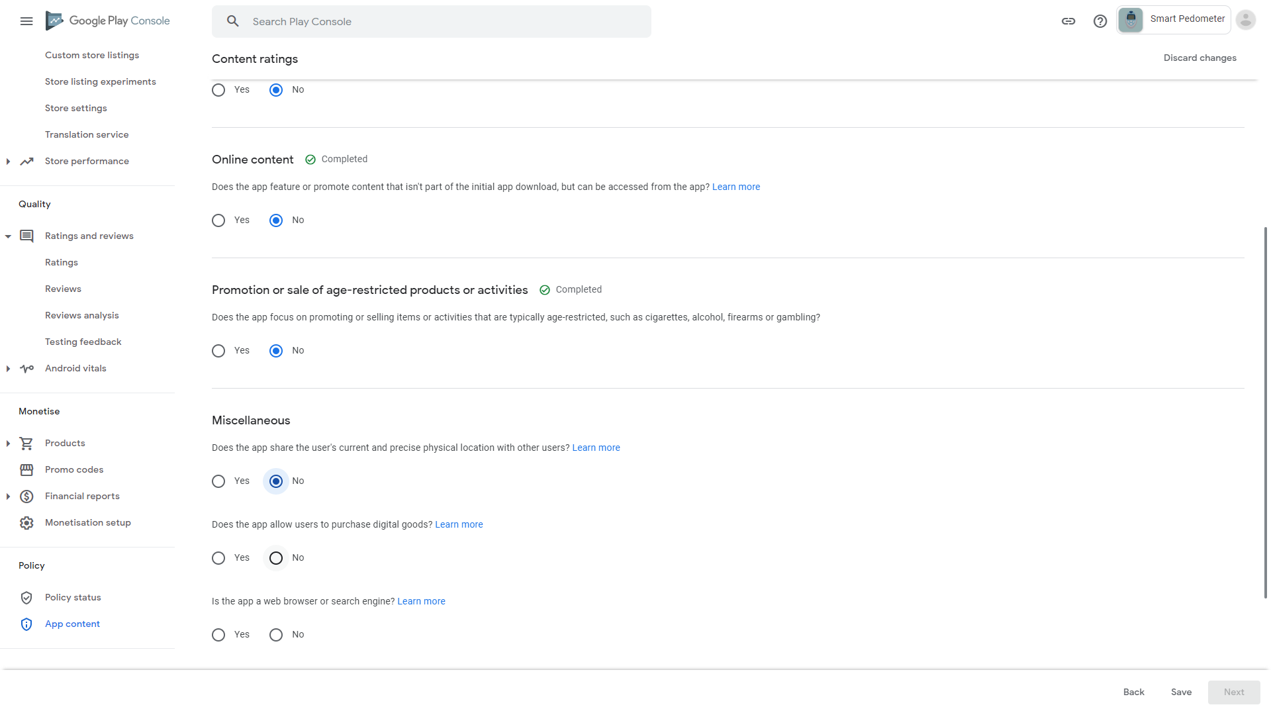
26. Our app is not a web browser or a search engine (where children may find adult content). Click No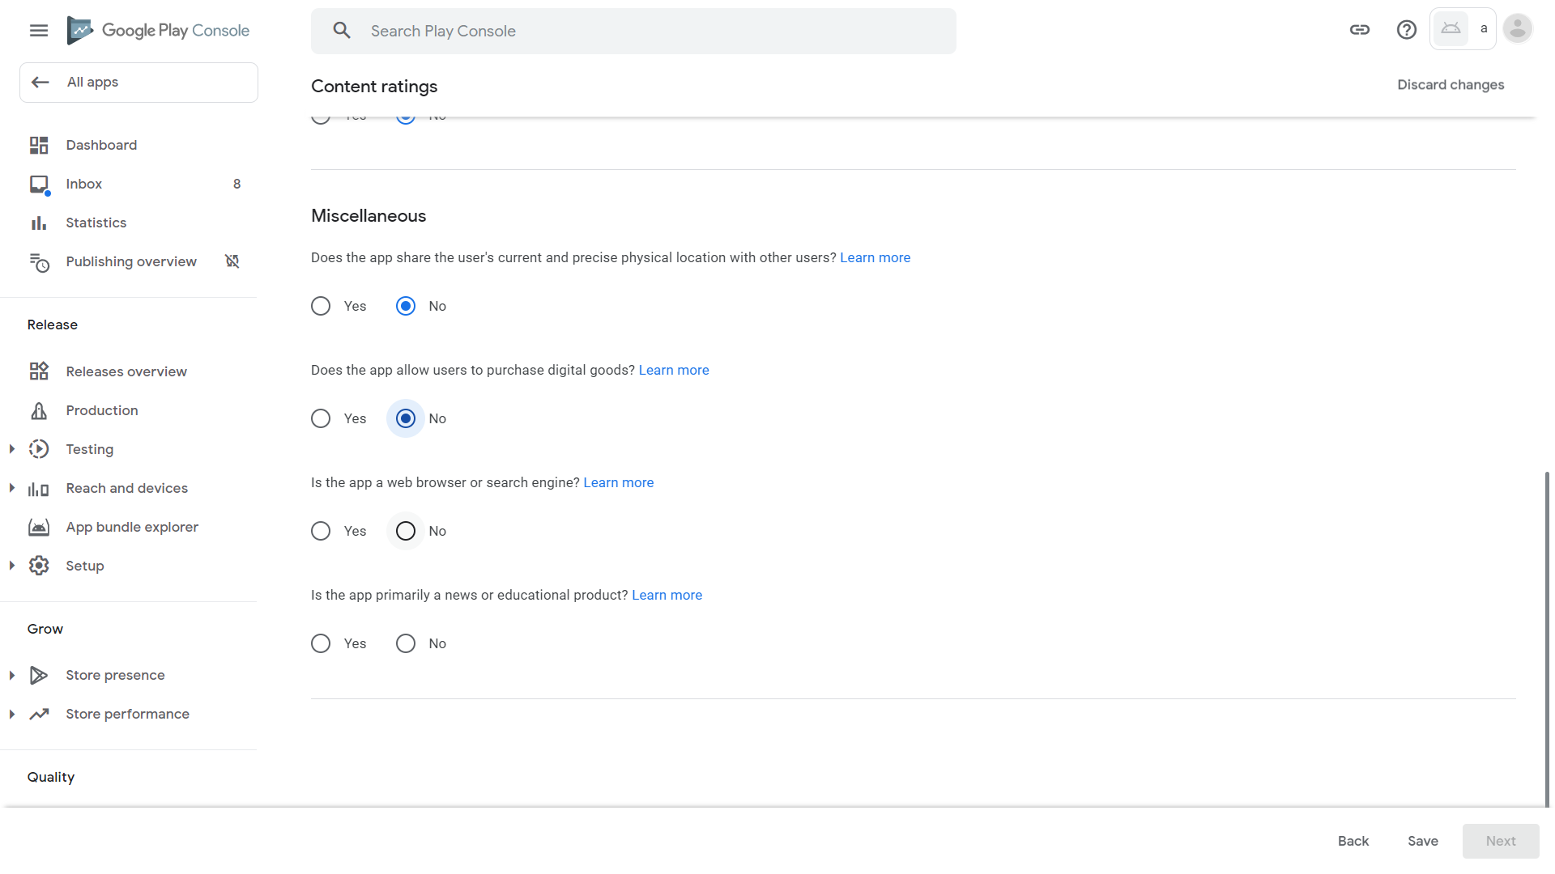
27. Our app is not a news or educational product (where our facts must be checked to prevent spreading propaganda to children). Click No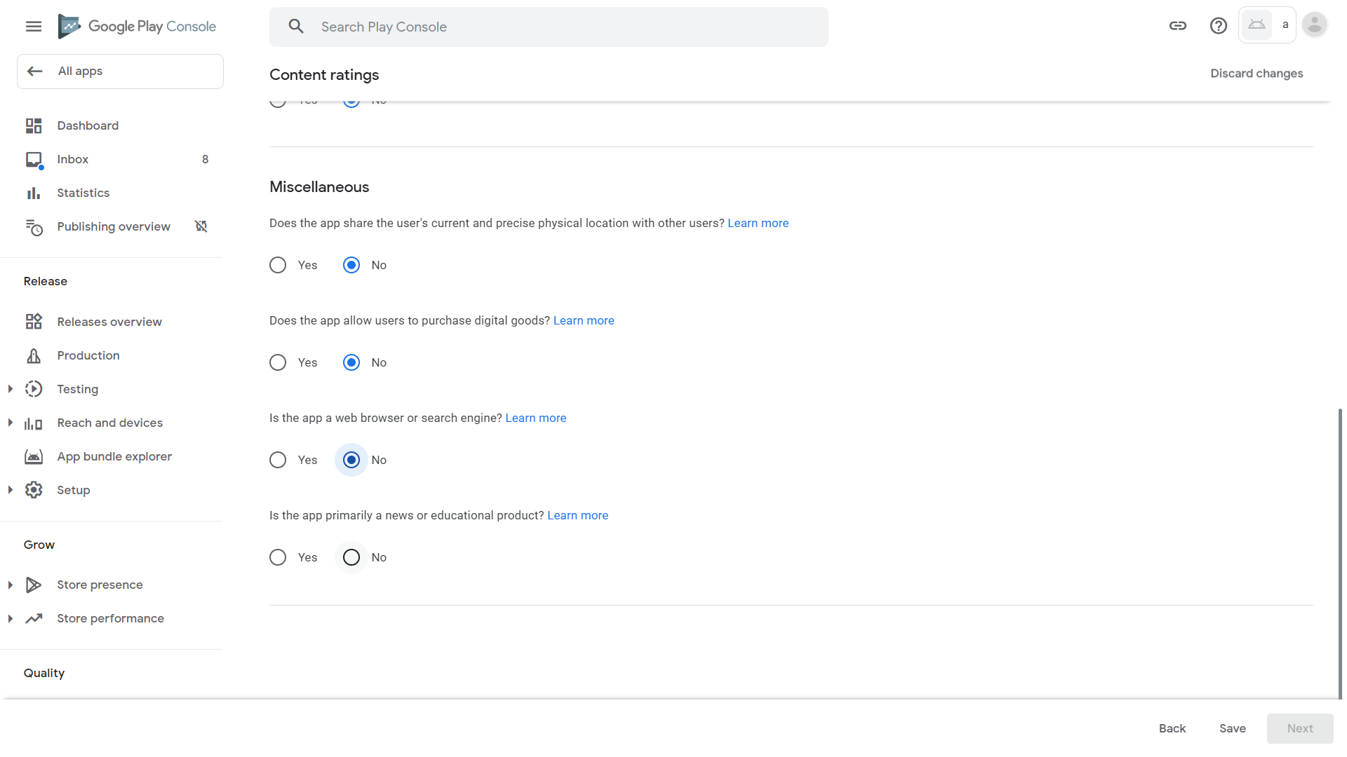
28. Click Save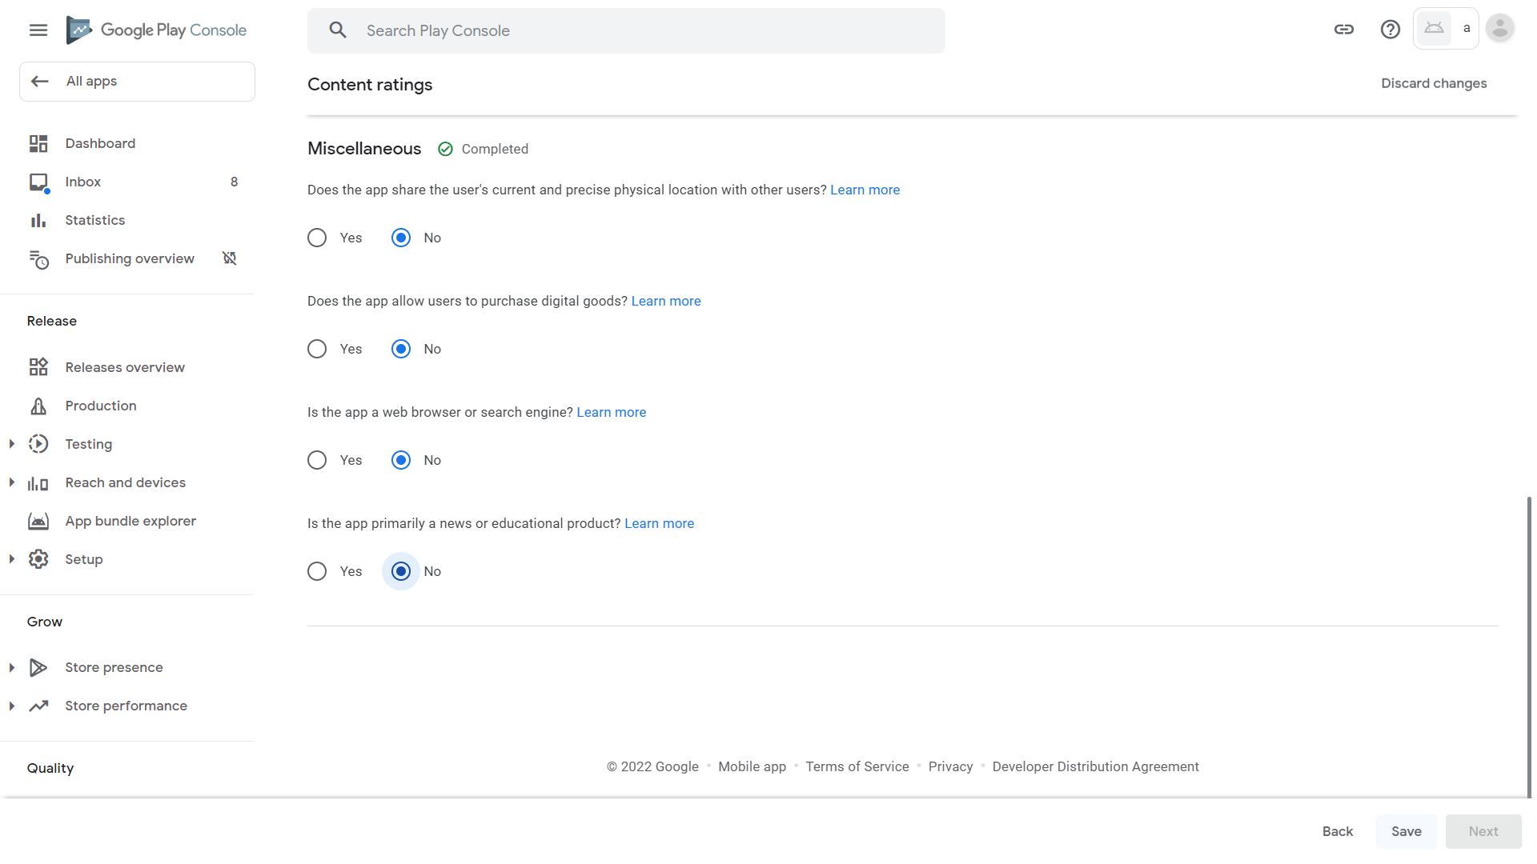
29. Click Next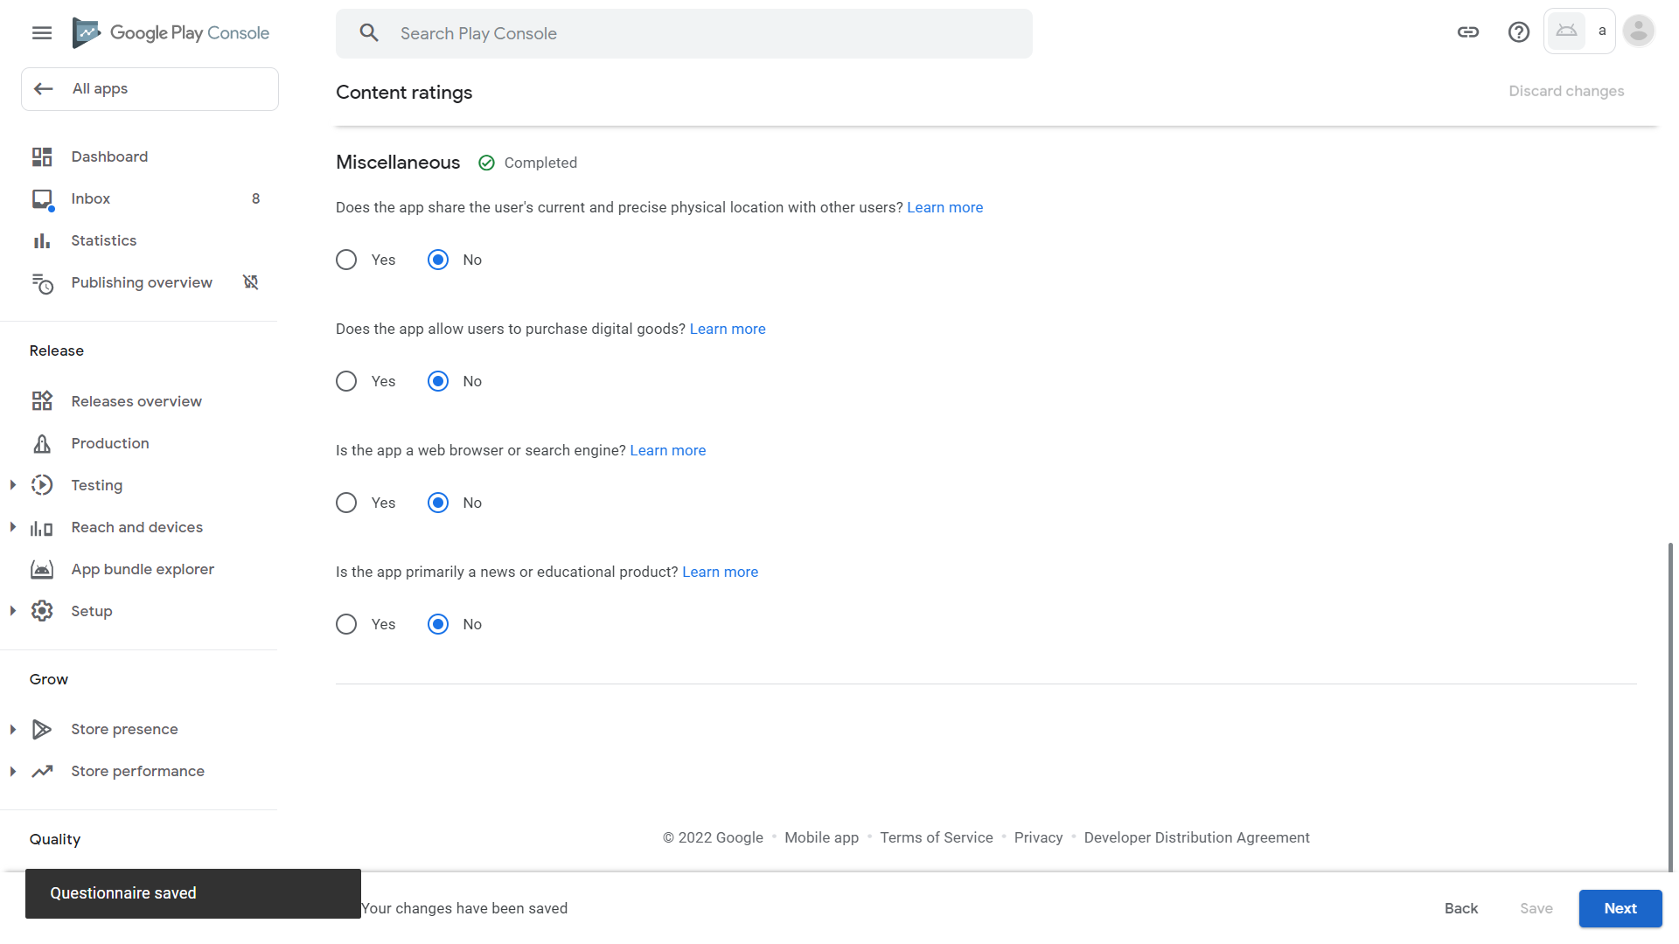
30. The results are available. Our app is suitable for all ages in Brazil. Scroll down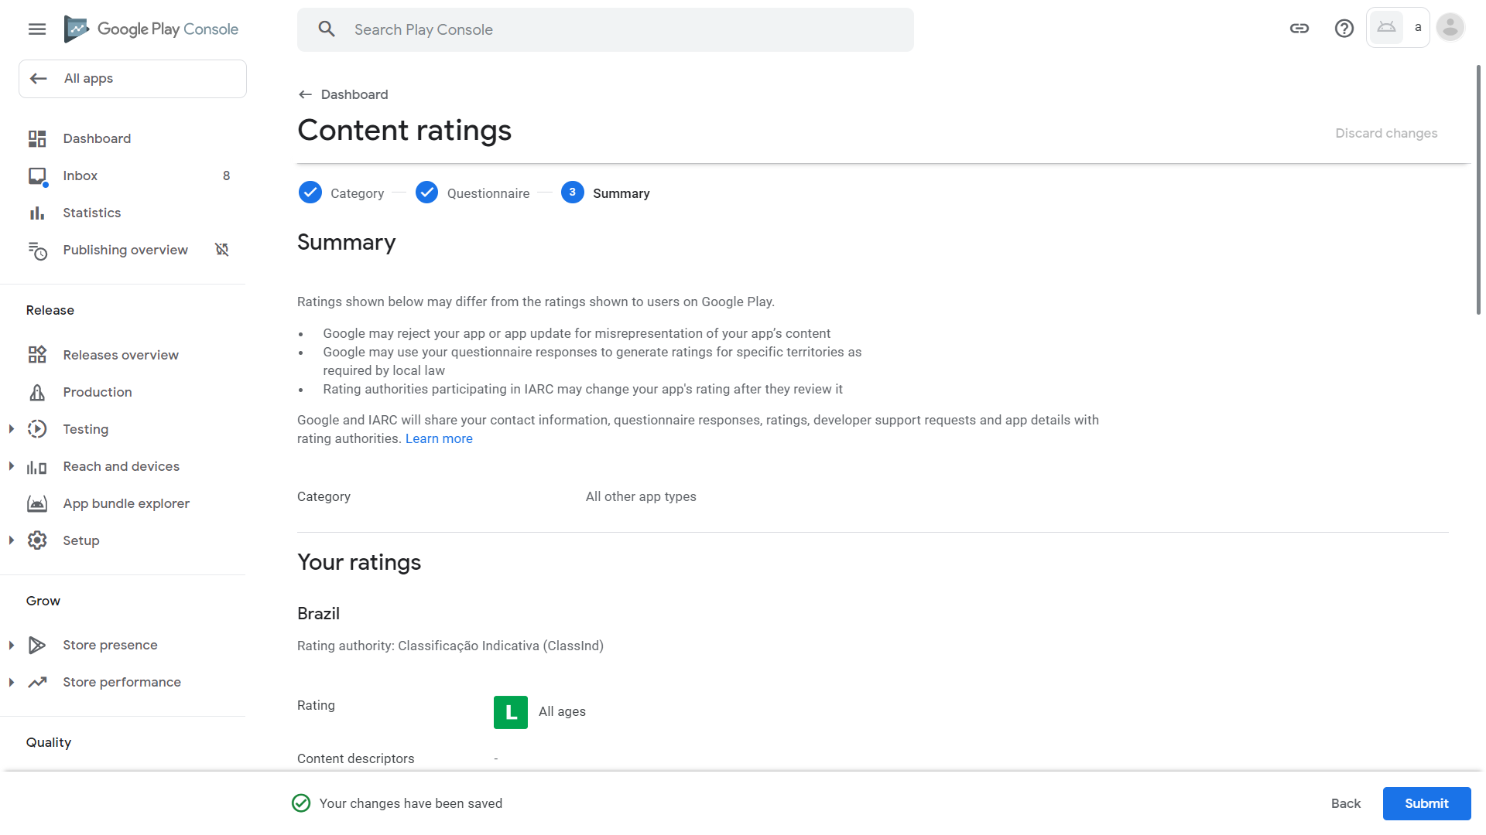
31. Our app is for everyone in North America. Our app is for anyone over the age of 3 (in reality it’s already the lowest classification, i.e. for everyone) in Europe. Our app is for all ages in Germany. Scroll down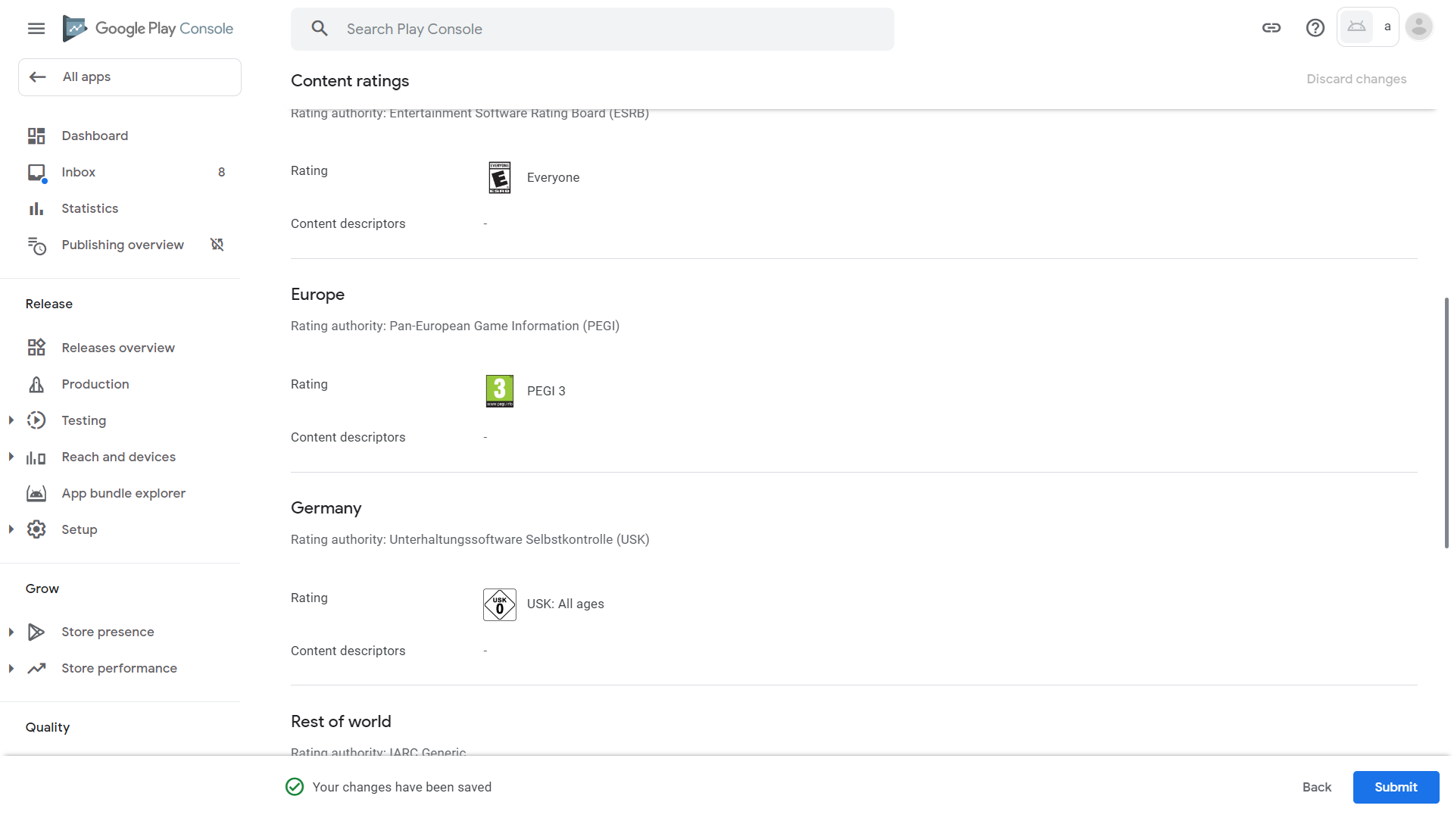
32. Our app is for anyone over the age of 3 (in reality for everyone) in Russia, South Korea, and the rest of the world. Click Submit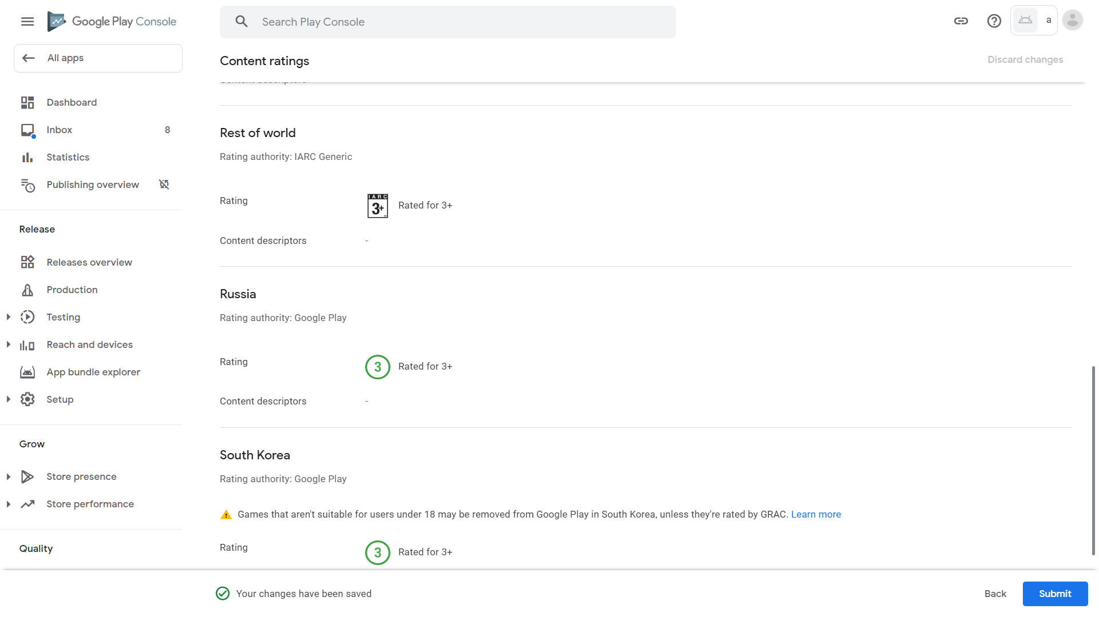
33. Our questionnaire has been successfully saved. Click Dashboard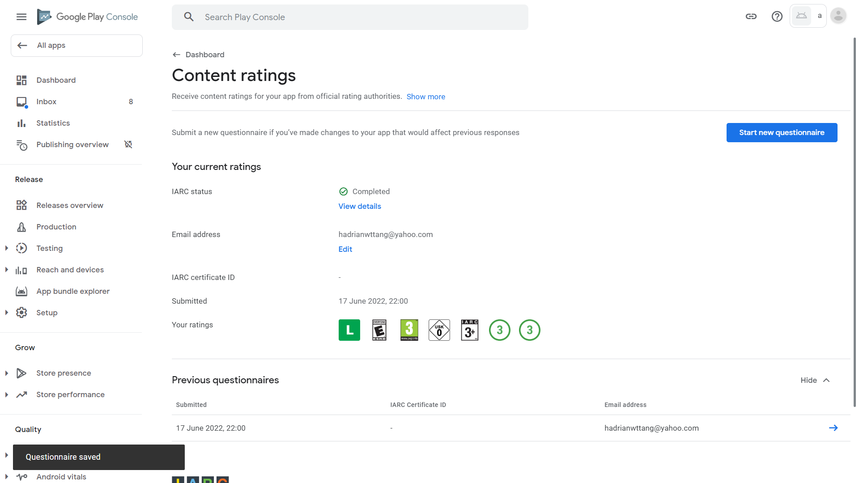
34. Scroll down and click “Target audience”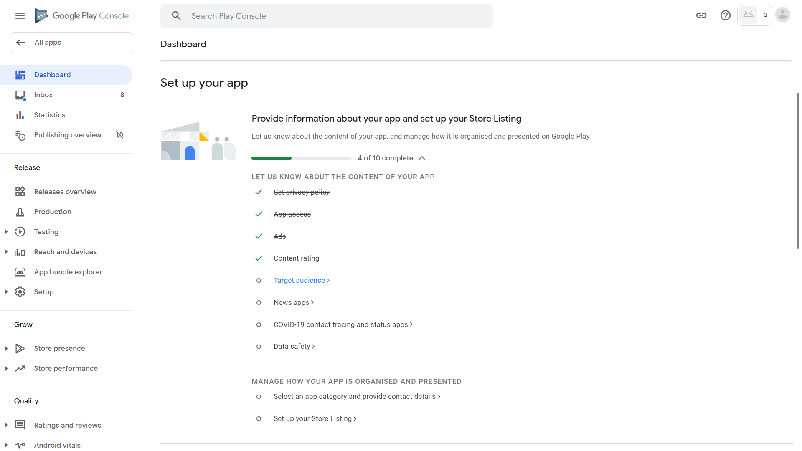
35. Our app targets everyone (unlike before, where that questionnaire was about who we are allowed to serve, this is about who we intend to serve). Click all checkboxes then scroll down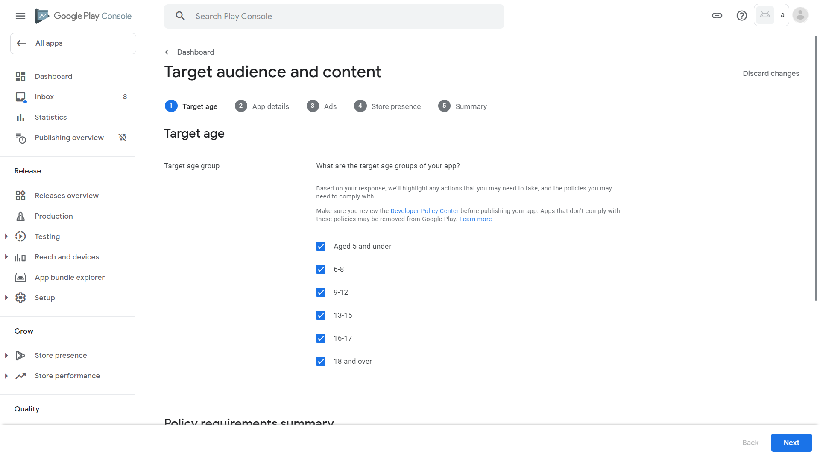
36. Since we intend to serve children, we must comply with child protection regulations. Click Next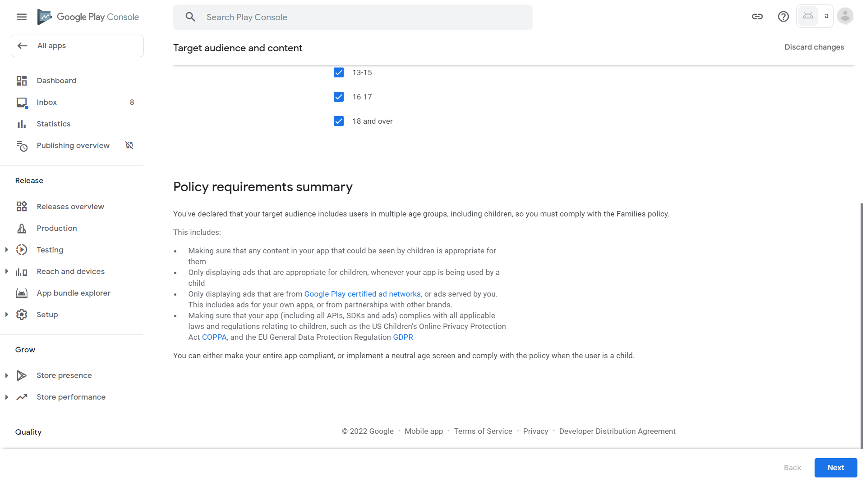
37. Google reminds us once again that failure to comply with child protection regulations will cause our app to be removed from Google Play. Click OK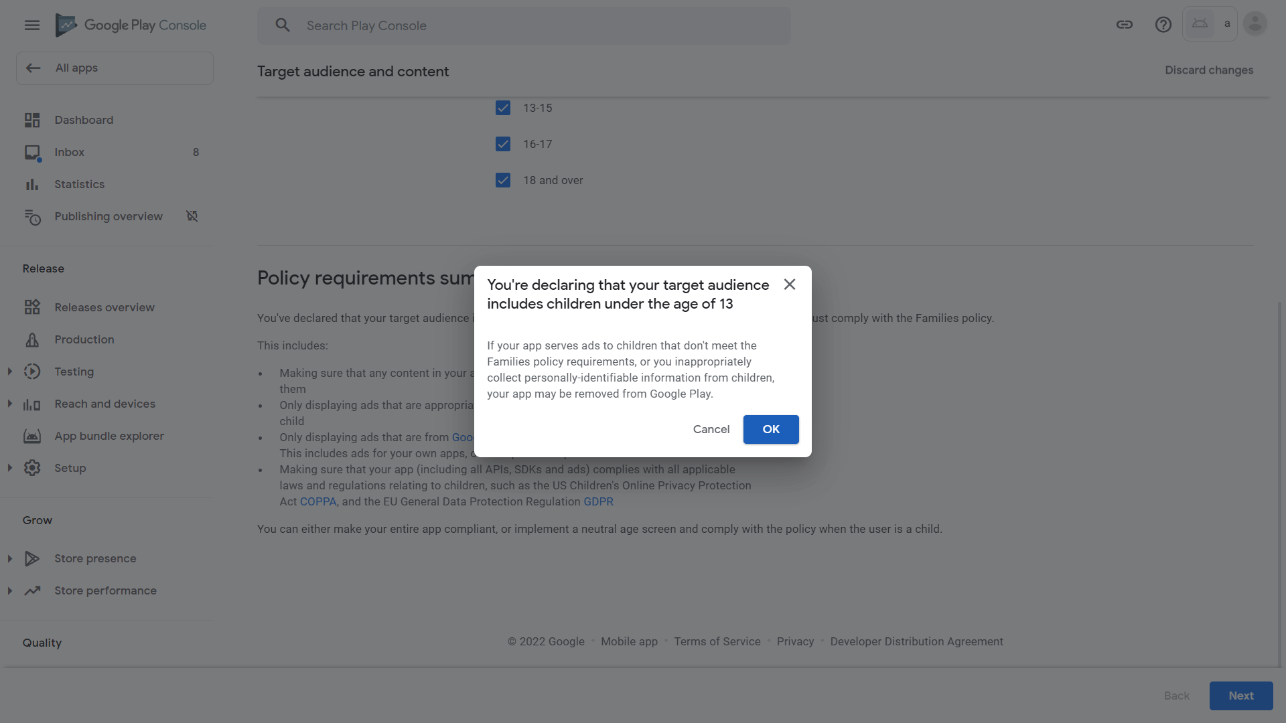
38. Although our pedometer app collects step counting data which is sensitive, since we do not store them after the app is closed, under guidelines outlined by the link under “personal and sensitive information” in this page, we can answer that we do not collect personal and sensitive information here. Click No, then click the checkbox indicating that all code from other people do comply with regulations related to children as well (ones that are widely used and trusted should satisfy this), then Next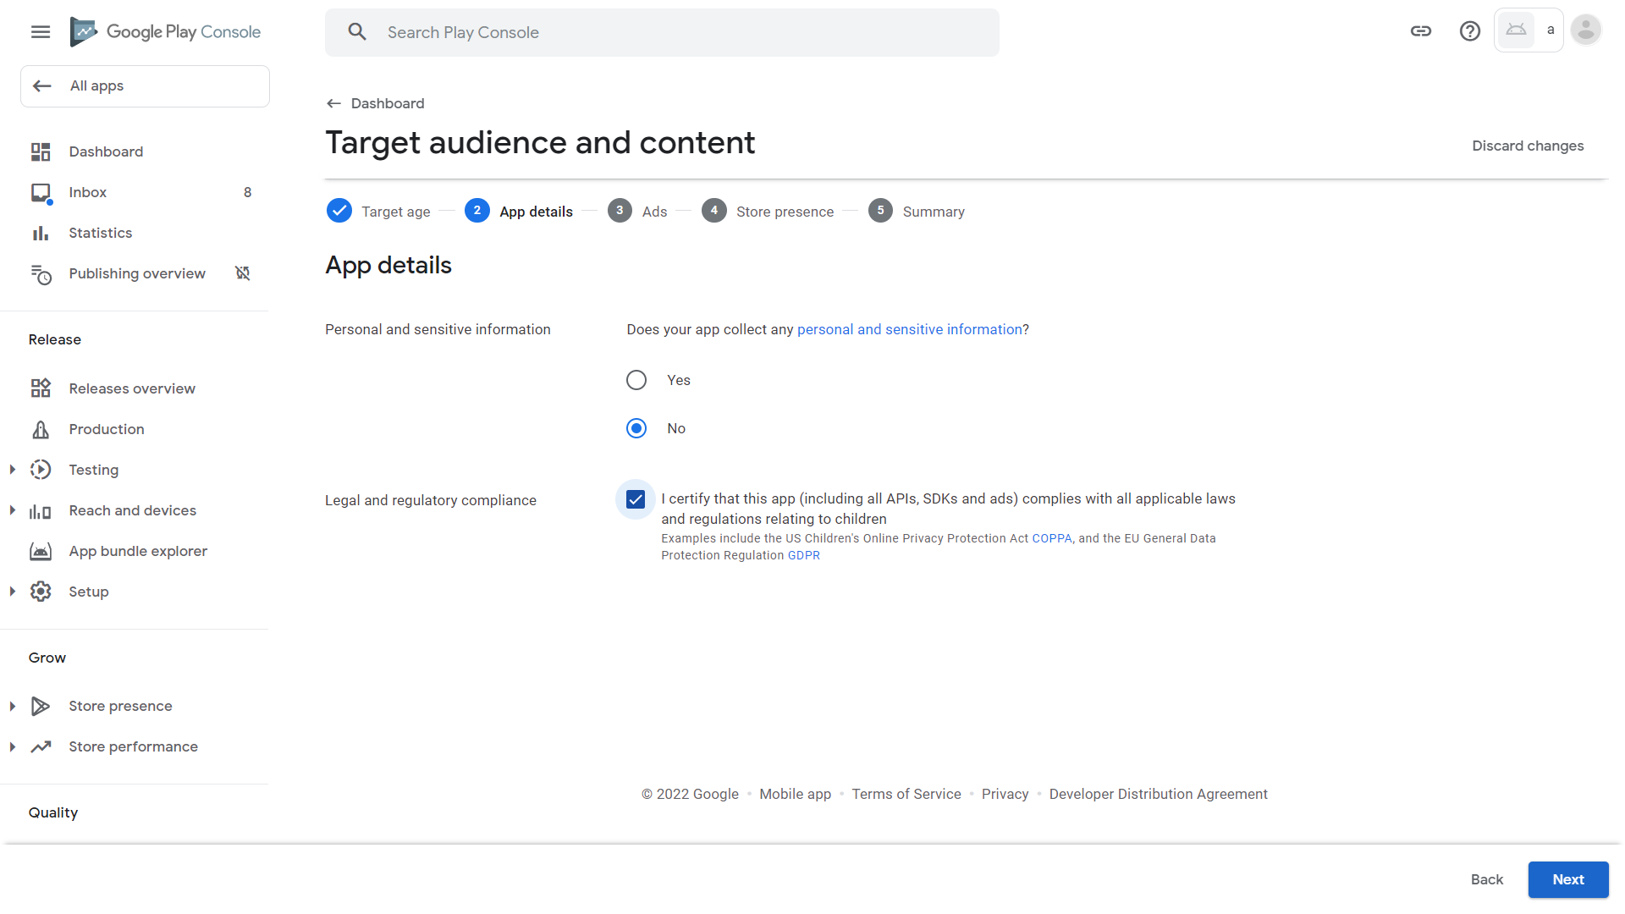
39. Google tells us that we have declared that our app does not contain ads. Click Next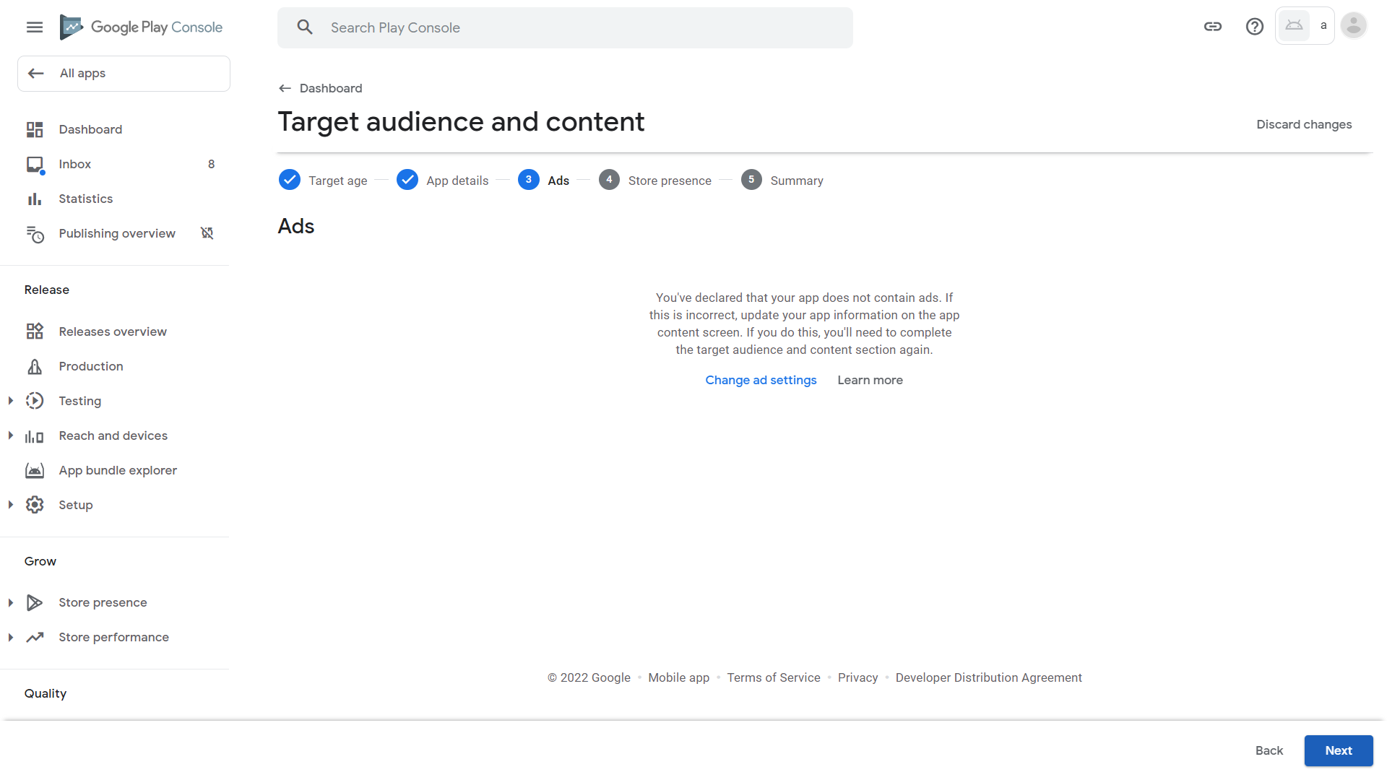
40. Click “No, I do not want to join Designed for Families” because that requires additional regulations. Then, click Next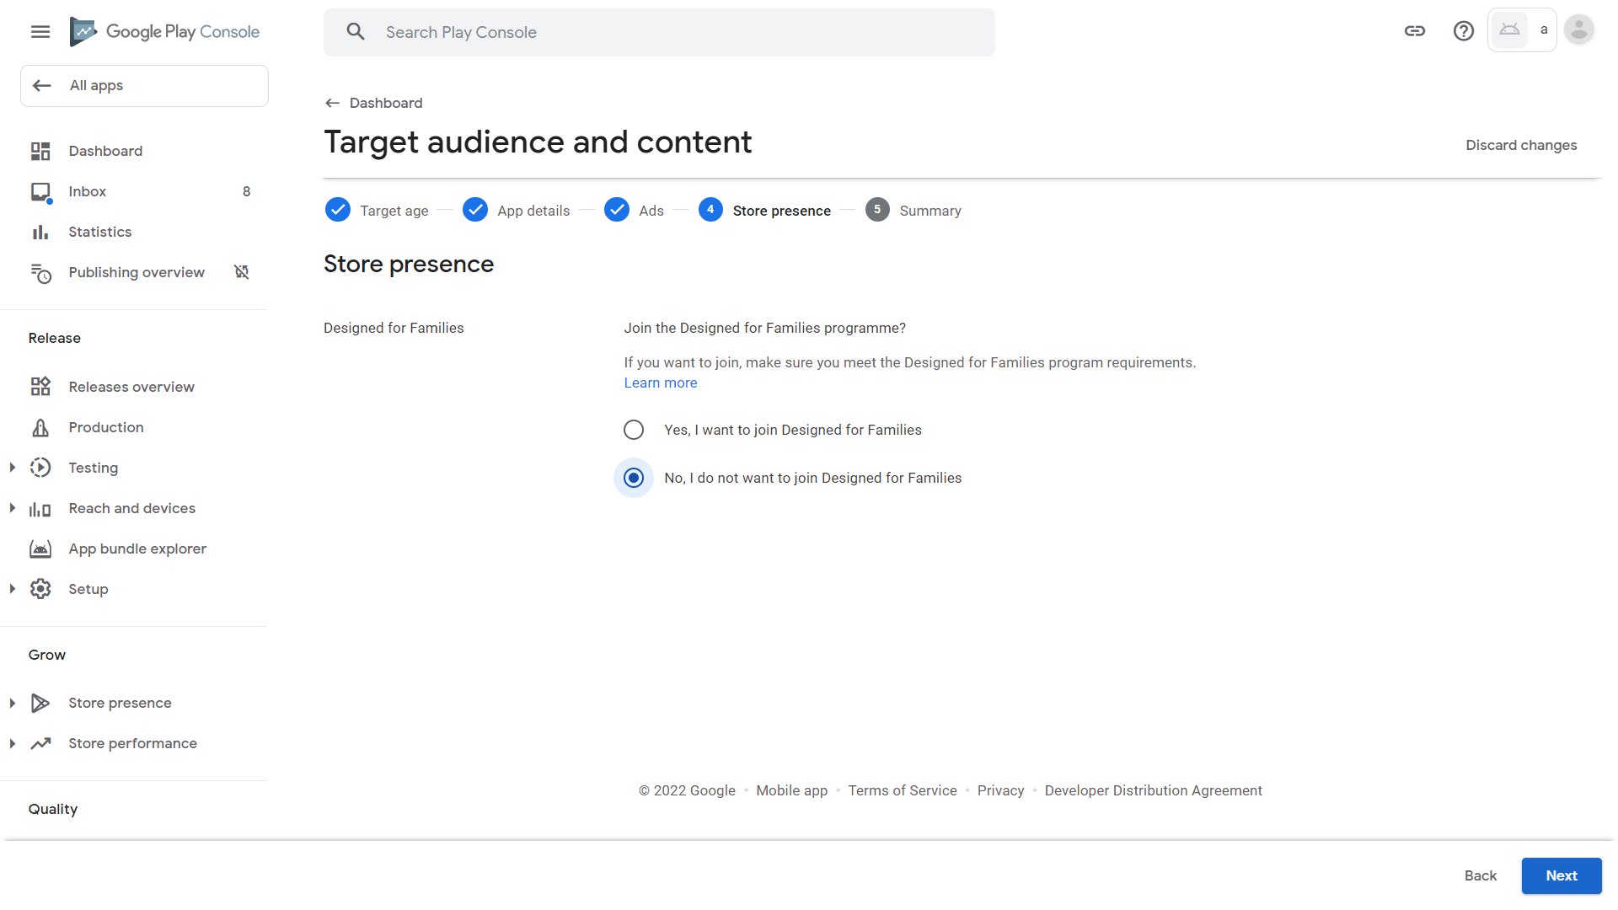
41. Click Save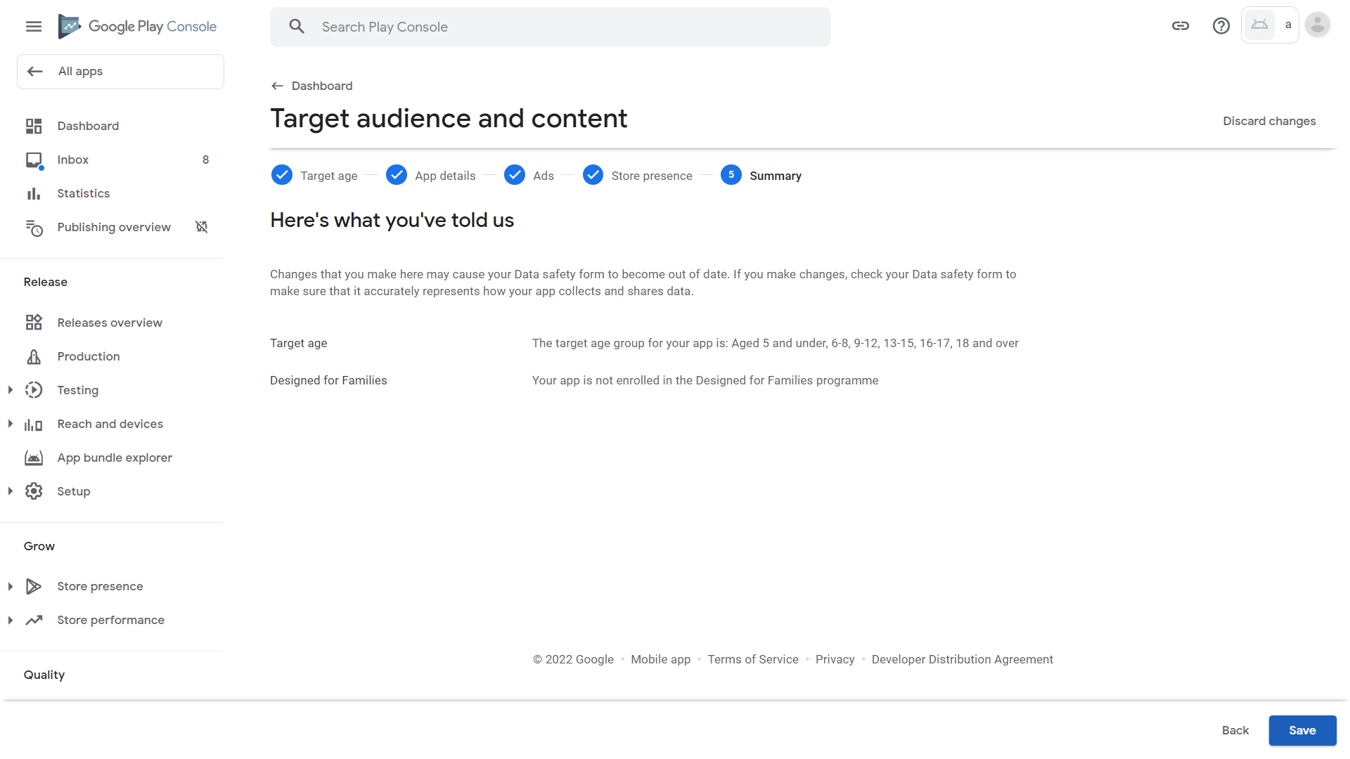
42. Click Dashboard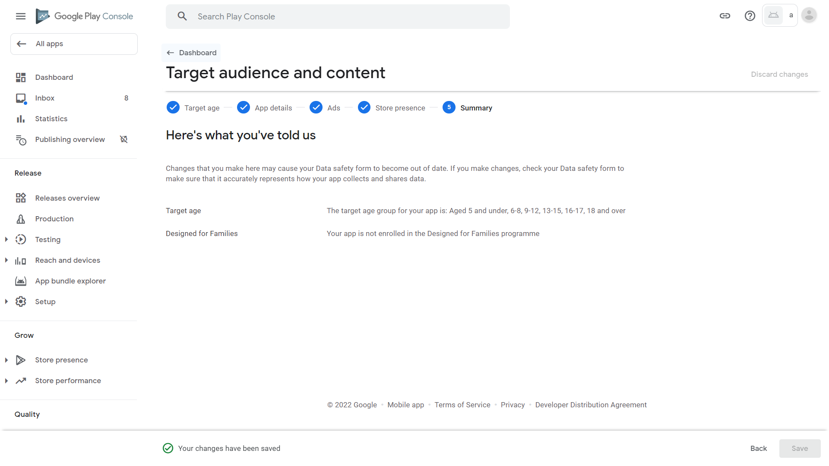
43. Scroll down and click “News apps” 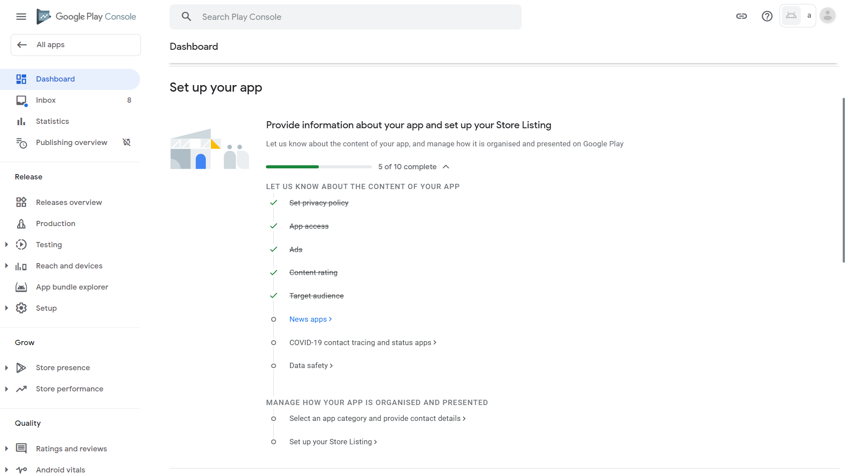
44. Our app is not a news app (and does not have to comply with news regulations). Click No, then Save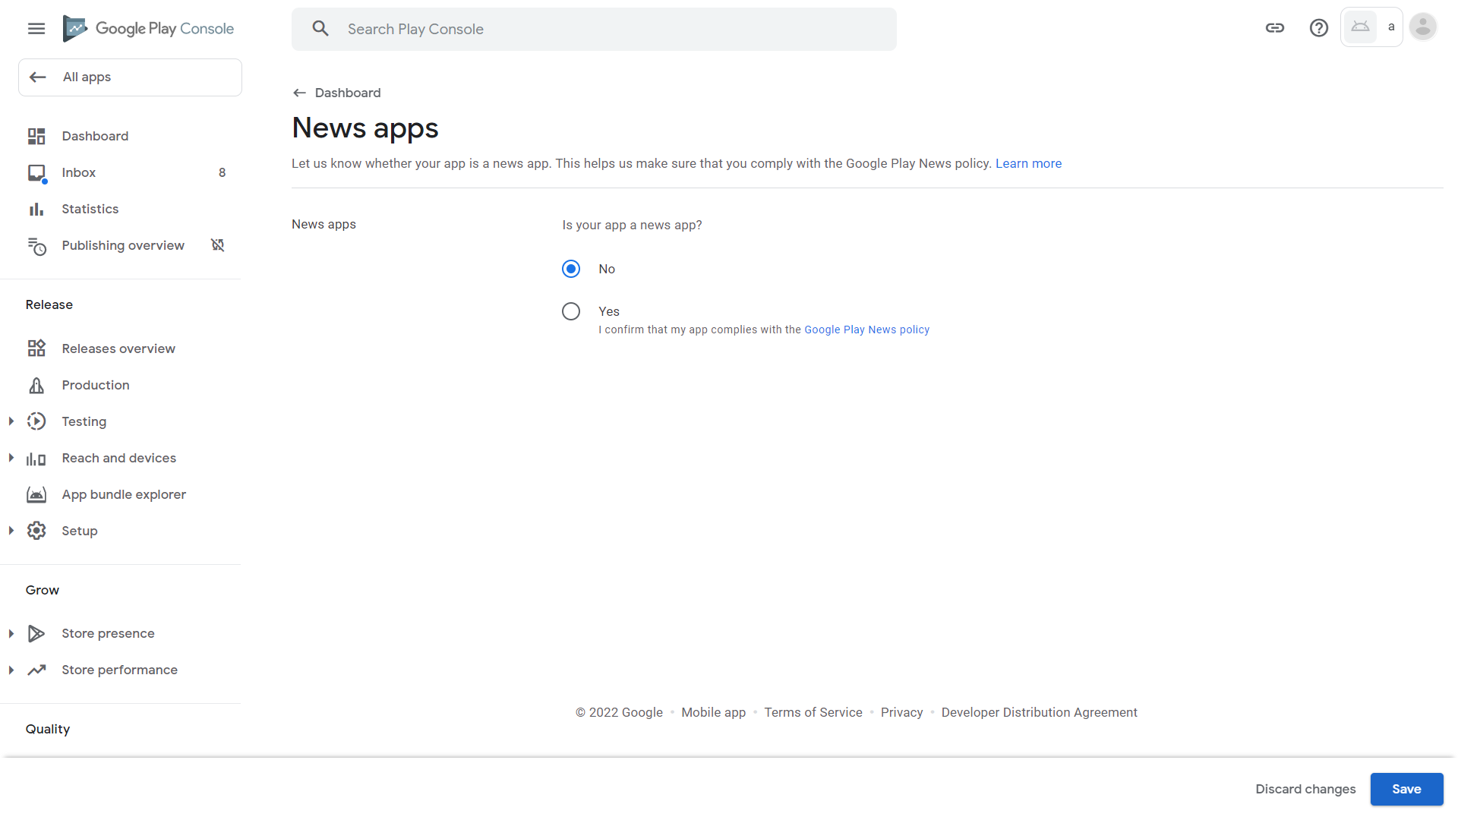
45. Click Dashboard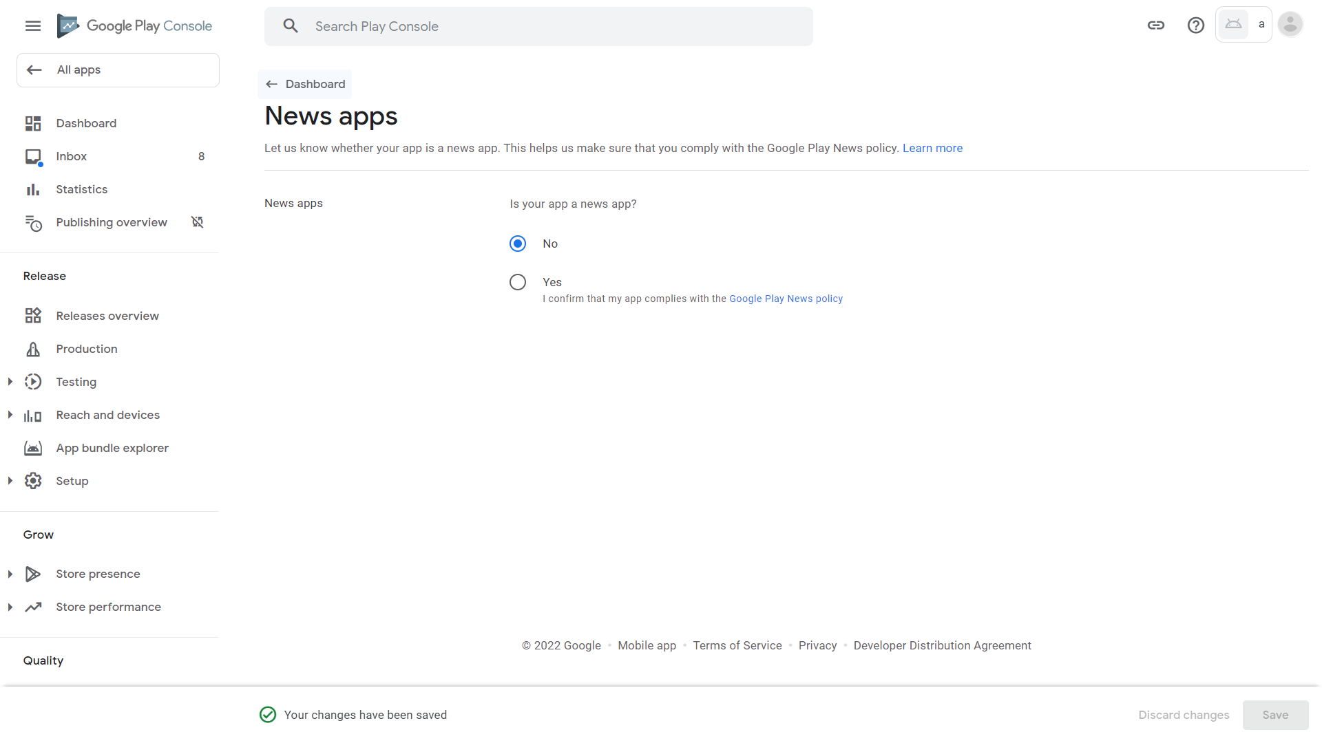
46. Scroll down and click “COVID-19 contact tracing and status apps” 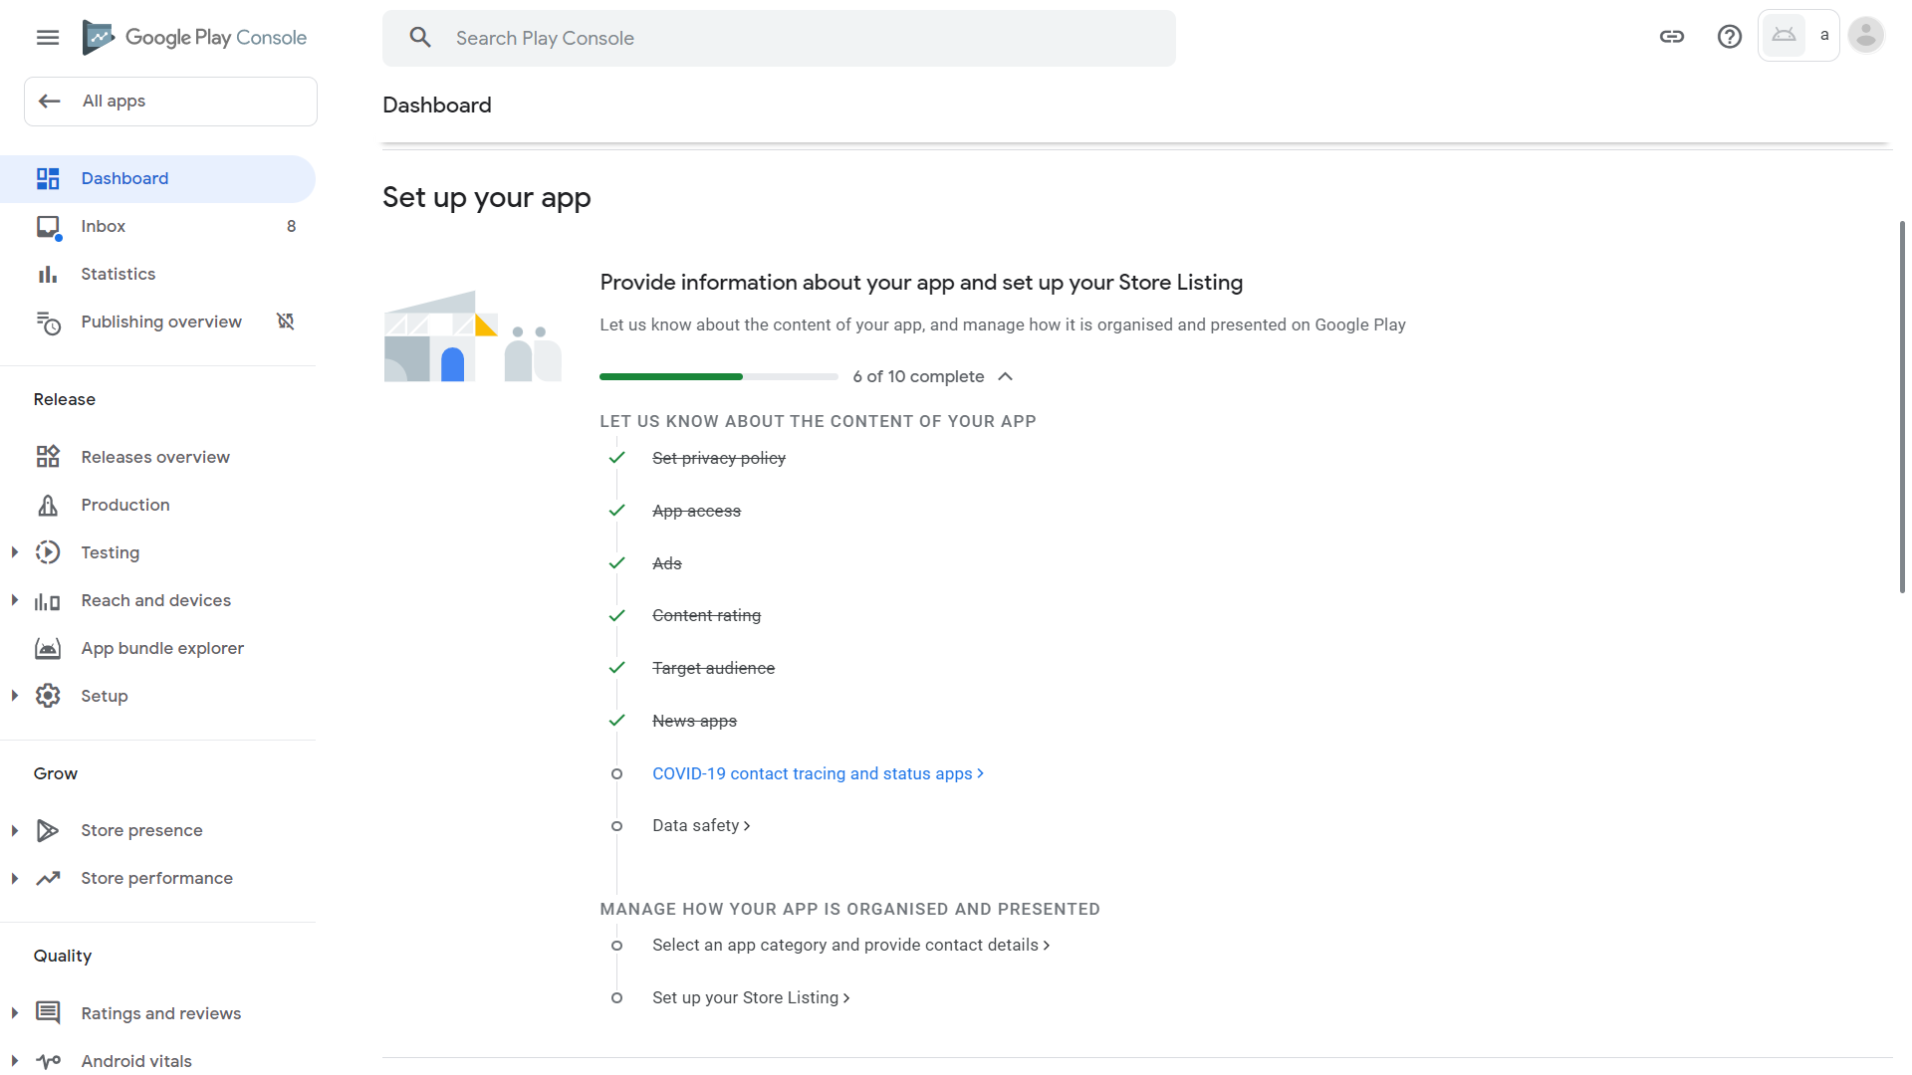
47. Click “My app is not a publicly available COVID-19 contact tracing or status app” (where additional regulations apply). Then click Save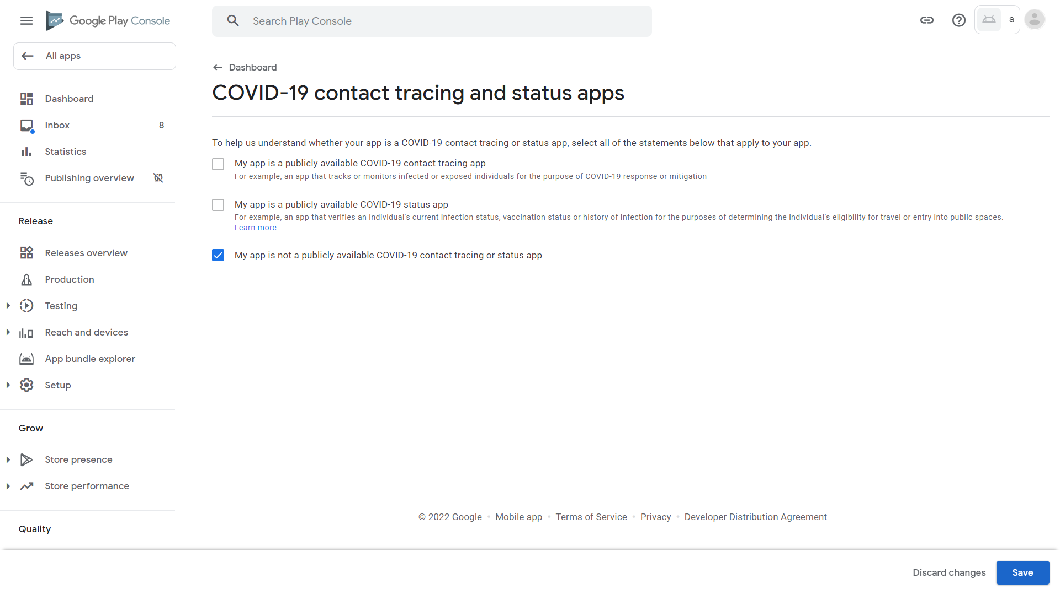
48. Click Dashboard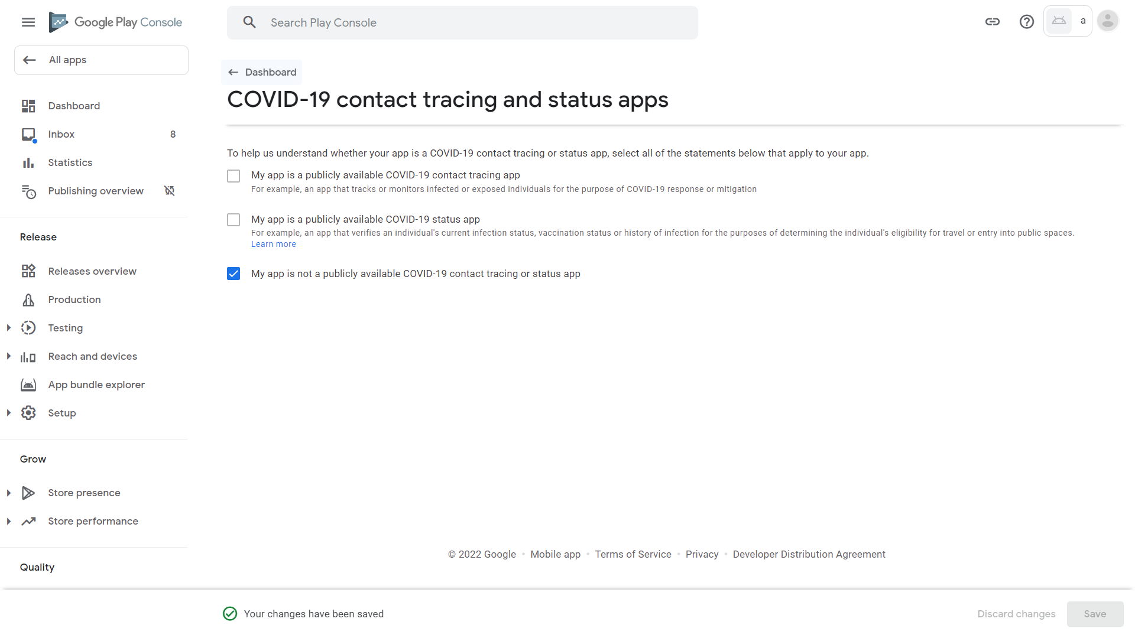
49. Scroll down and click “Data safety” 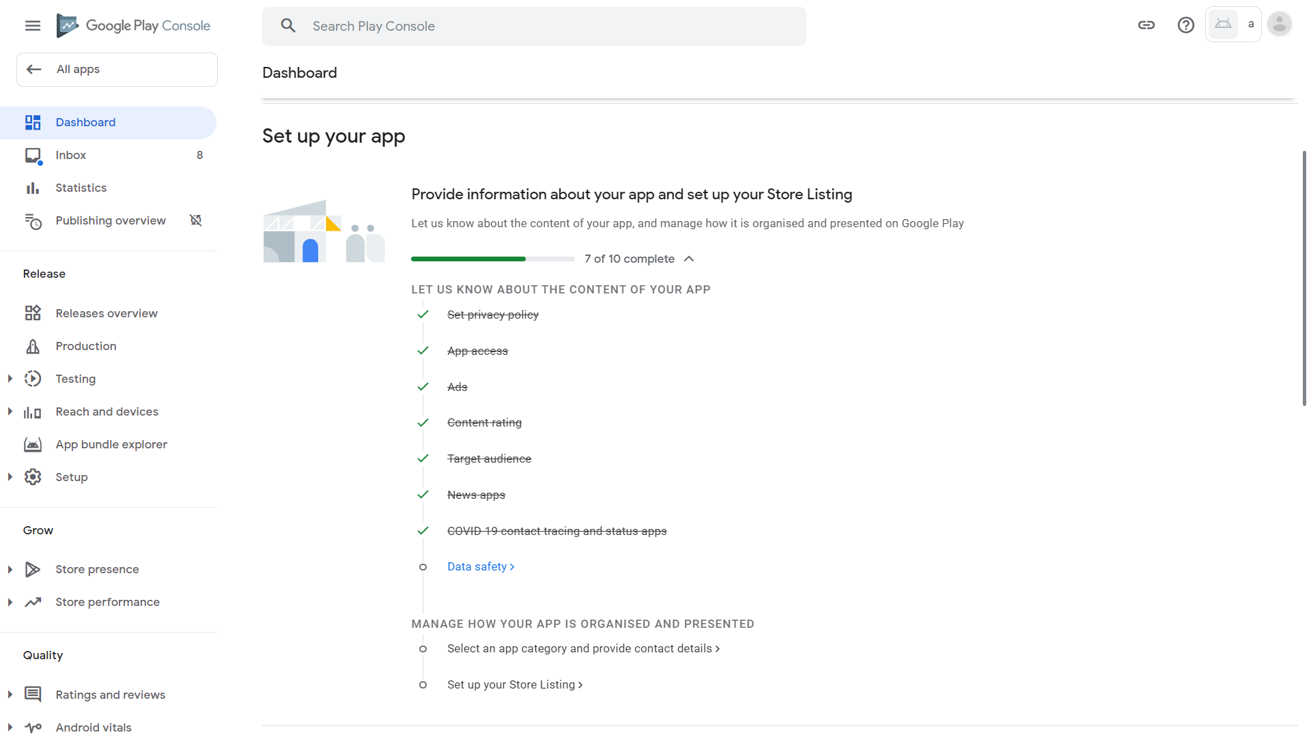
50. Click Next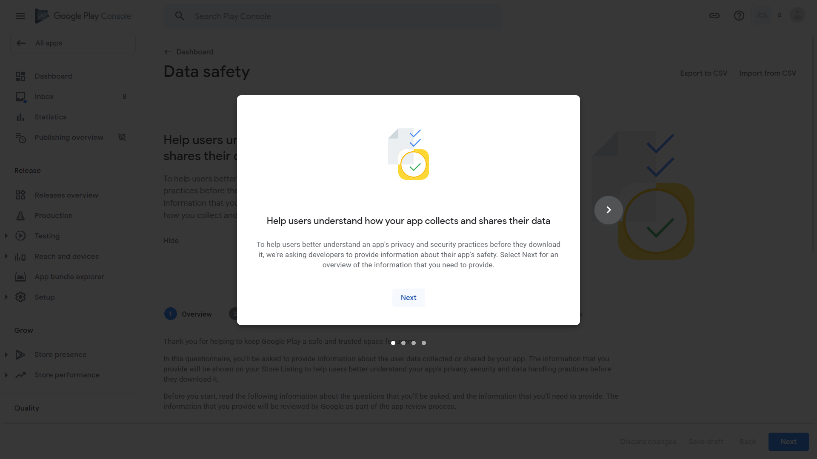
51. Click Next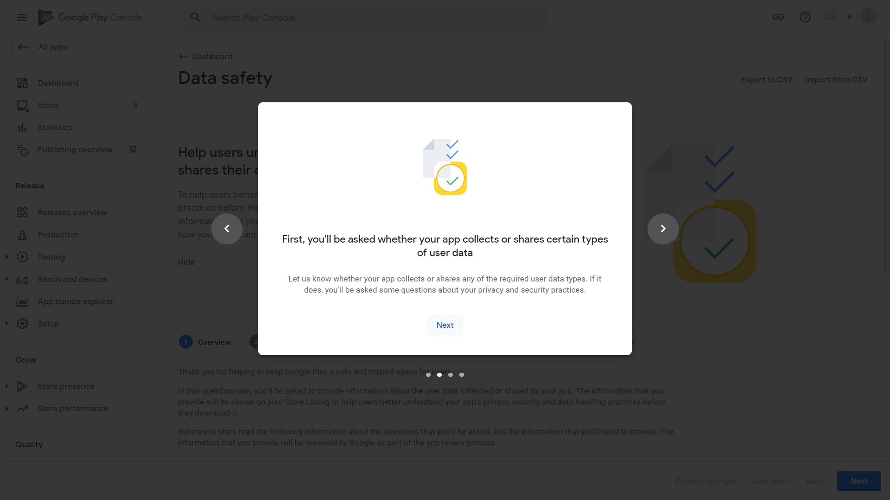
52. Click Next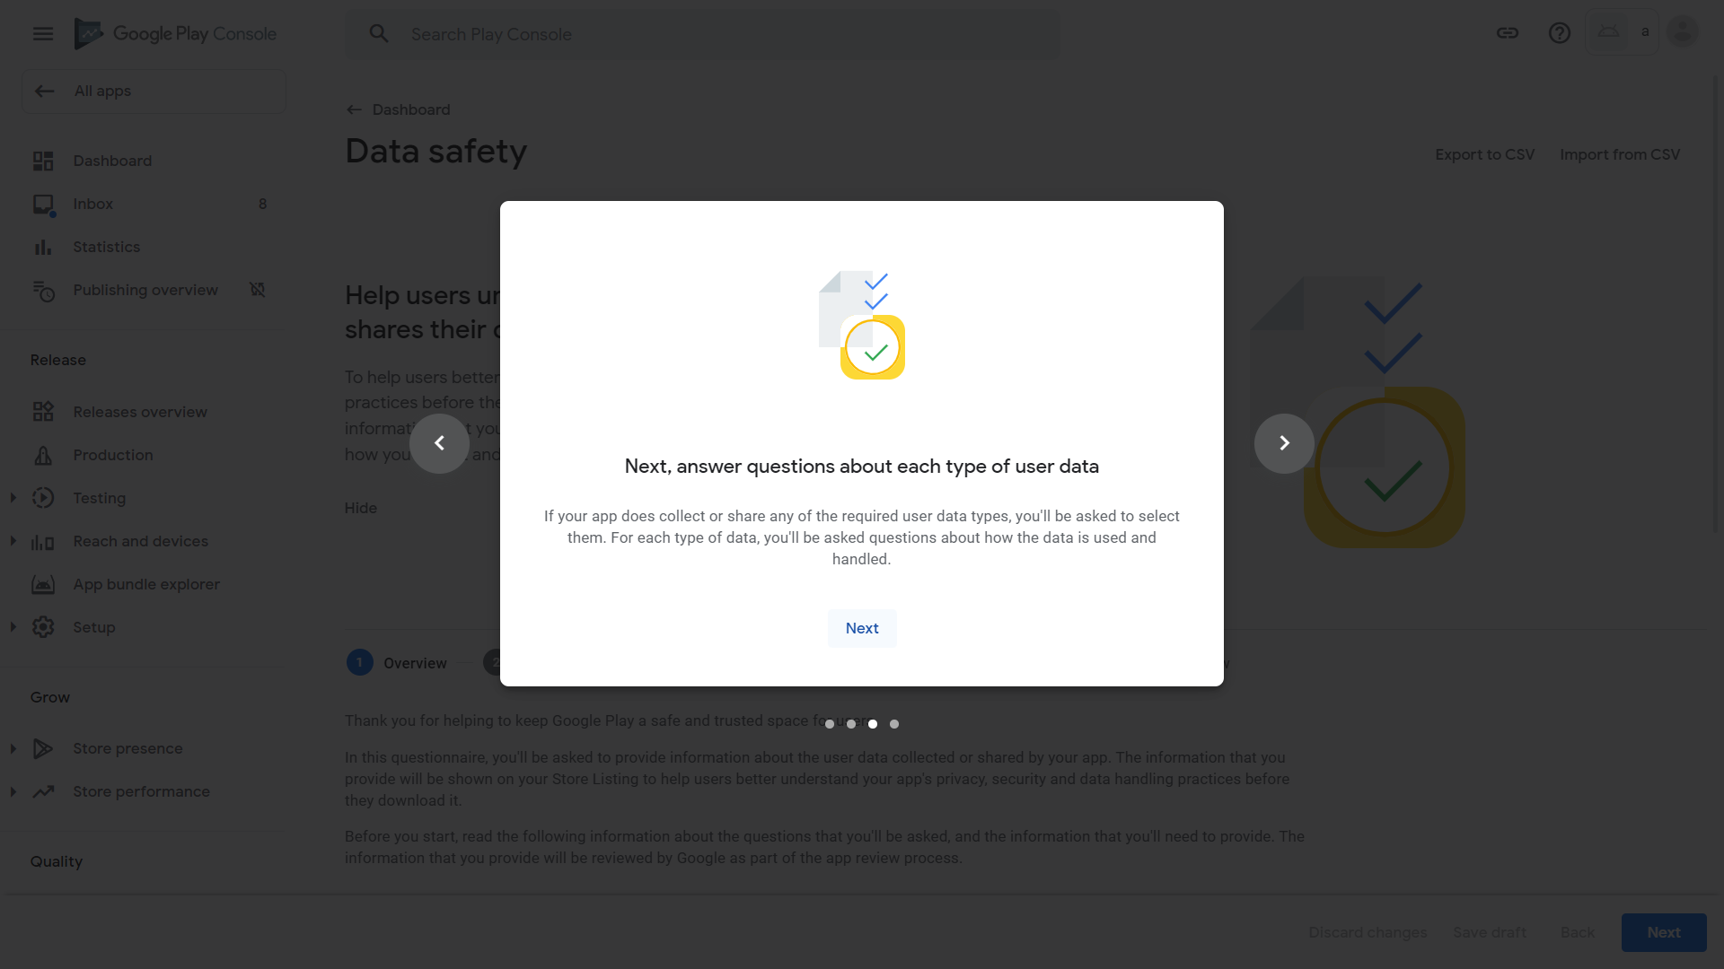
53. Click Start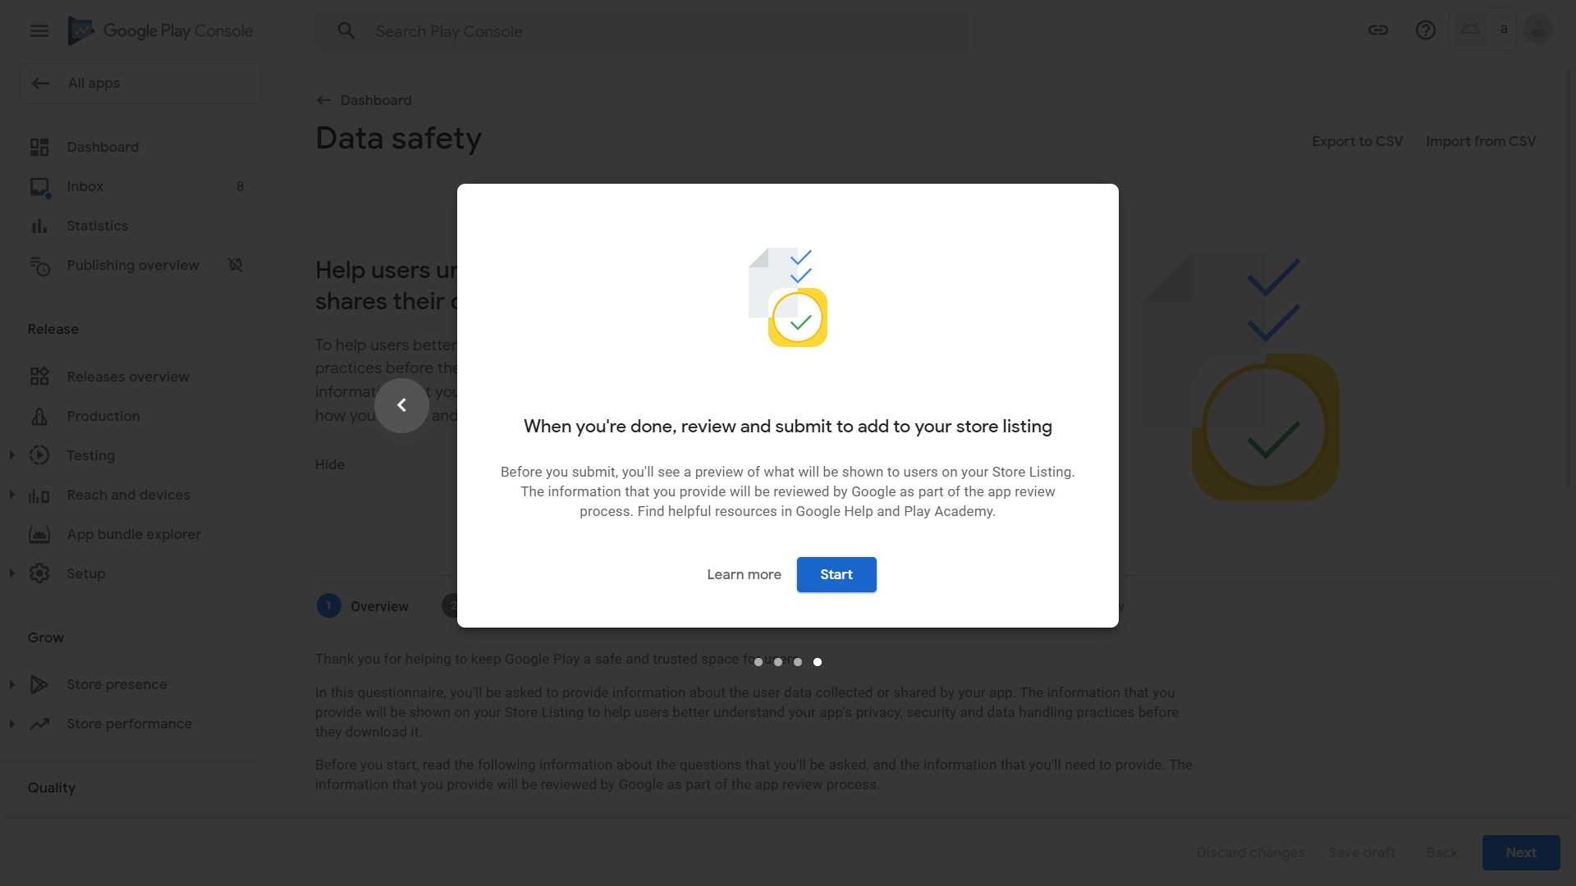
54. This questionnaire analyses our data collection and displays results to users. Scroll down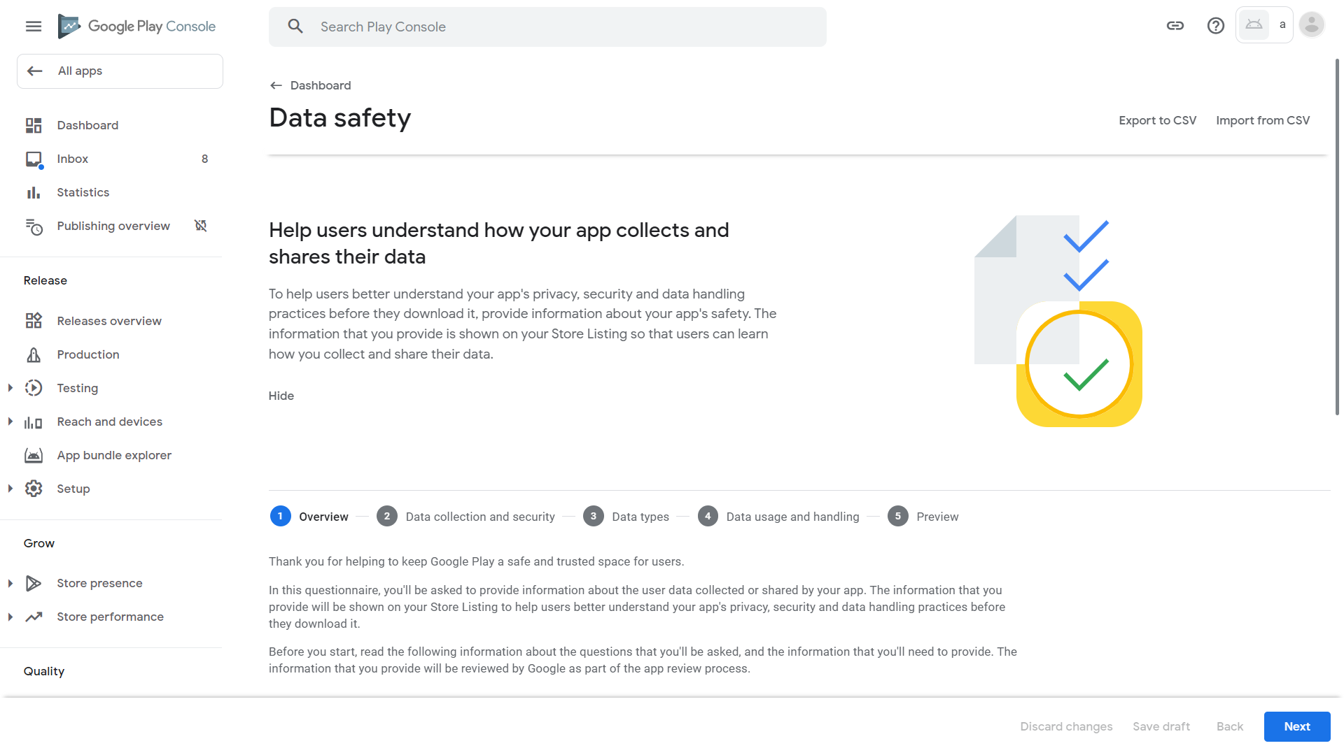
55. Click Next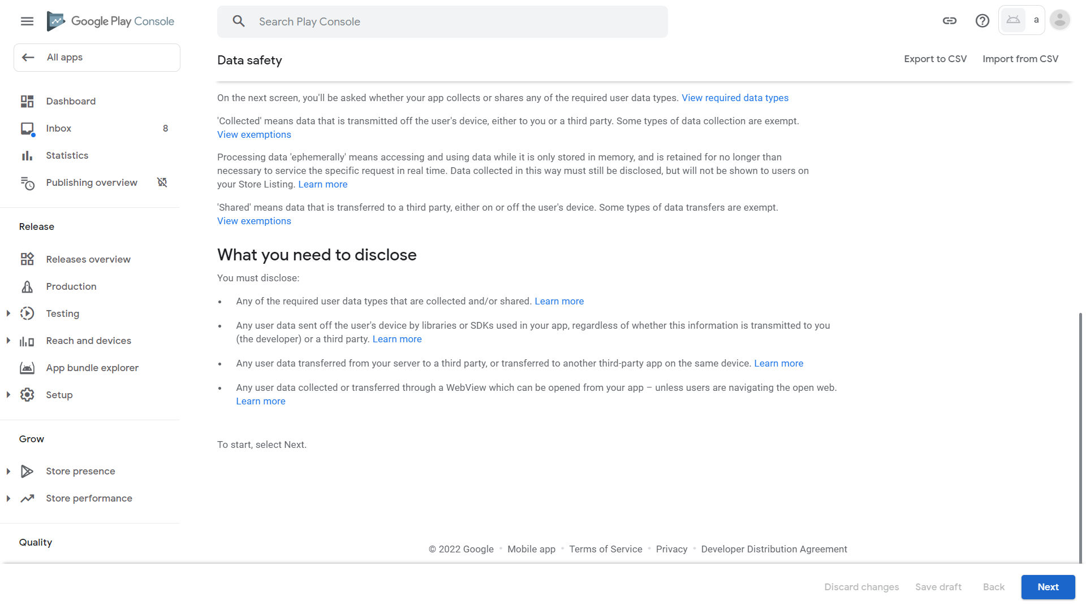
56. Scroll down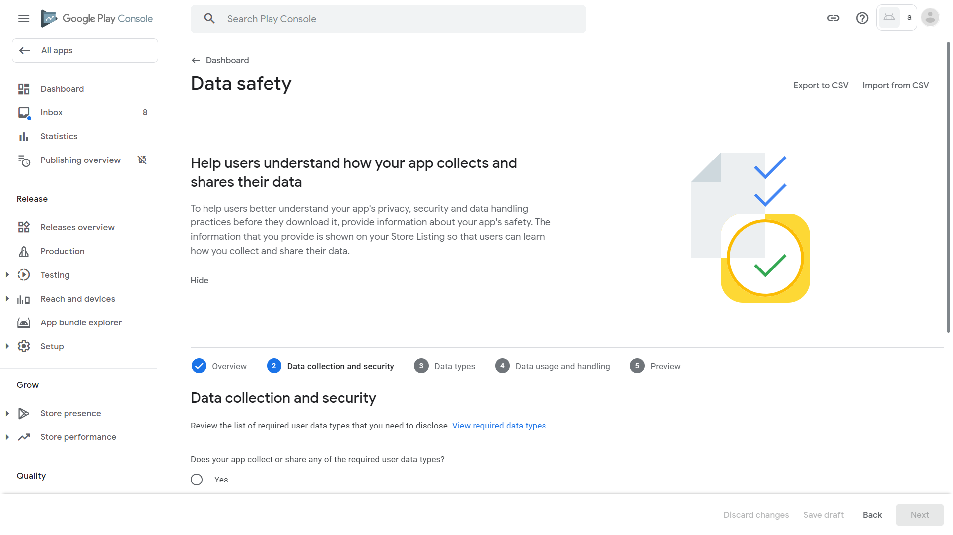
57. As explained before, our app can declare that no data is collected as they are not persisted. Click No then Next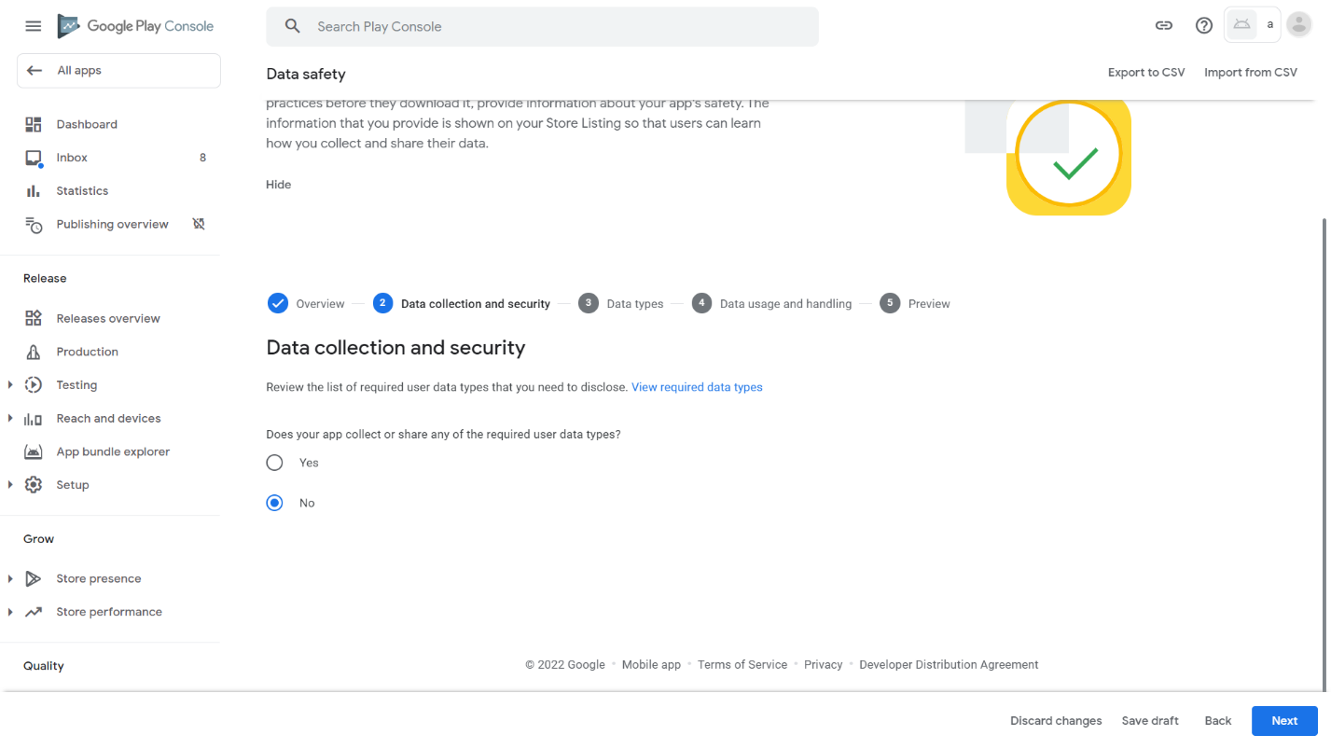
58. Click Save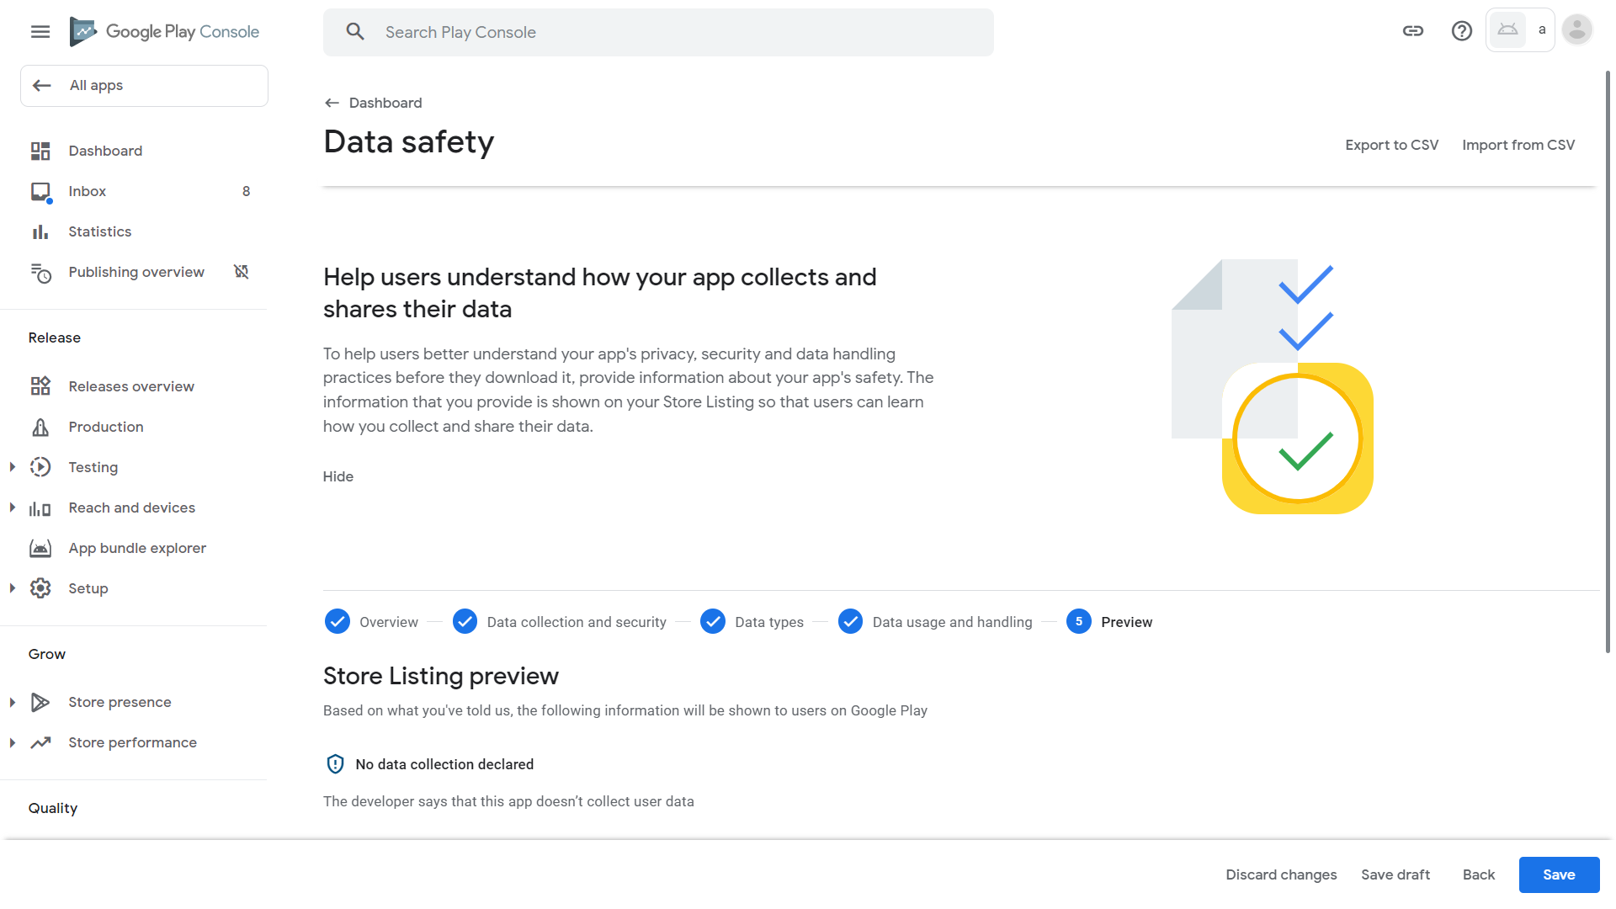
59. Click Dashboard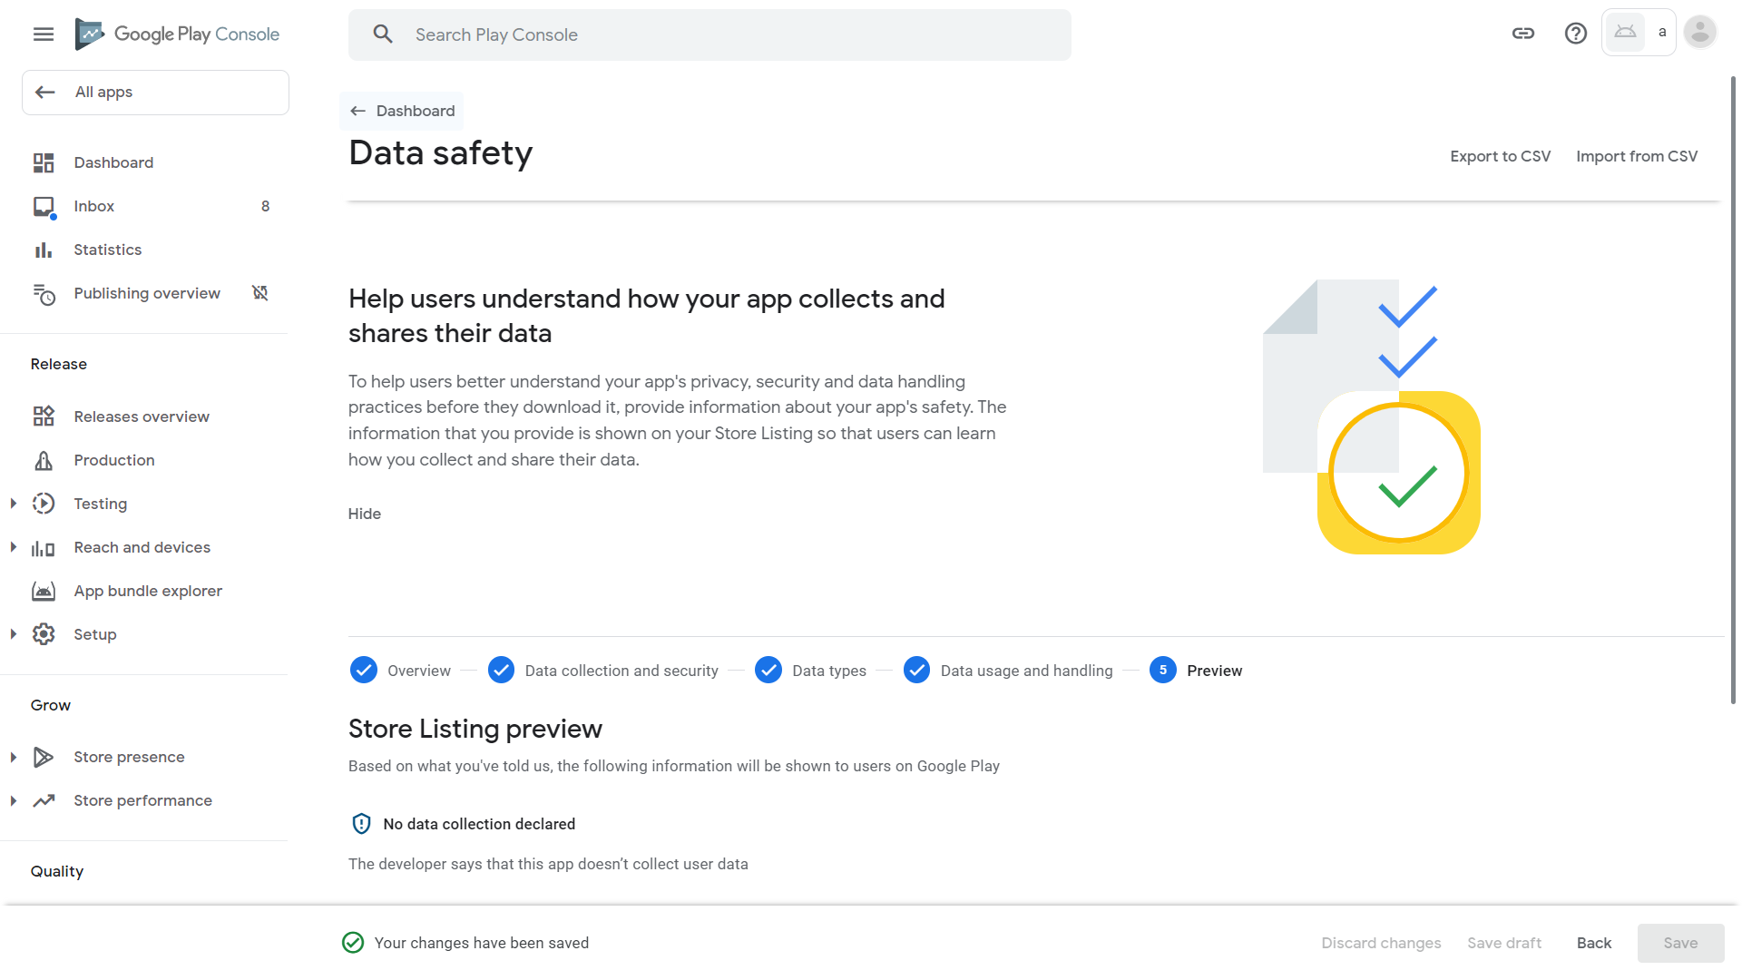
60. Scroll down and click “Select an app category and provide contact details” 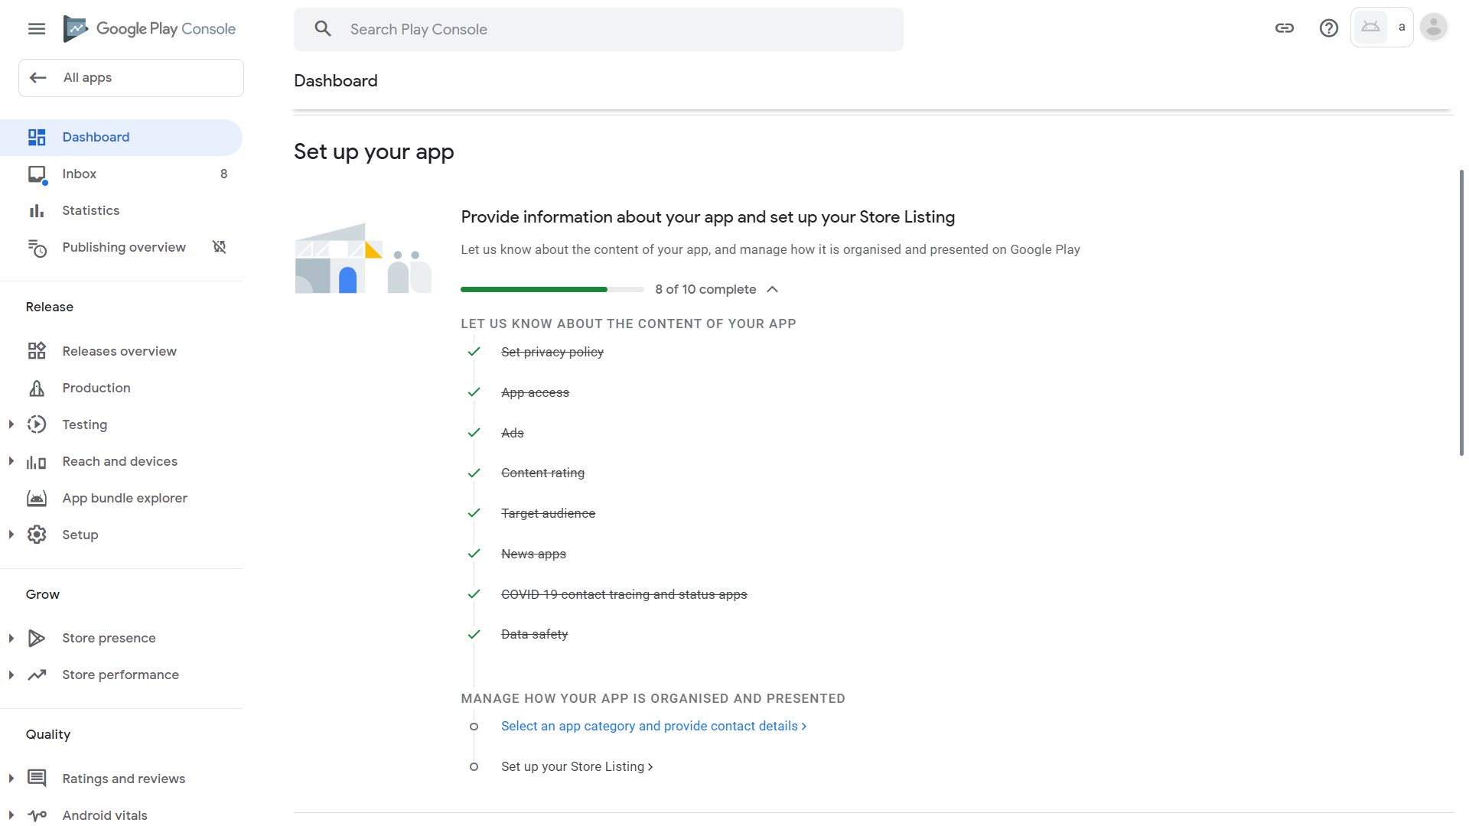
61. For the “App or game” dropdown, select App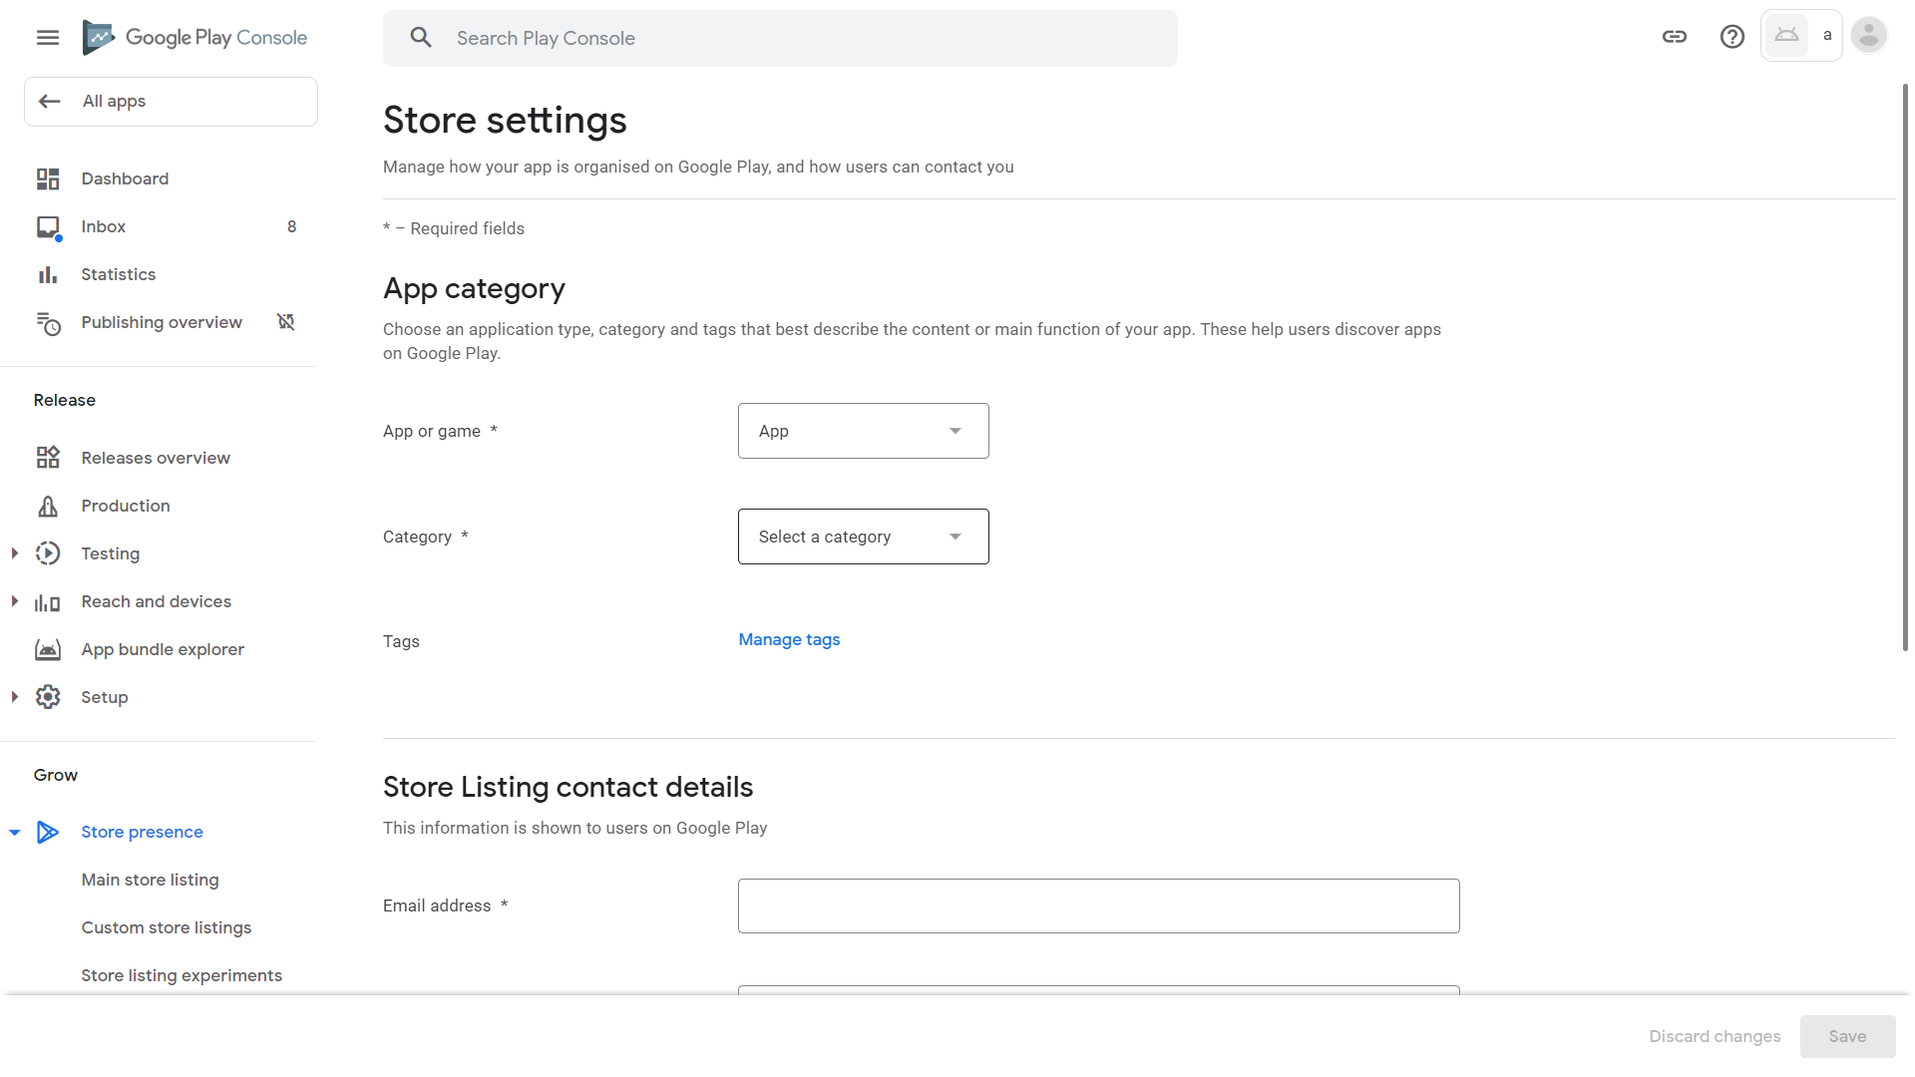
62. For Category dropdown, select “Health & Fitness” 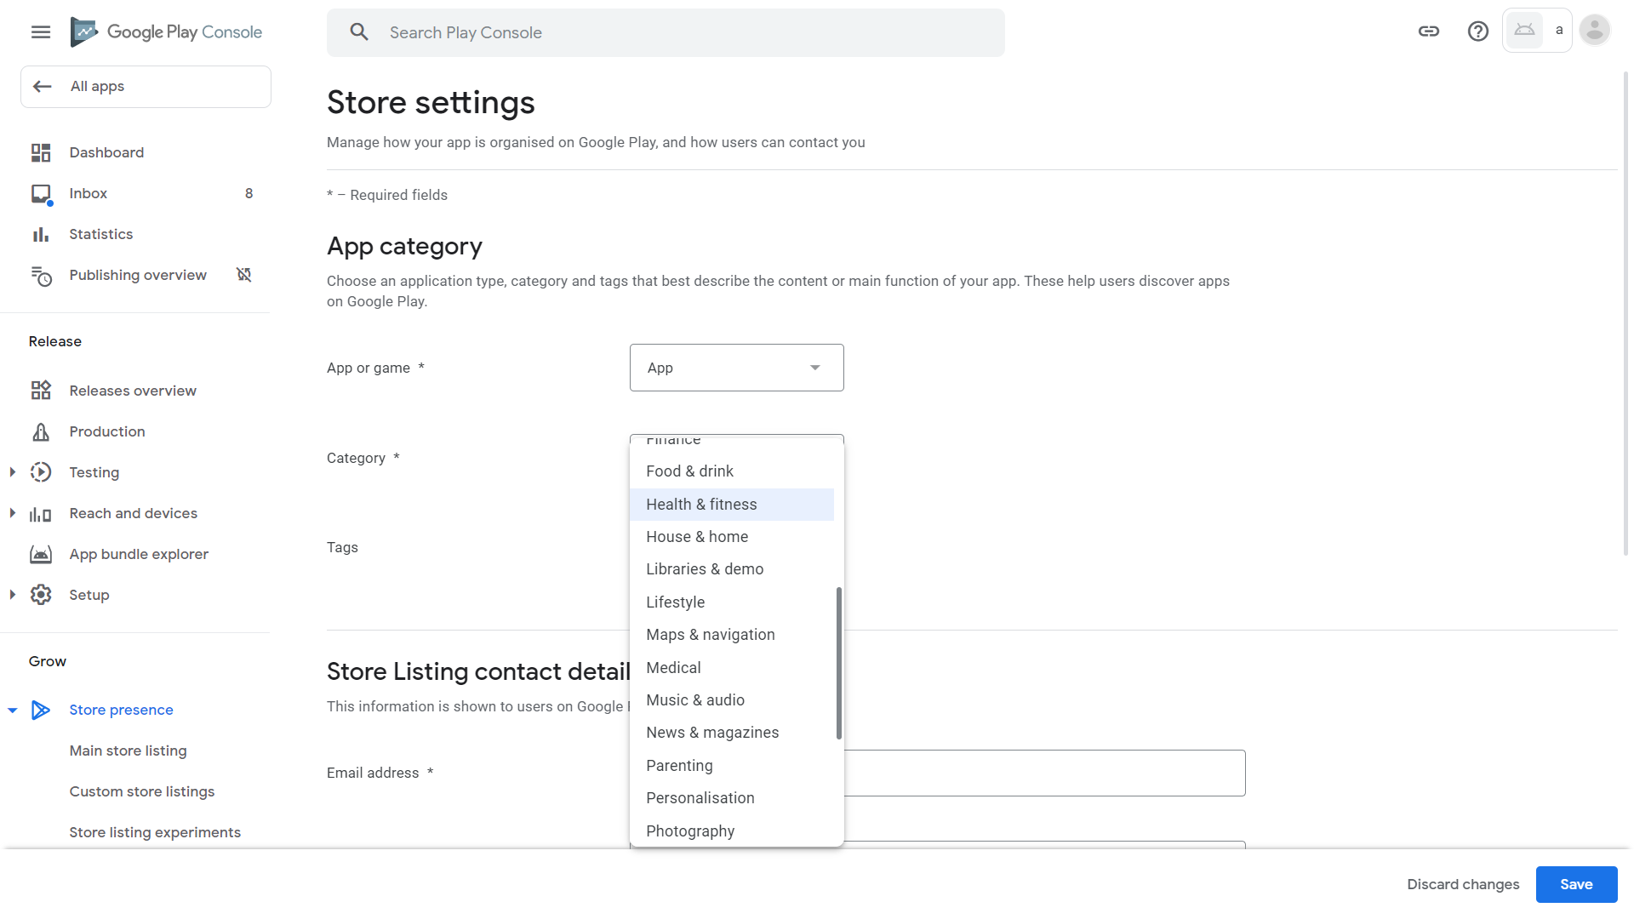
63. Click “Manage tags” 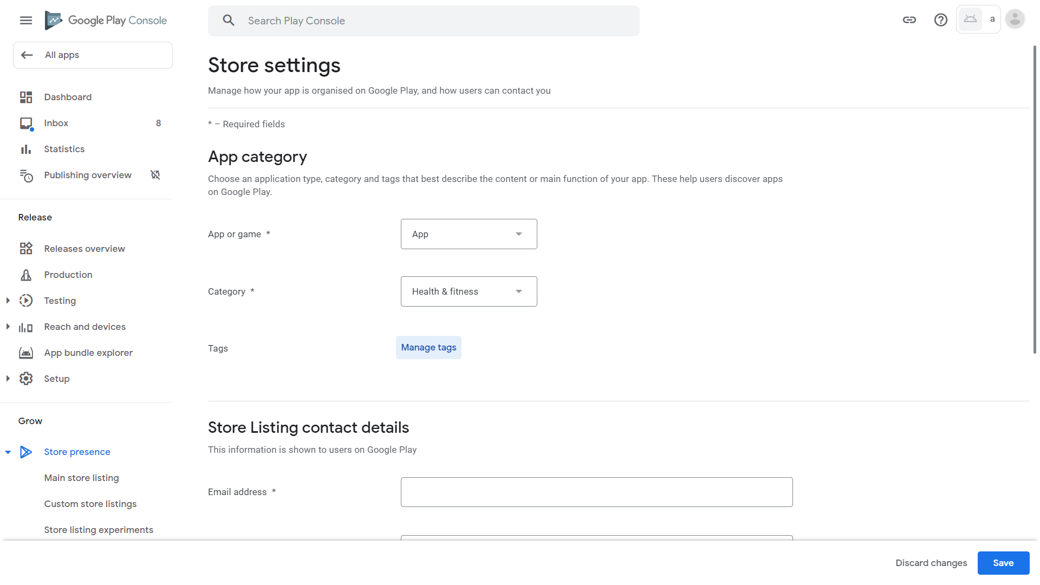
64. Click “Activity tracker” 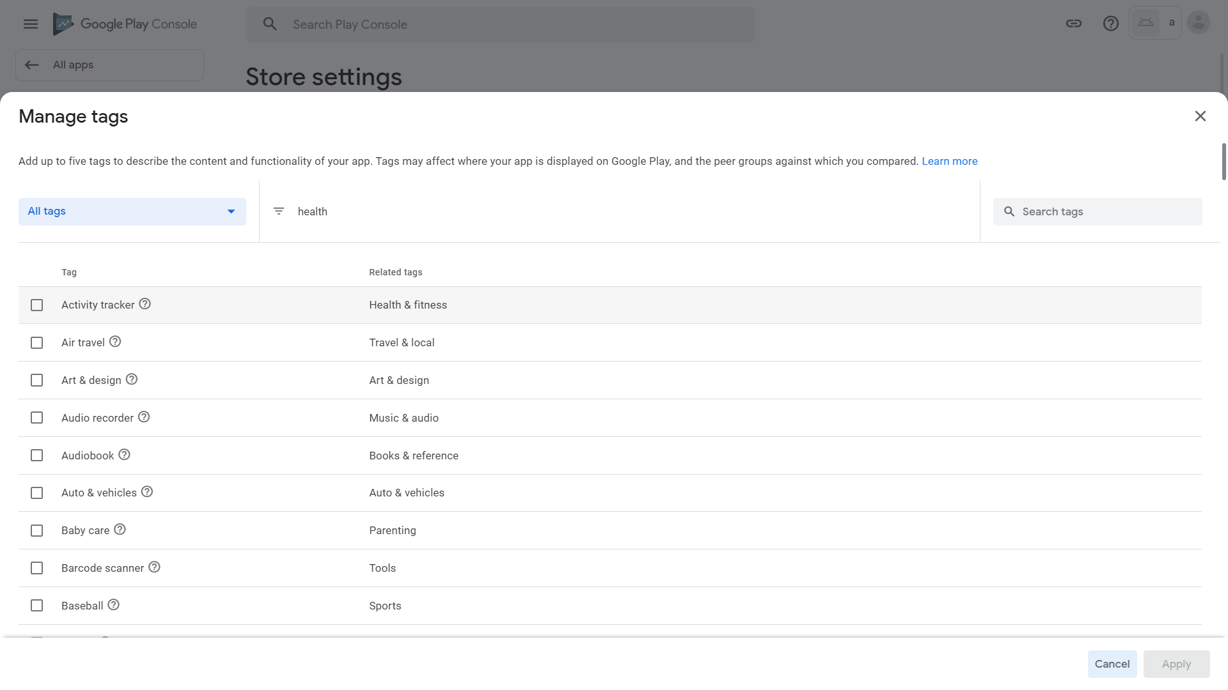
65. Click Apply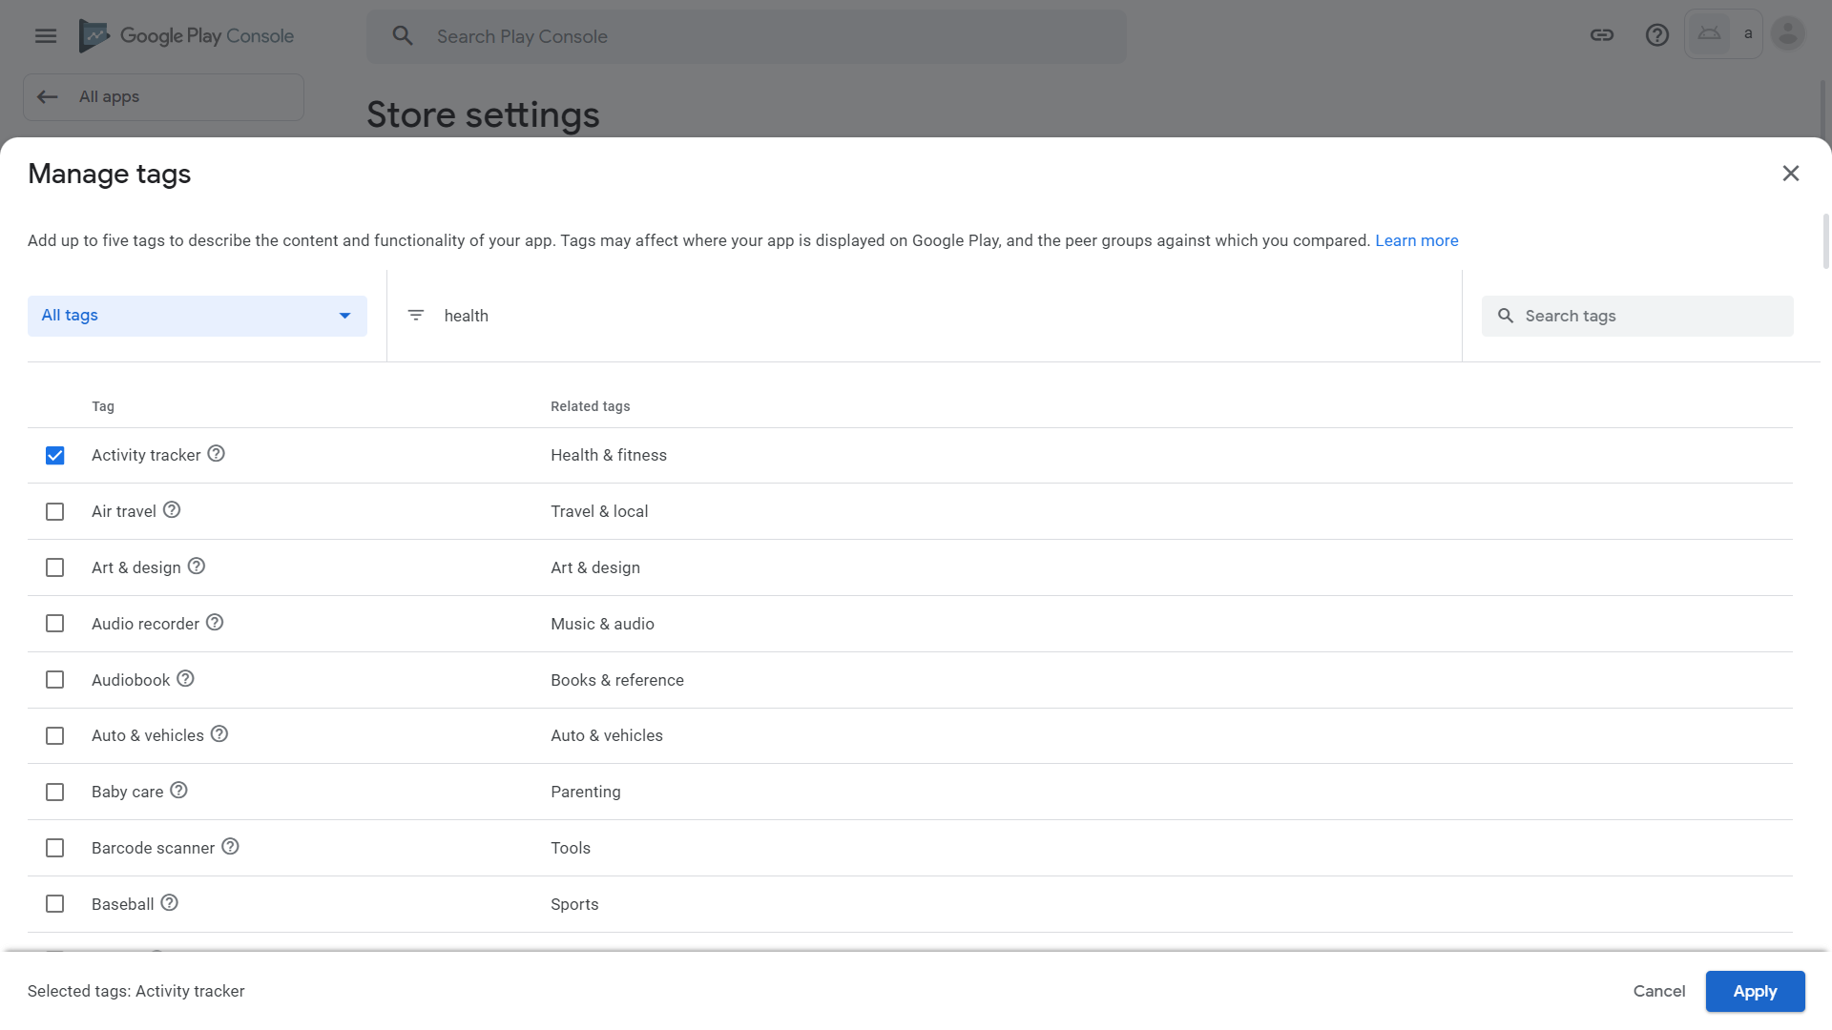
66. Enter an email address for contact. This is shown to users in Google Play. Optionally, enter a phone number and a website for display too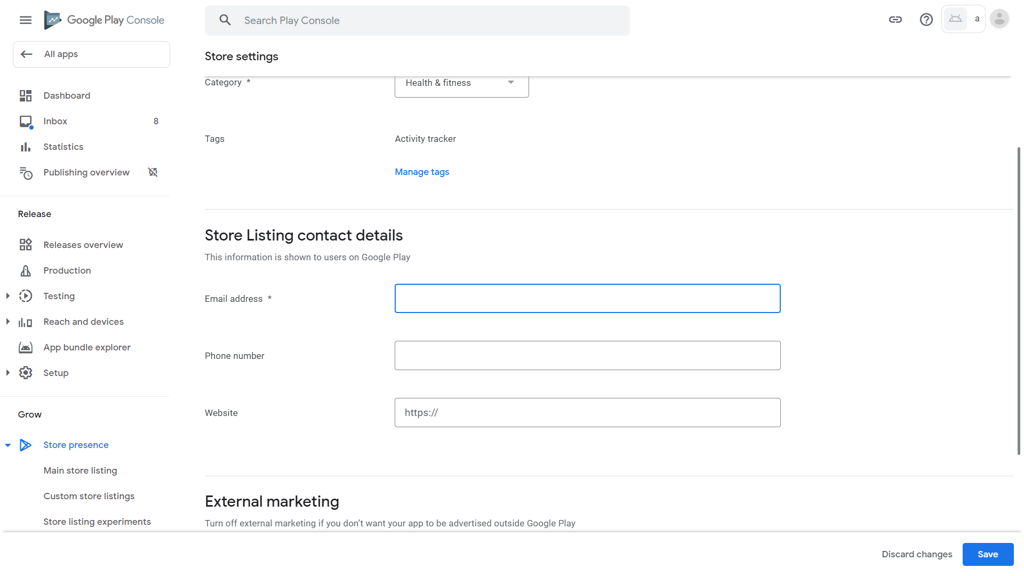
67. Optionally, turn on or off “Advertise my app outside Google Play” by clicking it. Then, click Save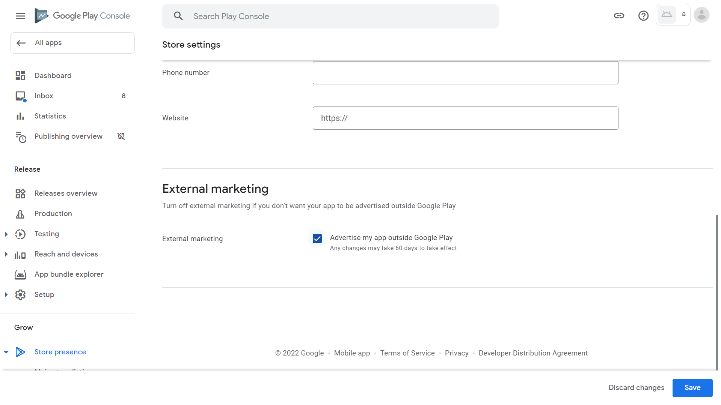
68. Click Dashboard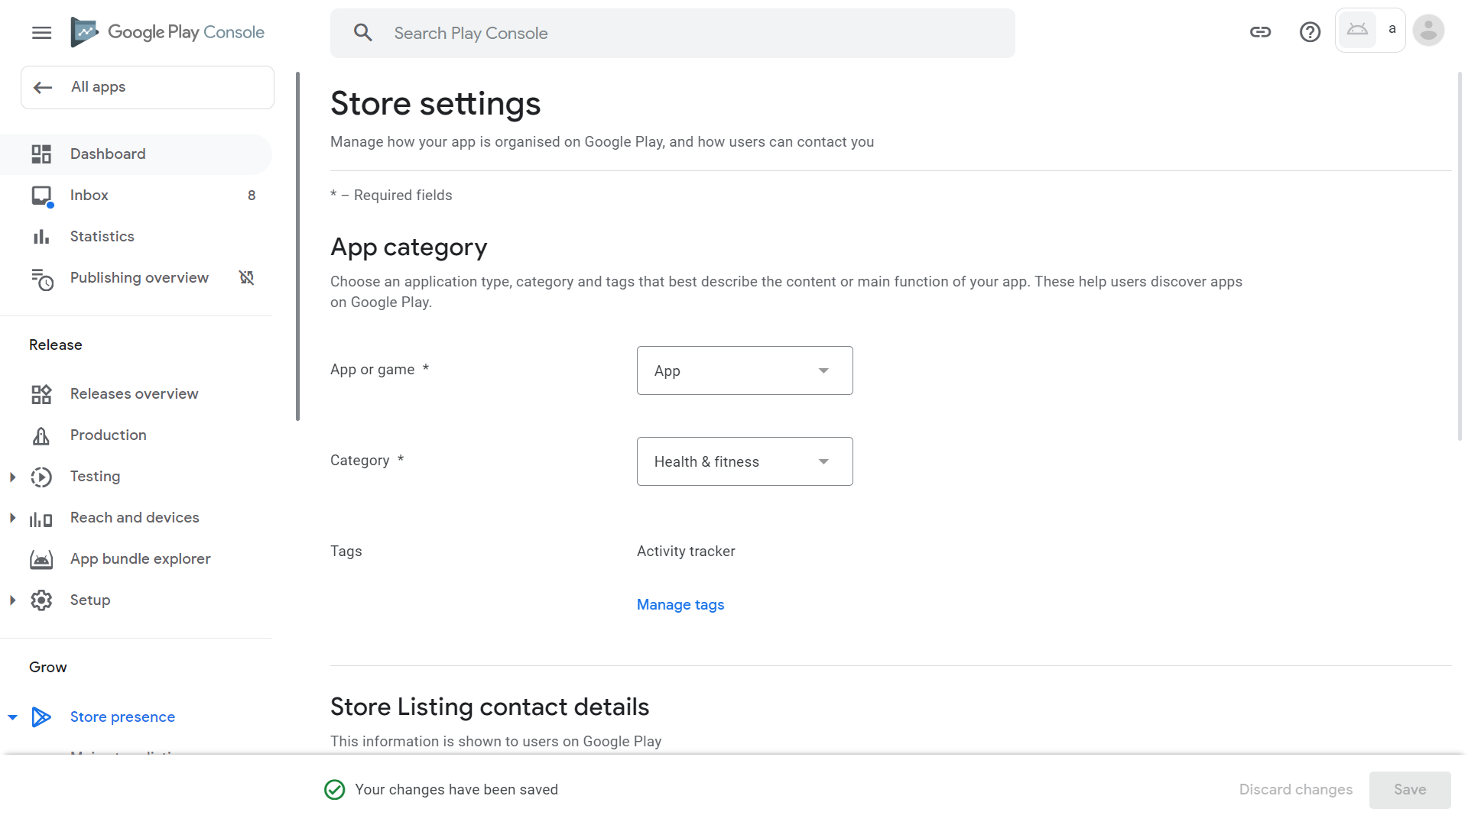
69. Scroll down and click “Set up your Store Listing” 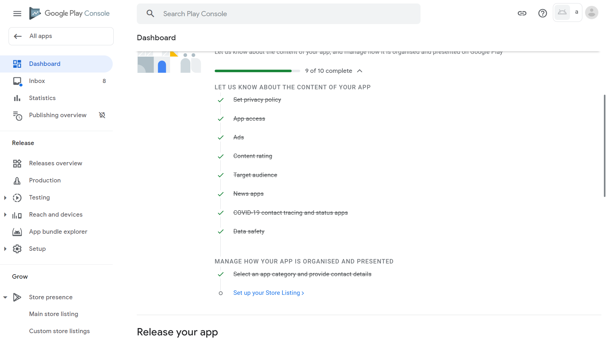
70. Enter “Smart Pedometer” as “App name”, “A pedometer app which can remind you to walk” as “Short description”, and “A pedometer app designed by a student aiming to encourage people walking everyday and keep healthy during the pandemic with a function: a timer to remind you to walk” as “Full description”. Note that these three fields cannot have duplicated content, or Google will just reject your app during review instead of providing an error before submission. 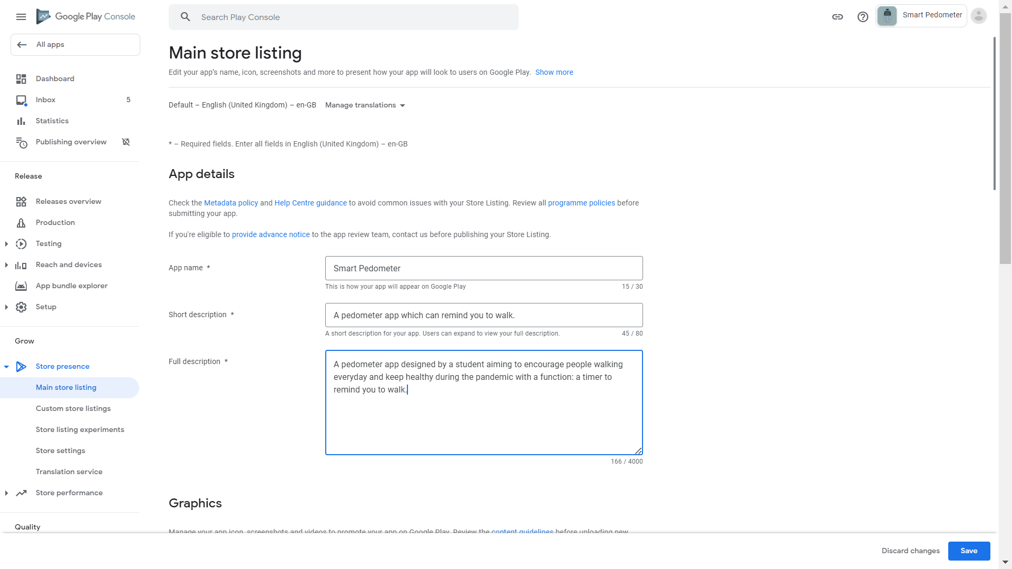
71. Scroll down and click Upload under “App icon”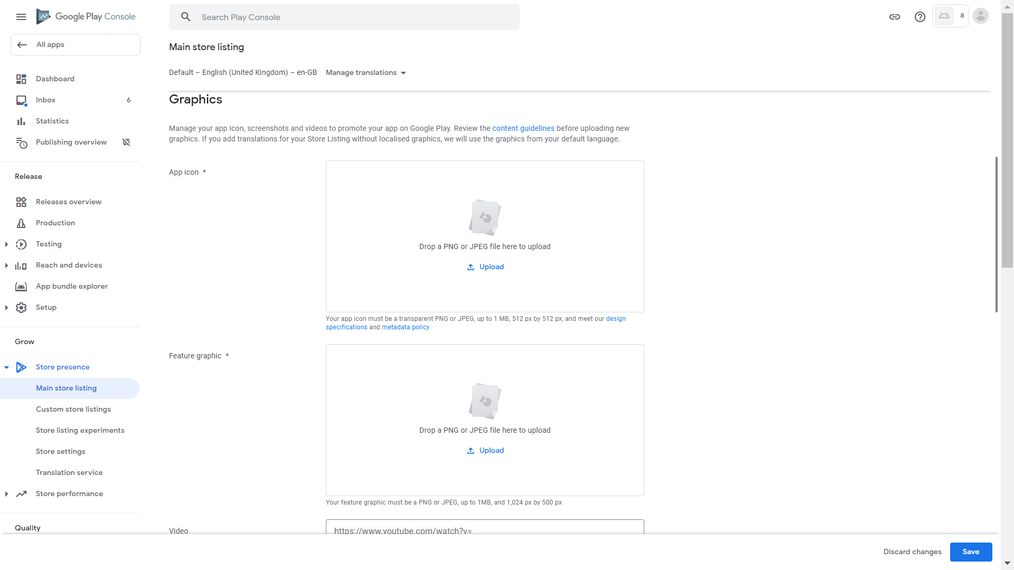
72. We have provided an icon for use here. Paste “%USERPROFILE%/source/repos/PedoApp2/sample” in the address bar of the popup dialog then click the right pointing arrow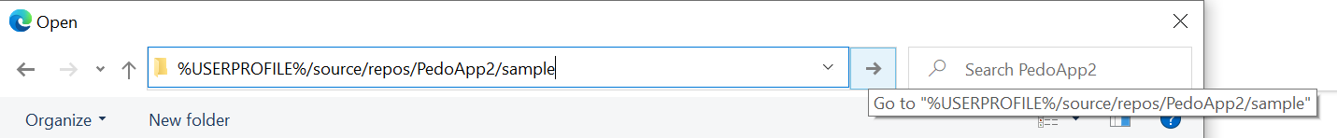
73. Click “icon.png” then click Open (Note that if you provide your own icon, Google requires that “Your app icon must be a transparent PNG or JPEG, up to 1 MB, 512 px by 512 px, and meet our [design specifications](https://developer.android.com/google-play/resources/icon-design-specifications) and [metadata policy](https://support.google.com/googleplay/android-developer/answer/9898842)”)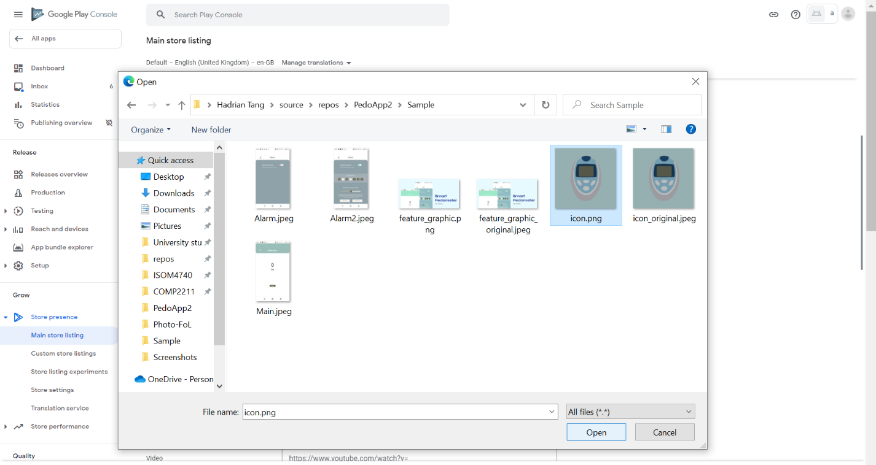
74. Click Upload under “Feature graphic” 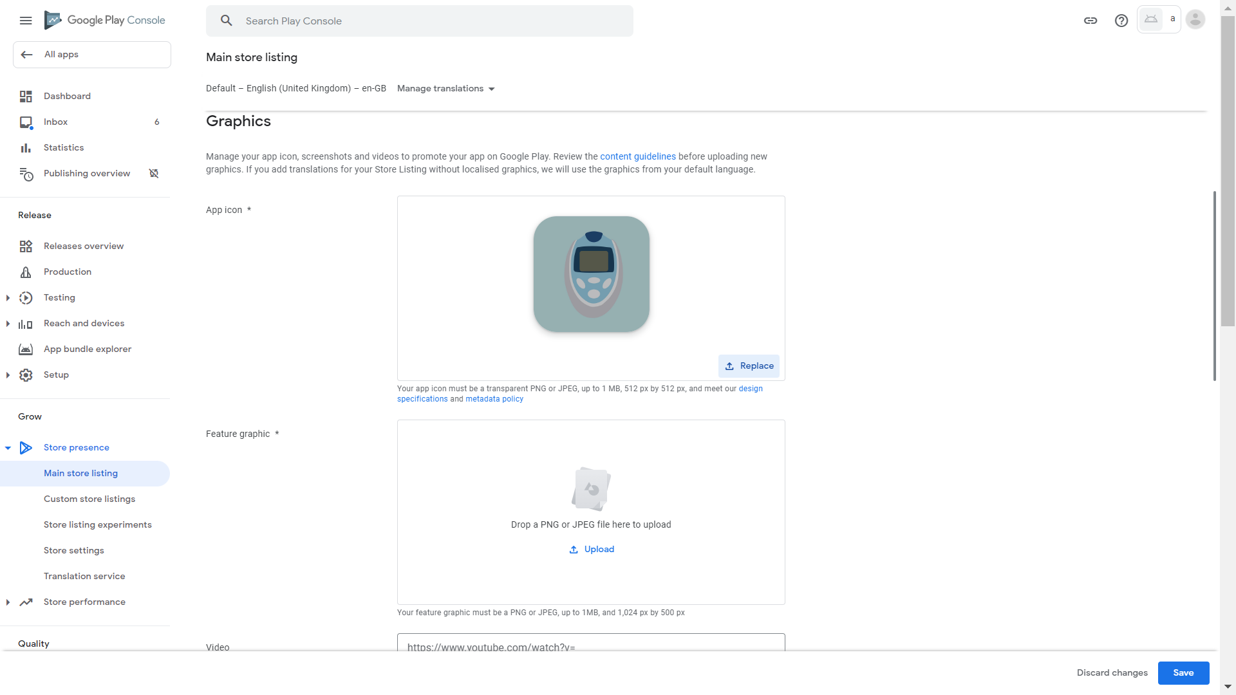
75. Click “feature_graphic.png” then click Open (Note that if you provide your own feature graphic, Google requires that ”Your feature graphic must be a PNG or JPEG, up to 1MB, and 1,024 px by 500 px”)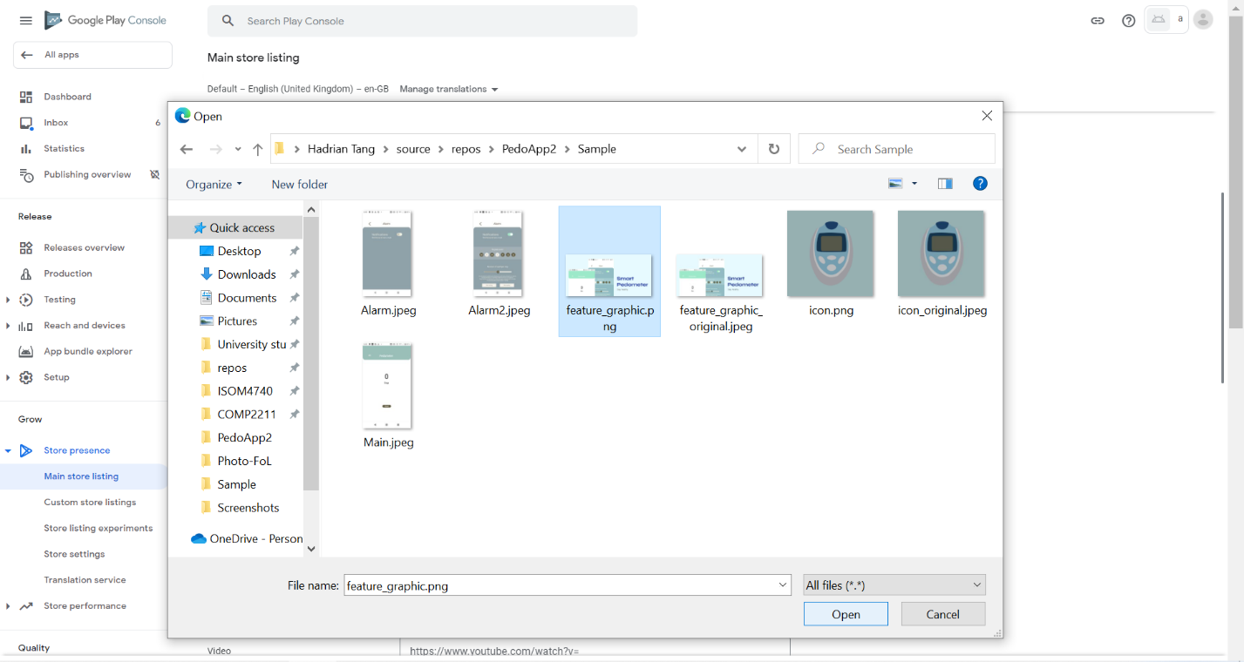
76. Scroll down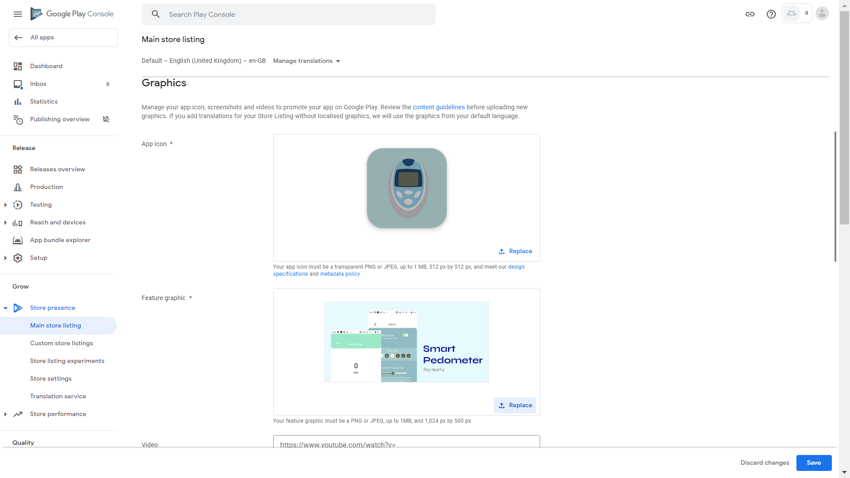
77. Click Upload under “Phone screenshots” 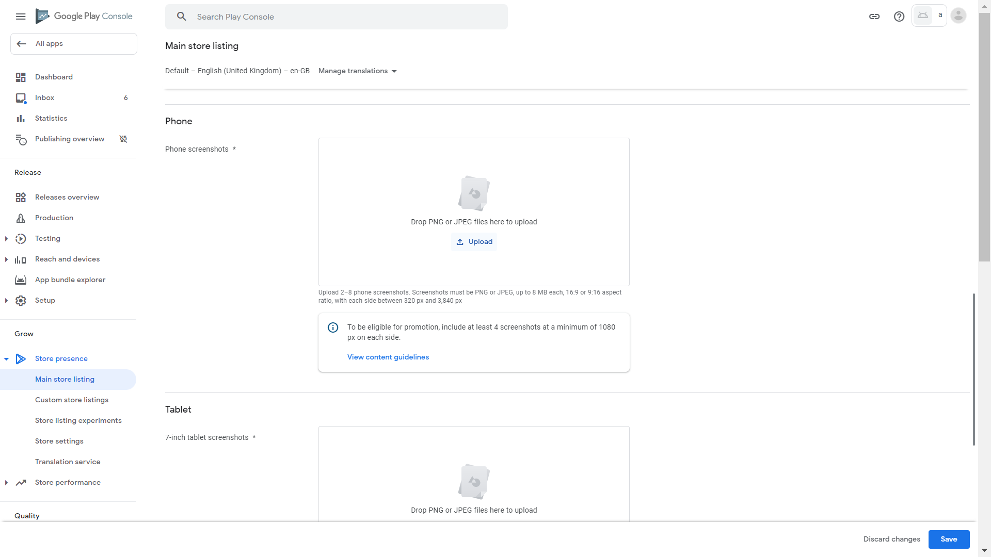
78. Select Main.jpeg, Alarm.jpeg, and Alarm2.jpeg (Or collect your own screenshots and select them instead) 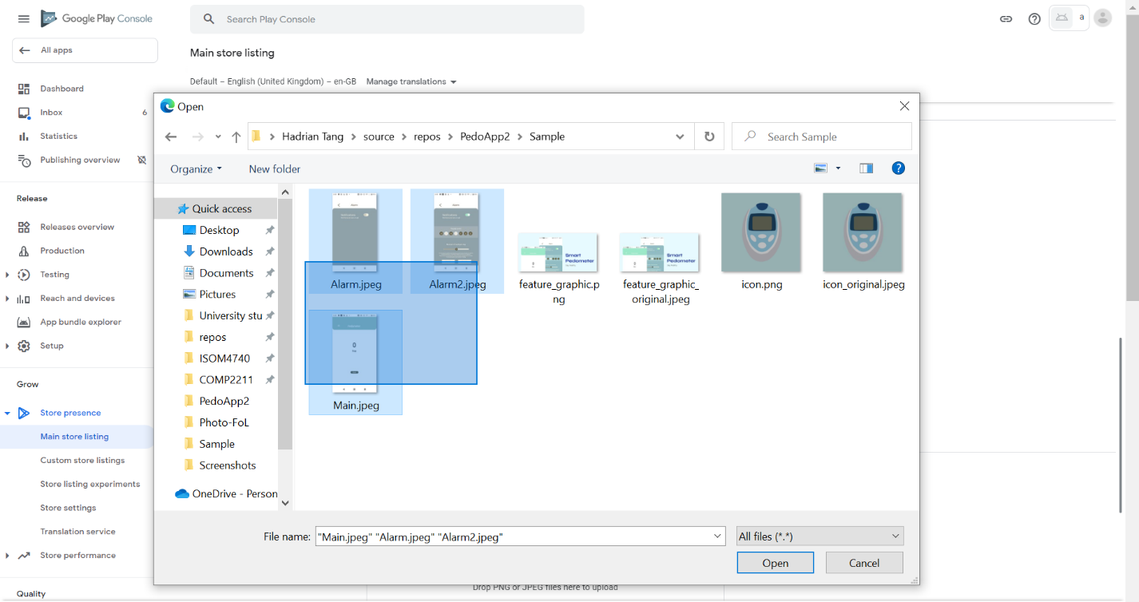
79. Click Open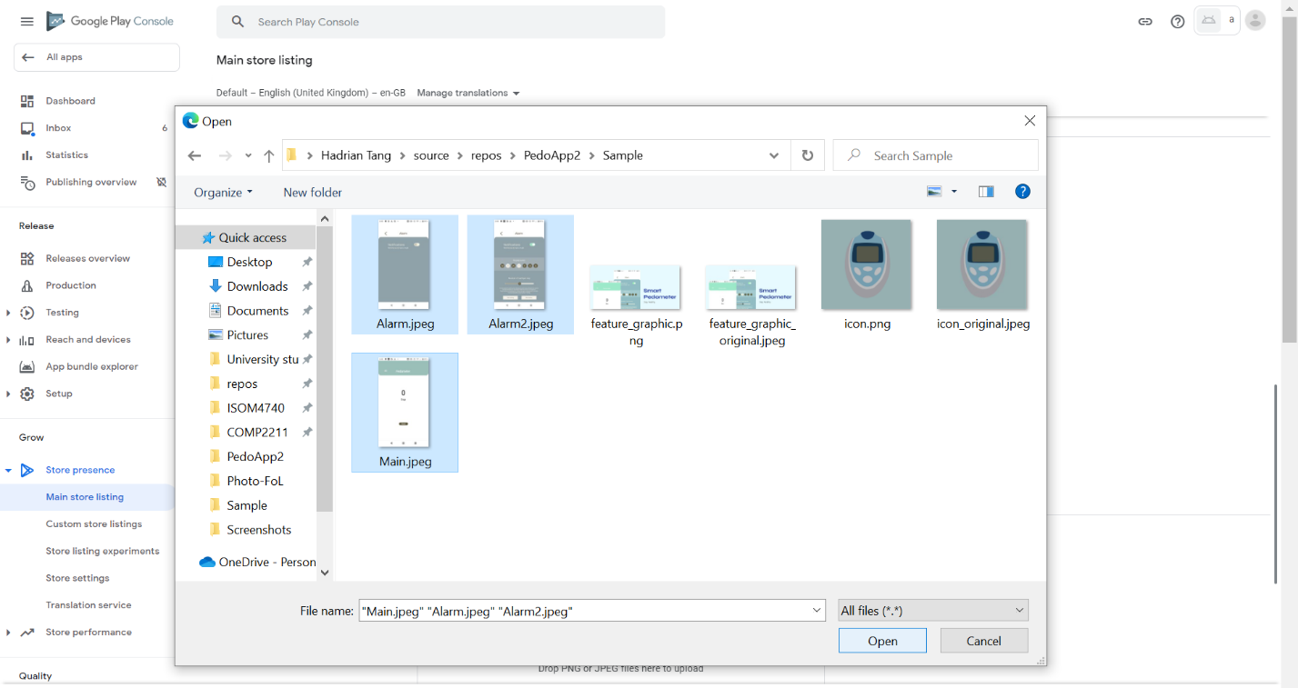
80. Wait for upload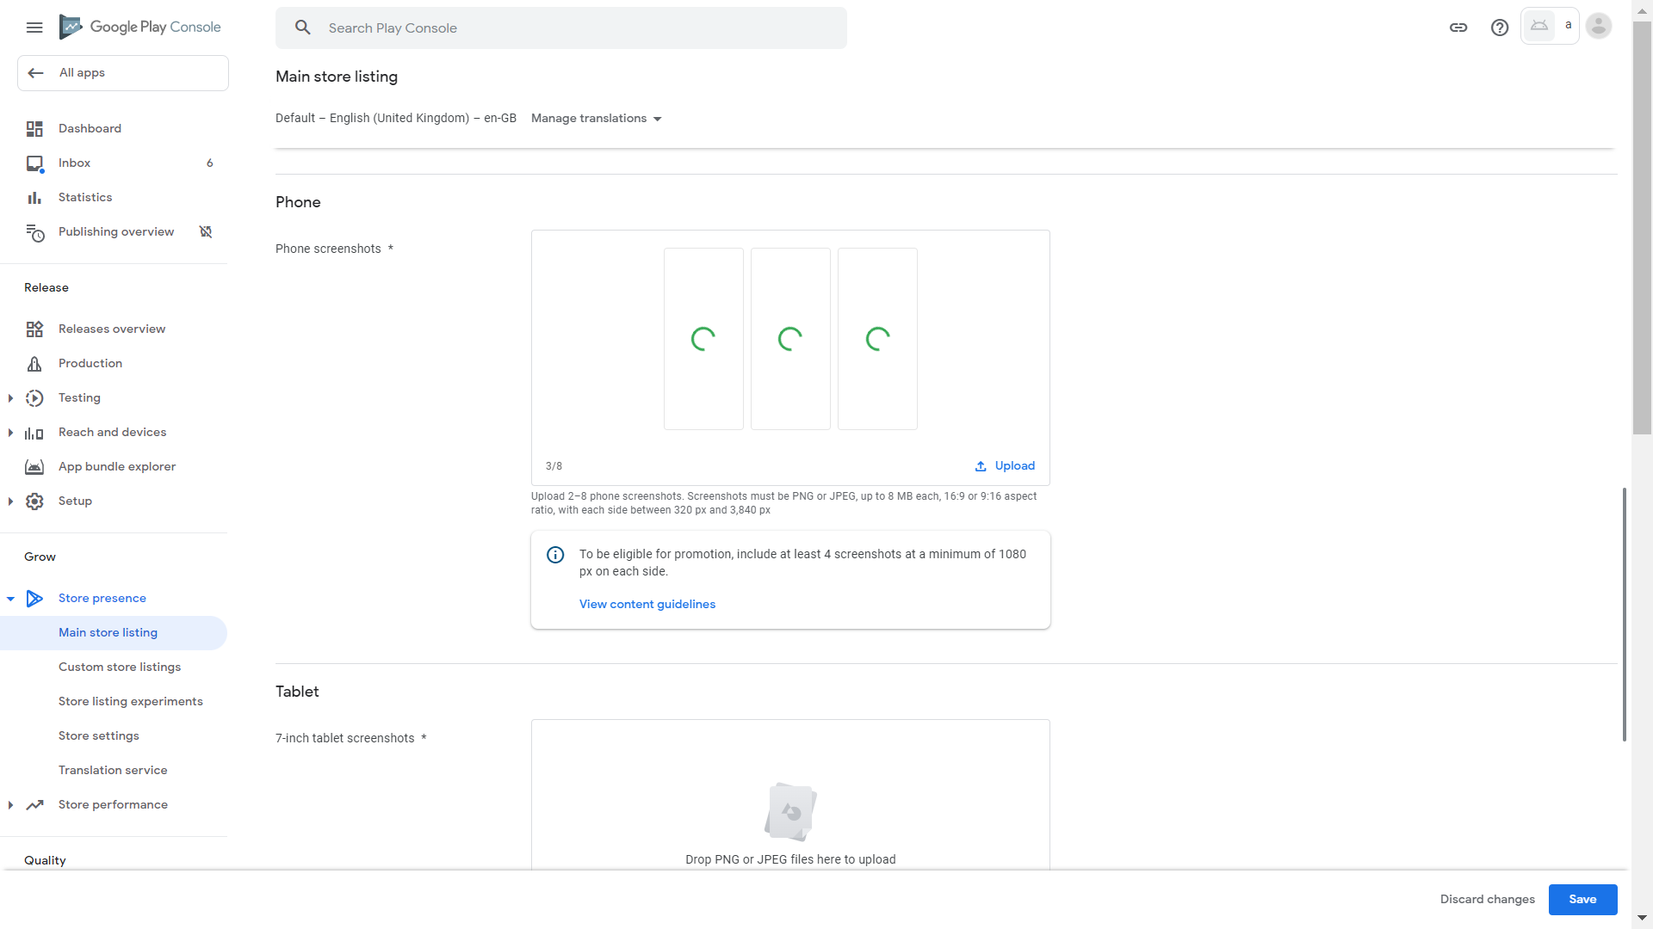
81. The screenshots have been uploaded successfully. Press and hold the left mouse button on Main.jpeg (or your own screenshot which appeared in the wrong order)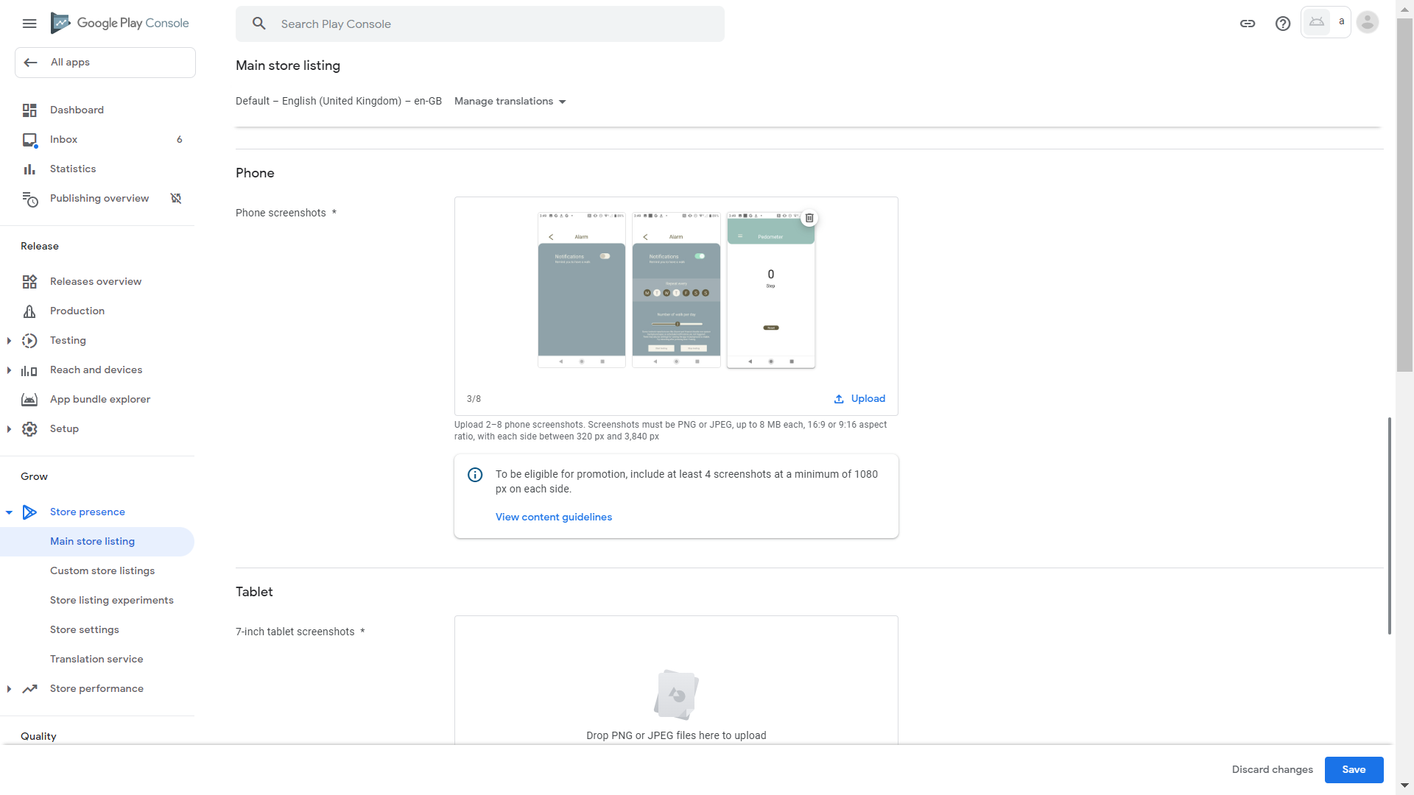
82. Drag it to the left (or the correct location of your own screenshot, then repeat these steps to make your screenshots appear in the correct order) 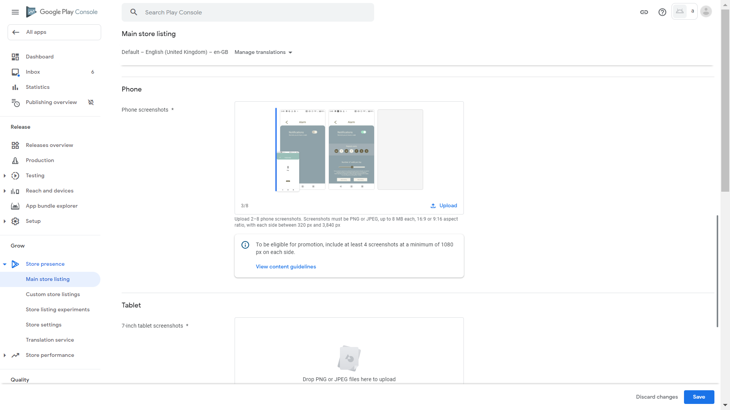
83. Scroll down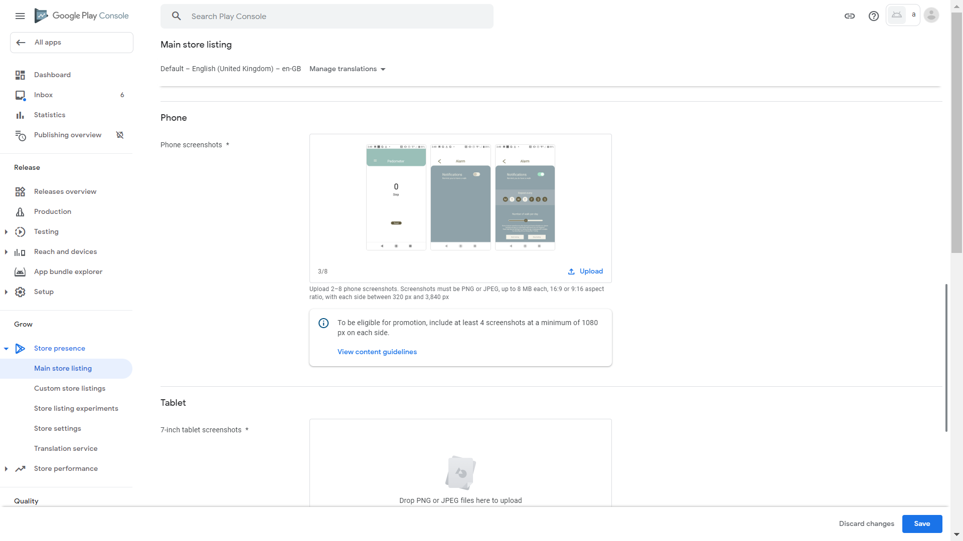
84. Click Upload under “7-inch tablet screenshots” 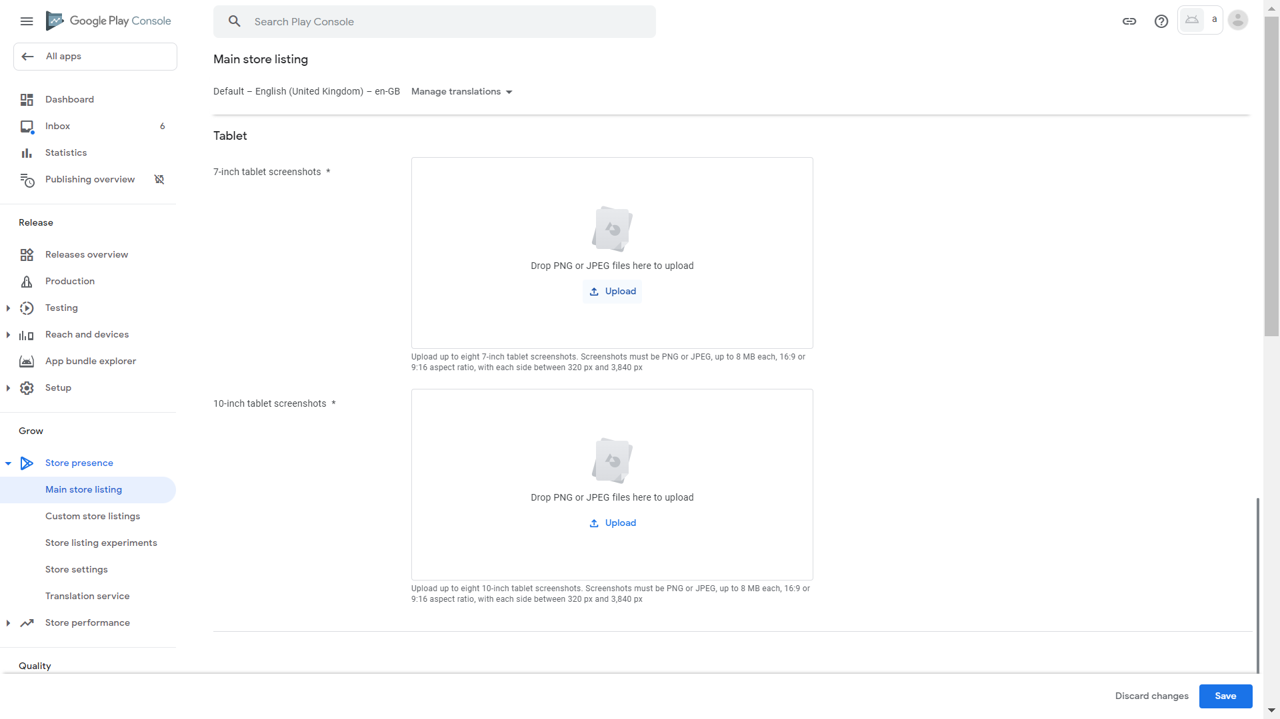
85. Internet resources indicate that we can just supply phone screenshots for tablet screenshots. Screenshots of different device types are displayed when Google Play Store is opened on different devices, matching the device used. We can just select the same files as used in phone screenshots (or tablet screenshots supplied by yourself)
86. Click Open
87. Wait for upload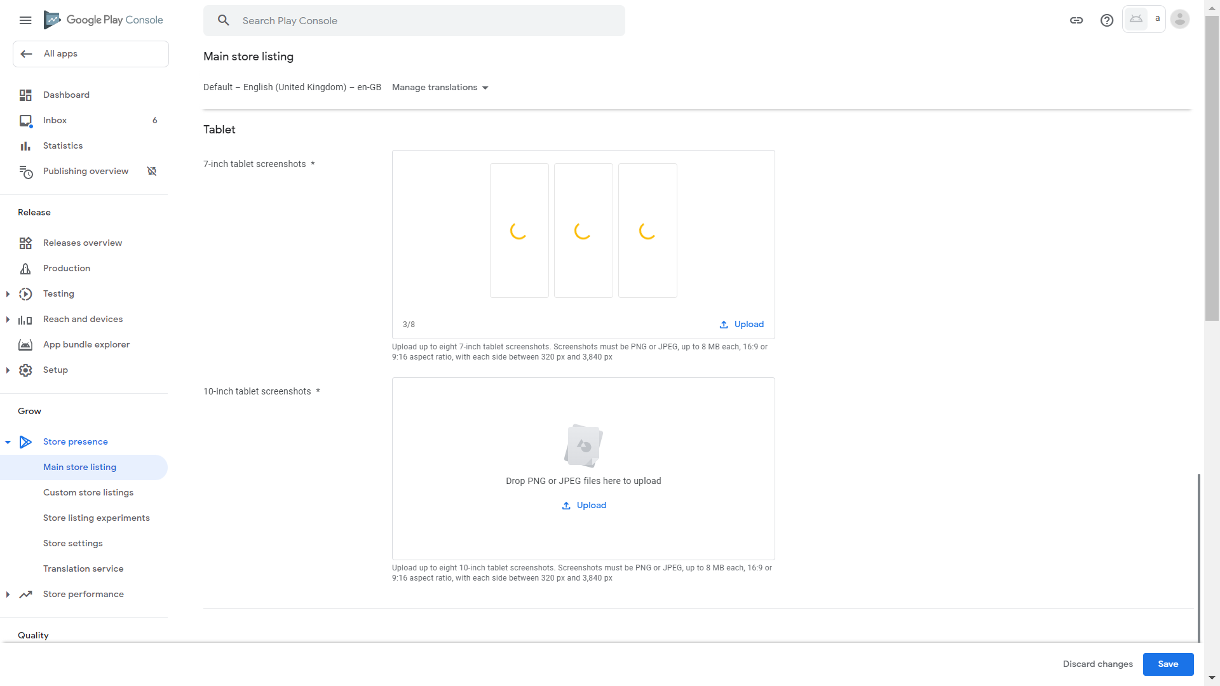
88. The screenshots have been uploaded successfully. Press and hold the left mouse button on Main.jpeg (or your own screenshot which appeared in the wrong order) 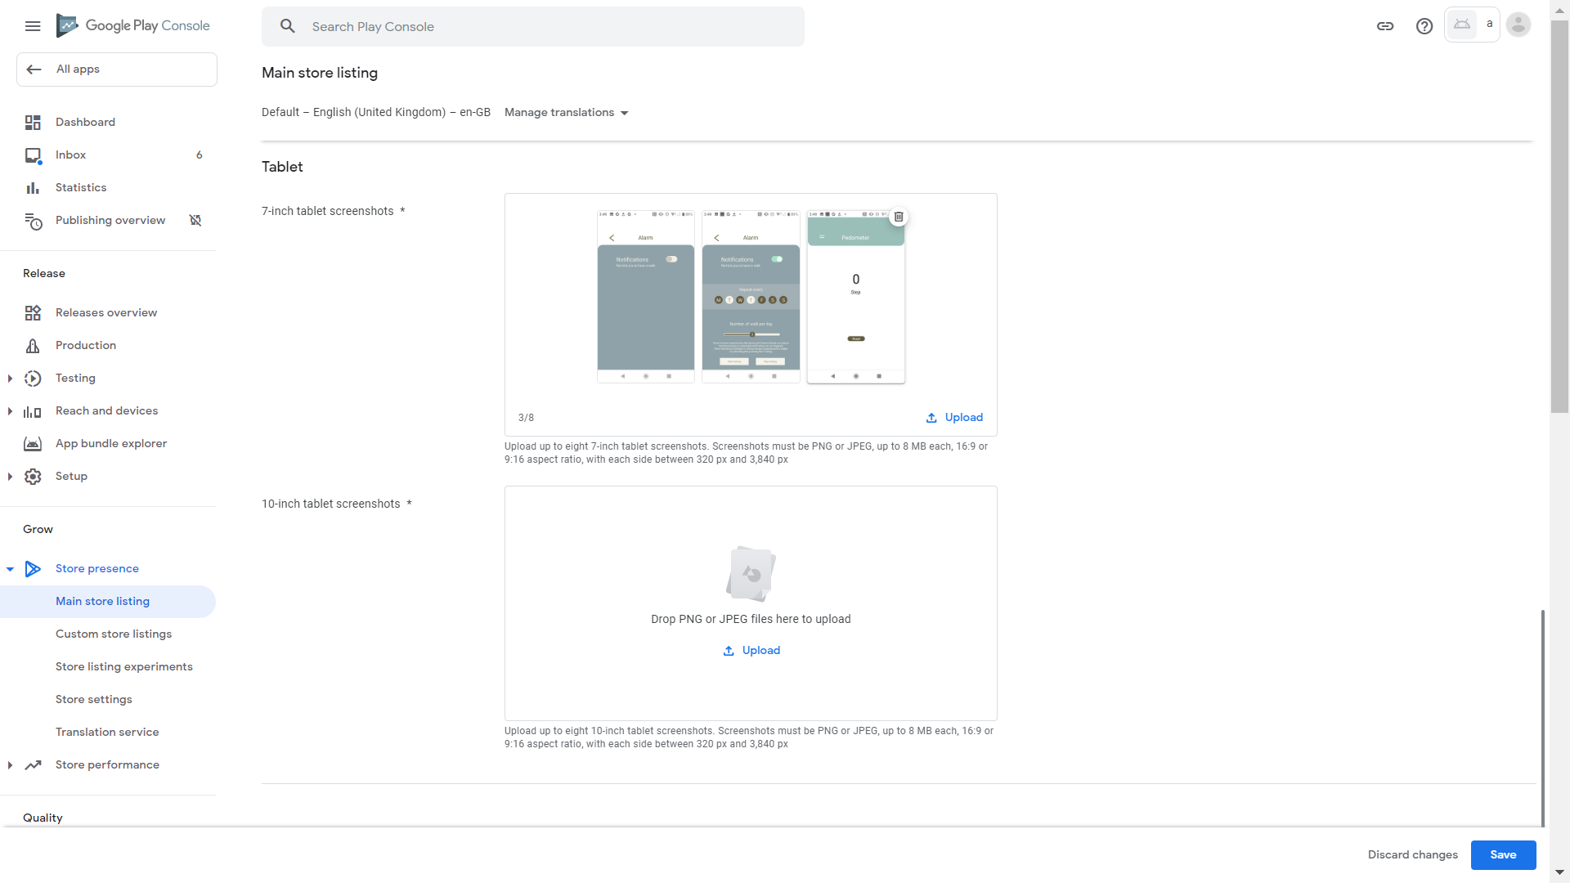
89. Drag it to the left (or the correct location of your own screenshot, then repeat these steps to make your screenshots appear in the correct order) 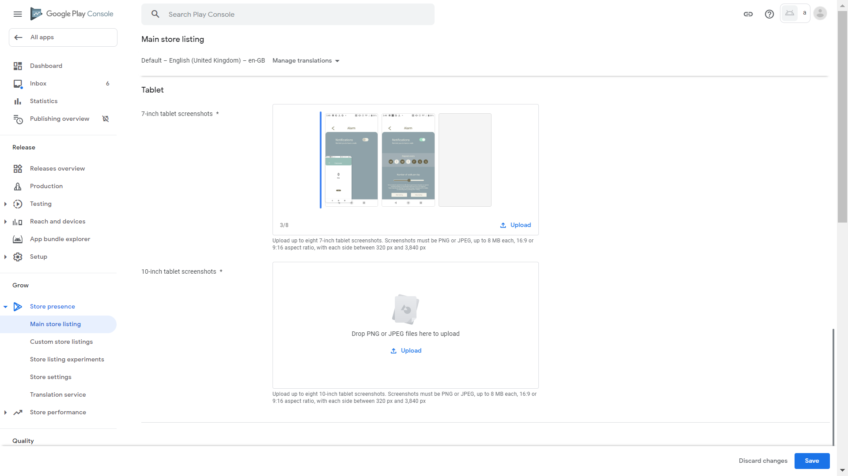.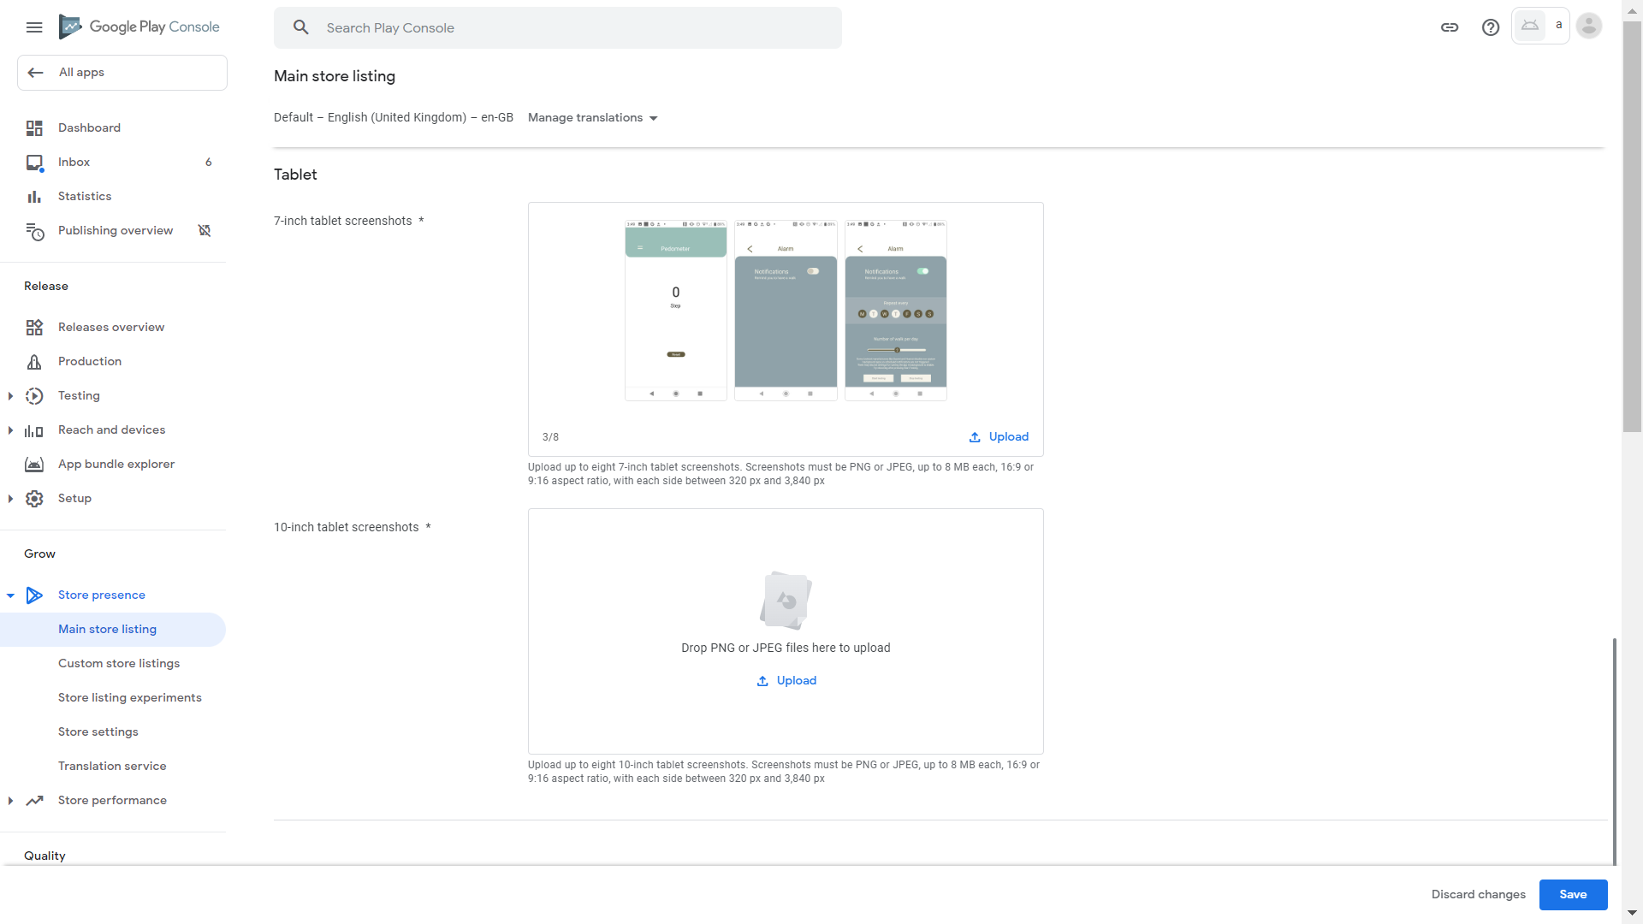
90. Click Upload under “10-inch tablet screenshots” 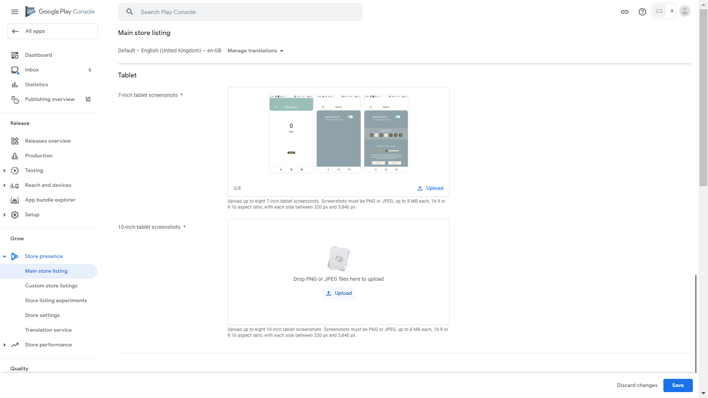
91. Internet resources indicate that we can just supply phone screenshots for tablet screenshots. Screenshots of different device types are displayed when Google Play Store is opened on different devices, matching the device used. We can just select the same files as used in phone screenshots (or tablet screenshots supplied by yourself) 
92. Click Open
93. Wait for upload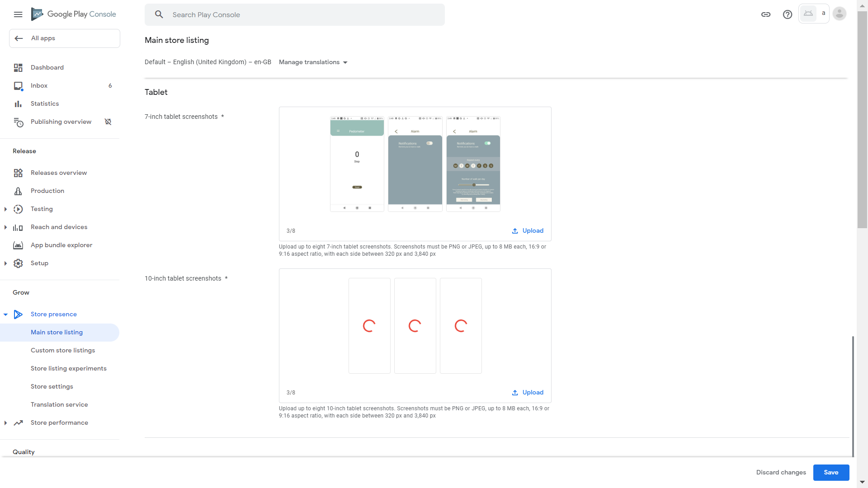
94. The screenshots have been uploaded successfully. Press and hold the left mouse button on Main.jpeg (or your own screenshot which appeared in the wrong order)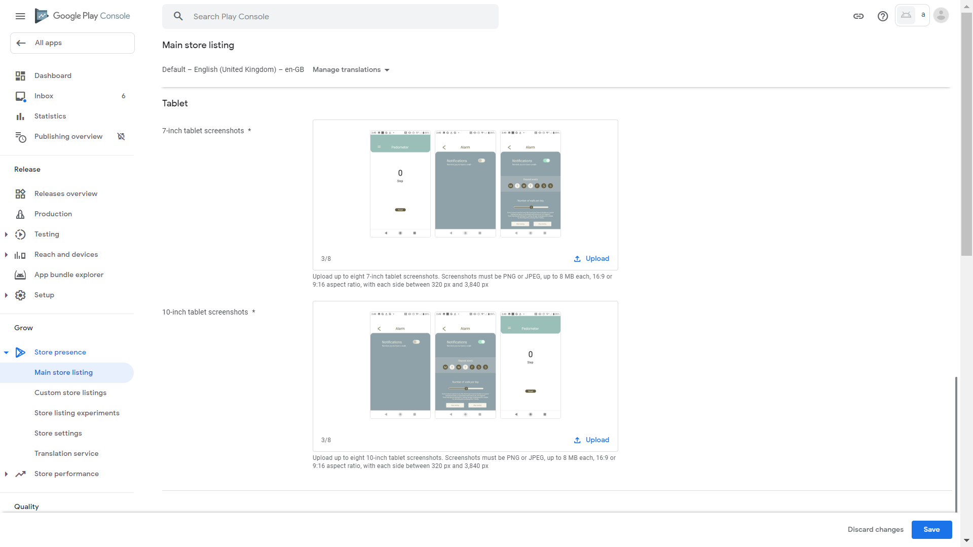. 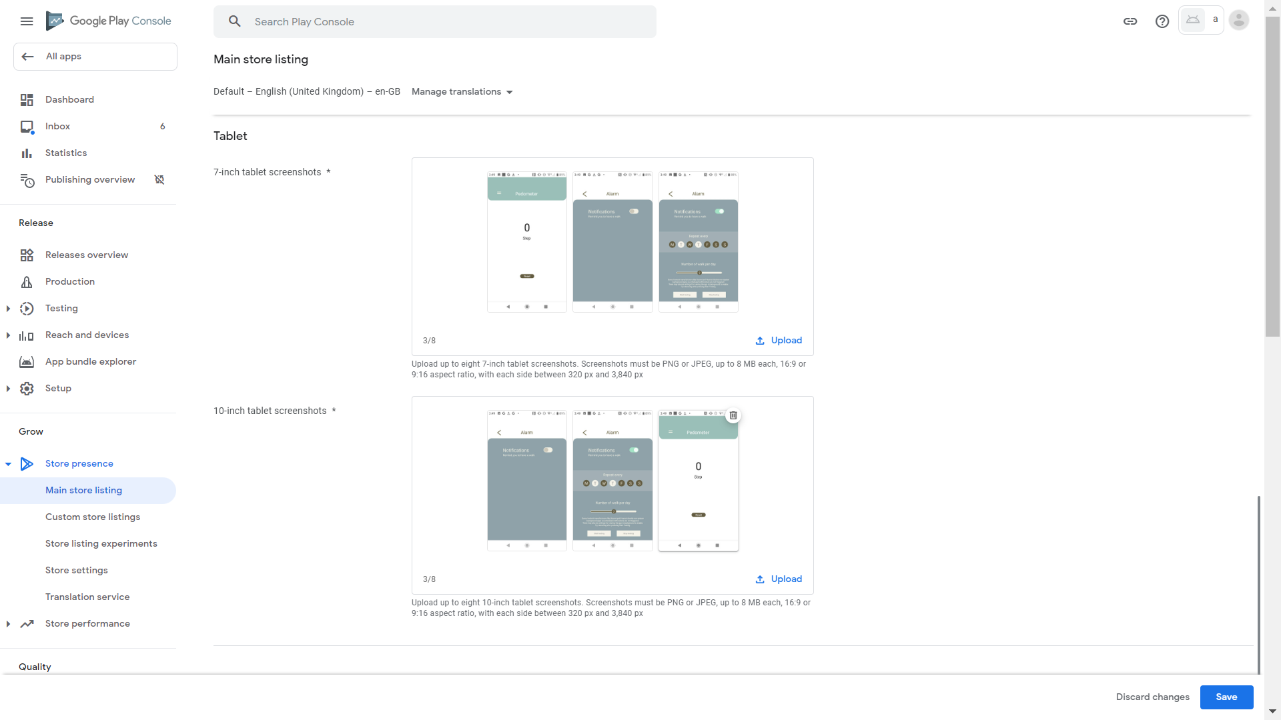
95. Drag it to the left (or the correct location of your own screenshot, then repeat these steps to make your screenshots appear in the correct order) 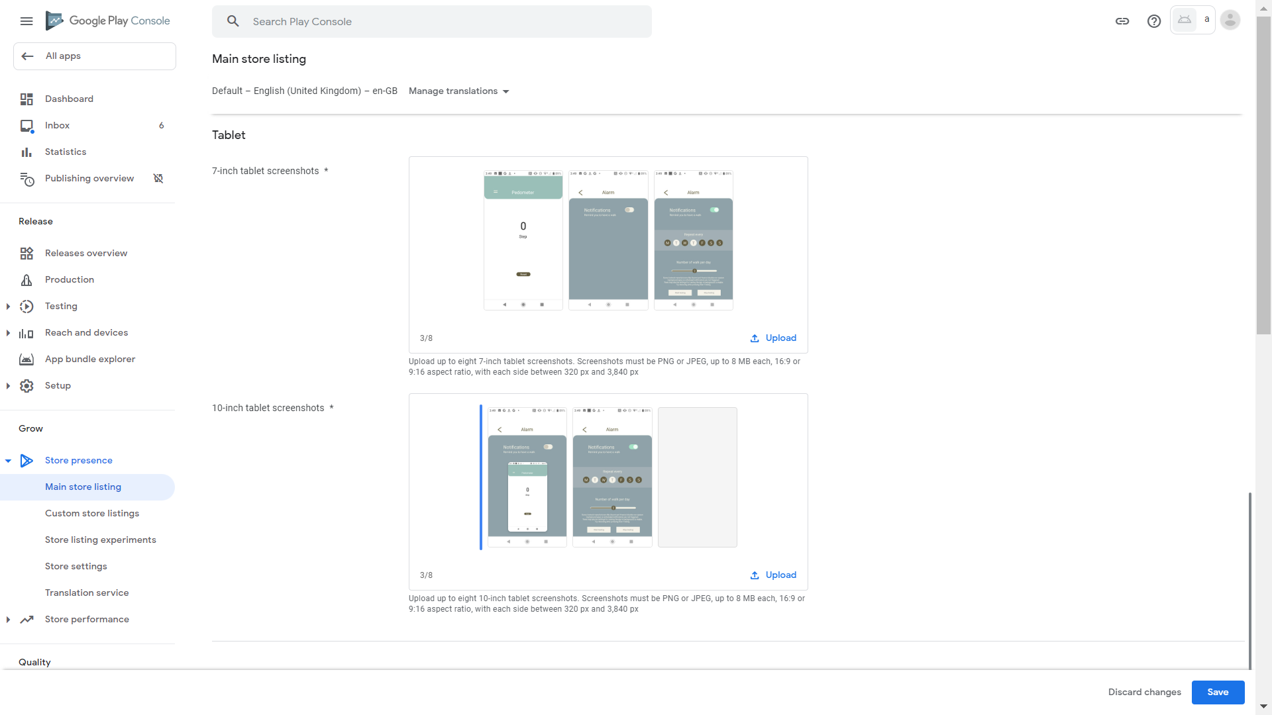
96. Click Save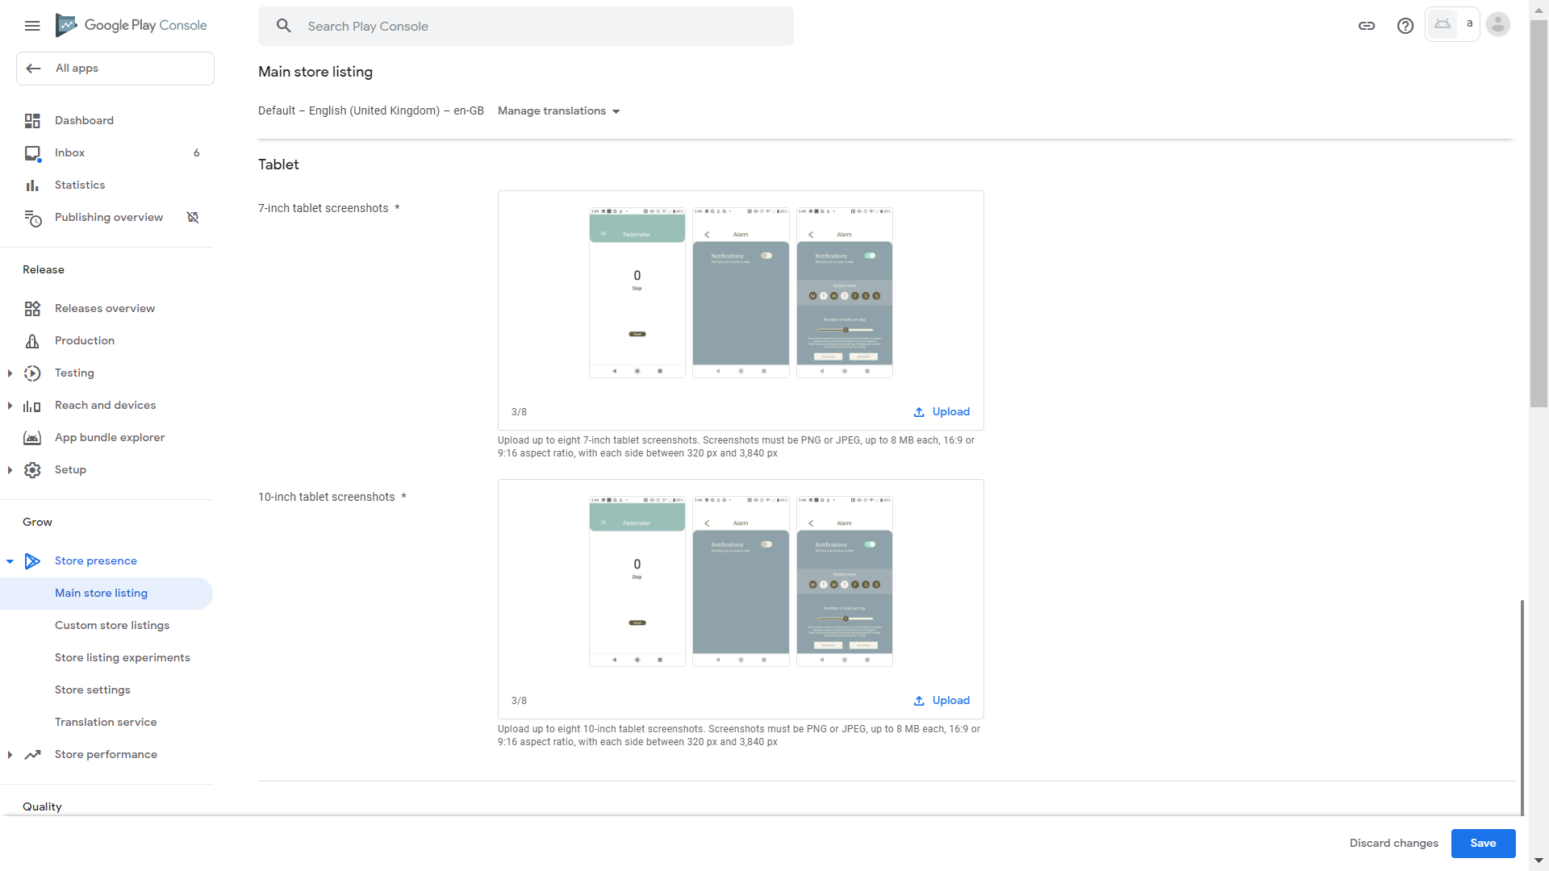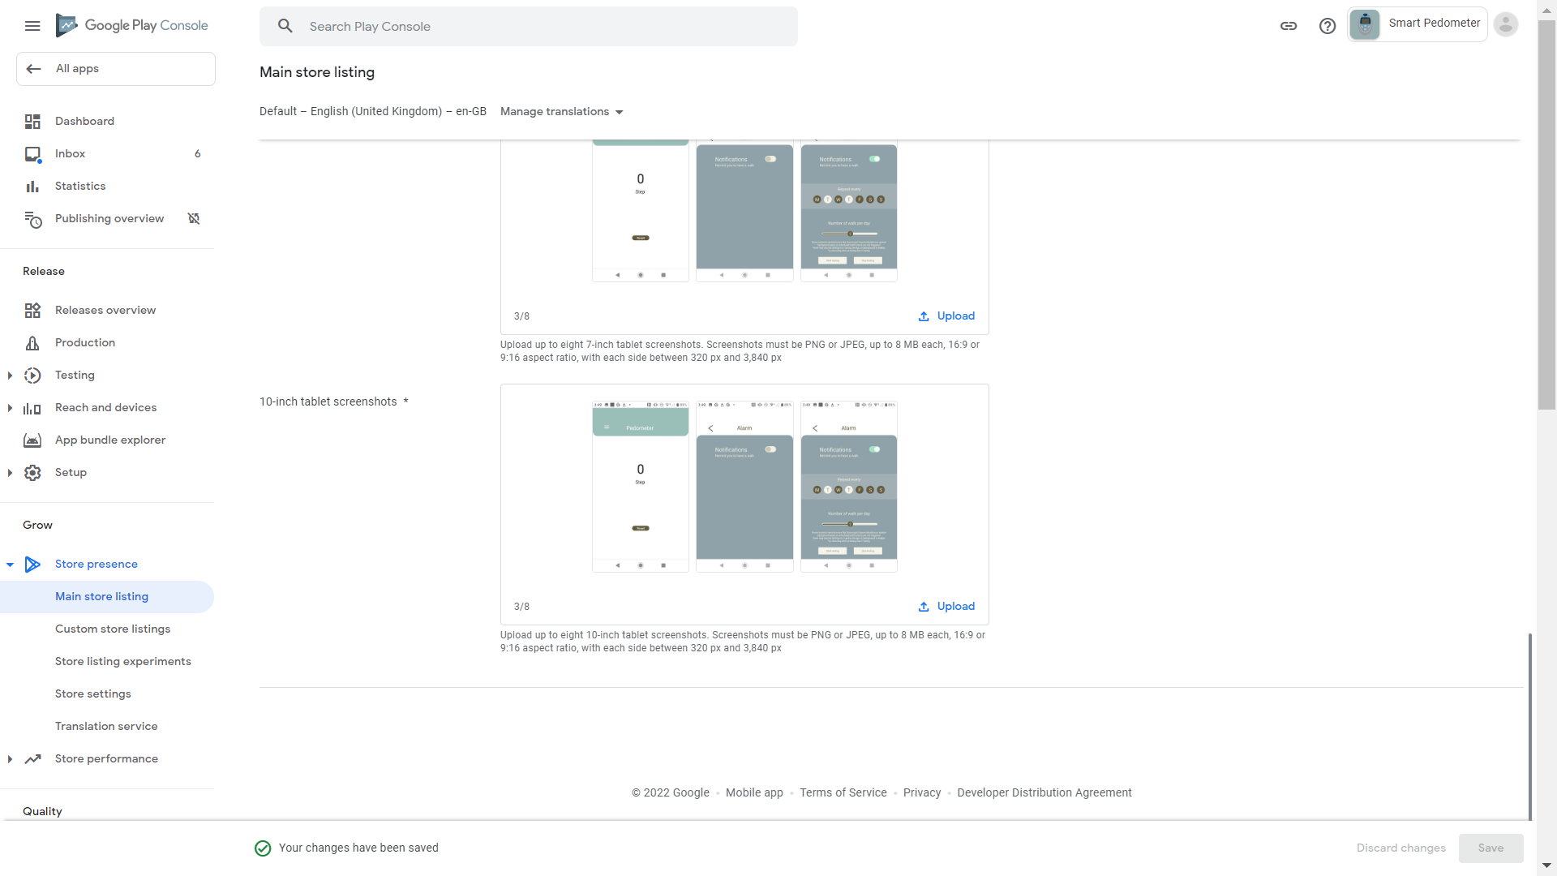
97. Click Dashboard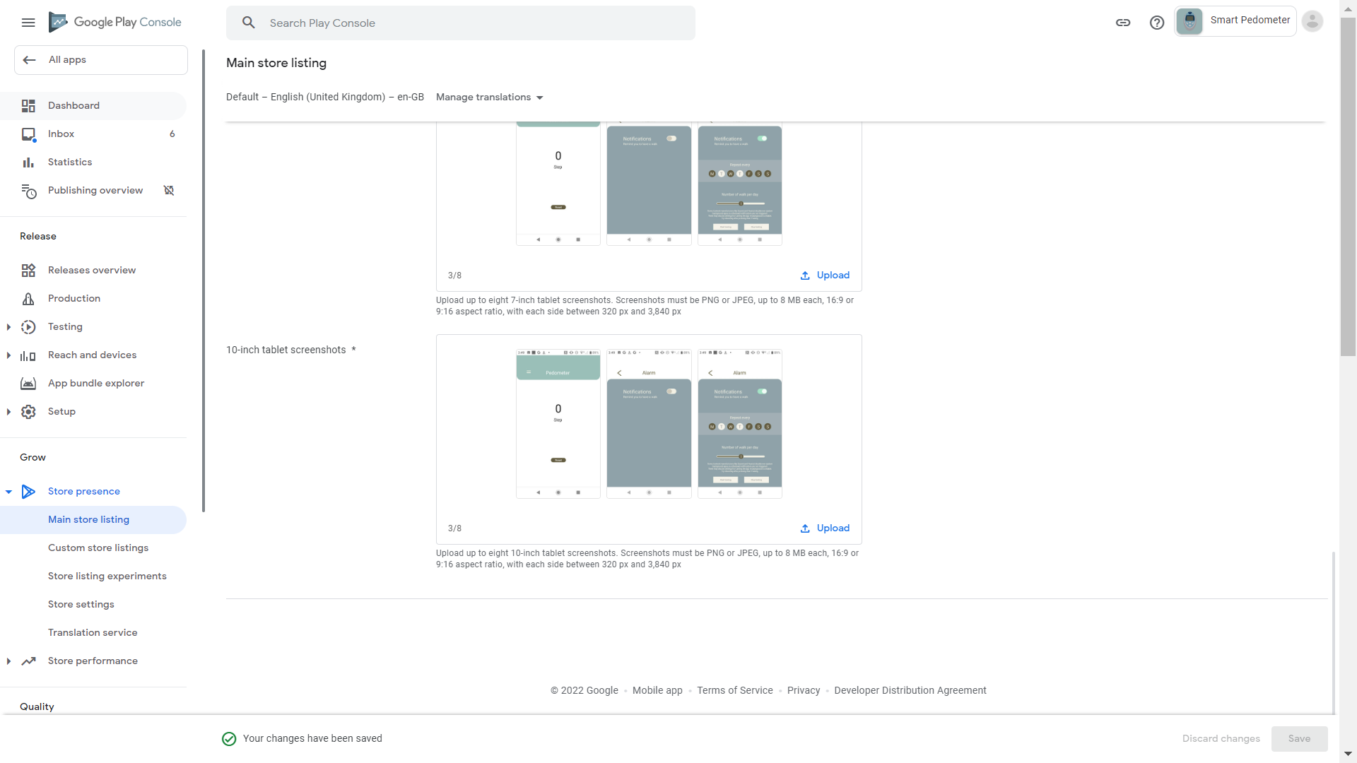
98. Scroll down then click “View tasks” under “Publish your app on Google Play” 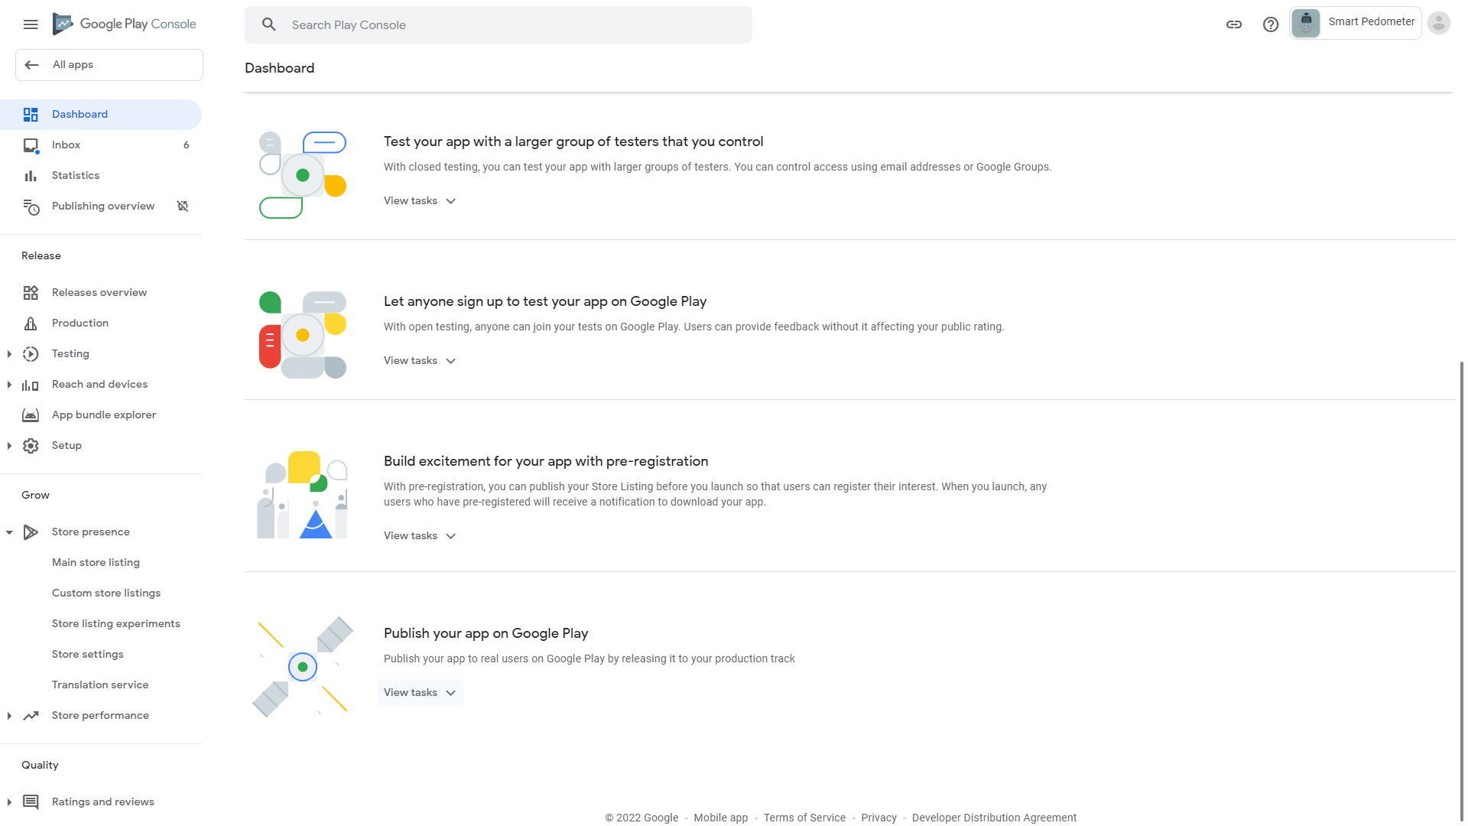
99. Click “Select countries and regions” 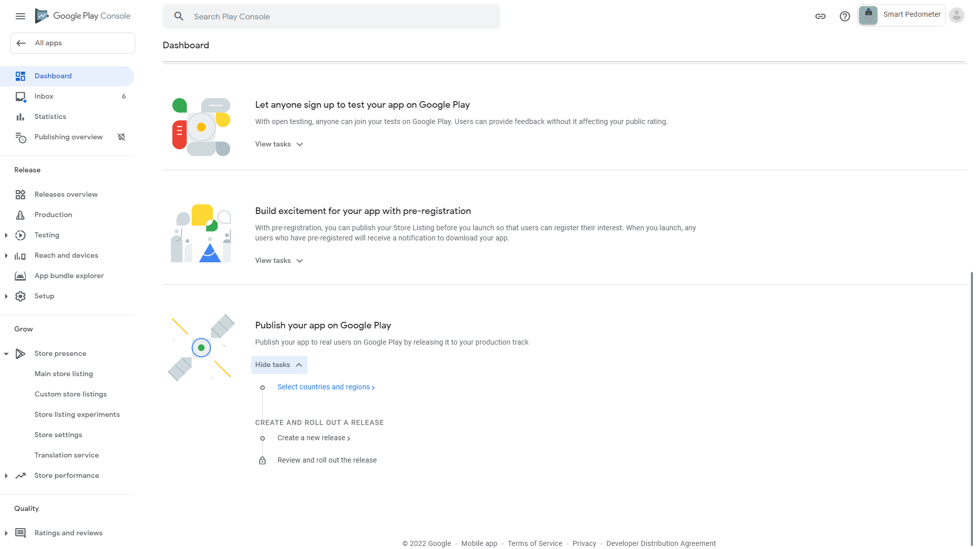
100. Click “Add countries/regions”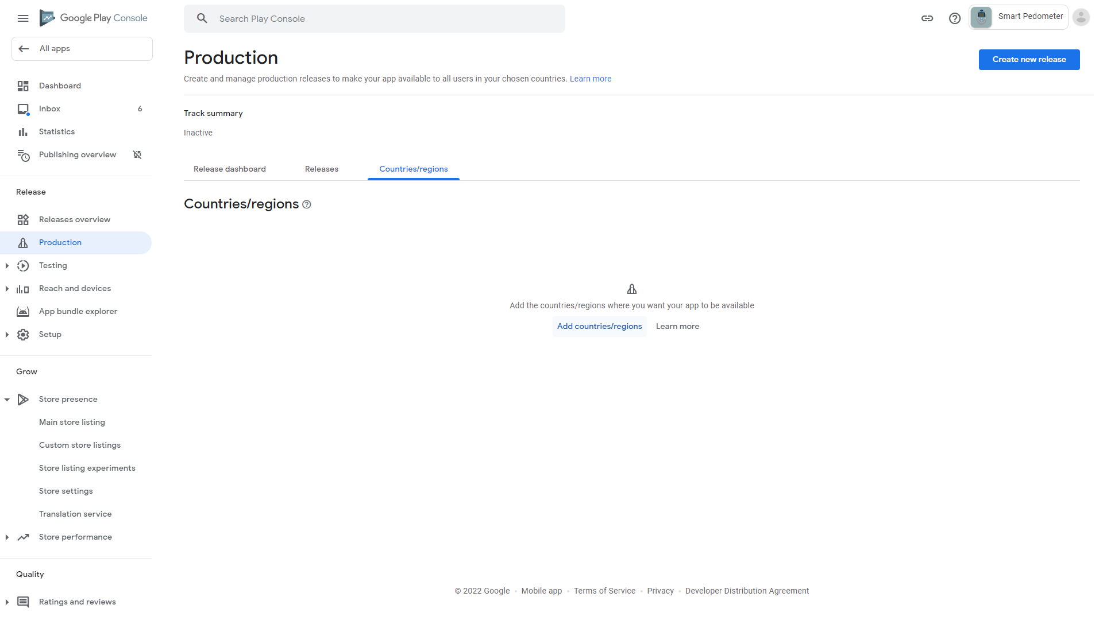
101. Click “Country/region” at the top to check all countries because we don’t limit what countries our app can appear in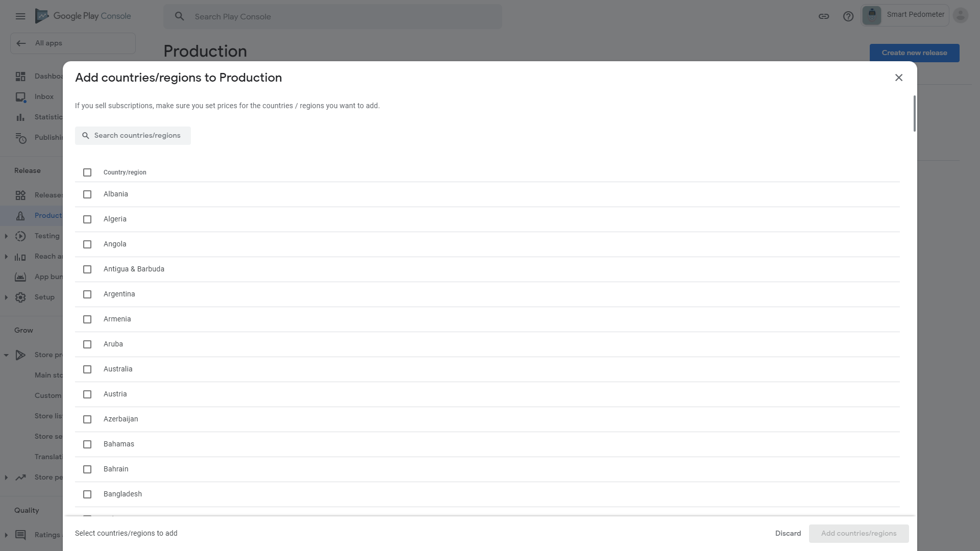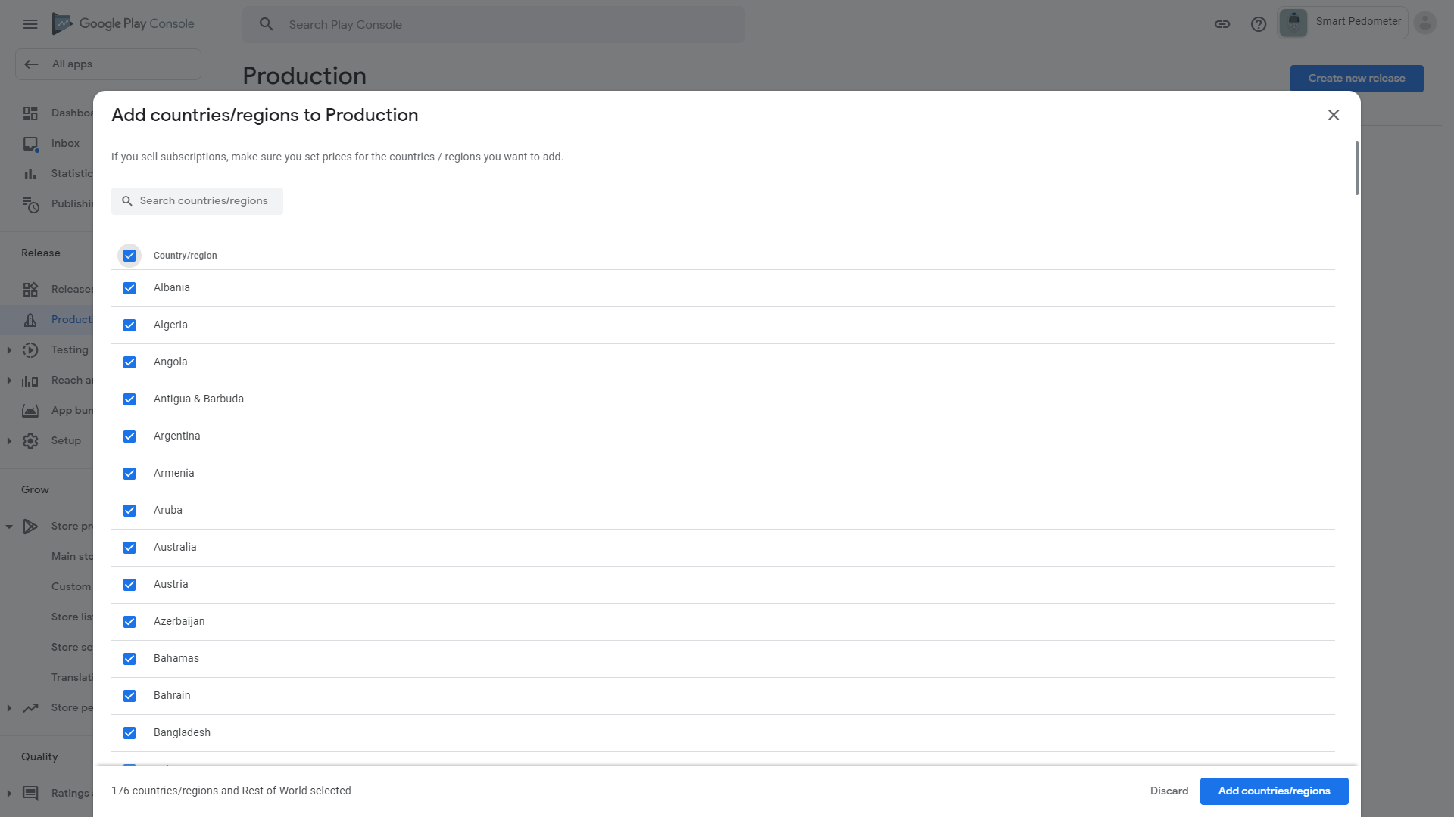
102. Click “Add countries/regions” 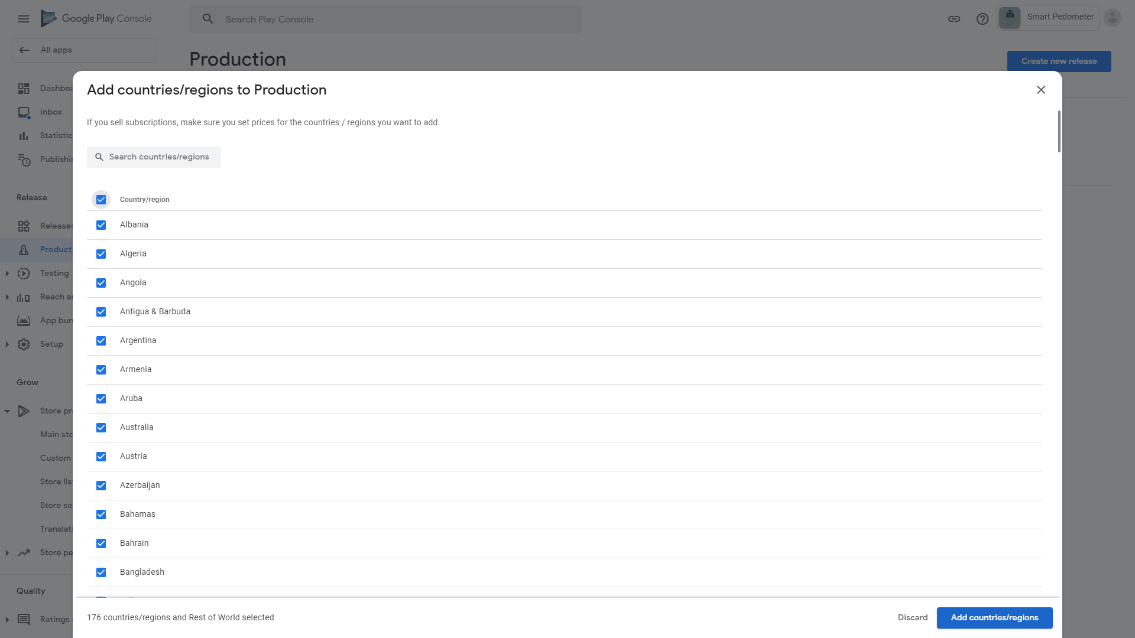
103. Click Add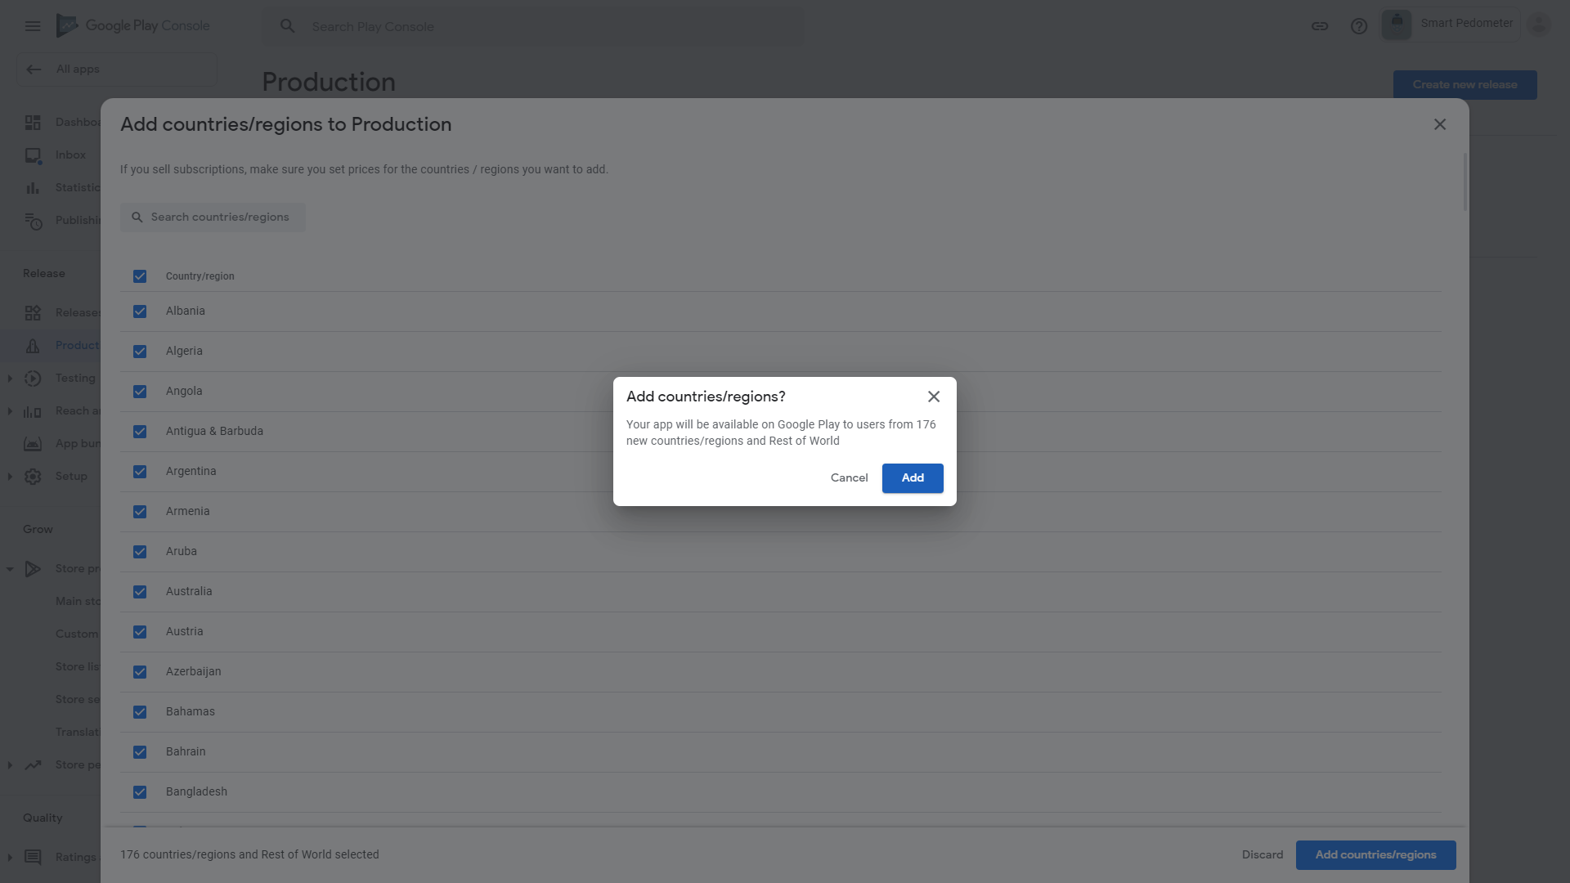.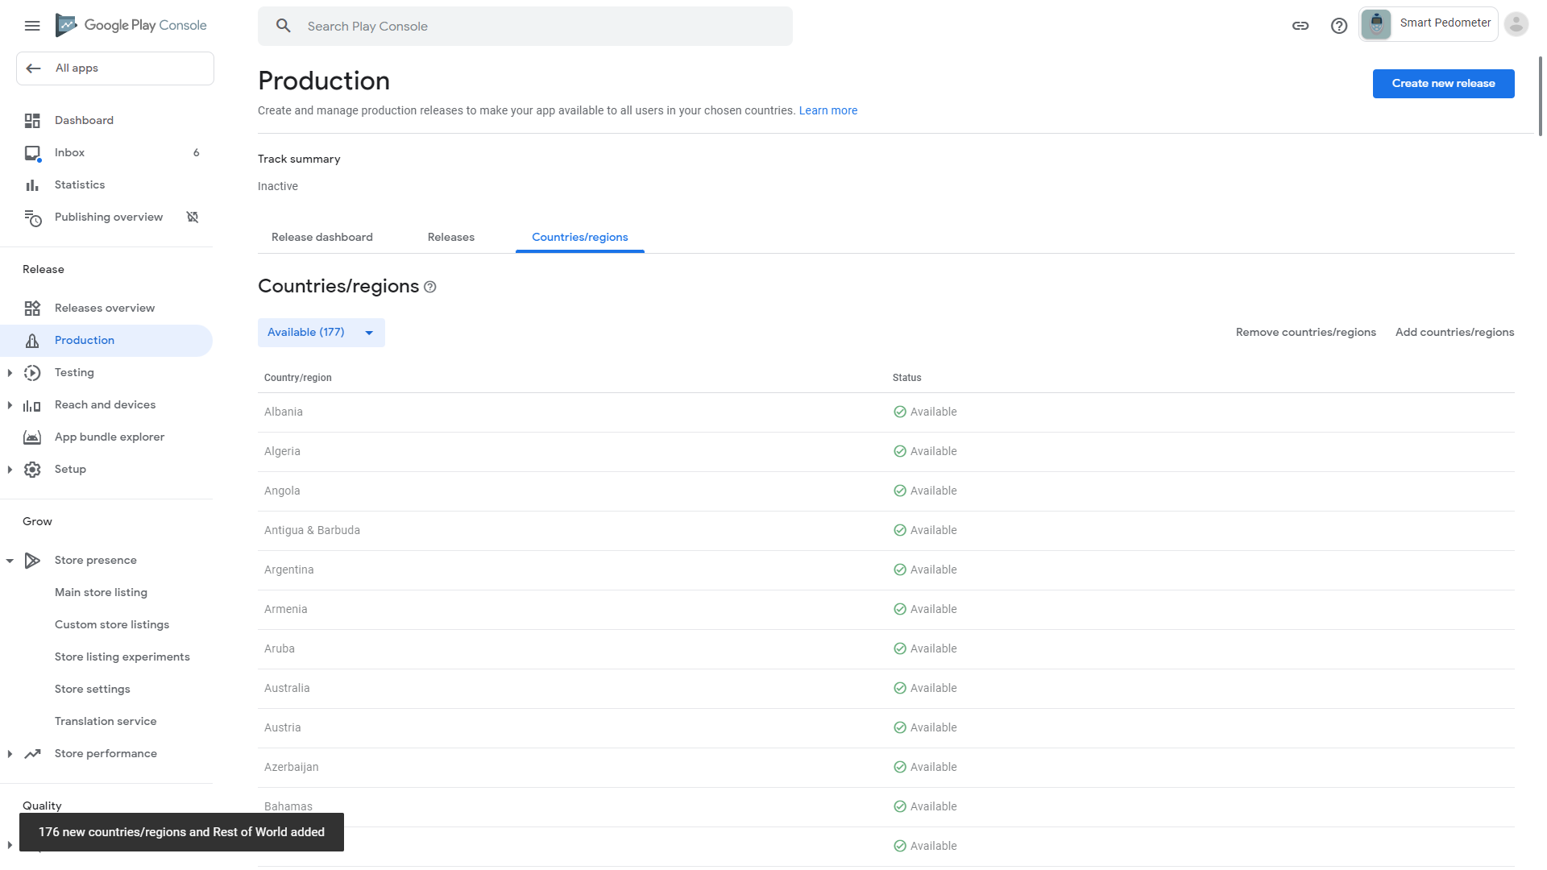
104. Click Dashboard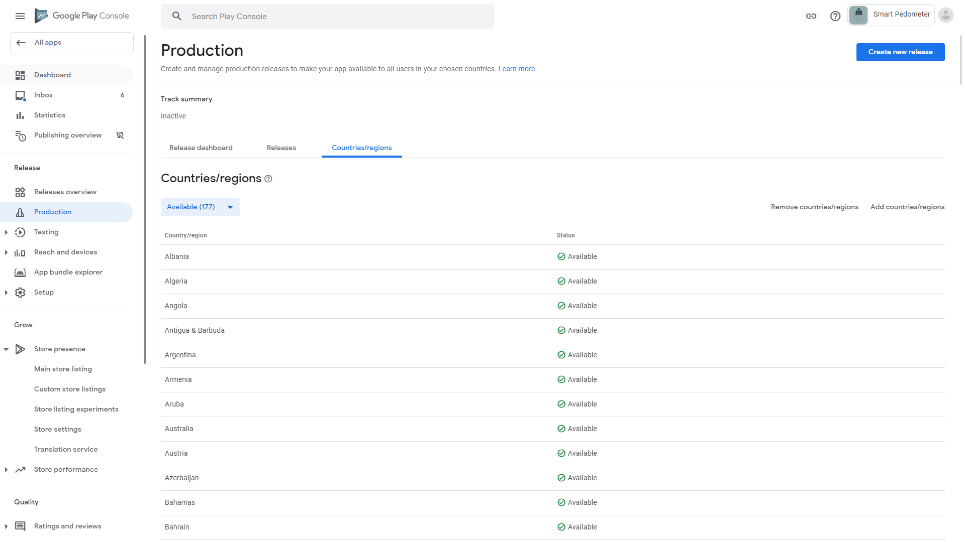
105. Scroll down and click “Create a new release” 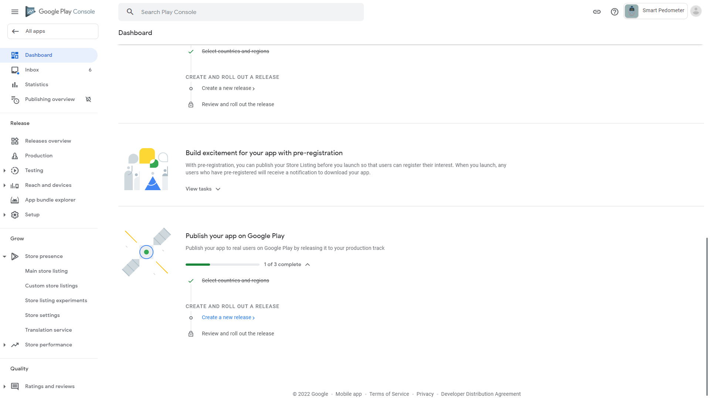
106. Click “Create new release” 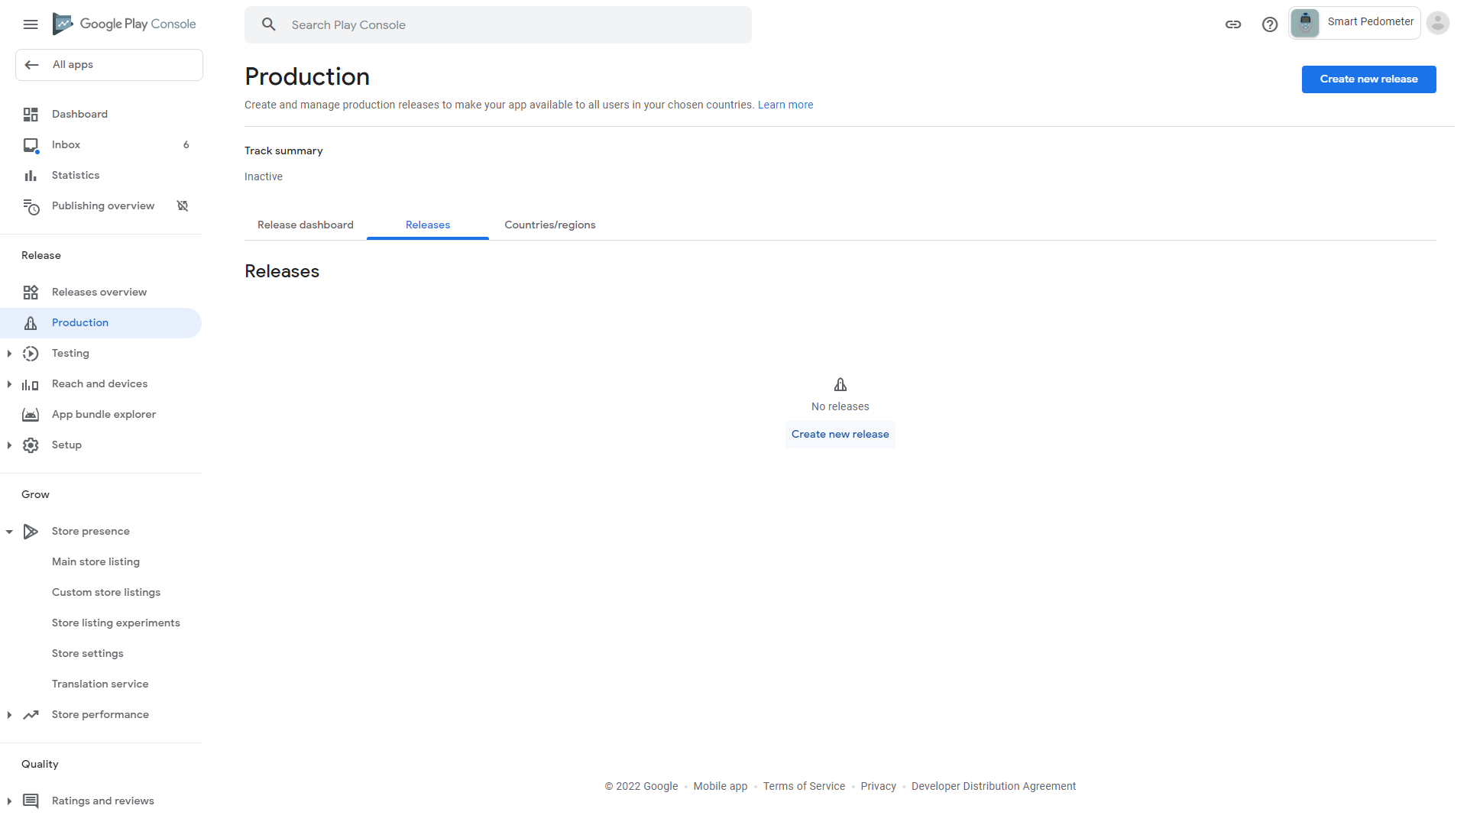
107. Click Upload

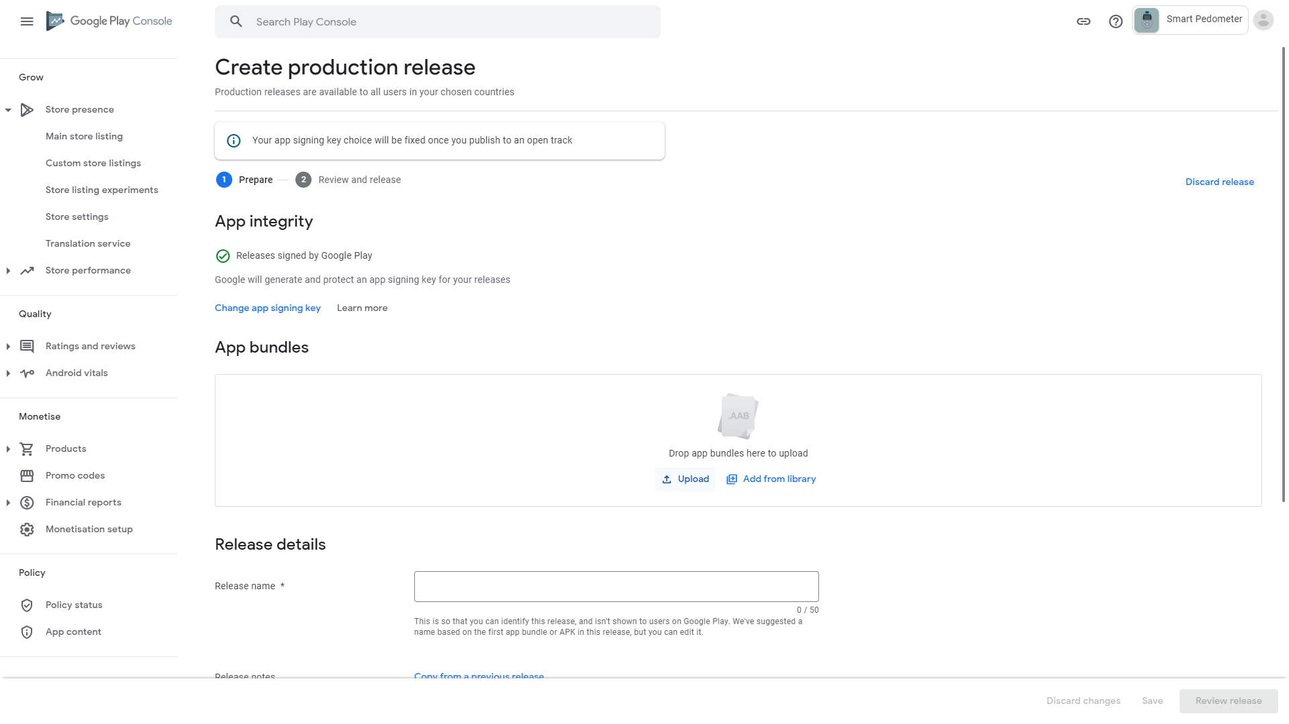

1. Click the Downloads folder, click our AAB file generated previously, then click Open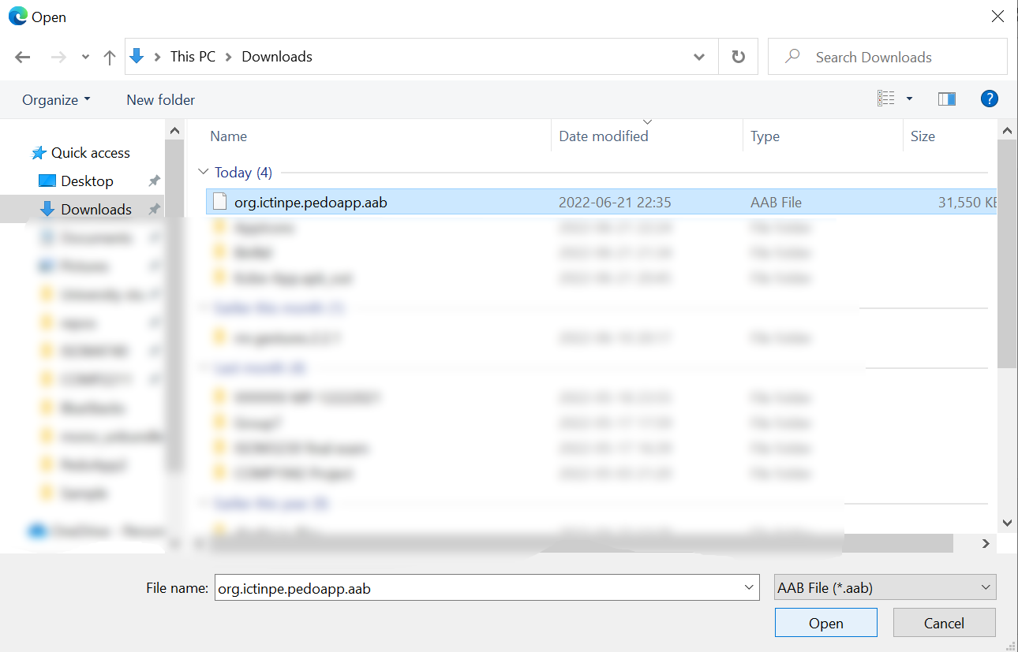
2. Wait for upload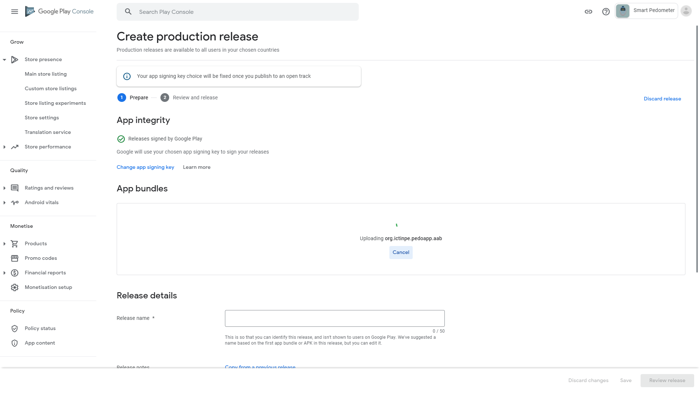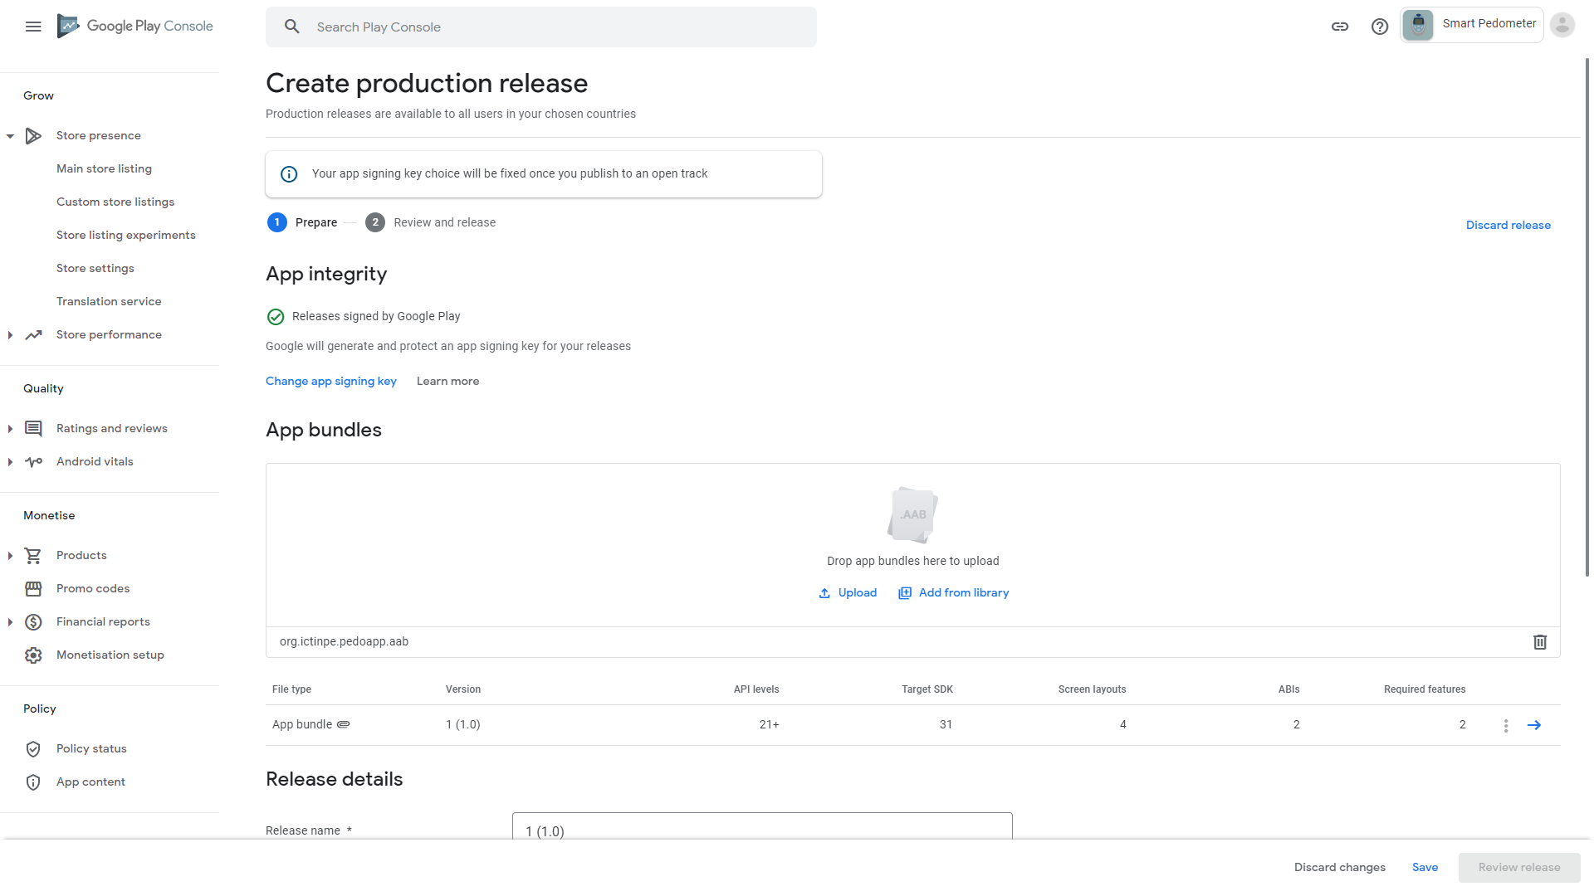
3. Scroll down and click the “Release notes” textbox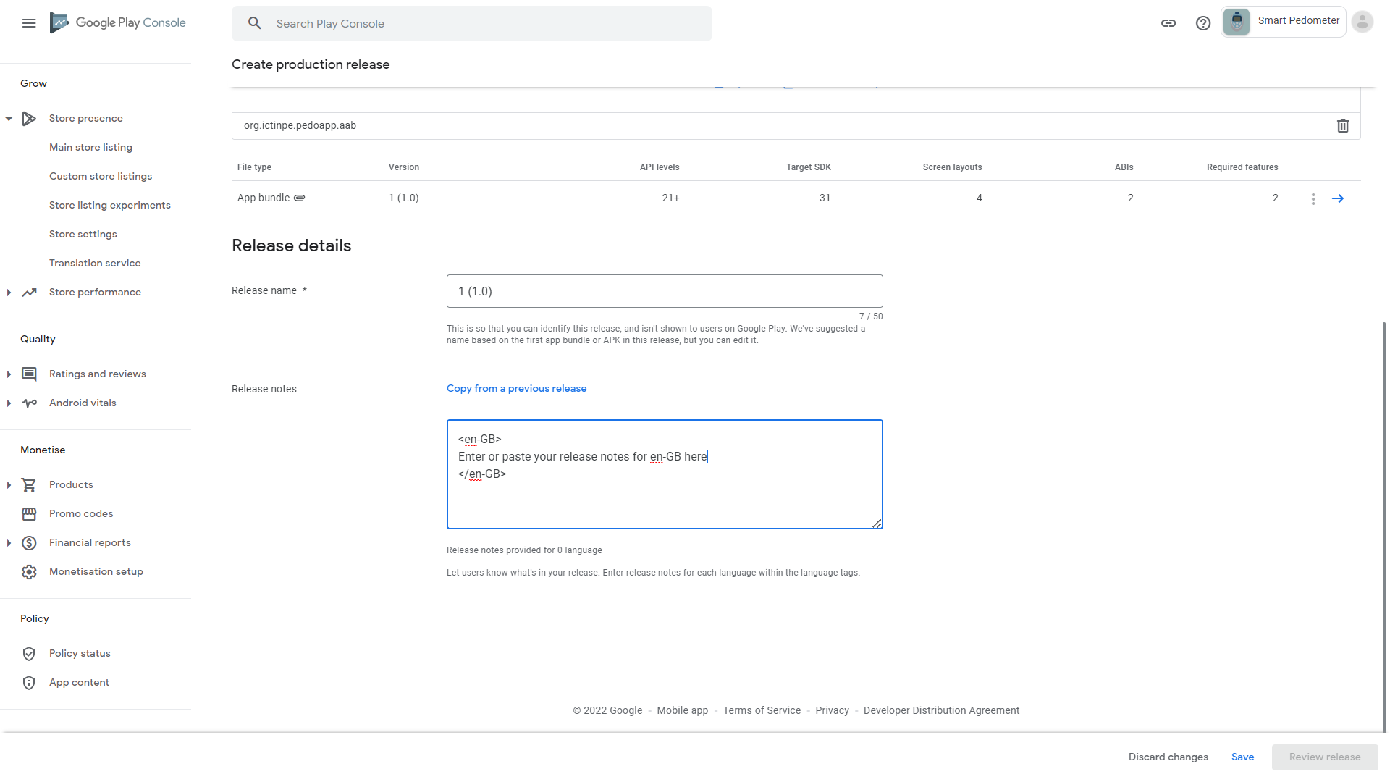
4. Change “Enter or paste your release notes for en-GB here” to “Initial release” (or any other description for this app version that you want to write), then click Save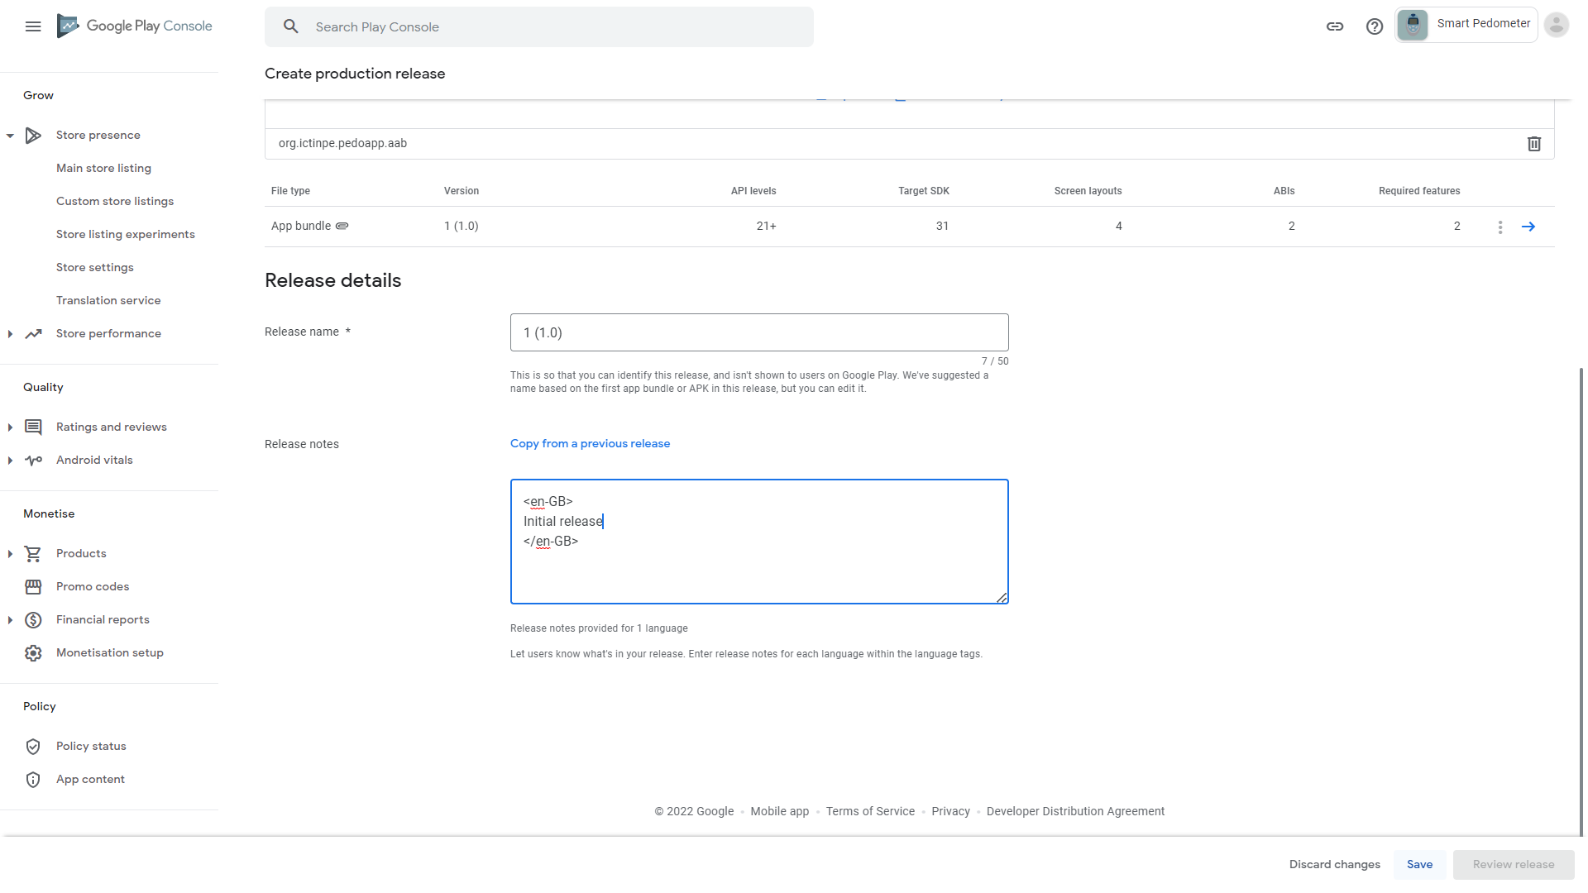
5. Click “Review release” 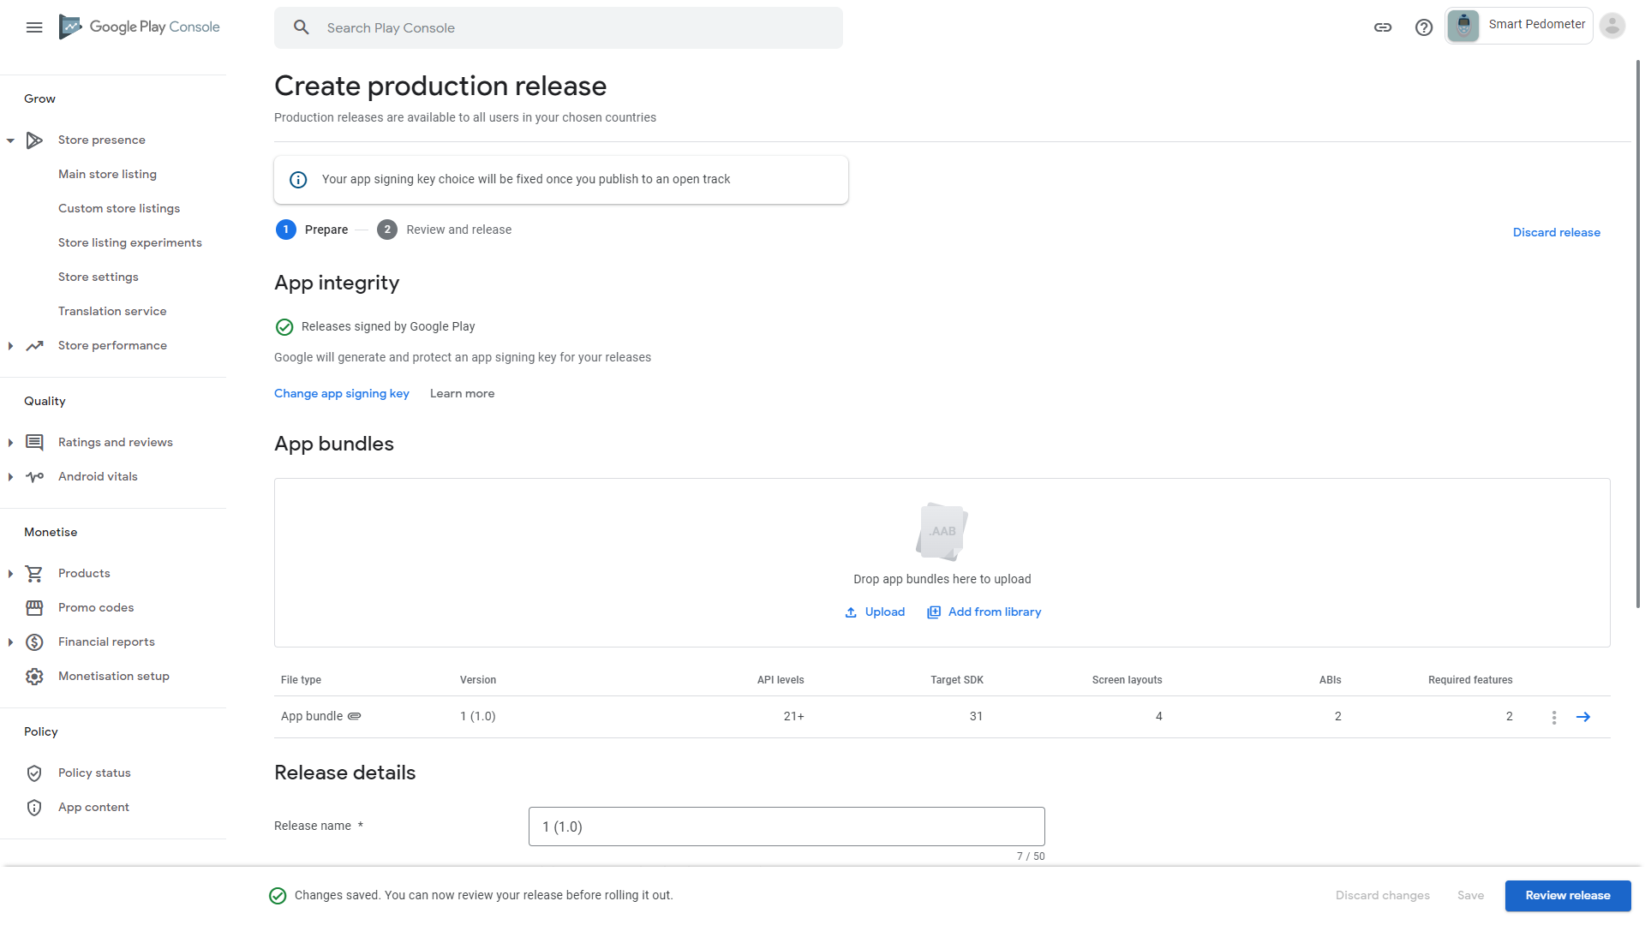
6. Click “Start roll-out to Production” (ignore the warning because it is not what we can control, and it is of informational-level severity only (debugging purposes), not affecting app functionality nor review processes)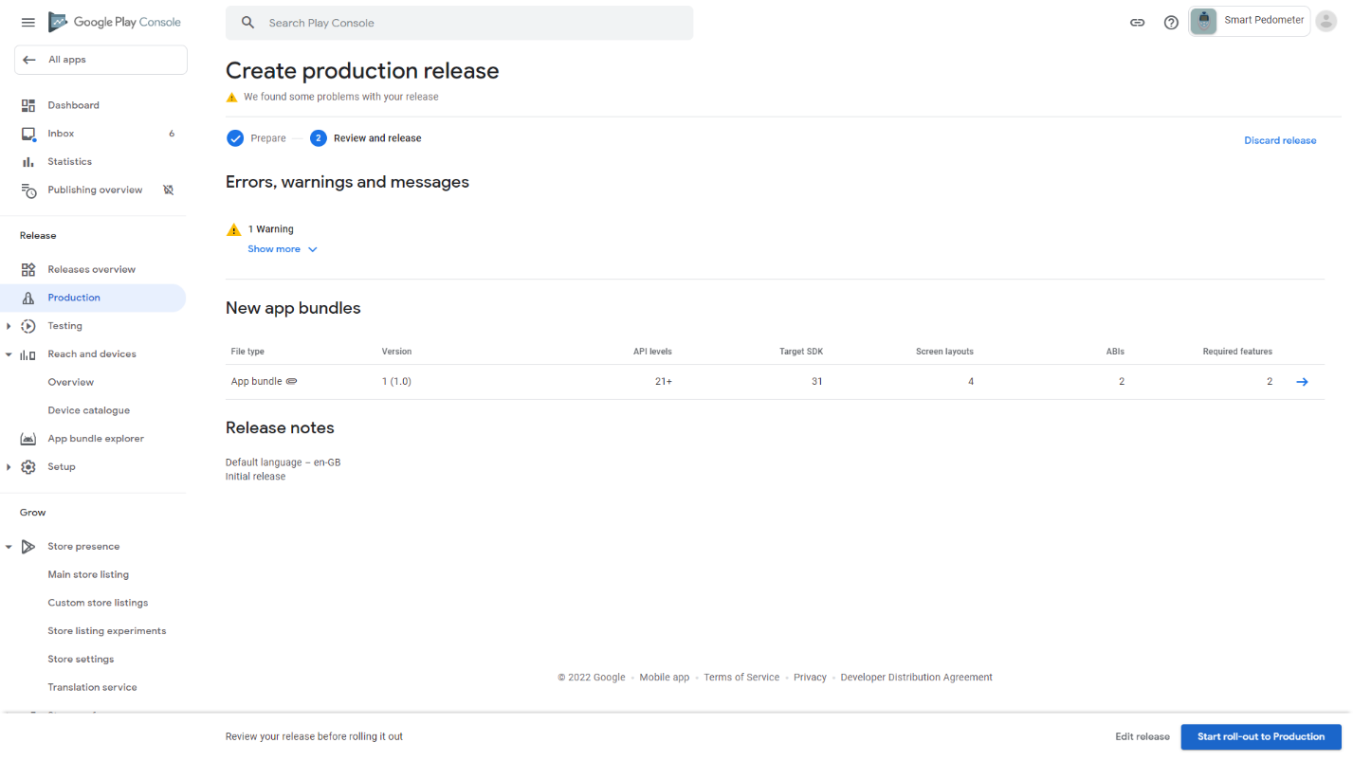
7. Click Rollout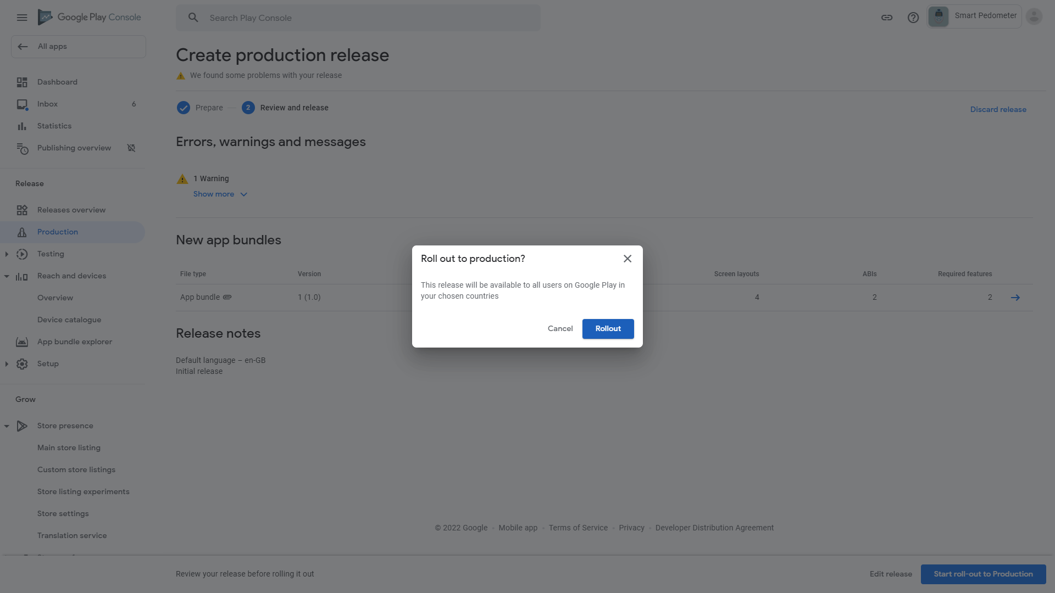
8. We have completed releasing our app to Google Play. What is left is for Google to review our app which may take up to a week. We can confirm this by looking at the “In review” text